Wireless Configuration

In order to access the wireless network that has just recently been expanded and upgraded on the Delaware campus, you will need an 802.11b network interface card. Some laptops come with these built in, while other will need to obtain one that will interface with the pcmcia (PC Card) slot on the laptop. Prior to purchasing one of these cards, make sure that you have an available pcmcia slot on your laptop, and that the card you are purchasing is compatible with your operating system.

Due to the number of different vendors that manufacture 802.11b wireless cards, and variations in the different operating systems, these instructions may not match your configuration exactly. The card that is recommended by ITS, due to price and availability, is the Netgear MA401 wireless PC adapter. Although this card will work in the wireless environment, it requires additional steps to configure that some of the higher end cards may not. An example of such a card is the Symbol Spectrum 24 High Rate 11 Mbps Wireless LAN adapter. This card is roughly twice the price of the Netgear card, but requires little more than installing the card and installing the appropriate drivers for your operating system, it will then detect any available wireless network and connect the PC to it.

When you purchase your wireless adapter, it will most likely be packaged with an installation disk / cd-rom and an instruction manual. At this point follow the instructions as each adapter is different. Some will require that the drivers and software be installed prior to placing the wireless card within the PC while other vendors expect the reverse to happen. If you have never had your PC connected to a network prior to this, the software will most likely step you through getting this configured as well.

When you install the wireless adapter, depending on your operating system, you will most likely receive a window that looks like this:

Note: These examples where all taken from a system using the Windows XP professional operating system.

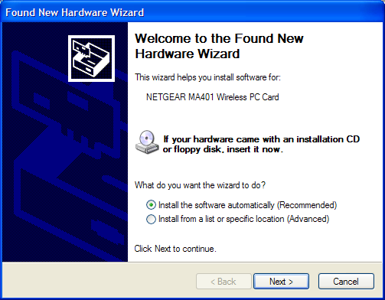

This is where you should be following the instructions that came with the wireless card, which probably tell you to put in the cd-rom and continue.

At this point, your drivers and software should be installing, and you should receive a screen that looks like the following if everything installed correctly.

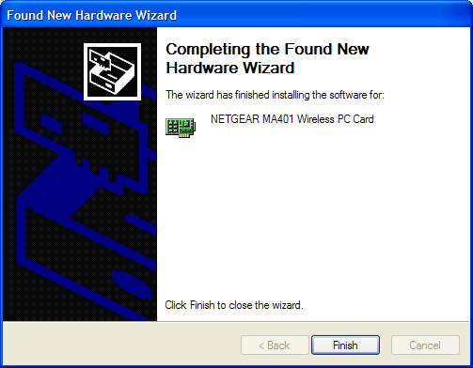

At this point, depending on the adapter you choose to purchase, you can either start to surf the net, or proceed to the next step which involves modifying the wireless cards configuration to talk to the wireless networks Access Points.

Look for either the “Network Neighborhood” icon of the “My Network Places” icon on your desktop and right click the mouse on it. You should see a menu appear, left click on “Properties”. This should open a window that looks similar to this if you are using a newer version of windows. If you do not see a window similar to this, go to the next section.

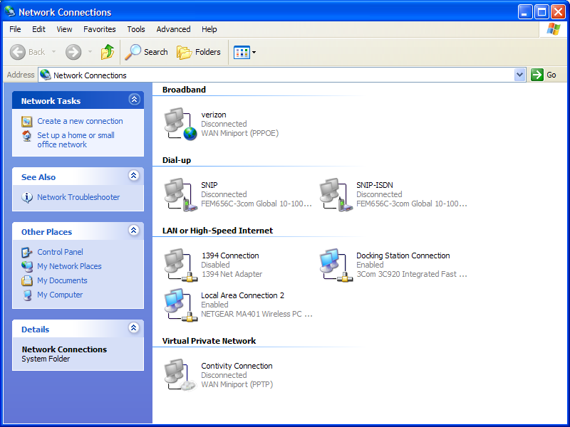

Click on the icon that is for the Wireless network card with the right mouse button, and then left click on properties.

It will open up a window that will allow you to configure your wireless adapter, and should look like this.

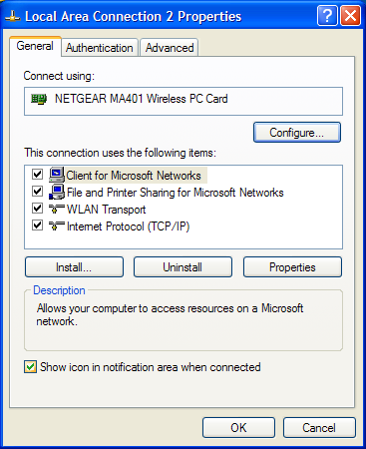

Those that are not running one of the new operating systems should see this screen as well from the previous step.

Now click on the configure button to open up this window.

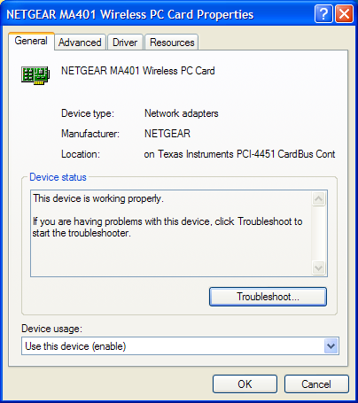

Now click on the advanced tab to open the next window. The next several pictures are how you should have your card configured to connect to the network. I am missing one of the screens as I am running an older version of the wireless cards drivers. It is the first option above channel. I believe that you can leave this as default. Actually, the only thing you really need to change is the Channel, Preamble Mode, and the SSID. Once you have made these changes, click on OK. Once these changes have been made, the LED on the Netgear card should stop blinking and glow a steady green. This will indicate that you are now connected to the network. You can use the steps above to check and see if you have a valid IP address. If you do, you should now be able to surf the web, and check your email.

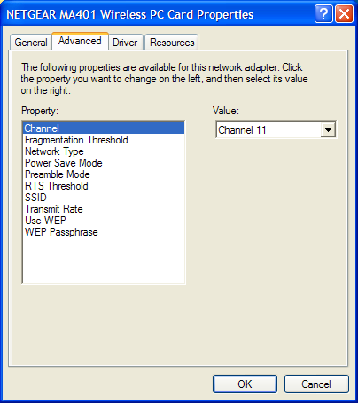

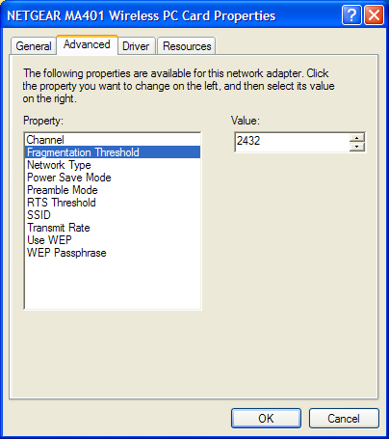

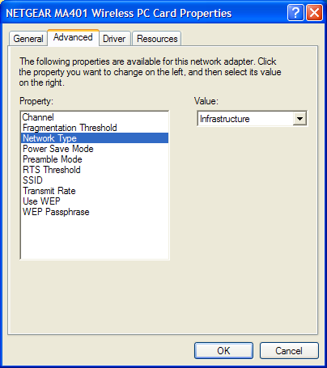

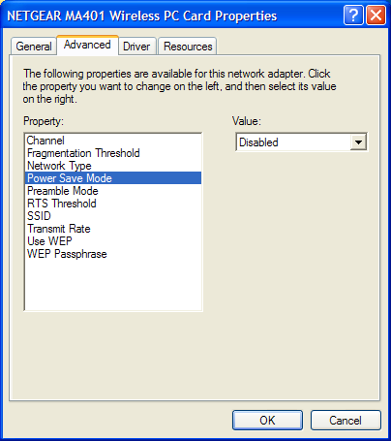

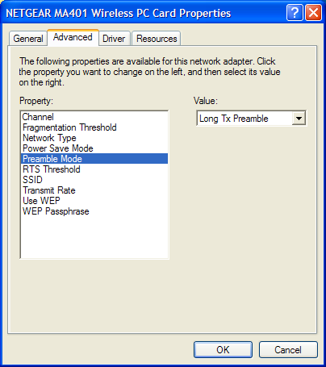

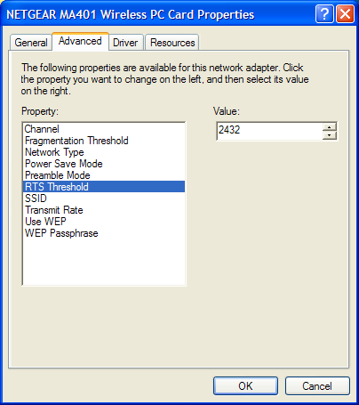

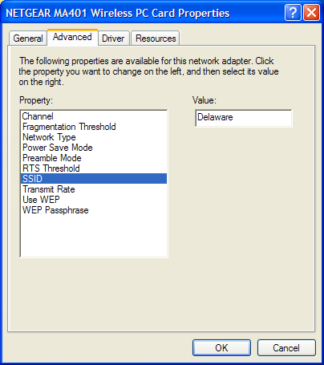

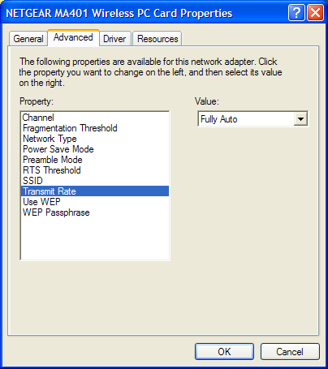

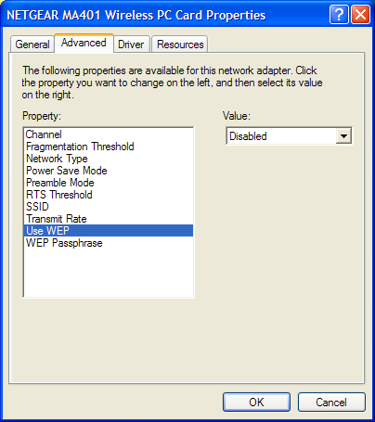

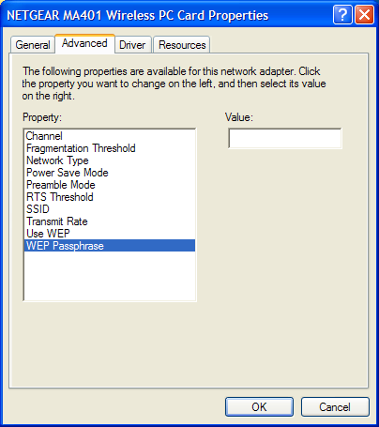

These screens may not match your screen exactly, but the some or all of the parameters should exist. Just configure your card so that they match and you should be in business.

The wireless network that is currently installed should give you access in the lounge and study area of Polishook, in the Barrister’s Club, the Lounge next to the Coffee shop in the Law Building, the lower and upper hallways of the law building, the 1st and second floor of the library, and out to the quad area as far as the flagpole.

If you need any additional information, please contact Information Technology Services at 302-477-2221 or stop in the office between 8:00 am and 5:00 pm.

