**Abstract**

**Objective:** Links between social relationships and maintenance of cognitive functioning in older adulthood is a topic of considerable interest. Yet important questions remain about the presence and nature of associations. This investigation aims to address several of these questions. First, we evaluate whether relations with cognitive performance over time differ for structural aspects of social relationships (i.e., social network and social contact) versus functional/subjective aspects of social relationships (loneliness and social support). Second, we investigate whether associations are between stable, “trait-like” components of social relationships and cognitive performance or if fluctuations “ie., state-like” components of these constructs are related. Third, we examine the direction of the relations between components of cognitive and social factors. Fourth, the impacts of age, education, gender, cohort, and health conditions on these relations are considered.

**Method:** The sample included up to 5810 participants from each of six waves, years 2004 and later, of the Health and Retirement Study. Those who were 65 years old or older in 2004 (mean 2004 age = 72.12 years, SD = 5.82) and had data for at least one wave of cognitive and psychosocial variables were included. Autoregressive latent trajectory (ALT) models were used to investigate whether social network, social contact, social support, and loneliness are related to memory (immediate and delayed) and mental status. Separate models for each social and cognitive variable combination were estimated.

**Results:** Comparisons of fit indices of bivariate ALT models favored models with level, linear change, and autoregressive parameters of cognitive variables estimated but only level and autoregressive parameters of social variables. Associations between overall levels of cognitive performance and social factors were not found, indicating that “trait-like” components are not related. However, reciprocal cross-lagged relations between cognitive performance, specifically memory and mental status, and social factors were common.

**Conclusion:** There was little support for a link between “trait-like” level of social variables and “trait-like” levels of cognitive performance. However, there was evidence of a reciprocal link between fluctuations in cognitive performance and social factors. These results are novel in applying ALT models to examine the relations between state- and trait-like components of both structural and functional aspects of social relationships over time.

**Study 1: Structural and Functional Aspects of Social Relationships and Cognition in Aging**

With great gains in life expectancy and those over 80 representing the fastest growing age group in several developed nations (He et al., 2016), identifying factors that contribute to successful aging is of key importance. Social isolation in older adulthood is an increasingly prominent issue in light of evidence that many older adults are socially isolated, which has implications for quality of life and wellbeing (2014, Report on the Social Isolation of Seniors, Chen & Freely, 2014). Further, the link between social relationships and mortality risk is robust and well established (Holt-Lunstad et al., 2010). Cognitive changes in older adulthood are one of the major sources of declining functioning and most likely reasons for an older person to require extended care (Agüero-Torres, von Strauss, Viitanen, Winblad, & Fratiglioni, 2001). Although some research has suggested that social relationships are related to cognitive decline in older adulthood, current evidence is mixed and important questions remain.

Social relationships are complex and involve many facets that can be measured in different ways. It is not clear if different aspects of social relations are differentially related to different cognitive functions. A broad distinction is made between functional and structural aspects of social relationships. Functional aspects of social relationships include elements such as the provision of social support and relationship quality (i.e., how well the relationship is meeting needs), while structural aspects include social network size and frequency of contact with others which indicate the presence of social ties but not necessarily perceptions of quality (Holt-Lunstad et al., 2010).

Overall, social network characteristics have shown inconsistent relations to indicators of cognitive change in older adulthood ((Agüero-Torres, von Strauss, Viitanen, Winblad, & Fratiglioni, 2001; Green, Rebok, & Lyketsos, 2008; Holtzman et al., 2004; Seeman, Lusignolo, Albert, & Berkman, 2001; Zunzunegui, Alvarado, Del Ser, & Otero, 2003). Some studies have found protective effects of greater social network size (Holtzman et al., 2004; Zunzunegui et al., 2003) while others have failed to find such effects (e.g., (Green et al., 2008). Holtzman (2004) examined maintenance of Mini-Mental Status Exam (MMSE; Folstein, Folstein, and McHugh, 1975) performance among a group of adults over 50 years old and found that those with larger social networks at baseline had reduced odds of decline by the third wave of assessment. However, Green et al. (2008) found that social network size was not protective against later cognitive decline as measured by the MMSE performance and a delayed recall task. Notably, these studies investigated the relations between baseline social network and change in cognitive function but did not examine whether changes in social network and changes in cognitive function co-occur.

It may be that actual social contact is a more direct protective factor against cognitive decline than simple counts of social network members. However, studies investigating social contact have also shown mixed results. In one study, frequency of interactions with social network members and emotional support received were both examined; no associations between these variables and change in MMSE or delayed recall performance over time was found (Green et al., 2008). Yet in another study investigating social contact, Beland (2005) found that older adults (over 65 years old) with higher levels of family ties and social engagement with relatives maintained better cognitive function up until 80 years of age, though after 80 the difference diminished. In this study, social relationship variables were included as time-varying predictors of cognitive function, with age as the temporal variable.

It may be that it is subjective evaluations of one’s social relationships and whether one perceives one’s social relationships as meeting needs that is related to cognitive function. Overall fewer studies have investigated the relations between social support and cognitive function and several of those that have included it as part of a larger group of social measures (Hertzog, Kramer, Wilson, & Lindenberger, 2008). In one cross-sectional study, including individuals over age 55 who participated in the NIH Toolbox normative study, a significant association was found between emotional support and executive function and processing speed, controlling for a variety of covariates including general health status, education, negative affect and a number of indicators of positive affect (Zahodne, Nowinski, Gershon, & Manly, 2014). However, no associations were found between emotional support and working or episodic memory. No other psychosocial variables examined (life satisfaction, positive affect, friendship, loneliness, instrumental support or negative affect) were related to any of the cognitive domains after accounting for other variables in the model. The authors note that this pattern was maintained even after restricting the sample to what is typically considered older adults (age 65 plus) (Zahodne et al., 2014). (Ellwardt, Van Tilburg, & Aartsen, 2015) investigated the longitudinal relations between emotional and instrumental support, loneliness, and cognitive function using data from the Longitudinal Study of Aging Amsterdam (LASA). They found that an increase in received emotional support over time was related to an increase in cognitive functioning and a decrease in loneliness. However, a mediation analysis, revealed no indirect effect of emotional support on cognition through loneliness. The effect of increased emotional support had a larger and more direct effect on cognitive functioning than an initially high level (intercept) of emotional support. Interestingly, increased instrumental support was actually related to a decrease in cognitive functioning perhaps reflecting social network members recognition of increased need for instrumental support due to declining cognitive function (Ellwardt et al., 2015). In another study, greater baseline loneliness was found to be a significant predictor of global cognitive decline from baseline at 10 year follow up (RR = 3.0, 95% CI = 1.4–6.8) (Tilvis et al., 2004).

Studies examining associations between loneliness and specific domains of cognitive function have showed more mixed results. Lonelier individuals showed poorer immediate recall in some cross-sectional studies (Gilmour, 2012), but other studies failed to find a significant relationship (O’Luanaigh et al., 2012; Schnittger, Wherton, Prendergast, & Lawlor, 2012). Loneliness was also related to delayed recall in some (O’Luanaigh et al., 2012) but not all studies (Gilmour, 2012; Schnittger et al., 2012). In their cross-sectional study, O’Luanaigh et al. (2012) also reported no significant associations between verbal ﬂuency and loneliness when controlling for depression, social networks, and a range of demographic factors. Relations between loneliness and executive functions have also been examined cross-sectionally. Although a negative association between loneliness and executive function was found, in a multivariate model that included social interaction the association was no longer significant (Gilmour, 2012). Another study also reported a negative correlation between loneliness and executive function but found that in a multiple linear regression model that included depression, neuroticism, perceived stress, solitary living, and accommodation status the association was no longer significant. This suggests that impact of loneliness on executive function may not be a unique contribution, but rather overlaps with other constructs, such as psychological distress, or lack of cognitively stimulating activities that are also related to executive functioning. One consistent finding is the negative association between loneliness and processing speed that remains even after controlling for relevant confounds such as depression, social network, and other cognitive and demographic factors (Boss, Kang, & Branson, 2015; Gilmour, 2012; O’Luanaigh et al., 2012).

Several studies have examined longitudinal associations between loneliness and cognitive function but, although baseline associations were common, few longitudinal associations were found. In a longitudinal study with 4 years of follow-up, immediate and delayed recall performance were significantly and negatively associated with loneliness at baseline and four-year follow-up (Shankar, Hamer, McMunn, & Steptoe, 2013). However, for delayed recall, higher levels of isolation and loneliness were associated with poorer recall in individuals with lower levels of education only. Greater loneliness was also signiﬁcantly associated with low levels of verbal ﬂuency at baseline (p < 0.001), but not at follow-up (Shankar et al., 2013). Wilson et al. (2007) found that those reporting greater loneliness at baseline had lower episodic, semantic, and working memory performance at baseline. However only the relations between semantic memory and baseline loneliness was signiﬁcant at the fourth year follow-up (p = 0.01) when controlling for age, gender, and level of education. (Schnittger et al., 2012) reported that verbal ﬂuency was a signiﬁcant risk factor of social loneliness (p<0.05).

Donovan et al. (2017) found that baseline loneliness significantly predicted cognitive decline over a 12 year period and that baseline cognitive function predicted greater odds of loneliness over the 12 year follow-up, but this relationship became non-significant when controlling for depression while baseline loneliness continued to predict cognitive decline with marginal significance. Gow and Mortenson (2016) found in a study using 30 years of data that marital status at ages 50 and 60 and loneliness at age 70 were associated with cognitive change over time whereas social contact and social support failed to predict cognitive change.

In the Rush Memory and Aging Project (MAP), the relation between loneliness, cognitive outcomes, and AD pathology was examined (Wilson et al., 2007). For the over 800 participants who completed the loneliness scale, loneliness was related to the development of incident AD and to rate of cognitive decline. This remained true after controlling for numerous other factors including social networks, social, cognitive and physical activities, disability, and depressive symptoms. As part of participation in MAP, individuals are asked to donate their brain and spinal tissue to the study for autopsy. Over the study period examined, 135 people came to autopsy. In this group loneliness was not related to amyloid load, tangle density, or cerebral infarctions (Wilson et al., 2007). The authors interpret this as indicating that loneliness is related to whether or not there was a clinical manifestation of Alzheimers disease, in the presence of disease pathology, but not to the pathology itself.

Thus, there is some evidence for associations between a variety of social relationship factors and cognitive change in aging but there is no clear pattern indicating which social relationship factors are related to what aspects of cognitive functioning in older adulthood, highlighting the need for further research. Identifying individual social relationship factors related to cognitive change in aging is important for several reasons. First, they have different implications for possible interventions. If objective/structural social relationship factors are important for cognitive function, then intervening at this level, by providing opportunities for social contact and increased social network size may reduce the severity of cognitive decline. However, interventions that target feelings of not being supported by ones’ social network members, or feelings of loneliness may not be resolved by increasing social contact opportunities and these individuals may benefit from a more comprehensive intervention. Second, this distinction is important because the mechanistic pathways through which structural/objective social relationship measures and functional/subjective social relationship measures are related to cognitive function may differ.

Many studies do not examine change in both social and cognitive measures and instead use baseline measures of social factors to predict trajectories of cognitive function. When a single measurement is taken at a particular occasion, both the relatively stable individual trait (e.g., general sociability, tendency to feel loneliness), and fluctuating components that may be more related to factors unique to that particular occasion are included in each person’s score. This is true for each of social relationship factors discussed as well for cognitive functioning. Distinguishing between these components is important, as it is possible, and perhaps likely, that one has a relationship to cognitive performance while the other does not (Hoffman & Stawski, 2009). Further, relations between fluctuating “state-like” components have different implications than relations between relatively stable “trait-like” components. Stable “trait-like” or “level” components of social network, social contact, perceived social support, and loneliness likely reflect a myriad of factors including personality and socioeconomic status that may themselves be related to cognitive performance and risk of cognitive decline. Within the social realm it is likely that an individual’s general sociability and their present circumstance (e.g., access to social contacts, marital status, etc.) are components of any single assessment. Thus, predicting later cognitive changes from a single data point at baseline means it is difficult to disentangle in what way the social relationship factor is related to cognitive function many years later.

Much of the existing literature uses latent growth modeling to examine intra-individual stability. The LGMs used in previous research do not provide information regarding autoregressive relationships or time-specific relationships. Autoregressive latent trajectory models allow for the examination of both state-like and trait-like components simultaneously. This means that a bivariate autoregressive latent trajectory model (ALT) can be used to examine relations between both components of each variable(Morin, Maiano, Marsh, Janosz, & Nagengast, 2011). Further, the ALT model can include cross-lagged components to allow examination of the dynamic interplay of social relationship and cognitive factors. This is an important advantage as the temporal relationship between social relationship factors and cognitive performance is unclear.

The present study aims to answer the following questions:

1. Do structural, specifically social network size and social contact, and functional, specifically social support and loneliness, social relationship factors show linear change over time?
2. Is there a relationship between levels of social relationship factors and levels of cognitive performance?
3. Is there a relationship between linear trajectories of social relationship factors and linear trajectories of cognitive performance?
4. What is the direction of the “state-like” relations between social relationship factors and cognitive performance?

**Method**

**Participants**

Participants were drawn from the 2004, 2006, 2008, 2010, 2012, and 2014 waves of the Health and Retirement Study (HRS). The HRS is a nationally representative longitudinal panel study of individuals over the age of 50 and their spouses of any age in the United States of America. Specifically, the RAND HRS data files (RAND Center for the Study of Aging, 2008) were used as they are more user-friendly. The HRS is supported by the National Institute on Aging (NIA U01AG009740) and the Social Security Administration. In 2004, the HRS piloted a self-completed psychosocial questionnaire administered to a random sample of respondents (n=3, 262). Beginning in 2006, the HRS began enhanced face-to-face interviews on a rotating basis with 50% of the core panel. The respondent psychosocial questionnaire was administered to an alternating 50% of the core panel, every 2 years, resulting in longitudinal data for the same participants every 4 years. In the present analysis, participants were excluded if they were younger than 65 at their first assessment wave, if they did not have at least one wave of response data for all cognitive and social variables of interest, or if they reported ever having received a diagnosis of “memory-related disease”, Alzheimer’s disease, or dementia.

**Measures**

**Demographics.**Age at each occasion, gender, race, and years of education were gathered based on self-report. Cohort is based on birth year, Initial HRS 1931 to 1941, AHEAD born before 1924, Children of Depression cohort born 1924 to 1930, War Baby born 1942 to 1947, Early Baby Boomer cohort 1948 to 1953, Mid Baby Boomer born 1954 to 1959.

**Social Network Diversity.**Respondents were asked four questions about their social network composition: specifically, whether they have spouses/partners, children, other family, and friends (Smith et al., 2013). To each question they could respond yes ‘1’ or no ‘0’, for a maximum possible total of 4.

**Social contact.** Respondents were also asked the extent to which they are in contact with members in their social network (excluding spouses) (Smith et al., 2013). For each group (children, other family, and friends), participants responded to three questions regarding how often they ‘Meet up’, ‘Speak on the phone’, and ‘Write or email’. Responses were given on a 1 = Three or more times a week to 6 = Less than once a year or never, scale. Responses were reverse coded and a summed for a total score of overall contact with social network for a maximum possible total of 54.

**Social support/Relationship quality.** Social support was measured by three items of a social support scale developed by (Walen & Lachman, 2000). Similar measurements used in previous studies were found to be reliable (e.g.,(Bertera, 2005). Three items assessing social support include: ‘‘How much do they really understand the way you feel about things?’’, ‘‘How much can you rely on them if you have a serious problem?’’ and ‘‘How much can you open up to them if you need to talk about your worries?’’. Items were asked in four loops in reference to participants’ spouse/partner, children, family members, and friends. The response options ranged from 1 (a lot), 2 (some), 3 (a little), to 4 (not at all). Items were re-coded so that a higher value indicates a higher level of social support. A total social support score was calculated by summing responses to the three social support questions for all social network categories (i.e., spouse/partner, children, family members, and friends) and dividing that by the social network total so that having social network members in more categories did not necessarily result in a higher social support score. Thus, social support indicates the extent to which individuals rate their existing social networks as supportive with a maximum possible score of 12.

**Loneliness.** The Revised University of California Los Angeles Loneliness Scale is a self-report measure of loneliness (Hughes, Waite, Hawkley, & Cacioppo, 2004); (Russel, Peplau, & Cutrona, 1980). The Revised version of the UCLA Loneliness scale is a short form of the widely used original scale. Respondents were asked to rate, on a 3-point scale, how often they felt as if they (a) lacked companionship, (b) were left out, or (c) were isolated from others. To obtain an overall loneliness score, the mean of the 3 items will calculated, with a higher score representing greater loneliness (range 1–3).

**General Health.** General health is summarized by including a count of the number of medical conditions reported. The score is comprised of the most common medical conditions among older adults: hypertension, diabetes, cancer, lung disease, heart condition, arthritis and stroke each coded as 0 (absent) or 1 (present) for a total range of 0 –7 with higher numbers indicating a greater number of medical conditions.

**Episodic Memory.** Memory functioning was assessed either in a face-to-face interview or over the phone. The two modes are expected to result in comparable performance (Ofstedal, Fisher, & Herzog, 2005). Memory functioning in HRS was assessed with two memory tasks: 1) an immediate word recall task where respondents were aurally given a list of 10 nouns and asked to recall as many words as possible from the list in any order (range 0-10) and 2) a delayed verbal memory task where after 5 min of engaging in other survey questions, respondents were asked to repeat the list of nouns previously presented as part of the immediate recall task. In order to minimize the impact of prior experience with the material (at previous waves of assessment), four different lists of 10 words were constructed that contained different but equivalent nouns of one and two syllables with high frequency (Thorndike & Lorge, 1944), high imagery, and concreteness (6.0 or more according to the norms by (Paivio, Yuille, & Madigan, 1968). Nouns meeting the conditions were ordered by recall-ability according to norms developed by Rubin (Rubin & Friendly, 1986) and distributed to six lists. The four lists used in HRS were selected for maximum equivalence in a pretest with 30 HRS respondents. The lists were randomly assigned to participants so that they were initially equal in frequency. Participants receive the lists in order so that each form will be given only once to each participant over four visits.

**Mental Status.** Mental status was assessed in all HRS participants aged 65 and older with a series of questions (Ofstedal et al., 2005). Respondents were asked to count backwards, as quickly as possible, for 10 continuous numbers starting at the number 20. Respondents were asked to give “today’s date” including the month, day, year, and day of the week. Two object naming questions were asked “What do you usually use to cut paper?” and “What do you call the kind of prickly plant that grows in the desert?”. Respondents were asked to give the name of the current President and Vice President of the United States. Responses to mental status questions were summed for a mental status total score (range 0-9).

**Analytical Strategy**

Autoregressive Latent Trajectory (ALT) models were proposed by Bollen and Curran (2004, 2006) to include the important features of autoregressive and latent curve models for longitudinal data analysis. In bivariate autoregressive models each subsequent time point is defined by the previous time point value on the same variable, the previous time point on a second variable, plus a random disturbance (Bollen & Curran, 2004). The first occasion of measurement is typically treated as exogenous (i.e., pre-existing and not influenced by other variables in the model) and the autoregressive and cross-lagged effects are the same for each individual in the sample (Bollen & Curran, 2004). Latent growth models use all observed time points to estimate a latent trajectory for each person, and deviations from one’s predicted trajectory are treated as random errors. In autoregressive latent trajectory models these temporary “state-like” deviations from predicted trajectories can be of substantive interest and predicted from other variables in the model (Morin et al., 2011). To answer the proposed research questions, a progressive series of models was estimated, first to examine social and cognitive variables of interest individually, and then in bivariate models. Based on Bollen and Curran’s (2004, 2006) recommendations, first the univariate unconditional autoregressive models, LGM, and ALT models were estimated for each cognitive and social variable to understand each variable individually. For ALT models, the first measurement point for all processes was included in the model as predetermined and the time metric was study wave. LGM’s are not technically nested within the ALT model but when the cross-lagged parameters are fixed to zero; it is equivalent to a LGM with the first occasion of measurement treated as exogenous, and nested within the ALT. Additional constraints were then added to the full ALT model: 1) fixing the slope factor’s variance to zero, 2) excluding the slope factor, 3) constraining the autoregressive parameters to equality over time. Model fit was evaluated with multiple fit indices: the chi-squared likelihood ratio test, the Comparative Fit Index (CFI), the Tucker-Lewis Index (TLI), the Standardized Root Mean Square Residual (SRMR) and the Root Mean Square Error of Approximation (RMSEA). Values greater than 0.95 indicate good fit for CFI with greater than 0.90 indicating adequate fit (Bollen, 2989; Hu & Bentler, 1999). For RMSEA values smaller than 0.08 or 0.06 are considered acceptable and good, respectively. For SRMR 0.10 and 0.08 are considered acceptable and good fit respectively (Bollen, 1989; Hu & Bentler, 1999). Nested models were compared using the chi-square difference test (Bollen, 1989). The results of univariate models are presented in the supplemental materials section. The estimation of bivariate models followed a similar strategy with bivariate models estimated for each social-cognitive variable pair. For bivariate models the full ALT model was specified with correlations between the first measurement points of the cognitive and social variable, with autoregressive, cross-lagged parameters, and with time-specific correlations between the two processes that were unrestricted across time. In the bivariate model series restrictions were progressively added to the full ALT: (1) fixing the slope variance to zero; (2) excluding the slope factor; (3) constraining the time-specific uniquenesses’ correlations to equality over time; (4) excluding the time-specific uniquenesses’ correlations; (5) constraining the cross-lagged parameters to equality over time. The first three constraints were added first to the cognitive processes and then to the social process one at a time. In each case, if the more complex model did not result in a significantly better fit than the simpler model (i.e., the model with fewer parameters estimated or more contraints), that model was retained and further constraints tested against this model. All models were estimated with the MLR option for maximum likelihood estimation with robust standard errors in Mplus 7.4 (Muthen & Muthen, 2012-2015). Maximum likelihood estimation can handle even large proportions of missing data assuming missing at random, by using all available information from all cases (Muthen & Muthen, 2012-2015).

Once a final model was identified for each bivariate combination without covariates, the covariates were added to only that model. The intercept and slope parameters of each process (the cognitive and social) and the first measurement point (estimated as predetermined) were regressed on each covariate. In ALT models, because the first occasion of measurement is predetermined, the intercept is the portion of the Time-2 variable remaining unexplained by the Time-1 variable.

Results

The descriptive statistics for all included variables are presented in Table 1. Model fit indices are presented for each model series in Tables 2 through 12. Each process was investigated separately as a univariate model and then each cognitive - social combination was estimated. Univariate model results are presented in supplementary materials. First, the results from process of model building for each bivariate combination is described. Then results describing each process, the intercept, first wave value, trajectory shape and autoregressive parameters, are summarized from the results of all final bivariate models in which that process was included as the features of each variable should remain very similar regardless of the other variable included in the model. Following the summary of each variable, the bivariate relations between variables will be presented for each bivariate model.

**Model Building**

Initially the process described in the analysis section for comparing a series of models was attempted for all bivariate cognitive – social combinations. However, in all bivariate combinations, convergence issues limited the number of models included in the model building process and only models that converged without issue could be included in model comparisons. In many cases this meant that the full ALT model could not actually estimated. For all social variables estimating the slope parameter resulted in model convergence issues for some models in the series although, for some variable combinations it was possible to estimate the social variable slope when other model constraints were added, these cases are specifically described below. Model convergence with slopes estimated was not an issue in the univariate models, and thus it is likely related to increased model complexity in the bivariate models.

*Loneliness*

Full bivariate ALT models with loneliness did not converge when investigated with immediate or delayed word recall. When the slope term for loneliness was not estimated all models converged. Some models with the loneliness slope, and other model parameters constrained, did converge and so were included in model comparison.

*Immediate recall.* Model comparison results indicate that the slope of loneliness can be excluded, time-specific correlations can be removed, and autoregressive parameters for both immediate word recall and loneliness can be constrained to equality over time without a significant reduction in model fit from the ALT model with the loneliness slope estimated with variance fixed to 0 (see Table 2) all other constraints resulted in poorer model fit. The final model had excellent model fit according to all fit indices.

*Delayed recall.* The model fit results of the bivariate ALT model of delayed word recall performance and loneliness are reported in Table 3. Model fit results show that the following constraints can be added without a reduction in model fit: the slope term for loneliness can be excluded, correlations between time-specific uniquenesses between delayed word recall performance and loneliness can be removed, and the autoregressive parameters for both processes can be fixed to equality over time. However, constraining the cross-lagged regression components to being stationary over time resulted in significantly poorer model fit. Thus, the ALT model without the loneliness slope, time-specific correlations between delayed word recall and loneliness, and fixed autoregressions for both loneliness and delayed recall was retained. The final model had excellent model fit according to all fit indices

*Mental status.* The results of the bivariate models with mental status and loneliness are presented in Table 4. Progressive model constraints showed that the following constraints could be added without a significant reduction in model fit: excluding the time specific correlations between loneliness and mental status and constraining the loneliness autoregressive parameters to equality over time. Unlike all other models with loneliness, when included with mental status the best fitting model included a slope term for loneliness. However, to maintain consistency with other bivariate models including loneliness the model covariates were added to both models with and without an estimated loneliness slope.

*Social Contact*

Social contact bivariate models did not converge when the slope of social contact was estimated so models with intercept and autoregressive parameters for social contact were compared.

*Immediate recall.* Bivariate models indicate that in addition time-specific correlations can be excluded, and the immediate word recall autoregressive components can be constrained to equality over time without a significant decrease in model fit according to the chi-square difference test (see Table 5). The final model had excellent model fit according to all fit indices.

*Delayed recall.*  The model fit results of the bivariate ALT model of delayed word recall performance and social contact are reported in Table 6. The bivariate model results showed that several constraints can be added without a significant reduction in model fit. Specifically, the time-specific correlations between delayed word recall and social contact can be excluded, and the autoregressive parameters of delayed word recall can be constrained to equality over time. Model 6 is the best fitting model according to the ∆χ2 and has excellent model fit according to all fit indices.

*Mental status.* The results of the bivariate mental status and social contact analysis are presented in Table 7. According to the ∆χ2 the following constraints can be added without a significant reduction in model fit: excluding time-specific correlations between mental status and social contact and constraining autoregressive parameters of social contact to equality over time. Thus model 7 is the best fitting model and has excellent model fit according to all fit indices.

*Social Support*

The full ALT models with social support did not converge. However, for some variable combinations when other model constraints did converge with the social support slope estimated. These were included for model comparison purposes but for all combinations the models without a social support estimated were retained.

*Immediate recall.* The fit of all converged bivariate ALT models of immediate word recall performance and self-reported social support are reported in Table 8. According to the ∆χ2, the following constraints can be applied without a significant change in model fit: the slope of social support can be excluded, the time-specific correlations between uniquenesses of immediate word recall performance and social support can be excluded, and the autoregressive parameters of both immediate word recall and social support can be constrained to equality over time. All other constraints significantly decreased model fit. Model nine is retained as the most parsimonious and has excellent model fit according to all fit indices.

*Delayed recall.* The model fit of bivariate models of delayed word recall and social supported that converged are presented in Table 9. The progressive addition of further constraints showed that the slope of social support could be excluded, the correlations of time-specific uniquenesses of delayed word recall performance and social support could be excluded and the autoregressions of both delayed word recall and social support could be constrained to equality over time without a significant reduction in model fit. Model nine was retained and showed good model fit by all indices.

*Mental status.* The results of the bivariate mental status and social support models are presented in Table 10. Some models with a slope term for social support would not converge however, in some cases models with the slope term estimated but other model constraints did converge. The ALT model with only level of social support estimated, with the autoregressive parameters of social support constrained to be stationary over time, and time-specific correlations between mental status and social support excluded was the best fitting model according to χ2 difference testing and showed excellent model fit according to all indices.

*Social network composition*

Social network composition models would not converge with a slope term estimated. Thus, the full ALT model was not estimated and all models were specified with only intercept, first occasion of measurement, and autoregressive parameters for social network only.

*Immediate recall.* Model fit indices and comparisons are presented in Table 1. The best fitting model was the ALT modelwithout time specific correlations between immediate word recall and social network, and with the autoregressive parameters of immediate word recall constrained to be equal over time. This model showed good model fit according to all indices.

*Delayed recall.* The bivariate model fits for social network and delayed word recall are presented in Table 12. Model fit comparisons showed the following model constraints did not reduce model fit and so were retained in the final model: excluding time-specific correlations between social network size and delayed word recall and constraining the autoregressive parameters for delayed word recall to equality over time. This model showed good fit according to all indices.

*Mental status.* The results of the bivariate mental status and social network are presented in Table 13. Conducting a model fit comparison of only converged models with progressively added model constraints showed that the following constraints could be added without a significant decrease in model fit: the correlations of time-specific uniquenesses can be excluded, the autoregressive parameters for social network can be constrained to equality over time, and both the social network - on - mental status and the mental status - on - social network cross-lagged regression parameters can be constrained to equality over time. Thus, the best fitting model according the ∆χ2 test comparisons was model 8. This model also showed good model fit by all other fit indices.

**Univariate findings**

The univariate results are summarized from each of the bivariate models and presented below. All results are from bivariate models estimated without a social variable slope. Note that the results generally did not differ for the same variable, as would be expected, parameters are presented as one estimate or a range summarizing similar results from all bivariate models in which that variable was included.

Immediate Word Recall

Immediate word recall had a significant negative slope with a small but significant variance, consistent across all models and with the univariate immediate word recall results ( ranged from -0.15 to -0.08, = 0.00, *p* = 0.01). Further the proportion of state-like deviations in immediate word recall performance explained by performance at the previous wave remained consistently not significant ( = -0.02, *p* = n.s for all models) over time; allowing autoregressive parameters to vary over time did not significantly improve model fit (see tables 2, table 5, table 8, table 11).

Delayed Word Recall

When delayed word recall was examined in relation to the four social factors, the slope of delayed recall performance was consistently significant and negative with a small but significant variance parameter (range = -0.18 to -0.07, *p’s* ≤0.01, and = 0.01, *p* = 0.00). Previous time-specific uniquenesses in delayed word recall performance did not predict time-specific uniqueness in delayed word recall performance two years later ( = -0.01, *p* = n.s).

Mental Status

The slope of mental status was consistently significant and negative with a small but significance variance parameter (range = -0.32 to -0.25, *p’s* ≤0.01; = 0.01, *p’s* ≤0.01). The autoregressive parameters of mental status significantly predicted mental status two years later, became larger over time, and reached significance by the third occasion (social network: = -0.01, *p* = 0.67, = 0.03, *p* = 0.23; = 0.05, *p* = 0.01; = 0.13, *p* = 0; = 0.18, *p* = 0; social support: = -0.04, *p* = 0.28 = -0.00, *p* = 0.93; = 0.05, *p* = 0.01; = 0.12, *p* = 0; = 0.15, *p* = 0.00; social contact: = -0.04, *p* = 0.28, = -0.00, *p* = 0.93; = 0.05, *p* = 0.01; = 0.12, *p* = 0; = 0.15, *p* = 0.00; loneliness: = -0.02 *p* = 0.50, = 0.04, *p* = .09; = 0.06, *p* <.01; = 0.13, *p* < .01; = 0.17, *p* <.01).

Loneliness

Models did converge when the loneliness slope variance was constrained to zero (e.g., the bivariate immediate word recall and loneliness model). The mean loneliness slope was significant in the immediate word recall model, but not in the delayed word recall or mental status models. For consistency, the slope of loneliness was not included in any of the final models to which covariates were added. Across all models, model fit indices indicated that models with autoregressive parameters constrained to equality over time were superior and time-specific uniqueness in loneliness significantly predicted time-specific uniquenesses two years later: range = 0.17 to = 0.26, *p* ‘s < .01.

Social Contact

For two of the three bivariate models with social contact (mental status and delayed word recall) the full ALT model was not estimable due to convergence problems. Models without a slope term of social contact converged without issue. In one of the three models (with mental status) the allowing the autoregressive parameters of social contact to vary over time significantly improved model fit. Across all three bivariate models, social contact significantly predicted social contact two years later across all occasions (delayed word recall: = 0.26, *p* = 0; immediate word recall: = 0.30, *p* = 0; mental status: = 0.30, *p* = 0).

Social Support

As in the univariate models, model fit was not significantly improved by allowing the autoregressive parameters of social support to vary over time in any of the bivariate models. Across all models, time-specific uniqueness in social support significantly predicted time-specific uniquenesses in social support two years later ( = 0.28 to 0.30, *p*’s <.01).

Social Network

In all cognitive pairing models the autoregressive social network parameters were significant and positive such that time-specific uniquenesses in social network significantly predicted time-specific uniquenesses in social network two years later ( = 0.32 to 0.33, *p*’s <.01).

Covariate effects.

The predictors were added directly to each of the final ALT models. Fit indices for the final models are presented in the final rows of Tables 2 through 13. Bivariate model results are discussed below and presented in Figures 1 through 7. The relation of covariates to each process remained consistent across models and are thus presented in summary.

*Age.* Older individuals had significantly less social contact and smaller social networks overall across all occasions. However, older individuals also reported significantly higher initial levels of social support. Older individuals also had lower performance overall on all three cognitive measures, and a greater rate of decline over time in all three measures.

*Gender.* Women reported greater initial as well as overall loneliness despite reporting more social contact and greater social support initially as well as overall, across all occasions, compared to men. However, men had more diverse social network composition overall. Women had higher performance on immediate word recall, delayed word recall, and higher mental status scores both initially and overall across all occasions. Sex was not related to rate of change in any cognitive function examined.

*Years of education.* Those with more education reported significantly lower levels of loneliness overall and lower initial levels of loneliness, larger social networks, more social contact initially and overall across time, but lower overall levels of social support. More years of education was related to better initial performance on all three cognitive measures, and better performance overall across all occasions.

*Health conditions.* Individuals with more health conditions reported greater levels of loneliness overall and greater initial levels of loneliness. Individuals with more health conditions reported lower levels social support at the first measurement point and across all occasions. Health conditions were not related to social network or social contact. Greater number of health conditions was associated with lower initial performance and lower performance overall on all three cognitive measures.

*Cohort.* Cohort was not significantly related to any of the social or cognitive variables but was retained as a control variable.

Bivariate relations

*Loneliness and immediate recall.* In the final model the correlation between the intercept factors (level of loneliness and immediate recall net the impact of the first occasion of measurement) was not significant (corr. = 0.003, *p* = .765) nor was the correlation between time 1 loneliness and time 1 immediate word recall (corr. = -0.01, *p* = 0.46). Further, that the time-specific correlations could be removed without changing the overall fit of the model indicates that the time-specific uniquenesses, after accounting for the slope of immediate word recall, were not related at any given time point. The cross-lagged regressions of loneliness on immediate word recall were all significant except state-like deviations in time 2 loneliness did not significantly predict state-like deviations in time 3 immediate word recall performance ( = -0.08, *p* = 0.07). State-like deviations in immediate word recall performance significantly predicted state like deviations in loneliness across all occasions indicating a reciprocal relationship.

The predictors age, sex, years of education, cohort, and number of health conditions, were added to the final unconditional bivariate ALT model (see Figure 1). The model fit indices appear in the last row of Table 2 and show adequate fit by all indices. The addition of covariates did not substantial change the bivariate relations. When covariates were added to the model significant cross-lagged relations remained such that loneliness at time 3, 4, and 5 predicted immediate recall performance at time 4, 5, and 6, respectively and immediate recall performance at all occasions significantly predicted loneliness two years later (see Figure 1). The relation was negative indicating that lower immediate recall predicts greater loneliness.

*Loneliness - delayed recall.* In the final unconditional model the correlation between initial delayed word recall performance and loneliness was significant (corr. = -0.05, *p* = .024). However, correlation between the intercept factors was not significant (corr. = 0.01, *p* = .47). There was a significant cross-lagged relationship such that state-like increases in loneliness, from overall level, predicted decreased delayed word recall performance two years later. Further, decreases in delayed word recall performance, over and above that predicted from overall linear change over time, predicted increases in loneliness two years later.

When covariates were included, only time 1 and time 3 loneliness significantly predicted delayed word recall two years later (see Figure 2). State-like deviations in delayed word recall predicted state-like deviations in loneliness two years later at time 1 and time 2. The negative correlation between intercept factors was also no longer significant.

*Loneliness - mental status.* In the final loneliness and mental status model the initial values of mental status and loneliness were not significantly correlated, (corr. = -0.01, *p* = .29). Intercept terms were not significantly correlated (corr. = -0.00, *p* = .682). The cross-lagged regressions indicated that state-like deviations in loneliness at time 1 and time 2 did not predict deviations in mental status two years later (mental status - on - loneliness β = 0.03, *p* = 0.30) but loneliness did significantly predict mental status two years later at the third occasion and later (-0.13, *p* = .002; -0.133, *p* = .006; -0.14 , *p* = .03). In contrast, the loneliness - on - mental status cross-lagged regressions were consistently significant and negative, indicating that poorer mental status predicted greater loneliness two years later (loneliness-on-mental status = -0.05 to -0.01, *p’s* < .01). The parameter estimates, and thus conclusions drawn from this final model differed from the full ALT model in several important aspects. First, in the full ALT model, consistent with the univariate model of loneliness and the other bivariate models including loneliness, the slope of loneliness was not significant indicating that overall loneliness on average remains stable over time ( = 0.08, *p* = 0.01) the variance in the trajectories of loneliness was also not significant ( = 0.00, *p* = 0.02). In the full ALT model, loneliness was not predictive of mental status two years later at any occasion. Mental status was also not predictive of loneliness two years later at any occasion.

The effects of covariates were investigated in the final model (see Figure 3). There was a significant relationship between years of education and the first measurement occasion of mental status such that those with more years of education had a higher initial mental status. Cohort was also related to the first measurement occasion. Years of education was significantly related to the mental status intercept term. No other covariates were significantly related to mental status intercept. Age and education were significantly related to the mental status linear slope factor such that those who were older at baseline showed greater decline over time while those with more education showed less decline over time.

*Social contact - immediate recall.* In final unconditional model the correlation between initial immediate word recall performance and social contact was not significant (corr. = -0.30, *p* = 0.37) nor was the correlation between intercept terms (corr. = 0.27, *p* = .10). The cross-lagged parameters were allowed to vary over time. The social contact-on-immediate word recall regressions were consistently significant. The immediate word recall-on-social contact cross-lagged regressions were also consistently significant, indicating a reciprocal relationship.

The effect of predictors age, years of education, cohort, and number of health conditions were added directly to the final model (see Figure 4). When the covariates were included, the state-like deviations in social contact at time 3 were significantly related to state-like deviations in immediate word recall at time 4 as they were in the unconditional model. This relation is negative, suggesting that those with greater than expected social contact show worse than expected immediate word recall performance two years later. However, the relation between state-like deviations in social contact at time 4 and state-like deviations in immediate recall at time 5 became just non-significant (*p* = .056) and the cross-lagged regression between time 5 social contact and time 6 immediate word recall also became non-significant (*p* = .09).

*Social contact - delayed recall.*  The results of this model show that the correlation between initial delayed word recall performance and initial social contact was not significant (corr. = 0.20, *p* = .60). The correlation between the intercept terms of delayed word recall and social contact was also not significant (corr. = 0.36, *p* = .06). Time-specific deviations from level of social contact did not predict time-specific deviations from the predicted trajectory of delayed recall at time 2. Time-specific deviations from level of social contact at all other occasions significantly predicted deviations from the linear trajectory of delayed word recall two years later. At all occasions, deviations in delayed word recall significantly predicted deviations from social contact two years later.

The correlation between the intercept terms of delayed word recall and social contact became significant with the addition of covariates (see Figure 5). In the final covariate model, state-like deviations in social contact fluctuations did not predict deviations in delayed word recall performance two years later at any occasion. However, deviations in delayed word recall performance at time 2, time 3 and time 4 did significantly predict fluctuations in social contact two years later.

*Social contact - mental status.* In the final unconditional model there was no relationship between levels (corr. = 0.07, *p* = .42) or between initial values (corr. = -0.06, *p* = 0.73) of mental status and social contact. There was a significant cross-lagged relationship such that social contact at all occasions, except time 1, significantly and positively predicted mental status two years later, and occasion specific variations in mental status, after accounting for overall trajectory of mental status, significantly predicted occasion specific variations in social contact after accounting for mean level of social contact.

When covariates were added to the final model, the correlation between intercepts and between the first occasions of mental status and social contact remained not significant. Time-specific deviations in social contact at time two and time three predicted time-specific deviations in mental status two years later at time three and time four, respectively, but this association decreased to non-significance over time. State-like deviations in mental status predicted social contact two years later at all occasions.

*Social support - immediate recall.* In the final unconditional there was no relationship between initial values (corr. = 0.06, *p* = .26) or levels (corr. = 0.00, *p* = .964) or immediate word recall performance and social support. Examination of these parameters shows that only time-specific deviations in social support at time two predicted time-specific deviations in immediate word recall at time three. The association is positive indicating that, after accounting for level, higher reported social support at time two was associated with better immediate word recall two years later. No other cross-lagged associations were significant.

The effect of predictors age, years of education, cohort, and number of health conditions were added directly to the final model (see Figure 7). With the covariates added, none of the cross-lagged relationships were significant.

*Social support - delayed recall.* The results of the show that neither the correlation between initial delayed recall performance and self -reported social support (corr. = 0.01, *p* = 0.92) nor between the intercept terms was significant (corr. = -0.04, *p* = .186). State-like increases in social support at time 1 and time 2 significantly predicted state-like increases in delayed recall at time 2 and time 3 respectively. State-like deviations in delayed word recall did not significantly predict state like deviations two years later in social support at any occasion.

As in the unconditional model, the correlation between linear slope factors of delayed word recall and social support remained not significant once covariates were included in the model (see Figure 8). As in the unconditional model, state-deviations in social support showed a consistently positive relationship with delayed recall but only deviations from level of social support at time two significantly predicted deviations from the linear trajectory of delayed word recall at time three, whereas, in the unconditional model social support at time one also significantly predicted delayed word recall at time two.

*Social support - mental status.* In the final unconditional model, there was no significant relationship between the first occasions of mental status and social support (corr. = 0.01, *p* = 0.80 or between intercept terms (corr. = -0.01, *p* = .66). There was a significant decline in mental status over time with significant variance in the slope. Time-specific uniquenesses social support at time two significantly predicted mental status at time three (0.03, *p* = .004) but, time-specific uniquenesses in social support did not predict later time-specific uniquenesses in mental status at any other occasions. State-like deviations in mental status did not predict later state-like deviations in social support at any occasion.

As in the unconditional model, social support at time two significantly predicted mental status at time three only (0.03, *p* = 0.00) (see Figure 9). State-like deviations in mental status did not predict social support at any occasion.

*Social network - immediate recall.* In the final unconditional model the correlation between initial (corr. = 0.01, *p* = 0.79) and intercepts (corr. = 0.01, *p* = .36) of immediate word recall performance and social network were not significant. State-like deviations in social network predicted state-like deviations in immediate word recall two years later for all occasions except the first. Deviations from the linear slope in immediate word recall performance at the first, fourth and fifth measurement occasions significantly predicted deviations from predicted level social network of size two years later (occasions 2, 5, and 6).

Predictors age, years of education, cohort, and number of health conditions were added directly to the final model (see Figure 10). The lagged associations remained unchanged from the unconditional model. Thus, these associations were not accounted for by covariates.

*Social network composition - delayed recall.* In the final model, the correlation between initial delayed recall performance and initial social network composition was not significant 0.03, *p* = 0.33) nor was the correlation between intercept terms (corr. = 0.03, *p* = .05). State-like deviations in social network size at time one, time two, and time three did not predict state-like deviations in delayed word recall performance at time two, time three, and time four, respectively. However, state-like deviations at time four and time five in social network size did significantly predict state-like deviations in time five and time six delayed word recall performance. State-like deviations in delayed word recall performance at time one, time four, and time five significantly predicted state-like deviations in social network size at time two, time five, and time six, respectively.

Covariates were added to the final model (see Figure 11). State-like deviations in social network at time four no longer predicted state-like deviations in delayed recall two years later. Otherwise the addition of covariates did not alter any conclusions.

*Social network - mental status.* In the final unconditional model there was no significant correlation between the first included mental status and social network scores (corr. = -0.00, *p* = .86) or between intercept terms (corr. = -0.00, *p* = .85). Social network significantly predicted mental status two years later (0.03, *p* = 0.24) such that greater time-specific uniquenesses in social network predicted greater time-specific uniquenesses in mental status for all occasions except social network at time one did not predict mental status at time two. Mental status also significantly predicted greater social network size two years later at all occasions (0.06, *p* < .01).

Covariates were added directly to the final model (see Figure. The inclusion of covariates did not alter the significant relations of state-like components

**Discussion**

This investigation first examined whether structural aspects of social relationships (social network composition and social contact) and functional aspects (social support and loneliness) showed linear change over time. When social factors were investigated independently, functional aspects of social relations did not show a mean trend over time while structural social factors did show a small but significant trajectory of decline over time with significant variability between individuals. However, in the estimation of models including both cognitive and social factors, many models with a trajectory term for the social factor did not converge. This may be because including a trajectory term resulted in model misspecification. This attribution for models with structural factors is more difficult given the results of the univariate model and may reflect difficulties due to model complexity. Although this difference in univariate and bivariate model findings for structural social variables does suggest there are limitations in the interpretation of model findings, in supplementary analysis investigating predicted trajectories of social variables results were consistent. This means that in bivariate models including social network and social contact, the change in these variables was fully accounted for by the autoregressive component, whereas in the univariate models it was explained by both a slope (linear change) factor and the autoregressive components. Unlike cognitive variables there is no underlying theory to suggest that social network and social contact should show linear change over time.

This finding is consistent with the socio-emotional selectivity theory of social relationships in aging which suggests that older adults focus their social efforts on the most emotionally rewarding close relationships as social network ties decrease (Cartensen, 2006). As would be predicted by the theory, although there was some evidence of systematic change in structural social factors, older adults did not show a linear decrease in perceptions of social support, or increases in loneliness. This is also mostly consistent with previous research finding that ratings of emotional support do not decrease in aging except for those who experience changes in their closest relationship (Liao et al., 2016).

Overall, there were few relations between overall levels of social factors and level of the cognitive performance measures examined. Social contact was the exception, with level of social contact related to overall level of immediate and delayed recall. Given that trajectories of change in social factors were not included in bivariate models, no relations between systematic change over time was found. Trajectories of change in immediate and delayed memory and mental status were not significantly predicted by the overall level of social network diversity, social contact, social support, or loneliness.

There were a number of significant relations where time-specific fluctuations in one variable, after accounting for level, and trajectory for the cognitive variables, was predictive of time-specific deviations in the other two years later. However, no clear differentiation between structural (social network composition and social contact) and functional (social support and loneliness) social factors and their relations to cognitive performance emerged. Specifically, in the final covariate models there was some evidence of a cross-lagged relationship between social network diversity and immediate and delayed recall that increased to become significant in later occasions, although this was less consistent for delayed recall where fluctuations in delayed recall performance predicted fluctuations in social network two years later at the first occasion and last two only. The relationship between social network composition fluctuations and mental status was consistently reciprocal.

State-like increases in immediate and delayed recall performance predicted state-like increases in social contact two years later from the third wave onwards. State-like increases in social contact were not predictive of state-like increases in immediate or delayed recall. State-like increases in mental status predicted state-like increases in social contact two years later at all occasions but the reverse was true only with time two and time three social contact predicting time three and time four state-like deviations in mental status, respectively. This provides little evidence that social contact itself is protective against decreases in memory or mental status, and instead suggests that older adults who are experiencing changes in memory or mental status are vulnerable to decreased social contact. This may be because change in these areas of cognitive function limit ability or motivation to participate socially.

Overall, there was little evidence for relations between social support and immediate recall, delayed recall, or mental status. This suggests that increasing social support is unlikely to benefit older adults in terms of cognitive functioning. However, positively, it suggests that individuals who are experiencing changes in memory and mental status, while at risk for decreased social contact, are not more likely to experience a loss of social support. Unfortunately, this was not true for loneliness, where although there were no relations between overall levels of loneliness and overall cognitive performance across any of the three domains, state-like decreases in immediate recall and state-like decreases in mental status consistently predicted increases in loneliness two years later. There was less consistent evidence for state-like changes in loneliness predicting state-like changes in cognitive performance.

Thus, there was little to suggest systematic relationships between structural or functional social factors and cognitive function, with the exception of social contact. In the present investigation social contact specifically excluded spouses, but included questions asking about children, other family members, and friends. It may be that individuals with better memory overall are more likely to remember to maintain social contact and that decreases in memory leave one vulnerable to decreasing social contact because one simply forgets to make plans to meet up, call someone, or send a letter or email. It is also possible that social interactions with someone with poorer memory are perceived as less fulfilling by family and friends and so others decrease the frequency of social interaction. Lastly, because assessing social contact relied on self-report of the individual, whereas memory performance was objectively assessed, a bias may be introduced particular to those who have poorer memory or are experiencing a memory change. However, it is unclear why the inaccuracy would be limited to reporting fewer social contacts and not extend to other social factors examined, but it is possible that participants with poorer memory could not recall social interactions and so under-reported them.

As a whole, these findings do not suggest a differential relationship between structural and functional social factors. However, they do suggest that relationships differ by the specific social construct examined and type of change being examined. Specifically, it may be that state-like changes in cognitive function are actually a risk factor for later decreases in social contact and increases in loneliness. Interestingly, state-like changes in social network composition showed the most reciprocal relations with cognitive function. This could be in part because of the way the variable was conceptualized in the present investigation as representing whether individuals had any individuals in four social categories (spouse/partner, children, other family, friends). Given the generality of this question it is possible that change in social network diversity is actually indicating significant loss, such as the loss of a spouse, the loss of an only or all children, or last remaining extended family or friends. Losses of this magnitude might reasonably predict state-like changes in cognitive performance two years later due to psychological factors (Vidarsdottir et al., 2014). The converse, that changes in cognitive function predict social network losses at later occasions may reflect a causal relationship, possibly operating through social contact, or simply an association of both being more likely among the oldest old.

Although, these findings provide interesting insights into the nature of the relations between structural and functional social factors and cognitive function, a number of important limitations should be considered. First, although the longitudinal design of the Health and Retirement Study provides a wealth of information, the fact that cognitive performance was assessed every two years, and social variables investigated every four years, makes it difficult to determine the time-course of relations and contributed to the convergence issues in model estimation due to a high proportion of missing data.

Second, because scores were used, rather than latent indicators of each variable, “state-like” uniquenesses of each process from which the autoregressive and cross-lagged regressions are estimated combine measurement error and state-like deviations which confounds the unreliability of measurement with actual change in variables of interest.

Third, estimation of the models was limited by convergence issues that are somewhat difficult to interpret. One possibility, particularly for social network and social contact, was that state-like uniqueness are actually reflecting linear change over time. However, theoretically, a level only model, meaning that individuals have a typical level of social contact that likely reflects a combination of characterological and relatively stable circumstance factors (like socioeconomic status) as well as state-like fluctuations in social contact reflecting more short-term circumstance factors (perhaps periods where friends or family have moved or lost touch but new friends can be added or contact resumed) could accurately describe social contact. Social network may, similarly, be accurately captured by such a model.

Fourth, although an attempt was made to investigate the direction of relations, which is a step towards causal inference, it cannot be taken as indicating such. There is the possibility that unmeasured variables are influencing both processes and responsible for observed associations, for example changing health status. An attempt was made to control for the influence of common health conditions, but it could not be included as a time-varying covariate due to modeling limitations.

In conclusion, there was little support for a link between “trait-like” level of social variables and “trait-like” levels of cognitive performance. Further, there was little evidence that functional and structural aspects of social relationships are differentially related to cognitive function. However, there was evidence of a reciprocal link between fluctuations in cognitive performance and social factors with more evidence for changes in cognitive ability occurring before changes in social contact and loneliness. This has implications for understanding the mechanisms through which social variables and cognitive performance are linked. Specifically, it suggests that although social engagement is often considered part of a healthy lifestyle those experiences cognitive changes may actually be more at risk for social changes. Although, there is little support for functional and structural social factors as protective against cognitive decline in the present study, this is not suggest that social factors do not have other important health implications. Thus, individuals experiencing even the relatively subtle cognitive changes observed in the present study, those who developed dementia were excluded, may be at risk for decreased social contact and increased loneliness. Further, these results are novel in applying ALT models to examine the relations between state- and trait-like components of both structural and functional aspects of social relationships over time. Being more specific about what relations are being examined, between what aspects of older adult’s social worlds and cognitive function is needed to clarify the mixed results of the current literature and elucidate mechanisms of association.

References

Agüero-Torres, H., von Strauss, E., Viitanen, M., Winblad, B., & Fratiglioni, L. (2001). Institutionalization in the elderly: the role of chronic diseases and dementia. Cross-sectional and longitudinal data from a population-based study. *Journal of clinical epidemiology, 54*(8), 795-801.

Bertera, E. M. (2005). Mental health in US adults: The role of positive social support and social negativity in personal relationships. *Journal of Social and Personal Relationships, 22*(1), 33-48.

Bollen, K. A., & Curran, P. J. (2004). Autoregressive latent trajectory (ALT) models a synthesis of two traditions. *Sociological Methods & Research, 32*(3), 336-383. doi:10.1177/0049124103260222

Boss, L., Kang, D.-H., & Branson, S. (2015). Loneliness and cognitive function in the older adult: a systematic review. *International Psychogeriatrics, 27*(04), 541-553.

Ellwardt, L., Van Tilburg, T. G., & Aartsen, M. J. (2015). The mix matters: Complex personal networks relate to higher cognitive functioning in old age. *Social Science & Medicine, 125*, 107-115.

Gilmour, H. (2012). Social participation and the health and well-being of Canadian seniors. *Health reports, 23*(4), 1B.

Green, A. F., Rebok, G., & Lyketsos, C. G. (2008). Influence of social network characteristics on cognition and functional status with aging. *International journal of geriatric psychiatry, 23*(9), 972-978.

Hertzog, C., Kramer, A. F., Wilson, R. S., & Lindenberger, U. (2008). Enrichment effects on adult cognitive development: Can the functional capacity of older adults be preserved and enhanced? *Psychological Science in the Public Interest, 9*(1), 1-65.

Holtzman, R. E., Rebok, G. W., Saczynski, J. S., Kouzis, A. C., Doyle, K. W., & Eaton, W. W. (2004). Social network characteristics and cognition in middle-aged and older adults. *The Journals of Gerontology Series B: Psychological Sciences and Social Sciences, 59*(6), P278-P284.

Hughes, M. E., Waite, L. J., Hawkley, L. C., & Cacioppo, J. T. (2004). A short scale for measuring loneliness in large surveys results from two population-based studies. *Research on aging, 26*(6), 655-672.

Morin, A. J. S., Maiano, C., Marsh, H. W., Janosz, M., & Nagengast, B. (2011). The Longitudinal Interplay of Adolescents' Self-Esteem and Body Image: A Conditional Autoregressive Latent Trajectory Analysis. *Multivariate Behavioral Research, 46*(2), 157-201. doi:10.1080/00273171.2010.546731

Ofstedal, M. B., Fisher, G., & Herzog, R. (2005). *Documentation of Cognitive Functioning Measures in the Health and Retirement Study* (HRS Documentation Report DR-006). Retrieved from

O’Luanaigh, C., O’Connell, H., Chin, A.-V., Hamilton, F., Coen, R., Walsh, C., . . . Lawlor, B. (2012). Loneliness and cognition in older people: the Dublin Healthy Ageing study. *Aging & Mental Health, 16*(3), 347-352.

Paivio, A., Yuille, J. C., & Madigan, S. A. (1968). Concreteness, imagery, and meaningfulness values for 925 nouns. *Journal of experimental psychology, 76*(1p2), 1.

Rubin, D. C., & Friendly, M. (1986). Predicting which words get recalled: Measures of free recall, availability, goodness, emotionality, and pronunciability for 925 nouns. *Memory & Cognition, 14*(1), 79-94.

Russel, D., Peplau, L. A., & Cutrona, C. E. (1980). The revised UCLA Loneliness Scale: Concurrent and discriminant validity evidence. *Journal of personality and social psychology, 39*(3), 472-480.

Schnittger, R. I., Wherton, J., Prendergast, D., & Lawlor, B. A. (2012). Risk factors and mediating pathways of loneliness and social support in community-dwelling older adults. *Aging & Mental Health, 16*(3), 335-346.

Seeman, T., Lusignolo, T., Albert, M., & Berkman, L. (2001). Social relationships, social support, and patterns of cognitive aging in healthy, high-functioning older adults: MacArthur studies of successful aging. *Health Psychology, 20*(4), 243.

Shankar, A., Hamer, M., McMunn, A., & Steptoe, A. (2013). Social isolation and loneliness: relationships with cognitive function during 4 years of follow-up in the English Longitudinal Study of Ageing. *Psychosomatic Medicine, 75*(2), 161-170.

Smith, J., Fisher, G., Ryan, L., Clarke, P., House, J., & Weir, D. (2013). *Psychosocial and Lifestyle Questionnaire 2006-2010*. Retrieved from Ann Arbor, Michigan:

Thorndike, E. L., & Lorge, I. (1944). The teacher's wordbook of 30,000 words. New York: Columbia University, Teachers College. In: Bureau of Publications.

Tilvis, R. S., Kähönen-Väre, M. H., Jolkkonen, J., Valvanne, J., Pitkala, K. H., & Strandberg, T. E. (2004). Predictors of cognitive decline and mortality of aged people over a 10-year period. *The Journals of Gerontology Series A: Biological Sciences and Medical Sciences, 59*(3), M268-M274.

Vidarsdottir, H., Fang, F., Chang, M., Aspelund, T., Fall, K., Jonsdottir, M. K., . . . Valdimarsdottir, U. (2014). Spousal Loss and Cognitive Function in Later Life: A 25-year Follow-up in the AGES-Reykjavik Study. *American Journal of Epidemiology, 179*(6), 674-683. doi:10.1093/aje/kwt321

Walen, H. R., & Lachman, M. E. (2000). Social support and strain from partner, family, and friends: Costs and benefits for men and women in adulthood. *Journal of Social and Personal Relationships, 17*(1), 5-30.

Wilson, R. S., Krueger, K. R., Arnold, S. E., Schneider, J. A., Kelly, J. F., Barnes, L. L., . . . Bennett, D. A. (2007). Loneliness and risk of Alzheimer disease. *Archives of General Psychiatry, 64*(2), 234-240.

Zahodne, L. B., Nowinski, C. J., Gershon, R. C., & Manly, J. J. (2014). Which Psychosocial Factors Best Predict Cognitive Performance in Older Adults? *Journal of the International Neuropsychological Society, 20*(5), 487-495. doi:10.1017/S1355617714000186

Zunzunegui, M.-V., Alvarado, B. E., Del Ser, T., & Otero, A. (2003). Social networks, social integration, and social engagement determine cognitive decline in community-dwelling Spanish older adults. *The Journals of Gerontology: Series B: Psychological Sciences and Social Sciences, 58B*(2), S93-S100. doi:10.1093/geronb/58.2.S93

Table 1

*Descriptive statistics by year.*

|  |  |  |  |  |  |  |
| --- | --- | --- | --- | --- | --- | --- |
|  | 2004 | 2006 | 2008 | 2010 | 2012 | 2014 |
|  | M (SD) | M (SD) | M (SD) | M (SD) | M (SD) | M (SD) |
|  | n = 5531 | n = 5720 | n = 5810 | n = 5698 | n = 5165 | n = 4454 |
| Women (%) | 59.68 | 51.21 | 50 | 50 | 50 | 50 |
| Age | 72.13 (5.82) | 74.07 (5.83) | 76.01 (5.85) | 78.31 (5.77) | 79.62 (5.47) | 81.15 (5.26) |
| Yrs Education | 12.38 (3.1) | 12.38 (3.1) | 12.38 (3.1) | 12.38 (3.1) | 12.38 (3.1) | 12.38 (3.1) |
| Health Conditions | 1.96 (1.19) | 2.13 (1.22) | 2.28 (1.23) | 2.47 (1.25) | 2.53 (1.26) | 2.58 (1.26) |
| Mental status | 8.53 (0.79) | 8.51 (0.81) | 8.44 (0.88) | 8.07 (1.1) | 8.09 (1.16) | 7.97 (1.32) |
| Word recall immediate | 5.45 (1.5) | 5.31 (1.53) | 5.18 (1.54) | 4.86 (1.64) | 4.74 (1.63) | 4.63 (1.65) |
| Word recall delayed | 4.4 (1.84) | 4.23 (1.89) | 4.12 (1.88) | 3.75 (1.95) | 3.61 (1.97) | 3.49 (1.96) |
| Psychosocial Variables | n = 1061 | n = 2787 | n = 2737 | n = 2646 | n = 2235 | n = 2031 |
| Loneliness | 1.35 (0.47) | 1.43 (0.51) | 1.44 (0.51) | 1.43 (0.51) | 1.46 (0.5) | 1.43 (0.51) |
| Social contact | 30.56 (8.37) | 29.6 (8.14) | 29.61 (8.6) | 29.41 (8.49) | 28.99 (8.78) | 28.65 (8.75) |
| Social support | 9.81 (1.53) | 9.58 (1.52) | 9.56 (1.6) | 9.58 (1.56) | 9.61 (1.59) | 9.58 (1.61) |
| Social network diversity | 3.44 (0.76) | 3.41 (0.72) | 3.31 (0.77) | 3.25 (0.79) | 3.12 (0.84) | 3.04 (0.86) |

Table 2

*Model Fit Indices for Immediate Word Recall and Loneliness*

|  |  |  |  |  |  |  |  |  |  |
| --- | --- | --- | --- | --- | --- | --- | --- | --- | --- |
| Model |  | df | CM |  | df | CFI | TLI | RMSEA | SRMR |
| 1 - LGM, bivariate unconditional | 181.072 | 64 | - | - | - | 0.989 | 0.989 | 0.018 | 0.091 |
| 2 - Autoregressive model, bivariate | 3403.405 | 40 | - | - | - | 0.687 | 0.484 | 0.119 | 0.178 |
| 3 - ALT, nested LGM | 214.596 | 60 | - | - | - | 0.986 | 0.984 | 0.021 | 0.101 |
| 4 - ALT, no cognitive slope | 246.939 | 40 | - | - | - | 0.981 | 0.968 | 0.029 | 0.078 |
| 5 - ALT, fixed social slope variance | 136.115 | 38 | 4 | 103.64 | 2 | 0.991 | 0.984 | 0.021 | 0.111 |
| 6 - ALT, no social slope | 133.726 | 40 | 5 | 1.21 | 2 | 0.991 | 0.986 | 0.020 | 0.108 |
| 7 - ALT, no social slope, no time-correlations | 140.543 | 45 | 6 | 7.14 | 5 | 0.991 | 0.987 | 0.019 | 0.108 |
| 8 – ALT-7 + fixed immediate word recall autoregressions | 143.531 | 49 | 7 | 3.64 | 4 | 0.991 | 0.988 | 0.018 | 0.108 |
| 9 – ALT-7 + fixed loneliness autoregressions | 142.312 | 49 | 8 | 0.00 | 0 | 0.991 | 0.988 | 0.018 | 0.108 |
| **10 – ALT-7 + fixed IWR and loneliness autoregressions** | **145.470** | **52** | **9** | **3.31** | **3** | **0.991** | **0.989** | **0.017** | **0.109** |
| 11 – ALT-10 + fixed IWR->Lone and Lone ->IWR regressions | 189.502 | 61 | 10 | 44.46 | 9 | 0.988 | 0.987 | 0.019 | 0.109 |
| **Final Conditional Multivariate ALT** | **182.692** | **86** | **-** | **-** | **-** | **0.993** | **0.990** | **0.014** | **0.081** |

*Notes*. *p ≤ 0.01; Retained models bolded; ALT = Autoregressive latent trajectory; IWR = Immediate word recall; *X*2 = chi-square test of model fit; df = degrees of freedom; CM = comparison model in the ; = chi square difference test; = change in degrees of freedom; CFI = comparative fit index; TLI = Tucker-Lewis index; RMSEA = root mean square error of approximation; SRMR = standardized root mean square residual. Retained model bolded.

Table 3

*Model Fit Indices for Delayed Word Recall and Loneliness*

|  |  |  |  |  |  |  |  |  |  |
| --- | --- | --- | --- | --- | --- | --- | --- | --- | --- |
| Model |  | df | CM |  | df | CFI | TLI | RMSEA | SRMR |
| 1 - LGM, bivariate unconditional | 203.454 | 64 | - | - | - | 0.988 | 0.988 | 0.019 | 0.088 |
| 2 - Autoregressive model, bivariate | 3400.978 | 40 | - | - | - | 0.711 | 0.523 | 0.119 | 0.175 |
| 3 - ALT, nested LGM | 246.571 | 60 | - | - | - | 0.984 | 0.982 | 0.023 | 0.100 |
| 4 - ALT, no cognitive slope | 294.111 | 40 | 5 | 112.33 | 4 | 0.978 | 0.964 | 0.033 | 0.077 |
| 5 - ALT, fixed social slope | 157.109 | 36 | 4 | 112.33 | 4 | 0.990 | 0.981 | 0.024 | 0.078 |
| 6 - ALT, no loneliness slope | 157.995 | 40 | 5 | 5.32 | 4 | 0.990 | 0.983 | 0.022 | 0.106 |
| 7 - ALT, no time-specific uniquesses correlations | 173.304 | 40 | 5 | 15.84 | 4 | 0.989 | 0.981 | 0.024 | 0.089 |
| 8 – ALT, no loneliness slope, no time-specific uniquesses | 164.898 | 45 | 6 | 7.67 | 5 | 0.990 | 0.985 | 0.021 | 0.106 |
| 9 – ALT-8 + fixed DWR autoregressions | 170.042 | 49 | 8 | 5.50 | 4 | 0.990 | 0.986 | 0.020 | 0.106 |
| 10 - ALT-7 + fixed DWR autoregressions | 673.007 | 45 | 5 | 6.34 | 9 | 0.946 | 0.921 | 0.048 | 0.107 |
| 11– ALT-8 + fixed loneliness autoregressions | 164.879 | 49 | 9 | 0.00 | 0 | 0.990 | 0.987 | 0.020 | 0.106 |
| **12 – ALT -11 + fixed DWR autoregressions** | 165.587 | 52 | 11 | 0.69 | 3 | 0.990 | 0.988 | 0.019 | 0.106 |
| 13 – ALT-12 + fixed DWR->lone & lone->DWR regressions | 227.997 | 61 | 11 | 63.46 | 12 | 0.986 | 0.984 | 0.021 | 0.108 |
| Final Conditional Multivariate ALT | 219.307 | 82 | - | - | - | 0.991 | 0.986 | 0.017 | 0.079 |

*Notes*. *p ≤ 0.01; Retained model bolded; ALT = Autoregressive latent trajectory; DWR = Delayed word recall; *X*2 = chi-square test of model fit; df = degrees of freedom; CM = comparison model in the ; = chi square difference test; = change in degrees of freedom; CFI = comparative fit index; TLI = Tucker-Lewis index; RMSEA = root mean square error of approximation; SRMR = standardized root mean square residual. Retained model bolded.

Table 4

*Model Fit Indices for Mental Status and Loneliness*

|  |  |  |  |  |  |  |  |  |  |
| --- | --- | --- | --- | --- | --- | --- | --- | --- | --- |
| Model |  | df | CM |  | df | CFI | TLI | RMSEA | SRMR |
| 1 - LGM, bivariate unconditional | 681.482 | 64 | - | - | - | 0.938 | 0.936 | 0.04 | 0.084 |
| 2 - Autoregressive model, bivariate | 1829.504 | 40 | - | - | - | 0.82 | 0.703 | 0.087 | 0.155 |
| 3 - ALT full model | 187.249 | 34 | - | - | - | 0.985 | 0.97 | 0.028 | 0.076 |
| 4 - ALT nested LGM | 376.982 | 60 | 3 | 170.5174 | 26 | 0.968 | 0.965 | 0.03 | 0.092 |
| 5 - ALT no mental status slope variance | 102.701 | 35 | 3 | 84.54 | 1 | 0.993 | 0.987 | 0.018 | 0.072 |
| 6 - ALT no mental status slope | 693.309 | 40 | 3 | 155.7277 | 6 | 0.934 | 0.891 | 0.052 | 0.093 |
| 7 - ALT no loneliness slope variance | 95.399 | 36 | 3 | 91.85 | 2 | 0.994 | 0.989 | 0.017 | 0.084 |
| 8 - ALT no loneliness slope | 126.537 | 40 | 3 | 9.129532 | 6 | 0.991 | 0.986 | 0.019 | 0.06 |
| 9 - ALT fixed time-specific uniquenesses correlations | 99.117 | 40 | 3 | 88.13 | 6 | 0.994 | 0.99 | 0.016 | 0.095 |
| 10 - ALT no time-specific uniquenesses correlations | 97.242 | 40 | 3 | 1.496138 | 6 | 0.994 | 0.99 | 0.016 | 0.074 |
| 11 - ALT-9 plus fixed MS autoregressions | 131.023 | 45 | 9 | 33.58778 | 5 | 0.991 | 0.987 | 0.018 | 0.091 |
| **12 - ALT-9 plus fixed autoregressions loneliness** | 96.502 | 44 | 9 | 2.184542 | 4 | 0.995 | 0.992 | 0.014 | 0.098 |
| 13 - ALT-9 loneliness and MS constrained | 127.542 | 49 | 9 | 28.8035 | 9 | 0.992 | 0.989 | 0.016 | 0.099 |
| Conditional Multivariate ALT-includes loneliness slope, | 137.359 | 78 | 12 | 38.27341 | 34 | 0.995 | 0.992 | 0.011 | 0.074 |
| Conditional Multivariate ALT-no loneliness slope | 140.948 | 82 | 12 | 42.46311 | 38 | 0.995 | 0.993 | 0.011 | 0.075 |

*Notes*. *p ≤ 0.01; Retained model bolded; ALT = Autoregressive latent trajectory; MS = Mental status; *X*2 = chi-square test of model fit; df = degrees of freedom; CM = comparison model in the ; = chi square difference test; = change in degrees of freedom; CFI = comparative fit index; TLI = Tucker-Lewis index; RMSEA = root mean square error of approximation; SRMR = standardized root mean square residual. Retained model bolded.

Table 5 *Model Fit Indices for Social Contact and Immediate Word Recall*

|  |  |  |  |  |  |  |  |  |  |
| --- | --- | --- | --- | --- | --- | --- | --- | --- | --- |
| Model |  | df | CM |  | df | CFI | TLI | RMSEA | SRMR |
| 1 - LGM, bivariate unconditional | 153.463 | 64 | - | - | - | 0.991 | 0.991 | 0.015 | 0.04 |
| 2 - Autoregressive model, bivariate | 2348.89 | 40 | - | - | - | 0.763 | 0.61 | 0.098 | 0.141 |
| 3 - ALT, nested LGM | 321.394 | 60 | - | - | - | 0.973 | 0.971 | 0.027 | 0.086 |
| 4 - ALT, no SC slope | 523.612 | 39 | - | - | - | 0.95 | 0.916 | 0.046 | 0.08 |
| 5 - ALT, no SC slope, no time-specific uniquenesses correlations | 210.386 | 45 | 4 | 313.226 | 4 | 0.983 | 0.975 | 0.025 | 0.073 |
| **6 - ALT-5 + fixed autoregressions for IWR** | 212.837 | 48 | 5 | 2.451 | 3 | 0.983 | 0.977 | 0.024 | 0.074 |
| 7- ALT-4 + fixed autoregressions for IWR | 195.425 | 44 | 4 | 328.187 | 5 | 0.984 | 0.977 | 0.024 | 0.073 |
| 8 - ALT-5 + fixed autoregressions for SC | 230.999 | 48 | 5 | 20.613 | 3 | 0.981 | 0.974 | 0.025 | 0.073 |
| 9 - ALT-5 + fixed autoregressions for IWR & SC | 234.786 | 52 | 6 | 21.949 | 4 | 0.981 | 0.976 | 0.024 | 0.073 |
| 10 - ALT-9, fixed SC->IWR regressions & fixed IWR -> SC regressions | 298.198 | 60 | 9 | 63.412 | 8 | 0.976 | 0.973 | 0.026 | 0.072 |
| Final Conditional Multivariate ALT | 292.821 | 82 | 4 | - | - | 0.986 | 0.978 | 0.021 | 0.054 |

*Notes*. *p ≤ 0.01; Retained model bolded; ALT = Autoregressive latent trajectory; SC = Social contact; *X*2 = chi-square test of model fit; df = degrees of freedom; CM = comparison model in the ; = chi square difference test; = change in degrees of freedom; CFI = comparative fit index; TLI = Tucker-Lewis index; RMSEA = root mean square error of approximation; SRMR = standardized root mean square residual. Retained model bolded.

Table 6 *Model Fit Indices for Social Contact and Delayed Word Recall*

|  |  |  |  |  |  |  |  |  |  |
| --- | --- | --- | --- | --- | --- | --- | --- | --- | --- |
| Model |  | df | CM |  | df | CFI | TLI | RMSEA | SRMR |
| 1 - LGM, bivariate unconditional | 212.757 | 64 | - | - | - | 0.988 | 0.988 | 0.02 | 0.035 |
| 2 - autoregressive model, bivariate | 3286.132 | 40 | - | - | - | 0.745 | 0.579 | 0.117 | 0.139 |
| 3 - ALT, nested LGM | 397.535 | 60 | - | - | - | 0.973 | 0.971 | 0.031 | 0.084 |
| 4 - ALT, no social contact slope | 350.313 | 40 | - | - | - | 0.976 | 0.96 | 0.036 | 0.083 |
| 5 - ALT, no social contact slope, no time-specific uniquenesses correlations | 368.332 | 44 | 4 | 18.019 | 4 | 0.974 | 0.962 | 0.035 | 0.101 |
| **6 - ALT-5 + fixed autoregressions for DWR** | 304.25 | 48 | 5 | 46.3736 | 4 | 0.98 | 0.972 | 0.03 | 0.071 |
| 7 - ALT-5 + fixed autoregressions for SC | 322.855 | 48 | 5 | 45.477 | 4 | 0.978 | 0.97 | 0.031 | 0.071 |
| 8 - ALT-5 + fixed autoregressions for DWR & SC | 322.701 | 52 | 6 | 18.94431 | 4 | 0.979 | 0.973 | 0.03 | 0.071 |
| 9 - ALT-8 + fixed DWR->SC & fixed SC->DWR | 398.945 | 60 | 8 | 76.244 | 8 | 0.973 | 0.971 | 0.031 | 0.069 |
| Final Conditional Multivariate ALT | 304.502 | 86 | - | - | - | 0.986 | 0.979 | 0.021 | 0.065 |

*Notes*. *p ≤ 0.01; Retained model bolded; ALT = Autoregressive latent trajectory; SC = Social contact; DWR = Delayed Word Recall; *X*2 = chi-square test of model fit; df = degrees of freedom; CM = comparison model in the ; = chi square difference test; = change in degrees of freedom; CFI = comparative fit index; TLI = Tucker-Lewis index; RMSEA = root mean square error of approximation; SRMR = standardized root mean square residual. Retained model bolded.

|  |  |  |  |  |  |  |  |  |  |
| --- | --- | --- | --- | --- | --- | --- | --- | --- | --- |
| Model |  | df | CM |  | df | CFI | TLI | RMSEA | SRMR |
| 1 - LGM, bivariate unconditional | 707.772 | 64 | - | - | - | 0.94 | 0.938 | 0.041 | 0.045 |
| 2 - Autoregressive model, bivariate | 1790.481 | 40 | - | - | - | 0.837 | 0.732 | 0.086 | 0.125 |
| 3 - ALT, nested LGM | 429.202 | 60 | - | - | - | 0.966 | 0.962 | 0.032 | 0.065 |
| 4 - ALT, no social contact slope | 137.924 | 39 | - | - | - | 0.991 | 0.984 | 0.021 | 0.092 |
| 5 - ALT, no social contact slope, no time-specific uniquenesses correlations | 174.817 | 44 | 4 | 38.74681 | 5 | 0.988 | 0.982 | 0.022 | 0.106 |
| 6 - ALT-5 + fixed autoregressions for MS | 212.781 | 48 | 5 | 37.964 | 4 | 0.985 | 0.979 | 0.024 | 0.098 |
| **7 - ALT-5 + fixed autoregressions for SC** | **149.847** | **48** | **5** | **11.923** | **4** | **0.991** | **0.987** | **0.019** | **0.057** |
| 8 - ALT-5 + fixed autoregressions for MS & SC | 181.1 | 52 | 7 | 43.24465 | 4 | 0.988 | 0.985 | 0.02 | 0.058 |
| 9 - ALT-8 + fixed MS->SC & fixed SC->MS | 459.385 | 60 | 8 | 278.285 | 21 | 0.963 | 0.959 | 0.033 | 0.06 |
| Final Conditional Multivariate ALT | 171.872 | 82 | - | - | - | 0.993 | 0.99 | 0.014 | 0.061 |

Table 7 *Model Fit Indices for Social Contact and Mental Status*

*Notes*. *p ≤ 0.01; Retained model bolded; ALT = Autoregressive latent trajectory; SC = Social contact; MS = Mental Status; *X*2 = chi-square test of model fit; df = degrees of freedom; CM = comparison model in the ; = chi square difference test; = change in degrees of freedom; CFI = comparative fit index; TLI = Tucker-Lewis index; RMSEA = root mean square error of approximation; SRMR = standardized root mean square residual. Retained model bolded.

Table 8. Model Fit Indices for Social Support Immediate Word Recall

|  |  |  |  |  |  |  |  |  |  |
| --- | --- | --- | --- | --- | --- | --- | --- | --- | --- |
| Model |  | df | CM |  | df | CFI | TLI | RMSEA | SRMR |
| 1 - LGM, bivariate unconditional | 224.642 | 64 | - | - | - | 0.986 | 0.986 | 0.021 | 0.11 |
| 2 - Autoregressive model, bivariate | 3559.657 | 40 | - | - | - | 0.697 | 0.5 | 0.122 | 0.183 |
| 3 - ALT, nested LGM | 168.958 | 60 | - | - | - | 0.991 | 0.99 | 0.017 | 0.109 |
| 4 - ALT, no SS slope | 123.24 | 40 | - | - | - | 0.993 | 0.988 | 0.019 | 0.122 |
| 5 - ALT, no SS slope, no time-specific uniquenesses correlations | 133.924 | 44 | 4 | 10.684 | 4 | 0.992 | 0.988 | 0.019 | 0.122 |
| 6 - ALT, SS slope estimated, constrained time-specific uniquenesses correlations | 132.162 | 40 | 5 | 1.762 | 4 | 0.992 | 0.987 | 0.02 | 0.081 |
| 7 - ALT, SS slope estimated, no time-specific uniquenesses correlations | 117.525 | 40 | 6 | 14.637 | 0 | 0.993 | 0.989 | 0.018 | 0.094 |
| 7 - ALT-5 + fixed autoregressions for IWR | 125.126 | 44 | 5 | 8.798 | 0 | 0.993 | 0.99 | 0.018 | 0.122 |
| 8 - ALT-5 + fixed autoregressions for SS | 132.774 | 48 | 5 | 1.15 | 4 | 0.993 | 0.99 | 0.017 | 0.121 |
| **9 - ALT-5 + fixed autoregressions for IWR & SS** | 135.078 | 52 | 8 | 2.304 | 4 | 0.993 | 0.991 | 0.016 | 0.121 |
| 10 – ALT-9 + fixed IWR ->SS & fixed SS->IWR | 175.236 | 60 | 5 | 40.158 | 8 | 0.99 | 0.989 | 0.018 | 0.12 |
| Final Conditional Multivariate ALT | 175.978 | 82 |  |  |  | 0.993 | 0.99 | 0.014 | 0.084 |

*Notes*. *p ≤ 0.01; Retained model bolded; ALT = Autoregressive latent trajectory; SS = Social support; IWR = Immediate word recall; *X*2 = chi-square test of model fit; df = degrees of freedom; CM = comparison model in the ; = chi square difference test; = change in degrees of freedom; CFI = comparative fit index; TLI = Tucker-Lewis index; RMSEA = root mean square error of approximation; SRMR = standardized root mean square residual. Retained model bolded.

Table 9 *Model Fit Indices for Social Support and Delayed Word Recall*

|  |  |  |  |  |  |  |  |  |  |
| --- | --- | --- | --- | --- | --- | --- | --- | --- | --- |
| Model |  | df | CM |  | df | CFI | TLI | RMSEA | SRMR |
| 1 - LGM, bivariate unconditional | 236.976 | 64 | - |  |  | 0.986 | 0.986 | 0.021 | 0.11 |
| 2 - Autoregressive model, bivariate | 3518.512 | 40 | - |  |  | 0.722 | 0.541 | 0.121 | 0.183 |
| 3 - ALT, nested LGM | 186.215 | 60 | - |  |  | 0.99 | 0.989 | 0.019 | 0.11 |
| 4 - ALT, no SS slope | 126.781 | 40 |  |  |  | 0.993 | 0.989 | 0.019 | 0.122 |
| 5 - ALT, no SS slope, no time-specific uniquenesses correlations | 141.967 | 44 | 4 | 15.186 | 4 | 0.992 | 0.988 | 0.019 | 0.122 |
| 6 - ALT, SS slope estimated, no time-specific uniquenesses correlations | 124.239 | 39 | 5 | 17.728 | 5 | 0.993 | 0.988 | 0.019 | 0.052 |
| 7 - ALT-5 + fixed autoregressions for DWR | 143.928 | 48 | 5 | 1.961 | 4 | 0.992 | 0.989 | 0.018 | 0.122 |
| 8 - ALT-5 + fixed autoregressions for SS | 141.224 | 48 | 6 | 2.704 | 0 | 0.993 | 0.99 | 0.018 | 0.122 |
| **9 - ALT-5 + fixed autoregressions for DWR & SS** | 143.564 | 52 | 6 | 19.325 | 13 | 0.993 | 0.991 | 0.017 | 0.122 |
| 10 – ALT-9 + fixed DWR ->SS & fixed SS->DWR | 198.382 | 60 | 9 | 54.818 | 7 | 0.989 | 0.988 | 0.02 | 0.12 |
| Final Conditional Multivariate ALT | 202.8 | 82 | 4 | 77.07787 | 42 | 0.992 | 0.988 | 0.016 | 0.084 |

*Notes*. *p ≤ 0.01; Retained model bolded; ALT = Autoregressive latent trajectory; SS = Social support; DWR = Immediate word recall; *X*2 = chi-square test of model fit; df = degrees of freedom; CM = comparison model in the ; = chi square difference test; = change in degrees of freedom; CFI = comparative fit index; TLI = Tucker-Lewis index; RMSEA = root mean square error of approximation; SRMR = standardized root mean square residual. Retained model bolded.

Table 10 *Model Fit Indices for Social Support and Mental Status*

|  |  |  |  |  |  |  |  |  |  |
| --- | --- | --- | --- | --- | --- | --- | --- | --- | --- |
| Model |  | df | CM |  | df | CFI | TLI | RMSEA | SRMR |
| 1 - LGM, bivariate unconditional | 737.37 | 64 | - |  |  | 0.937 | 0.935 | 0.042 | 0.11 |
| 2 - Autoregressive model, bivariate | 1914.887 | 40 | - |  |  | 0.824 | 0.709 | 0.089 | 0.166 |
| 3 - ALT, nested LGM | 358.712 | 60 | - | - |  | 0.972 | 0.969 | 0.029 | 0.108 |
| 4 - ALT, no SS slope | 128.514 | 39 | - | - | - | 0.992 | 0.986 | 0.02 | 0.058 |
| 5 - ALT, SS slope estimated, constrained uniquenesses correlations | 90.369 | 40 | - | - | - | 0.995 | 0.992 | 0.015 | 0.09 |
| 6 - ALT, SS slope estimated, no time-specific uniquenesses correlations | 78.054 | 40 | 5 | 12.315 | 0 | 0.996 | 0.994 | 0.013 | 0.091 |
| 7 - ALT, no SS slope, no time-specific uniquenesses correlations | 123.953 | 44 | 6 | 45.899 | 4 | 0.992 | 0.989 | 0.017 | 0.056 |
| 8 – ALT-6 + fixed autoregressions for MS | 108.599 | 45 | 6 | 30.545 | 5 | 0.994 | 0.991 | 0.015 | 0.104 |
| 9 - ALT-7 + fixed autoregressions for MS | 163.395 | 48 | 7 | 39.442 | 8 | 0.989 | 0.985 | 0.02 | 0.062 |
| 10 – ALT-6 + fixed autoregressions for SS | 91.388 | 45 | 6 | 13.334 | 5 | 0.996 | 0.994 | 0.013 | 0.114 |
| **11 - ALT-7 + fixed autoregressions for SS** | 93.663 | 48 | 10 | 2.275 | 3 | 0.996 | 0.994 | 0.013 | 0.12 |
| 12 – ALT-6 +fixed autoregressions for MS & SS | 110.562 | 49 | 11 | 16.899 | 1 | 0.994 | 0.992 | 0.015 | 0.115 |
| 13 – ALT-7 + fixed autoregressions for MS & SS | 112.238 | 52 | 11 | 18.575 | 4 | 0.994 | 0.993 | 0.014 | 0.12 |
| 14 – ALT-13 + fixed MS ->SS & fixed SS->MS | 356.674 | 60 | 11 | 263.011 | 11 | 0.972 | 0.969 | 0.029 | 0.119 |
| Final Conditional Multivariate ALT | 131.52 | 82 | 12 | 18.261685 | 33 | 0.996 | 0.994 | 0.01 | 0.083 |

*Notes*. *p ≤ 0.01; Retained model bolded; ALT = Autoregressive latent trajectory; SS = Social support; MS = Mental status; *X*2 = chi-square test of model fit; df = degrees of freedom; CM = comparison model in the ; = chi square difference test; = change in degrees of freedom; CFI = comparative fit index; TLI = Tucker-Lewis index; RMSEA = root mean square error of approximation; SRMR = standardized root mean square residual. Retained model bolded.

Table 11 *Model Fit Indices for Social Network Composition and Immediate Word Recall*

|  |  |  |  |  |  |  |  |  |  |
| --- | --- | --- | --- | --- | --- | --- | --- | --- | --- |
| Model |  | df | CM |  | df | CFI | TLI | RMSEA | SRMR |
| 1 - LGM, bivariate unconditional | 228.779 | 64 |  |  |  | 0.985 | 0.984 | 0.021 | 0.051 |
| 2 - Autoregressive model, bivariate | 3334.593 | 40 |  |  |  | 0.699 | 0.504 | 0.118 | 0.146 |
| 3 - ALT, nested LGM | 246.461 | 60 |  |  |  | 0.983 | 0.981 | 0.023 | 0.074 |
| 4 - ALT, no SN slope | 172.325 | 40 |  |  |  | 0.988 | 0.98 | 0.024 | 0.076 |
| 5 - ALT, no SN slope, no time-specific uniquenesses correlations | 165.019 | 40 | 4 | 0 | 0 | 0.989 | 0.981 | 0.023 | 0.07 |
| 5 - ALT, no time-specific uniquenesses correlations | 216.742 | 44 | 5 | 46.64913 | 4 | 0.984 | 0.976 | 0.026 | 0.104 |
| **6 - ALT-5 + fixed autoregressions for IWR** | 177.827 | 48 | 6 | 12.808 | 4 | 0.988 | 0.984 | 0.021 | 0.076 |
| 7 - ALT-5 + fixed autoregressions for SN | 232.378 | 48 | 6 | 16.18299 | 4 | 0.983 | 0.977 | 0.025 | 0.076 |
| 8 - ALT-5 + fixed autoregressions for IWR & SN | 230.689 | 52 | 8 | 0.283921 | 4 | 0.984 | 0.979 | 0.024 | 0.076 |
| 9 - ALT-8 + fixed IWR->SN & fixed SN->IWR | 489.732 | 60 | 9 | 342.2162 | 8 | 0.961 | 0.957 | 0.035 | 0.084 |
| Final Conditional Multivariate ALT | 1503.805 | 76 | 4 | 1402.894 | 36 | 0.9 | 0.834 | 0.056 | 0.064 |

*Notes*. *p ≤ 0.01; Retained model bolded; ALT = Autoregressive latent trajectory; SN = Social Network; IWR = Immediate word recall; *X*2 = chi-square test of model fit; df = degrees of freedom; CM = comparison model in the ; = chi square difference test; = change in degrees of freedom; CFI = comparative fit index; TLI = Tucker-Lewis index; RMSEA = root mean square error of approximation; SRMR = standardized root mean square residual. Retained model bolded.

Table 12 *Model Fit Indices for Social Network and Delayed Word Recall*

|  |  |  |  |  |  |  |  |  |  |
| --- | --- | --- | --- | --- | --- | --- | --- | --- | --- |
| Model |  | df | CM |  | df | CFI | TLI | RMSEA | SRMR |
| 1 - LGM, bivariate unconditional | 247.4 | 64 |  |  |  | 0.984 | 0.984 | 0.022 | 0.052 |
| 2 - Autoregressive model, bivariate | 3291.075 | 40 |  |  |  | 0.723 | 0.543 | 0.117 | 0.146 |
| 3 - ALT, nested LGM | 253.974 | 60 |  |  |  | 0.983 | 0.982 | 0.023 | 0.075 |
| 4 - ALT, no SN slope | 239.945 | 40 |  |  |  | 0.983 | 0.972 | 0.029 | 0.083 |
| 5 - ALT, no SN slope, no time-specific uniquenesses correlations | 235.62 | 44 | 4 | 9.750072 | 4 | 0.984 | 0.976 | 0.027 | 0.094 |
| **6 - ALT-5 + fixed autoregressions for DWR** | 196.878 | 48 | 6 | 10.15598 | 4 | 0.987 | 0.983 | 0.023 | 0.078 |
| 7 - ALT-5 + fixed autoregressions for SN | 288.932 | 48 | 6 | 71.79544 | 4 | 0.979 | 0.972 | 0.029 | 0.08 |
| 8 - ALT-5 + fixed autoregressions for DWR & SN | 289.514 | 52 | 7 | 95.59129 | 4 | 0.98 | 0.974 | 0.028 | 0.08 |
| Final Conditional Multivariate ALT | 226.877 | 82 |  |  |  | 0.99 | 0.985 | 0.017 | 0.05 |

*Notes*. *p ≤ 0.01; Retained model bolded; ALT = Autoregressive latent trajectory; SN = Social Network DWR = Delayed word recall; *X*2 = chi-square test of model fit; df = degrees of freedom; CM = comparison model in the ; = chi square difference test; = change in degrees of freedom; CFI = comparative fit index; TLI = Tucker-Lewis index; RMSEA = root mean square error of approximation; SRMR = standardized root mean square residual. Retained model bolded.

|  |  |  |  |  |  |  |  |  |  |
| --- | --- | --- | --- | --- | --- | --- | --- | --- | --- |
| Model |  | df | CM |  | df | CFI | TLI | RMSEA | SRMR |
| 1 - LGM, bivariate unconditional | 704.155 | 64 | - | - | - | 0.936 | 0.934 | 0.041 | 0.067 |
| 2 - Autoregressive model, bivariate | 1681.371 | 40 | - | - | - | 0.836 | 0.729 | 0.083 | 0.134 |
| 3 - ALT, nested LGM | 412.204 | 60 | - | - | - | 0.965 | 0.961 | 0.031 | 0.086 |
| 4 - ALT, no SN slope | 138.783 | 40 | - | - | - | 0.99 | 0.984 | 0.02 | 0.107 |
| 5 - ALT, no SN slope, no time-specific uniquenesses correlations | 155.846 | 44 | 4 | 17.2299 | 4 | 0.989 | 0.983 | 0.021 | 0.114 |
| 6 - ALT, no SN slope, fixed time-specific uniquenesses correlations | 165.111 | 44 | 4 | 28.40728 | 4 | 0.988 | 0.982 | 0.022 | 0.103 |
| 7 - ALT-5 + fixed autoregressions for MS | 185.921 | 48 | 5 | 30.074 | 4 | 0.986 | 0.981 | 0.022 | 0.108 |
| **8 - ALT-5 + fixed autoregressions for SN** | 133.81 | 48 | 5 | 22.036 | 5 | 0.991 | 0.988 | 0.017 | 0.084 |
| 9 - ALT-5 + fixed autoregressions for MS & SN | 158.229 | 52 | 8 | 24.419 | 4 | 0.989 | 0.986 | 0.019 | 0.085 |
| Final Conditional Multivariate ALT | 155.33 | 82 | - | - | - | 0.994 | 0.991 | 0.012 | 0.055 |

Table 13 *Model Fit Indices for Social Network and Mental Status*

*Notes*. *p ≤ 0.01; Retained model bolded; ALT = Autoregressive latent trajectory; SN = Social Network MS = Mental status; *X*2 = chi-square test of model fit; df = degrees of freedom; CM = comparison model in the ; = chi square difference test; = change in degrees of freedom; CFI = comparative fit index; TLI = Tucker-Lewis index; RMSEA = root mean square error of approximation; SRMR = standardized root mean square residual. Retained model bolded.

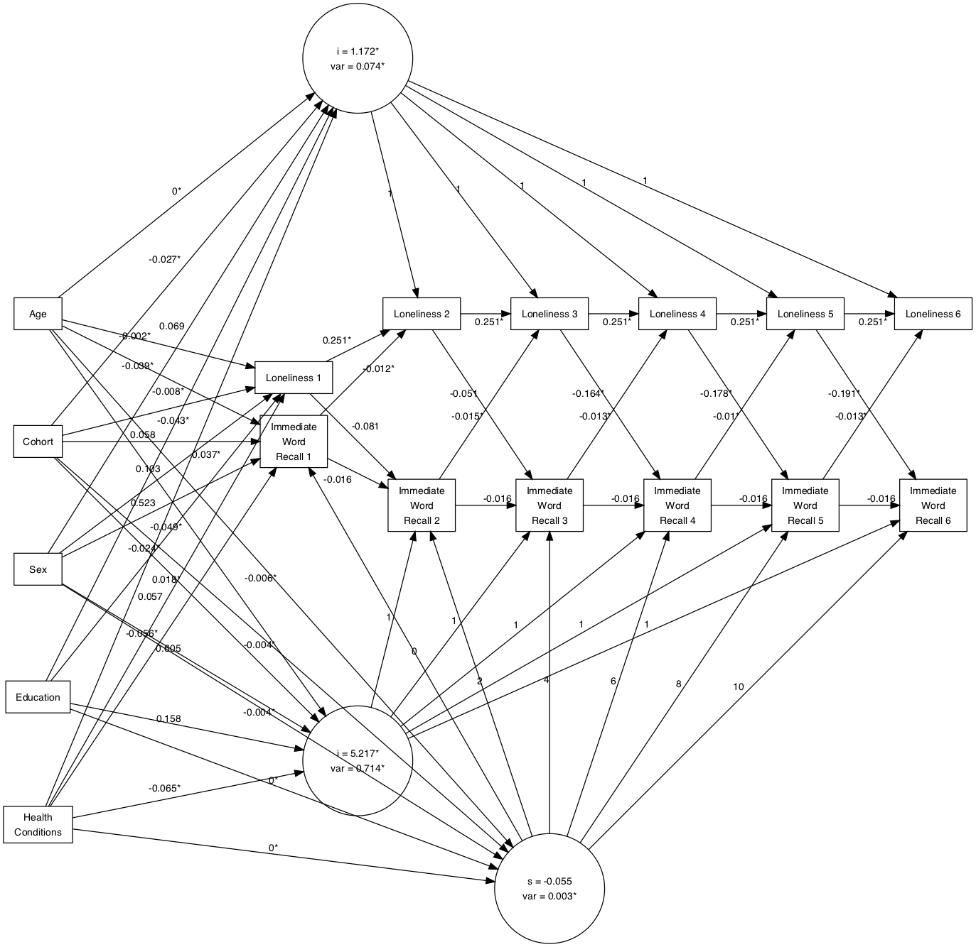

Figure 1. Autoregressive Latent Trajectory Model for Loneliness and Immediate Word Recall.

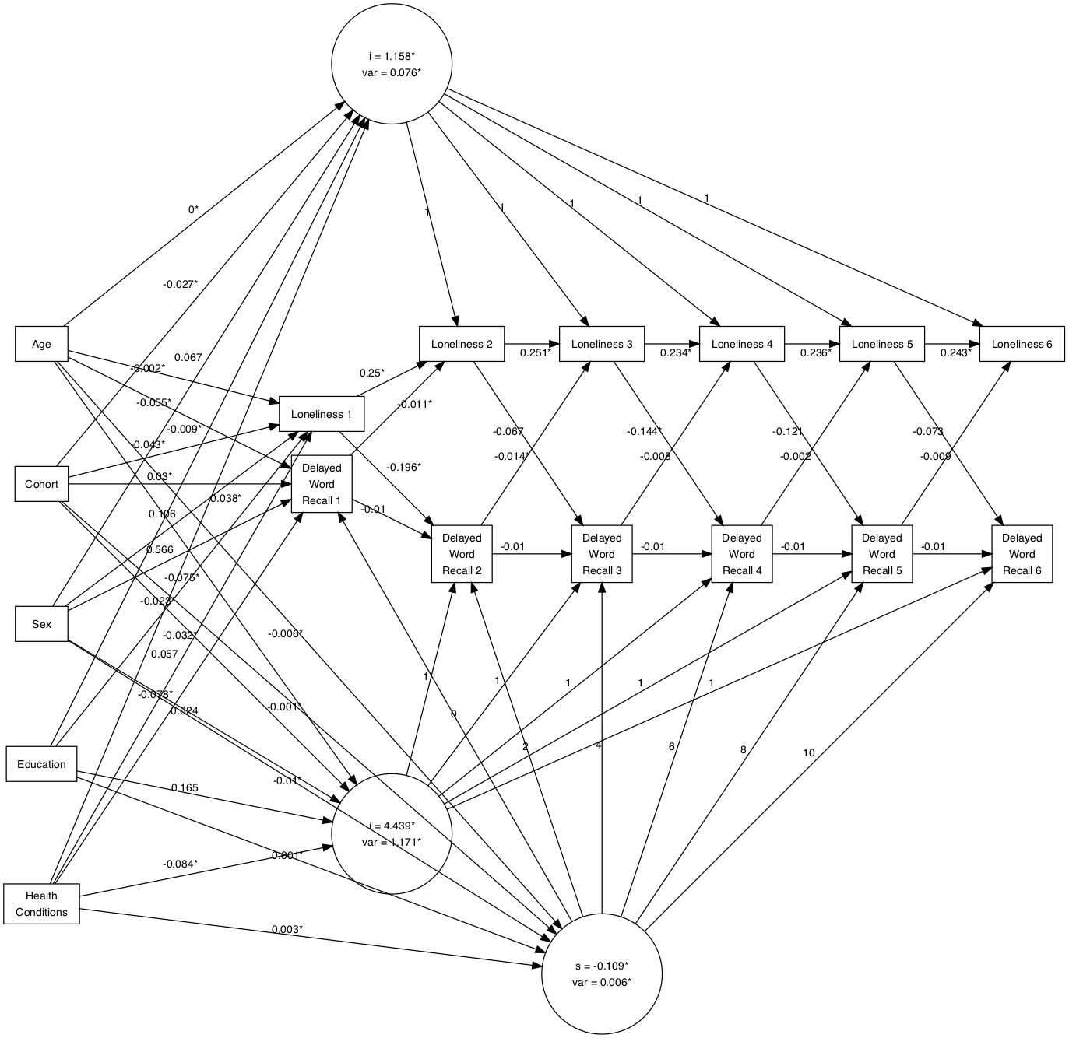

Figure 2. Autoregressive Latent Trajectory Model for Loneliness and Delayed Word Recall.

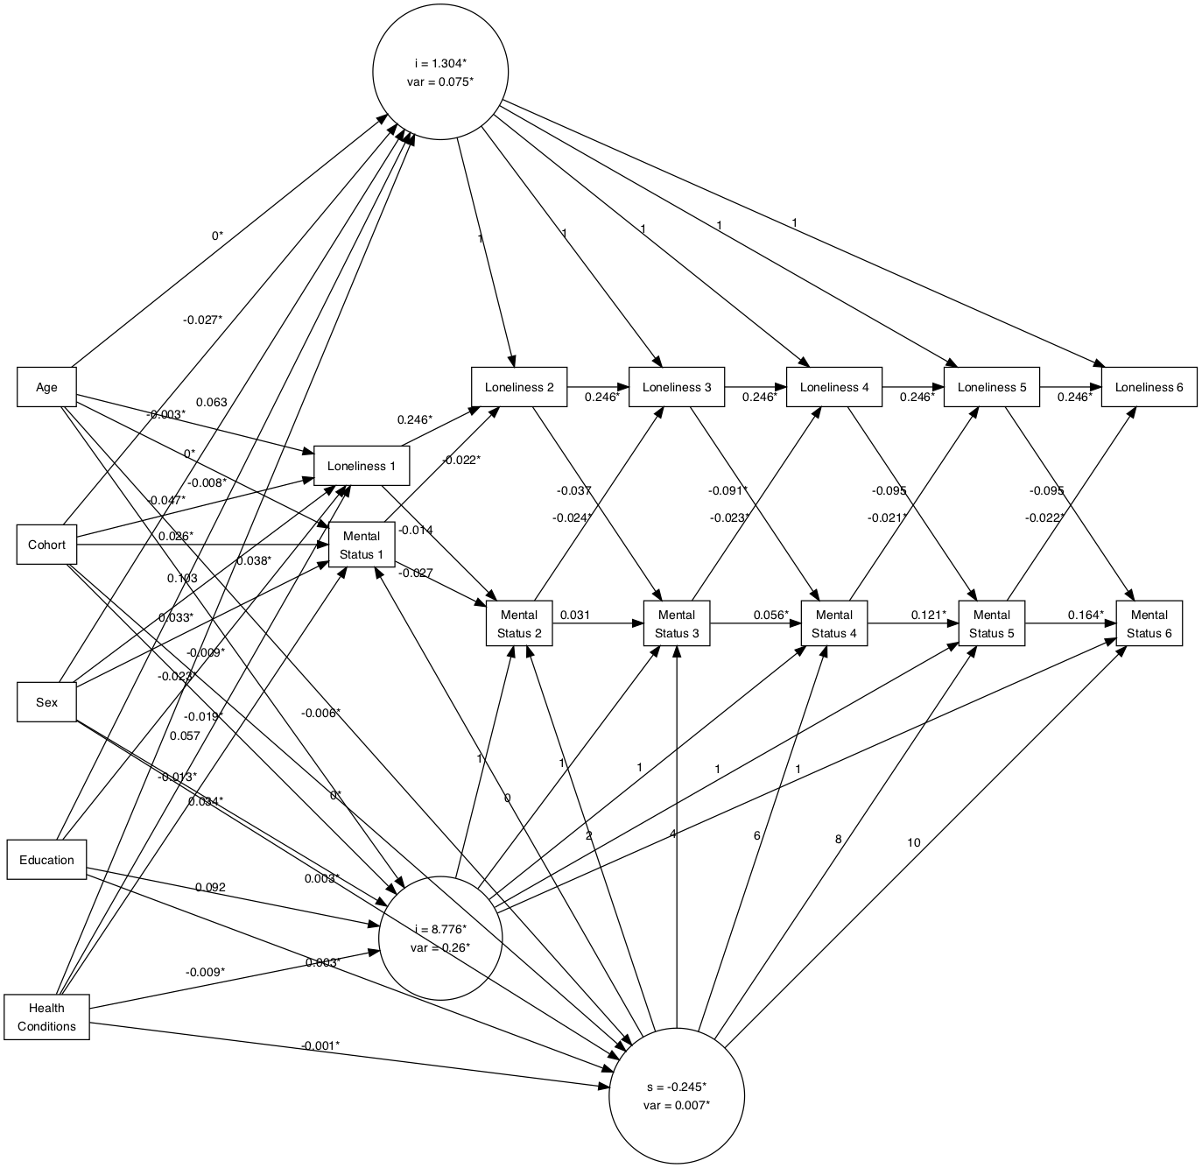

Figure 3. Autoregressive Latent Trajectory Model for Loneliness and Mental Status.

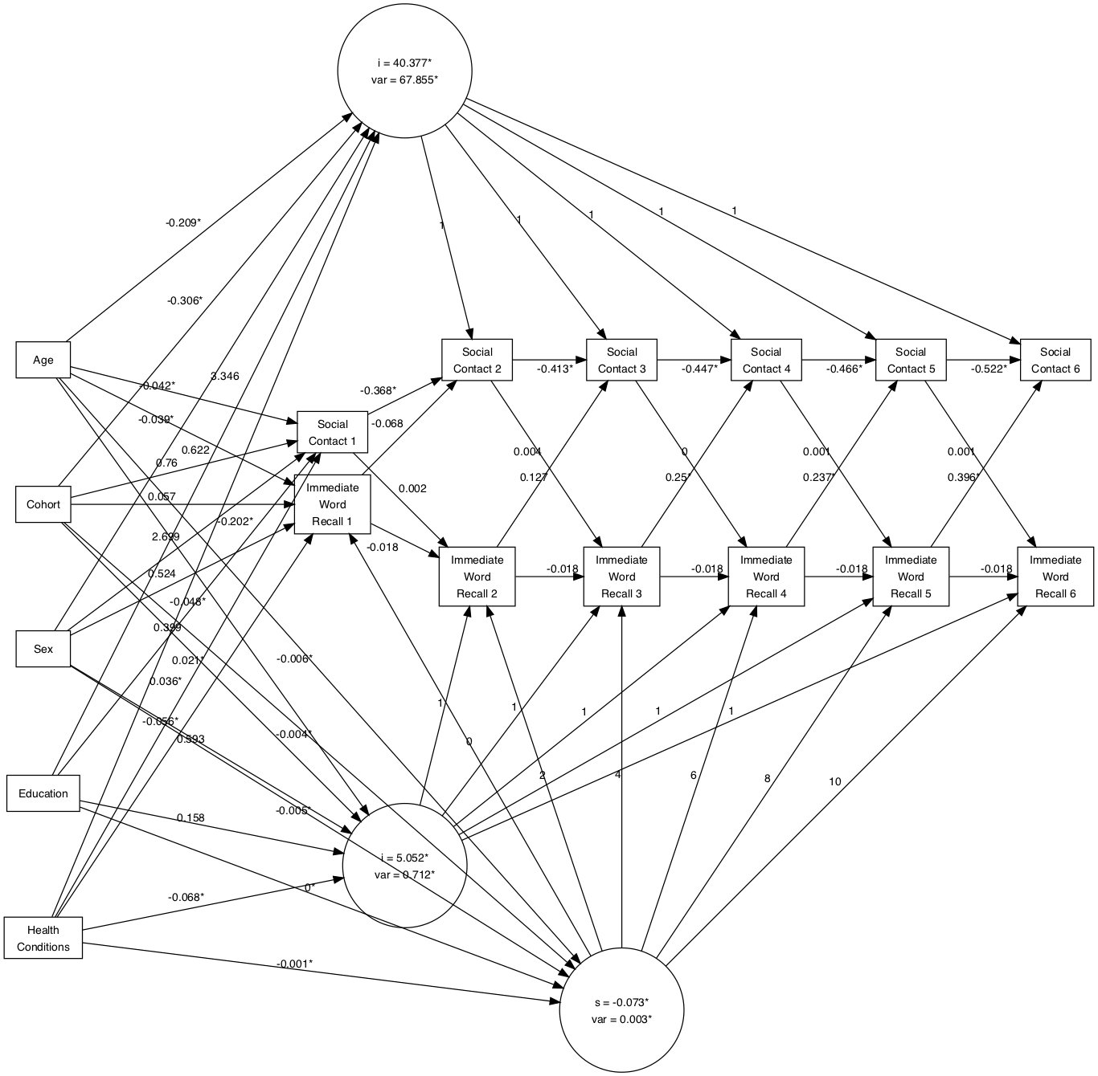

Figure 4. Autoregressive latent trajectory model for social contact and immediate word recall. * Indicate significance at a p <.05 level.

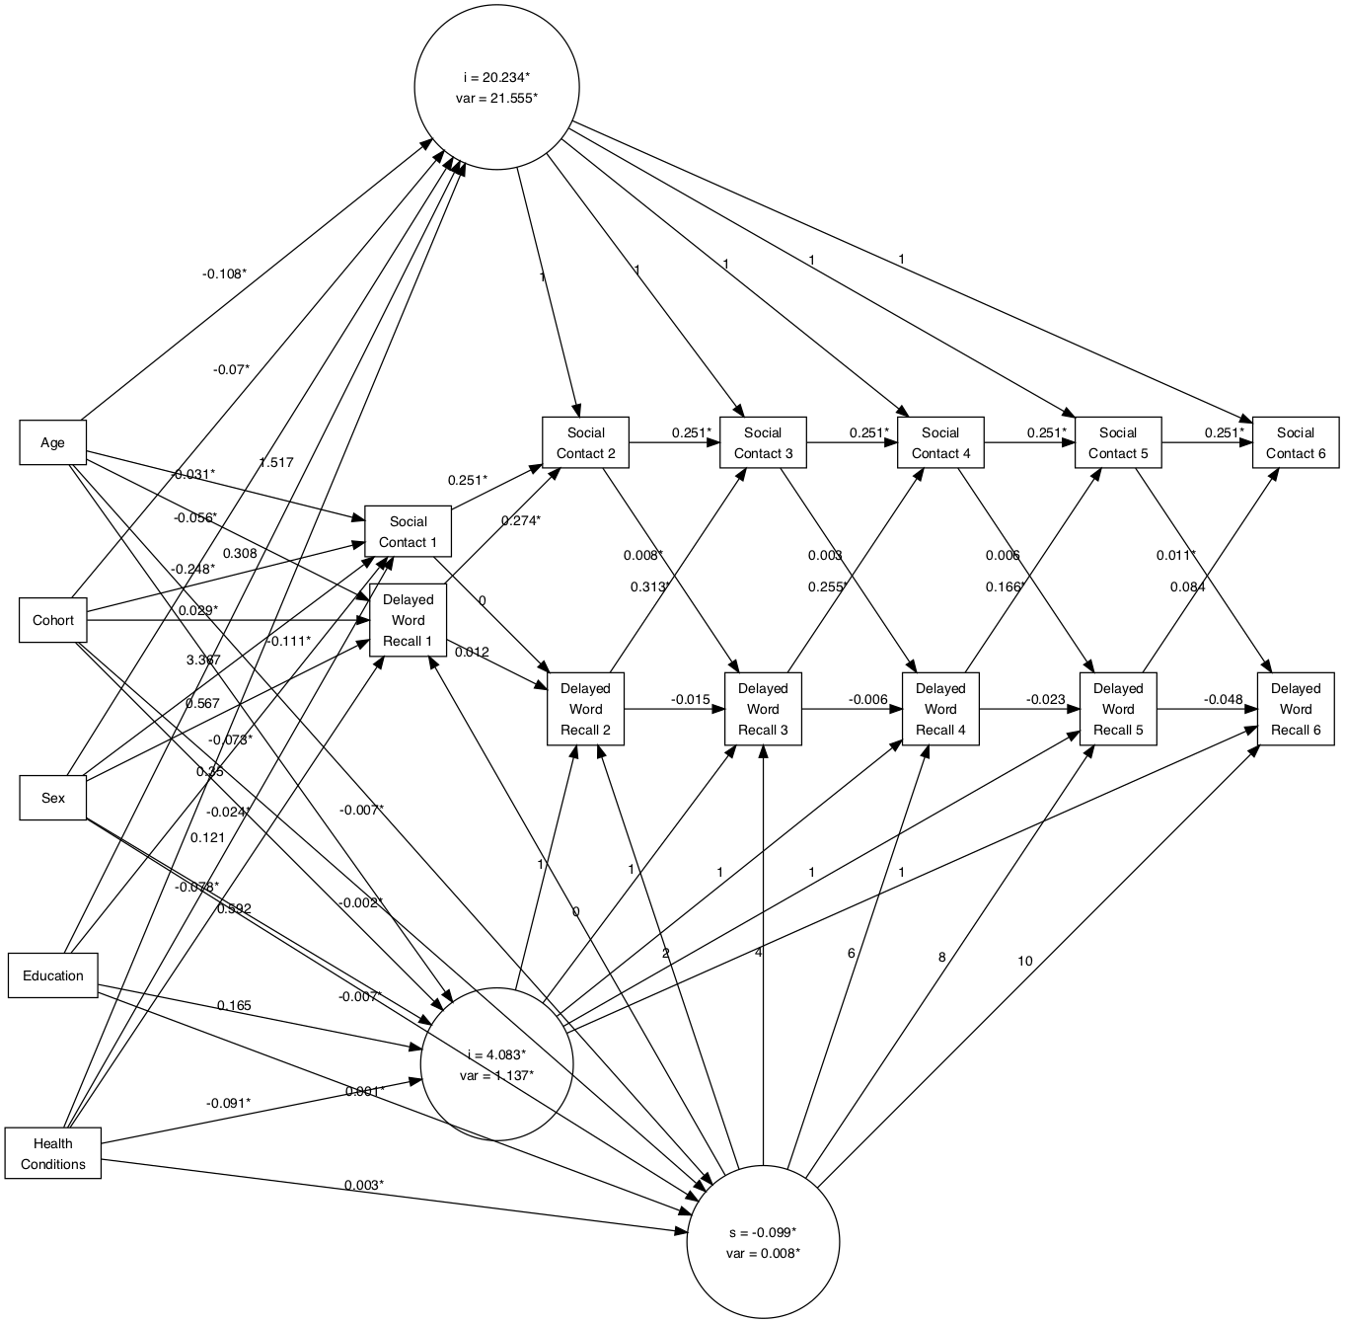

Figure 5. Autoregressive Latent Trajectory Model for Social Contact and Delayed Word Recall.

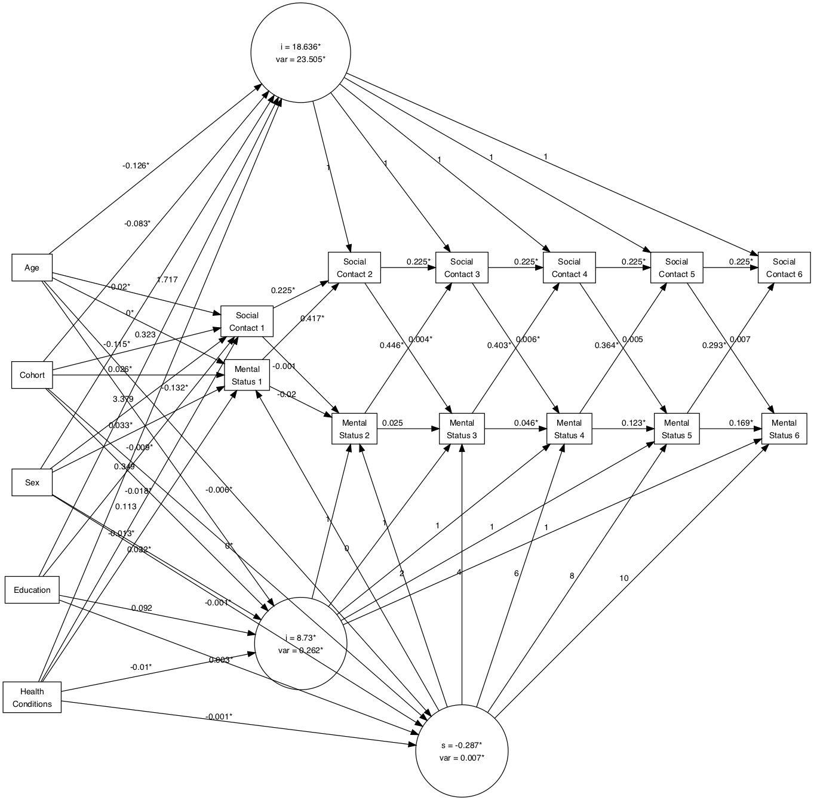

Figure 6. Autoregressive Latent Trajectory Model for Social Contact and Mental Status.

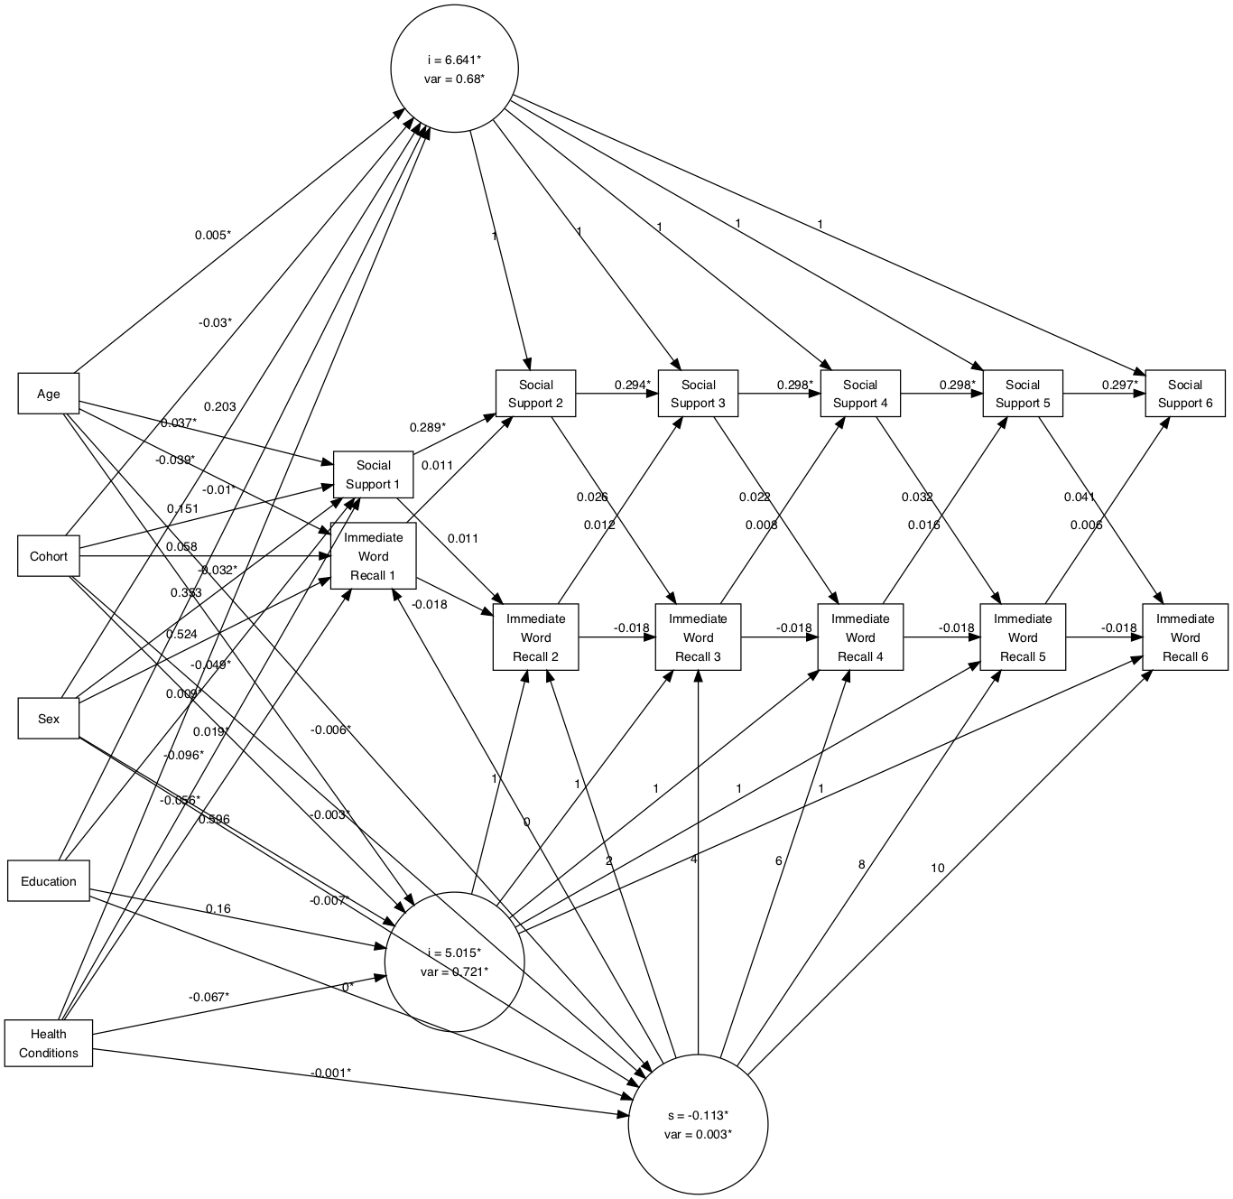

Figure 7. Autoregressive Latent Trajectory Model for Social Support and Immediate Recall.

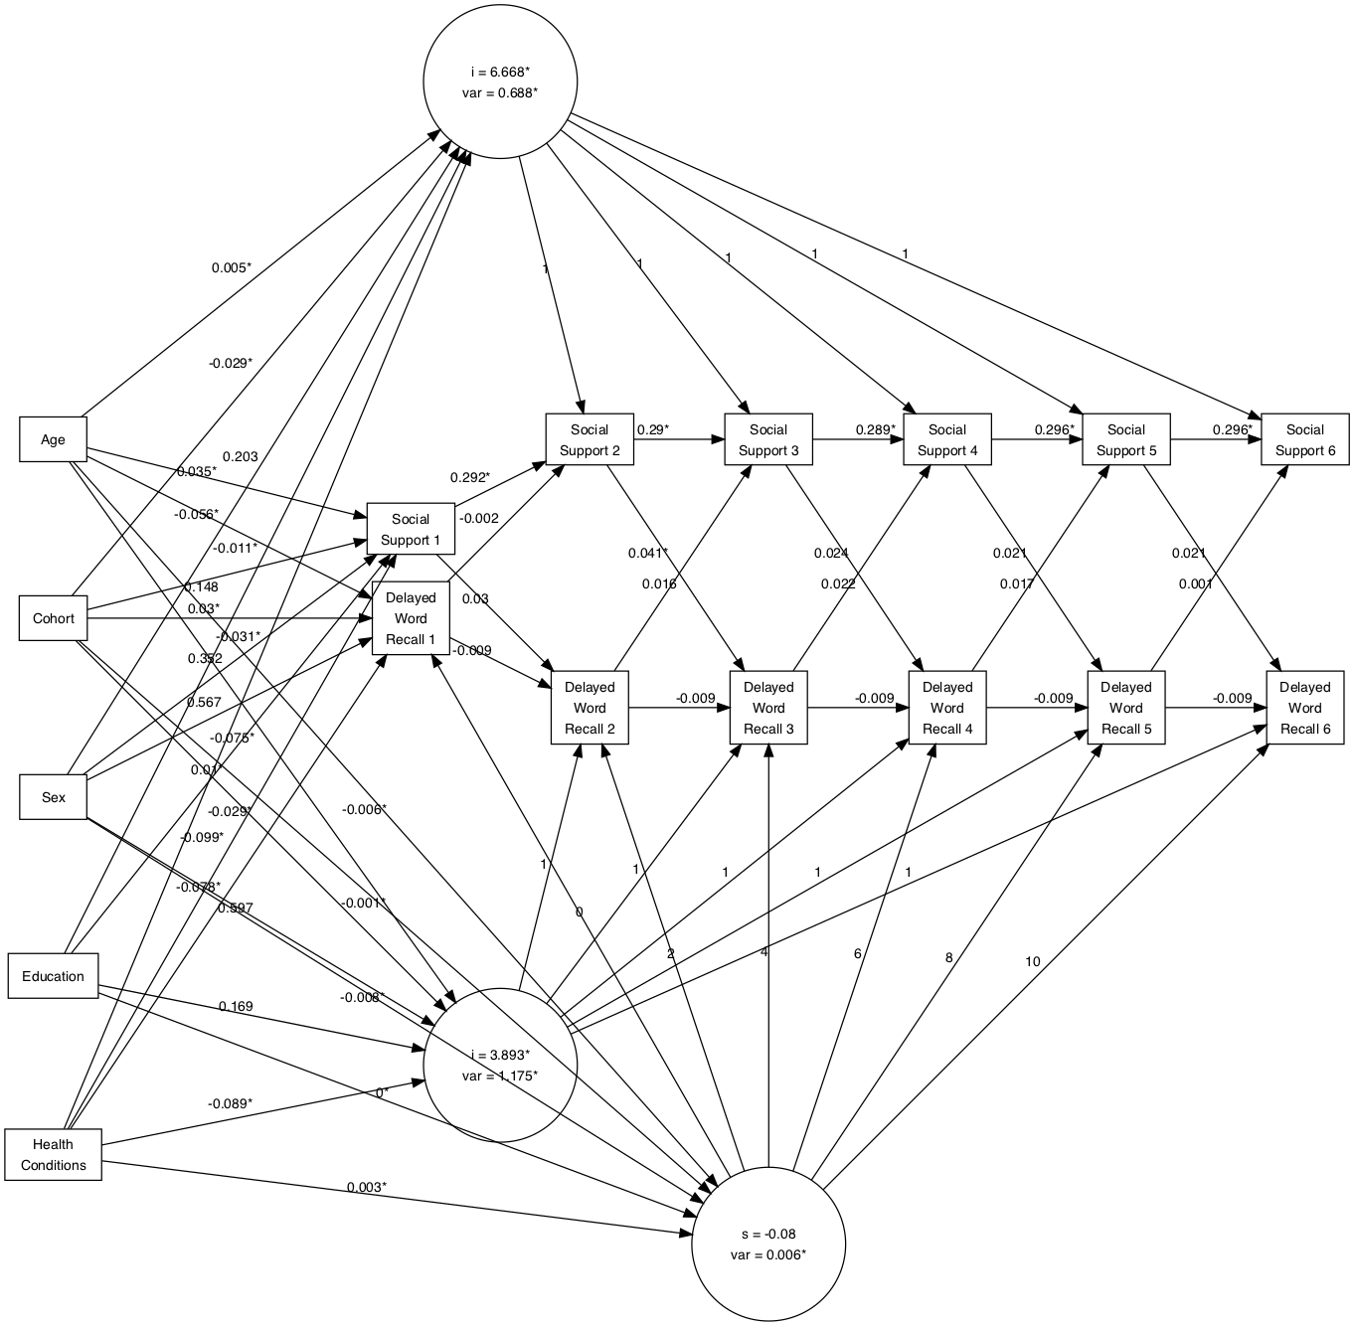Figure 8. Autoregressive Latent Trajectory Model for social support and delayed word recall.

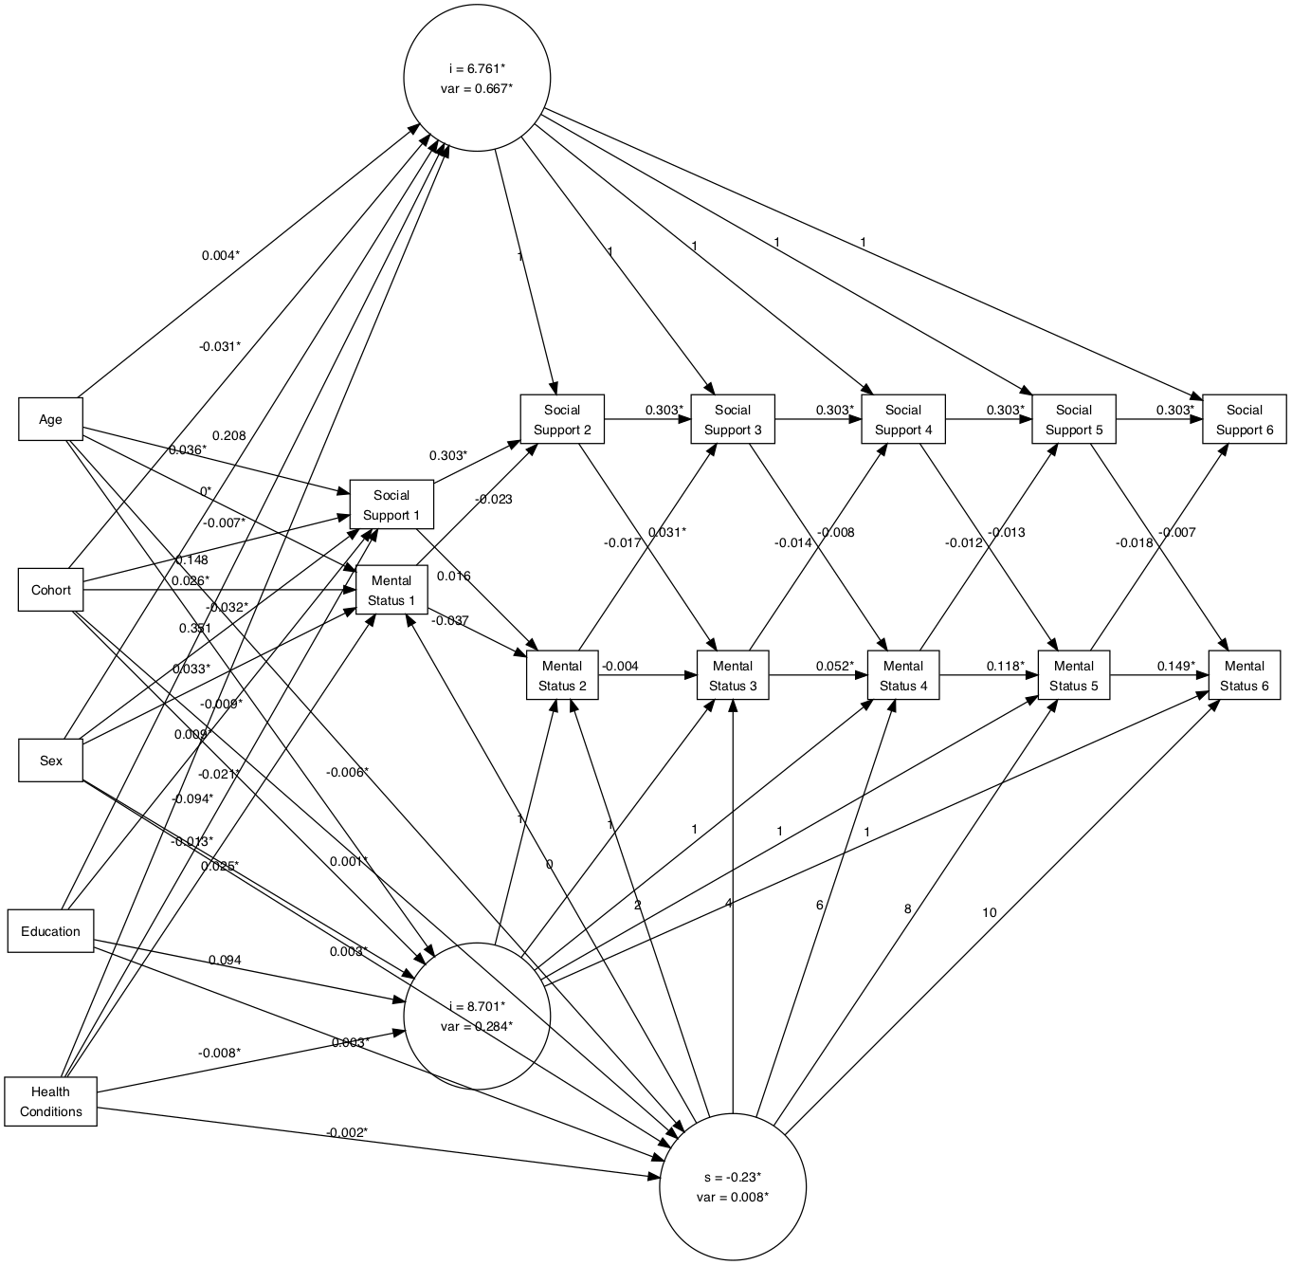

Figure 9. Autoregressive Latent Trajectory Model for social support and mental status.

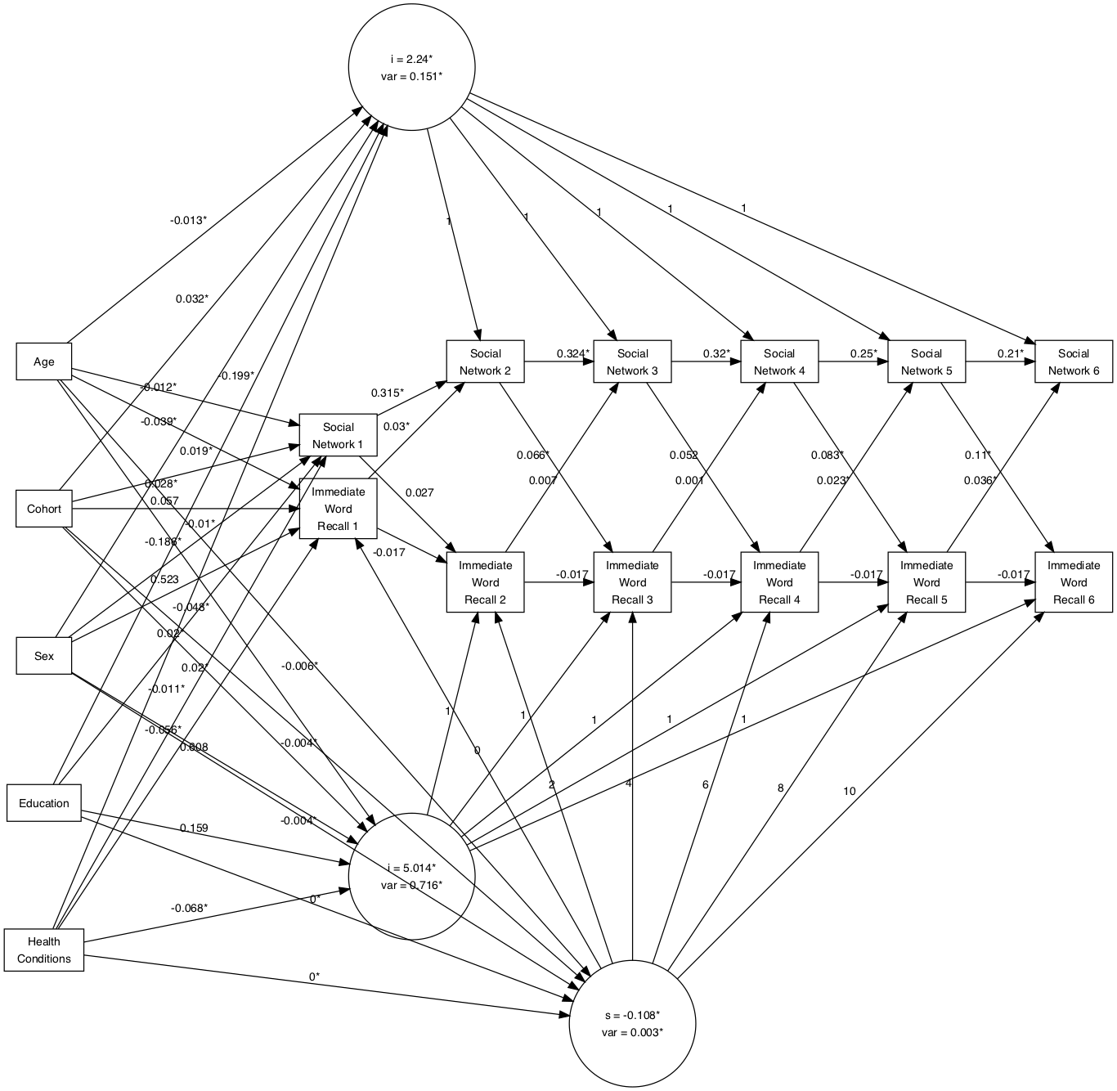

Figure 10. Autoregressive Latent Trajectory Model for social network composition and immediate word recall.

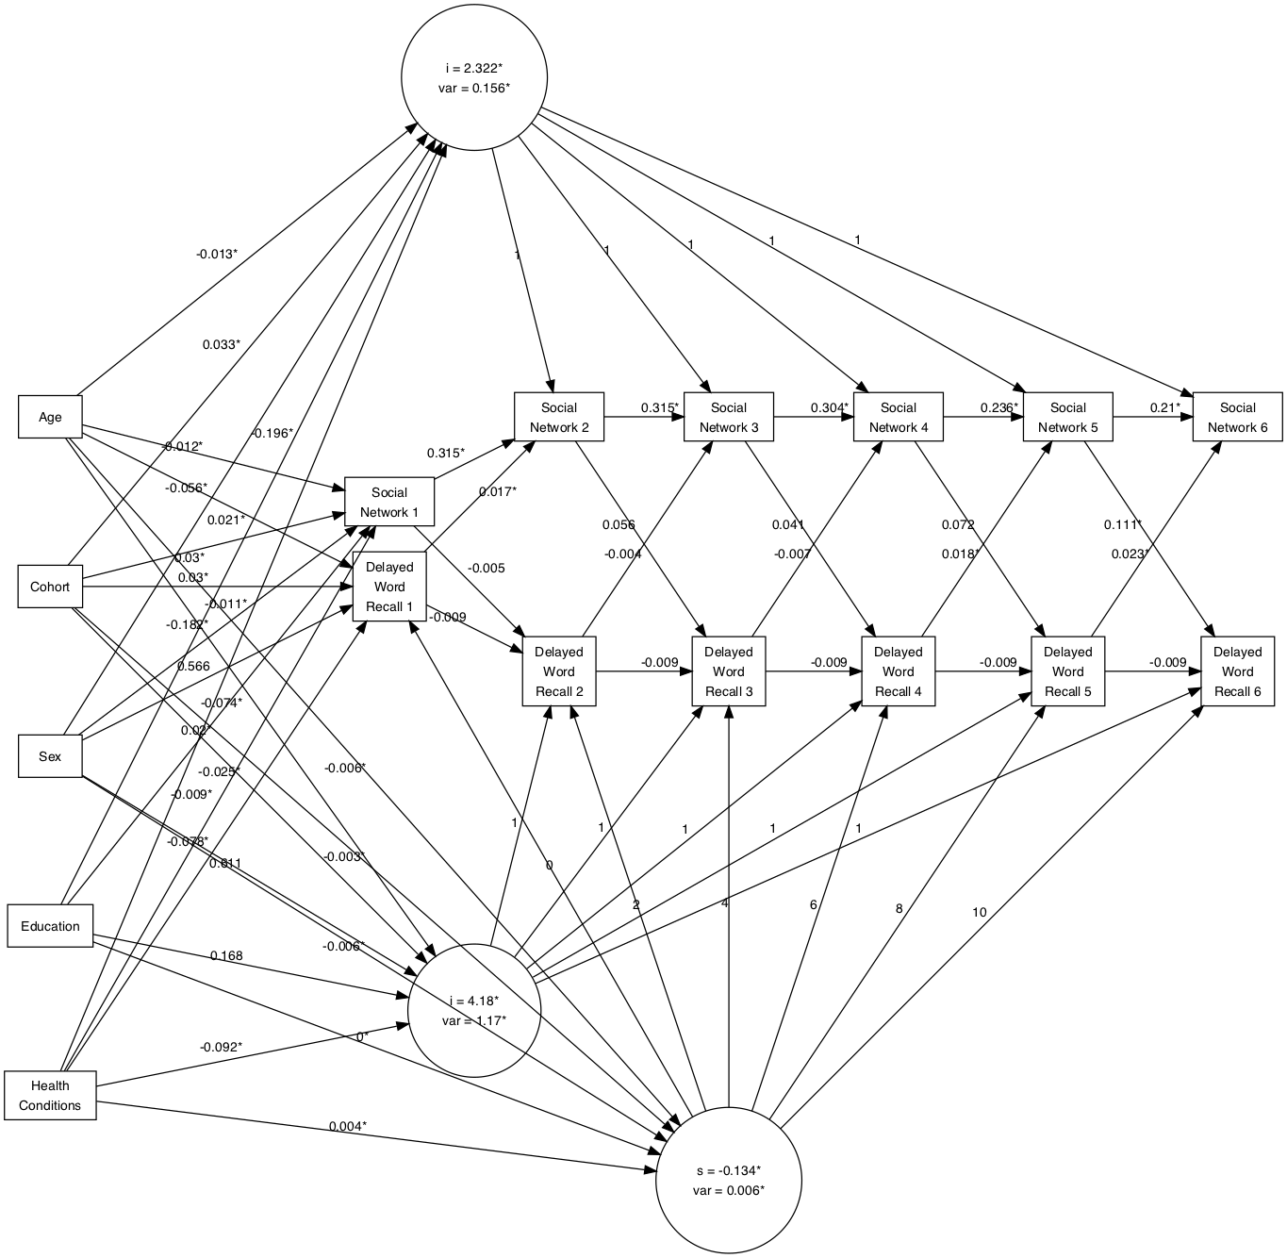

Figure 11. Autoregressive Latent Trajectory Model for social network composition and delayed word recall.

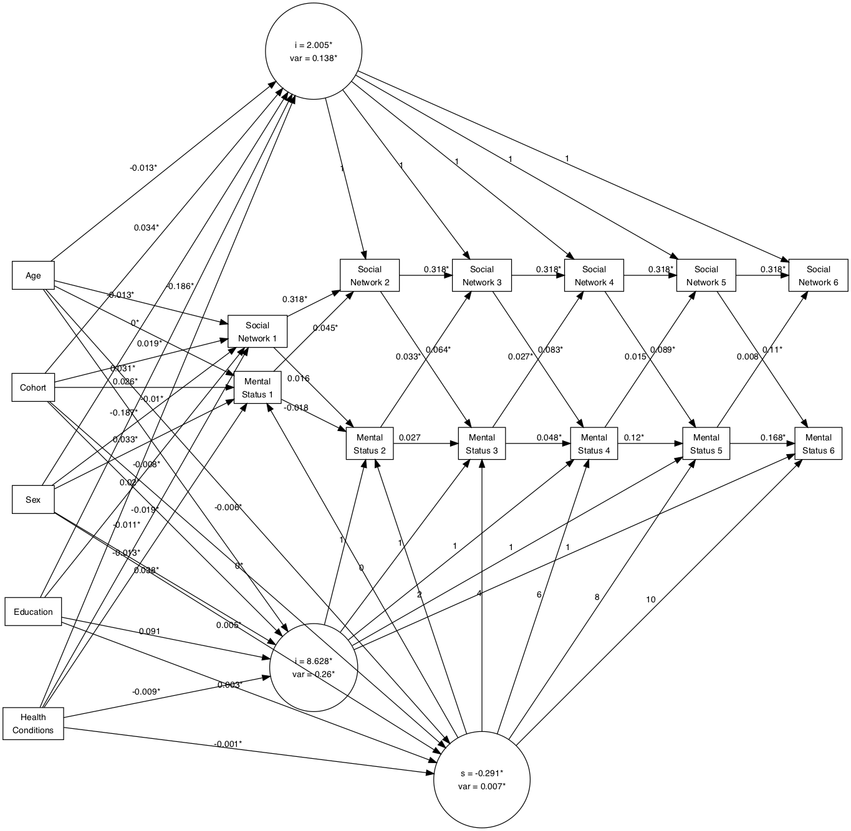

Figure 12. Autoregressive Latent Trajectory Model for social network composition and mental status.