Dashboard

Felipe Castillo

Catherine Williams

Data Presentation and Visualization

9/23/2022

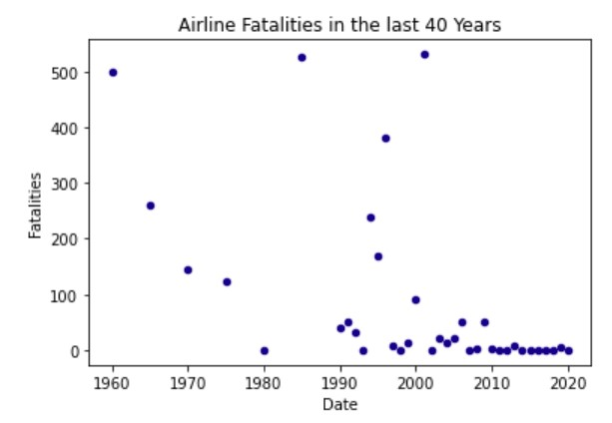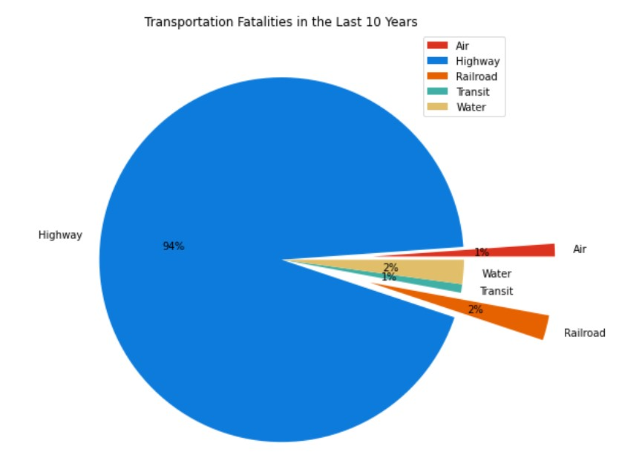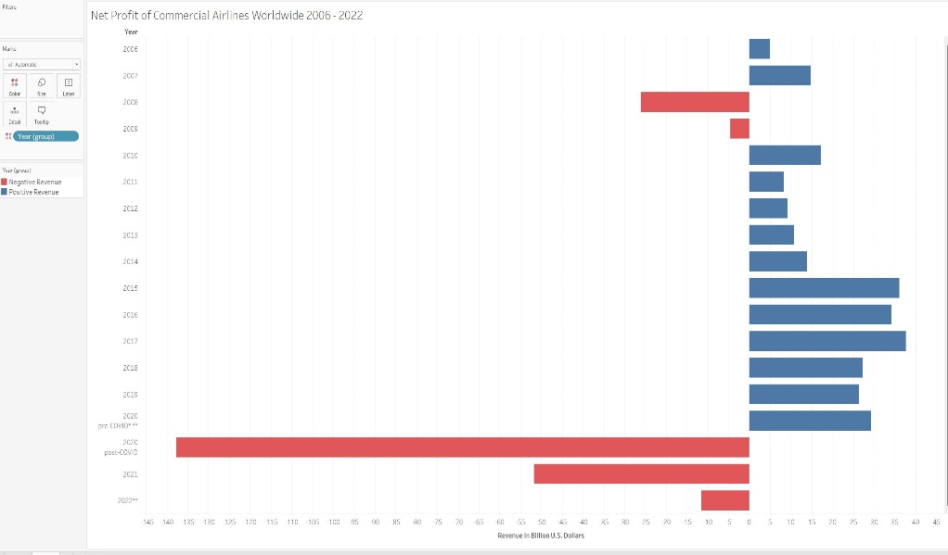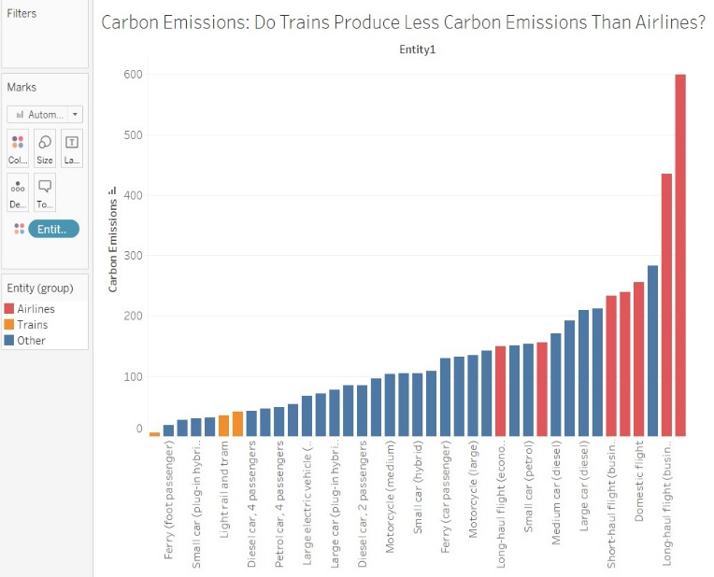

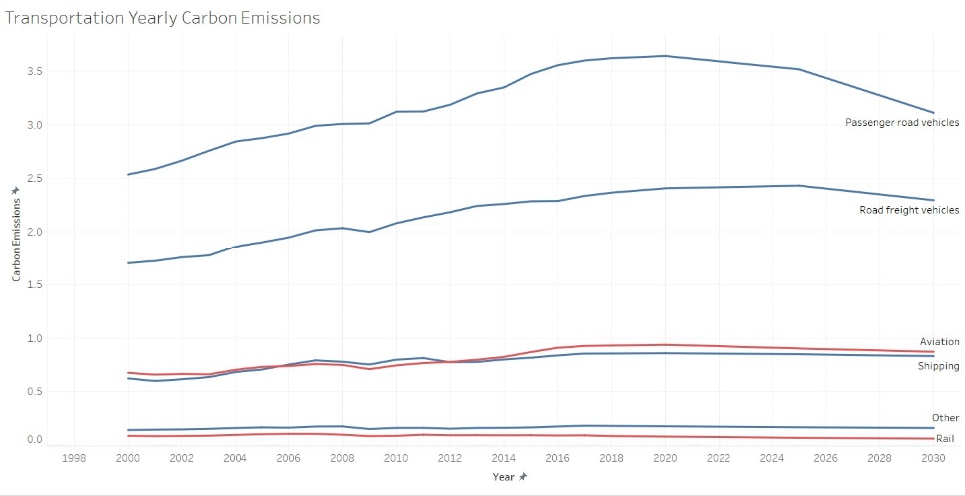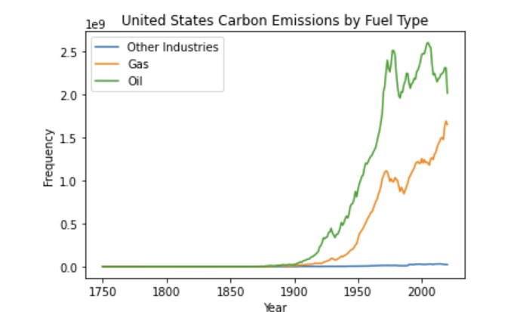

**Summary**

There is no doubt that airline transportation is safe. It is shown that it is even safer than other forms of transportation. First, we needed to establish a bases for airline safety. Safety was established with the pie chart. Next, we needed to establish if there were any trends as of late that would give the impression that planes were no longer safe. The scatter plot was perfect for indicating a decrease in fatalities over a 40-year period. For the last ten years it’s been consistently low. It was ranked as the best form of transportation. If safety is not the issue, then what could be the media’s driving factor. President Biden commented that "climate change is literally an existential threat to our nation and to the world. Our community is at stake.” (Jr, B. D, 2022) With a 2.2-billion-dollar commitment, the world also follows the trend. First, I establish whether there is an actual issue with carbon emissions in the world. Gas and oil are the top contributors to carbon emissions. Gas which power airplanes is only increasing in emissions. Some of the opinions that the media is currently rallying behind is the idea of electric and reducing vehicles in the world. The most popular idea right now is the making of bullet trains. “FAQ on transportation calls to build out high-speed rail at a scale where air travel stops becoming necessary. Investing in ... clean, affordable, and accessible transportation.” (Irfan, 2022) With major congressional leaders standing behind this statement, it’s clear that graphs on carbon emission and trains need to be evaluated. Lastly, even with the media attention, there should be no loss in revenue if anything is rising in price since Covid. However, this is not to say that it won’t have a longer impact longer term.

**Work Cited**

Jr, B. D. (2022, July 21). *Biden unveils $2.3bn plan to fight climate change*. BBC News. Retrieved September 23, 2022, from https://www.bbc.com/news/world-us-canada-62241954

Irfan, U. (2019, February 8). *America's trains are a drag. the green new deal wants to fix that.* Vox. Retrieved September 23, 2022, from https://www.vox.com/2019/2/8/18215774/green-new-deal-high-speed-train-air-travel