Blog Summary

Felipe Castillo

Catherine Williams

Data Presentation and Visualization

10/22/2022

For years the media has painted the image of flying in airplanes to be dangerous. Some would say that it’s the most dangerous form of transportation. The reality is that this statement couldn’t be further from the truth. In fact, the data shows that air travel is the safest form of transportation. Air travel fatalities make up one percent of the total fatalities in the United States. “The chances of dying in a plane crash are equivalent to being struck by lightning seven times — at least if flying in the U.S, insists one aviation expert.” With these odds its safe to say that there is a misconception with air travel.

There is also no hint of there being a rise in air travel fatalities. In fact, we can see a large decline in fatalities from 2003 and on. This could be aligned with stricter rules on flying. Whether that is the case or not, from 2003 until today fatalities have stayed consistently low. There is no indication that there has been a rise in incidents. This indicates that air travel has stayed consistent throughout time. There is no weird fluctuation to deem that it has gotten worse. Consistency tells us that the airlines are doing a great job mitigating risk.

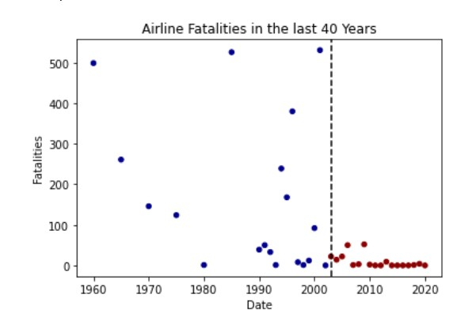

If airplanes are clearly a form of transportation, then why does the media perceive them as dangerous. The reality could be based on human perception. When there is fatal accident on the highway, it is not as flashy and advertised as a fatal plane accident. A team conducted a survey to question people on if they were comfortable with flying. The results point to that most people were not comfortable with flying. If people don’t like flying, they can be more prone to believe that planes are not safe.

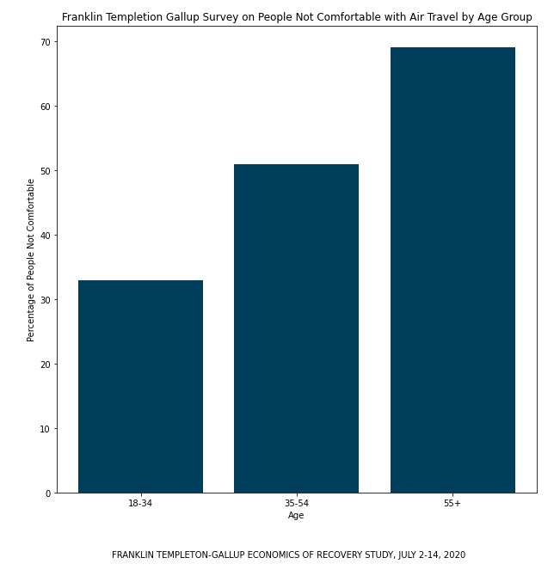

Flying by airplane is still the safest form of transportation. There is no indication that there is a rise in fatalities. If anything, the fatalities from airplane travel have gone down and stayed consistent. Human perception and not facts can lead people to believe something is more dangerous when it’s not.

https://www.nydailynews.com/news/national/common-plane-crashes-expert-weighs-deadly-week-article-1.1879212