Week 1-2 Graphs Assignment

Felipe Castillo

Catherine Williams

Data Presentation and Visualization

9/10/2022

**Tableau**

**Tableau – Bar Chart**

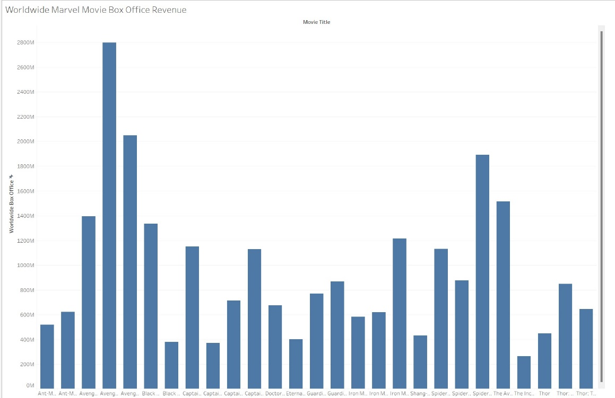

**Tableau – Donut Chart**

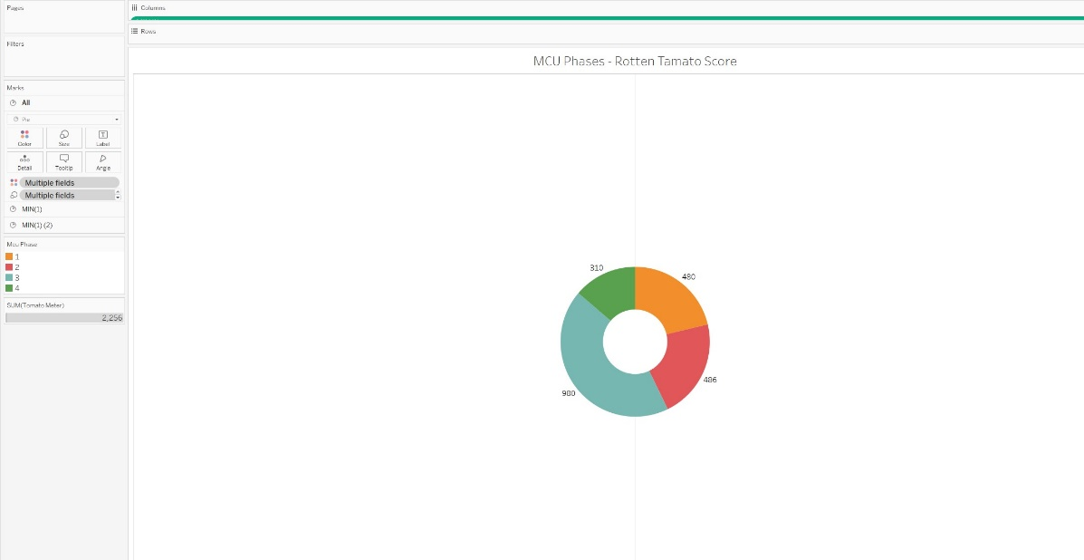

**Tableau – Pie Chart**

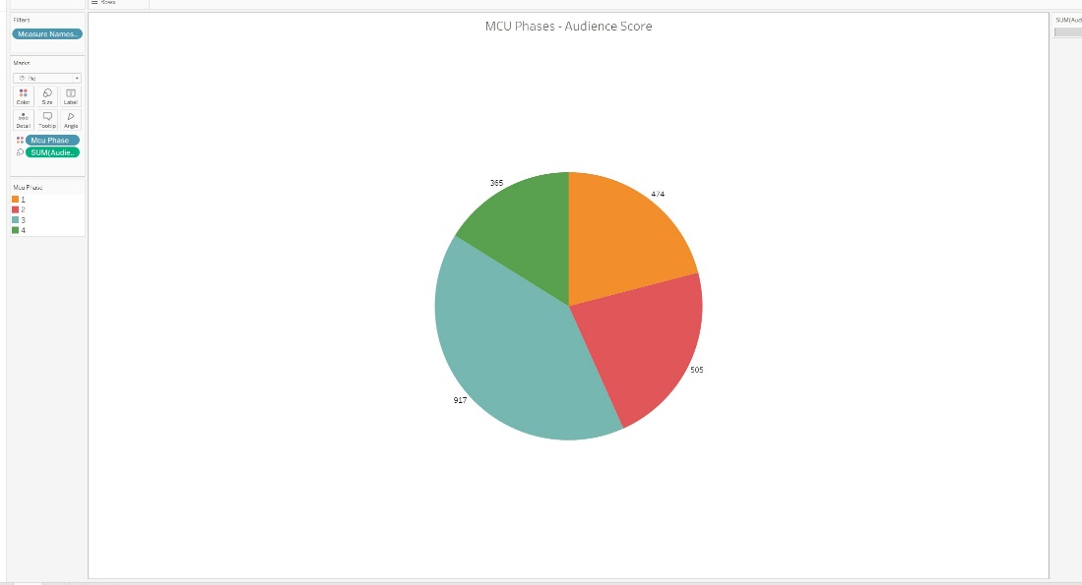

**Tableau – Stacked Bar Chart**

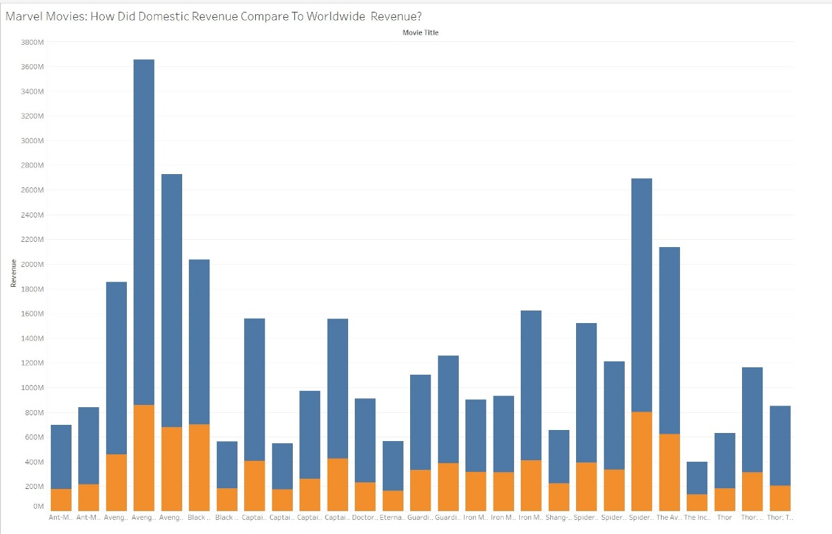

**R**

**R – Bar Chart**

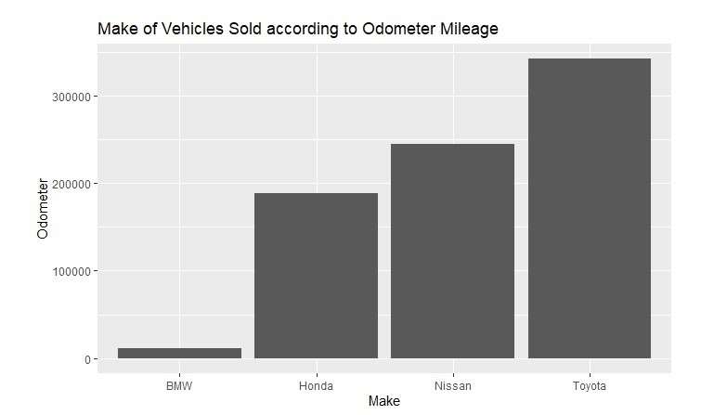

**R – Donut Chart**

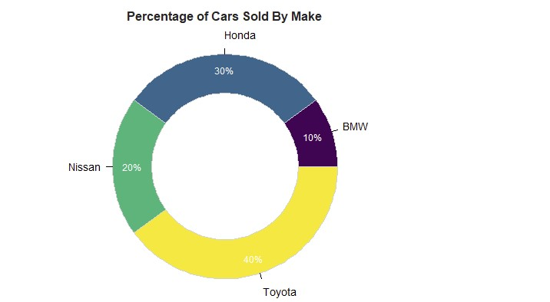

**R – Pie Chart**

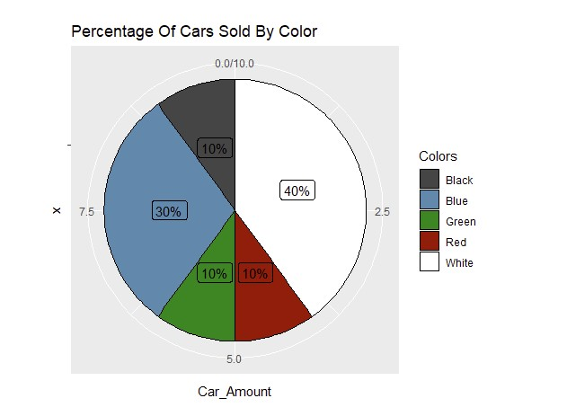

**R – Stack Bart Chart**

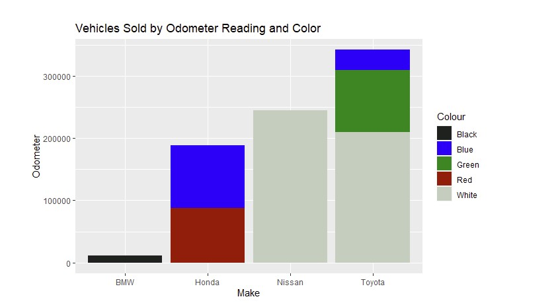

**Python**

**Python– Bart Chart**

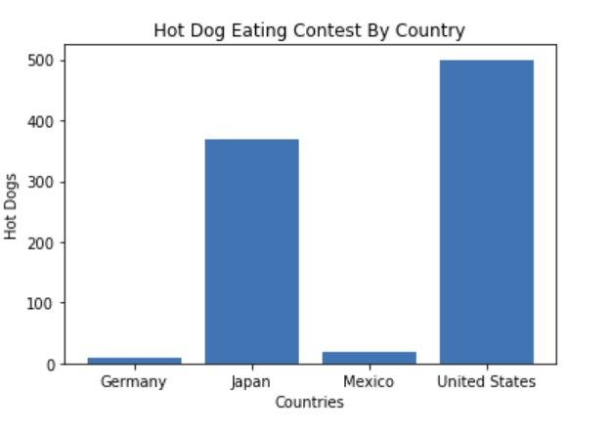

**Python – Donut Chart**

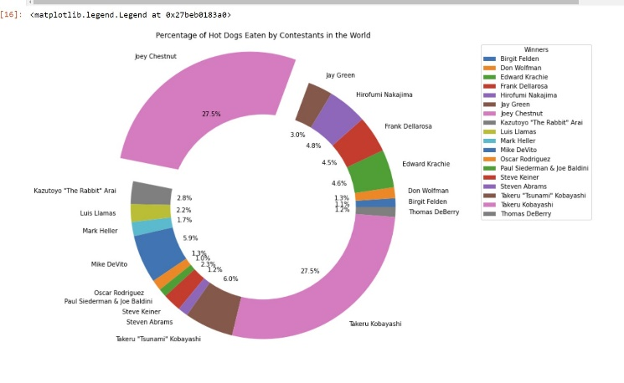

**Python – Pie Chart**

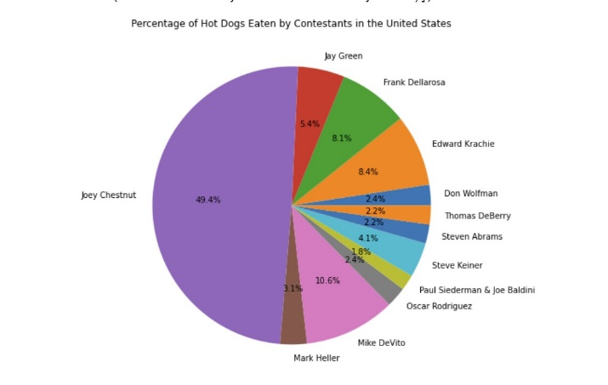

**Python – Stack Bar Chart**

