**Who am I**

Hello, everyone! My name is Felipe Castillo, and I work as a technology analyst for Infosys. I work directly with automation where I automate everyday tasks like data entry. Before this I was a software engineer for Blue Cross Blue Shield. I have three classes left before I graduate with my master’s degree. In my free time, I enjoy mountain biking and CrossFit. I will say that these days, I have very little free time as I am taking classes, working full time, and writing my first novel. I am a couple weeks from completing my novel actually! I live in Tulsa, Ok. I am excited to begin this new class!

**What skills are important to be able to visualize or story-tell with the data? What job titles would this traditionally fall under?**

There are a few key skills that are important to visualize and story tell with data. First, it doesn’t hurt to be a good communicator that knows how to move with emotion. This can be a vital skill that can make the difference in getting the point across. There is also soft skill in communication that help like persuasiveness. Also, it’s important to have a clear presentation with visuals to make it easier to follow the story. I think these skills translate to a lot of fields. Data presentation with visualization is something that is needed in all fields.

<https://www.forbes.com/sites/brentdykes/2016/03/31/data-storytelling-the-essential-data-science-skill-everyone-needs/?sh=12a3831952ad>

**Attach a picture/screenshot of your favorite visualization. What do you like so much about it, what are the pieces that stand out to you that made you choose this visualization? If you don’t have a favorite visualization in mind – what is your favorite chart type or even what is your favorite statistic represented visually?**

I don’t have a favorite visualization. However, there are visualizations like the screen shot that I posted that are eye catching. First, the color selection that the author made isn’t too bright or bold. The total deaths are bolded and made for the user to see. It’s also impactful for the way it’s referenced as stolen years. The wording is straight to the point, not allowing for any guesses. I also love the uniqueness of the graph. It’s not every day you see a graph like this. What are your guy’s thoughts on this?

[https://www.tapclicks.com/resources/blog/best-data-visualizations/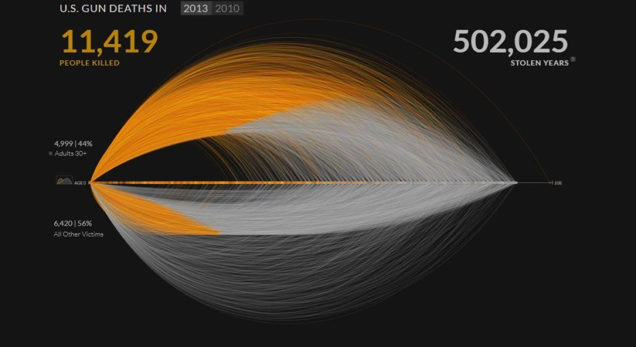](https://www.tapclicks.com/resources/blog/best-data-visualizations/)

**Attach a picture/screenshot of BAD visualization. What do you dislike so much about it, what are the pieces that stand out to you that made you choose this visualization. And what would you do different.**

I showed one of the more impressive graphs and it’s only fair to show an awful graph. The world is filled with good graphical representation, but it’s also filled with a lot of bad graphs. There are a lot of graphs during the COVID pandemic that made me research them more in depth. This graph that I have provided is an example of a bad graph. First, the dimensions of the images are distorted. In my opinion, it would be better served with the same width as the bar graph. Next, it’s very difficult to see the differences in the sale values. Take pizza hut and burger king. There is a substantial difference, but I must look really hard to notice the differences. I don’t know why they decided to include the Afghanistan picture in the graph. If the goal is to show the comparison between major franchises, then Afghanistan is not needed. If the goal is to show Afghanistan GDP, then all these franchises aren’t needed. A simple graph showing burger king’s GDP compared to Afghanistan’s should be enough. This tells the reader that Afghanistan is most likely impoverished. After all it’s different for a corporation to make this level of income verses a whole country. I can go on, but overall, this is one of my least favorite graphs.

https://www.businessinsider.com/the-27-worst-charts-of-all-time-2013-6#burger-king-has-3-times-as-much-in-sales-than-starbucks-it-makes-sense-that-its-three-times-taller-but-the-fact-that-its-area-is-nine-times-that-of-starbucks-shows-why-this-chart-exemplifies-everything-that-is-wrong-with-charts-that-try-to-incorporate-cutesy-graphics-2

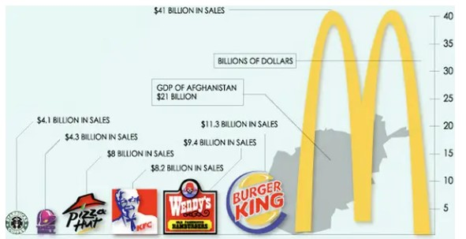

Describe the concepts behind the 3-minute story and the big idea – how do these resonate to data presentation and visualization?

There are three main points behind the 3-mintue story. First, the article needs to articulate the main point of view. Secondly, it must convey what is at stake. Lastly, it must be a complete sentence. The point of the 3-minute story is to get the optimal amount of time to both get to the main premise and for it to resonate with others. Why have a 20-minute story when people will only listen and remember 5 minutes of it? This way you make sure that the audience gets the message. It becomes clear for them. The longer you keep your audience the more likely their attention is lost. Therefore, it is important to have a plan to have success in storytelling.

What are some strategies you can create for getting to know your audience, segmenting your audience and creating common ground?

Knowing the audience is one of the best ways to deliver a presentation. There are a few strategies to get to know the audience. If there is data collected on an audience previously, we can analyze it to understand the audience better. We can predict what the audience might want with buyers’ personas. We can conduct surveys to see what the audience is like. Seeing what the computer is doing can give us a solid idea of what hurdles our customers will want to see. I also think it’s important to keep up with comments. This is our direct link to interacting with our audience. In this case, bother segmenting the audience and creating common ground is important. I couldn’t say one is more important than the other. All the same we should strive to get to know our audience.

https://blog.hubspot.com/service/know-your-audience