Week 11-12 Graphs Assignment

Felipe Castillo

Catherine Williams

Data Presentation and Visualization

11/18/2022

**Tableau**

**Tableau – Histogram**

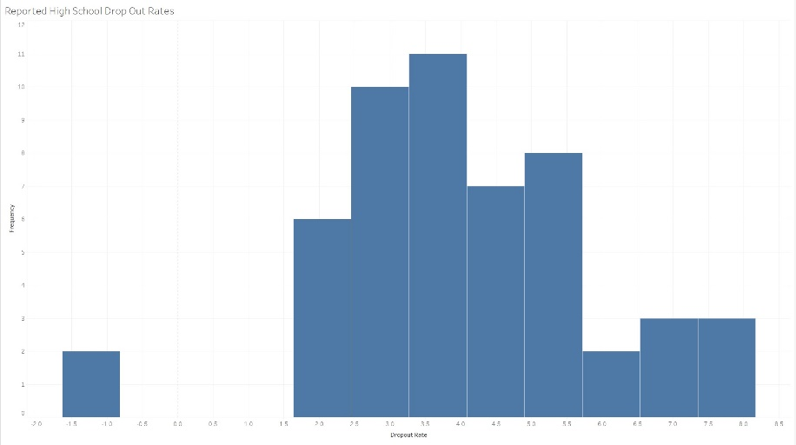

**Tableau – Box Plot**

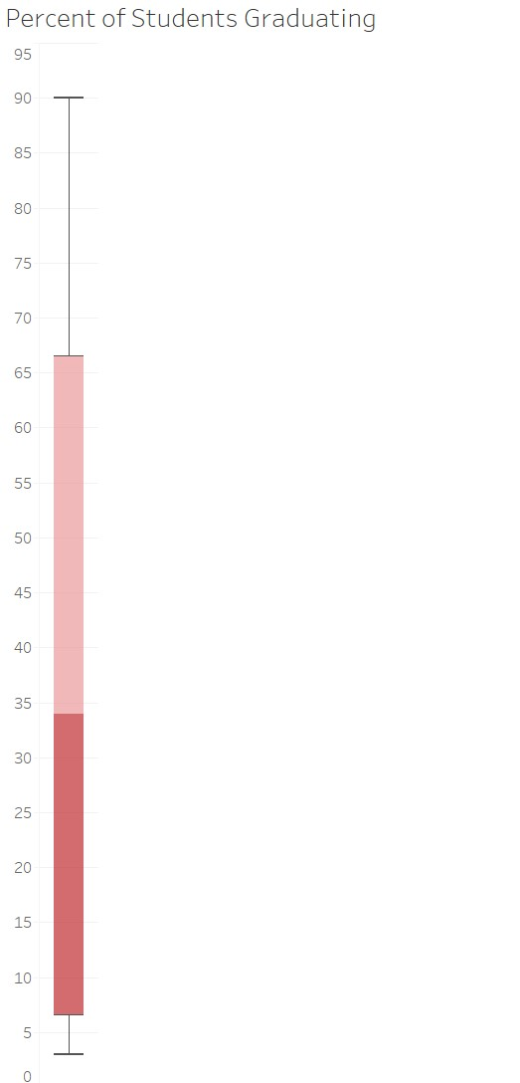

**Tableau – Bullet Chart**

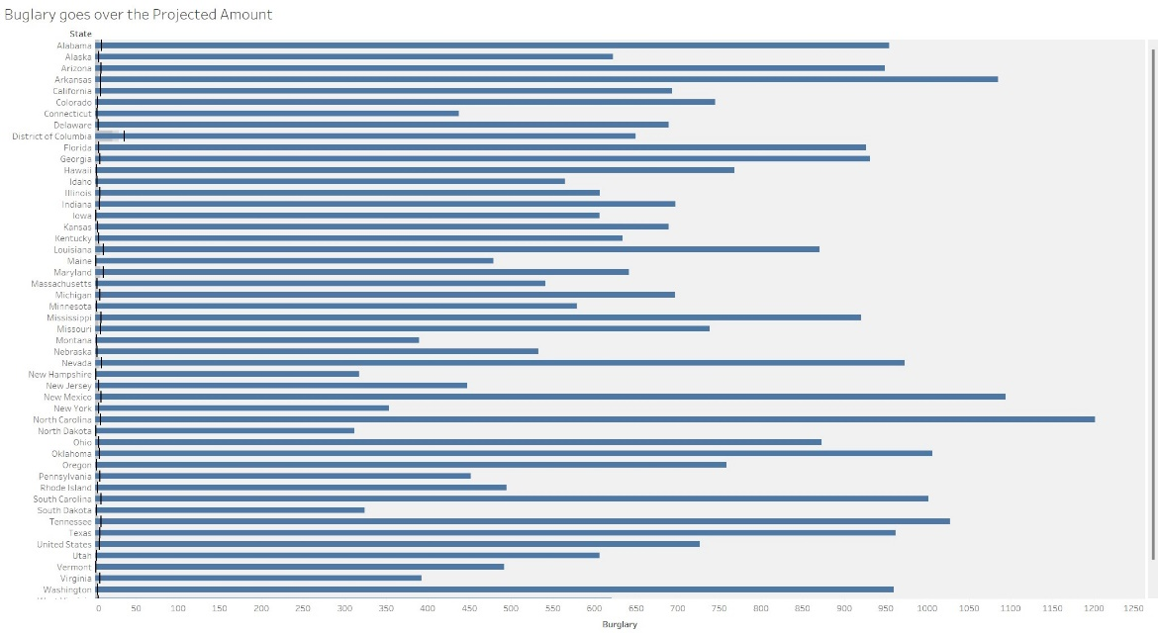

**Tableau – Horizontal Bar Chart**

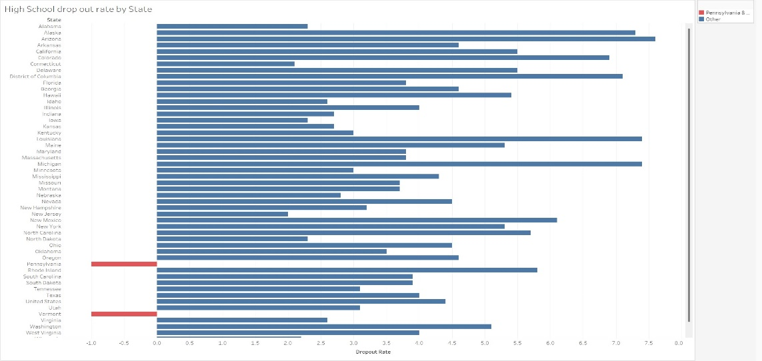

**Python**

**Python – Histogram**

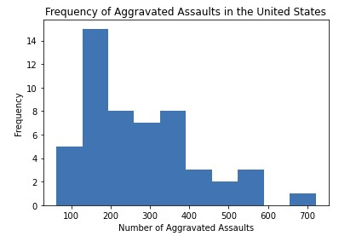

**Python – Box Plot**

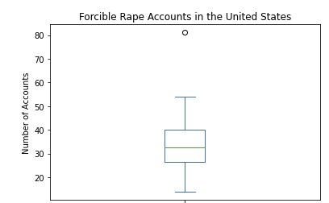

**Python – Bullet Chart**

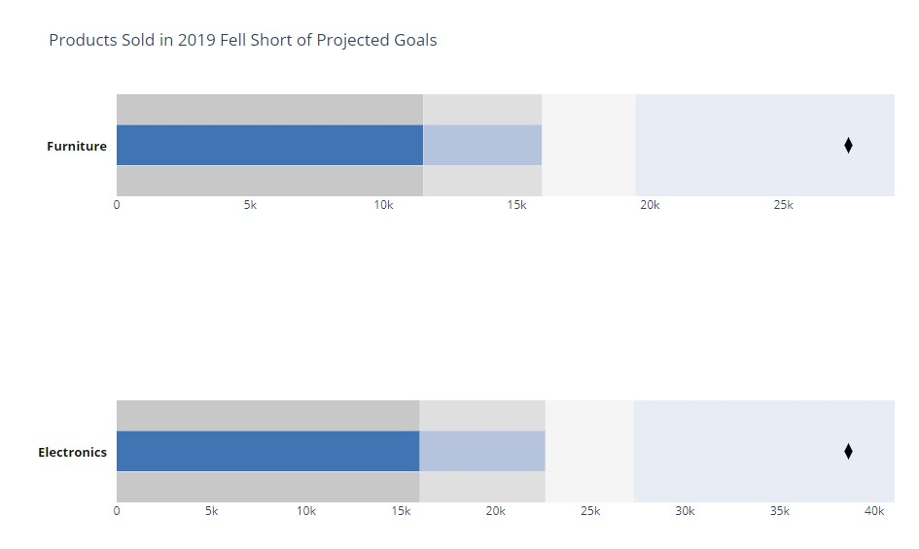

**Python – Scatter Plot**

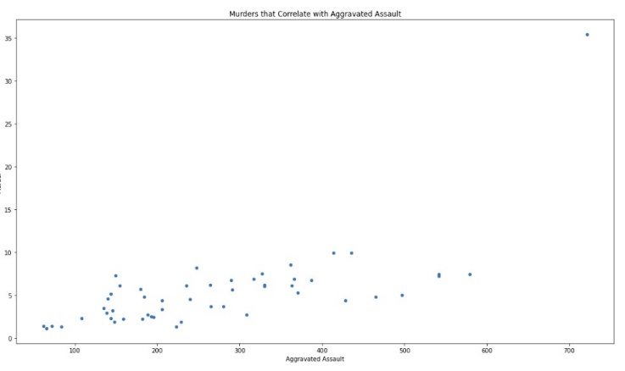

**R**

**R – Histogram**

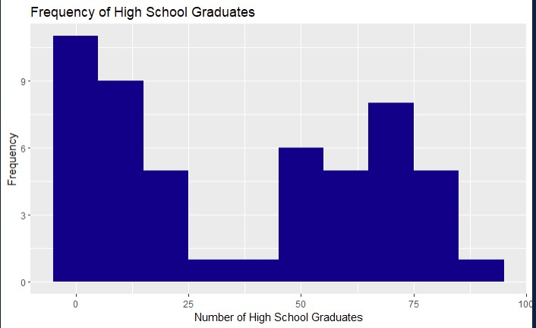

**R – Box Plot**

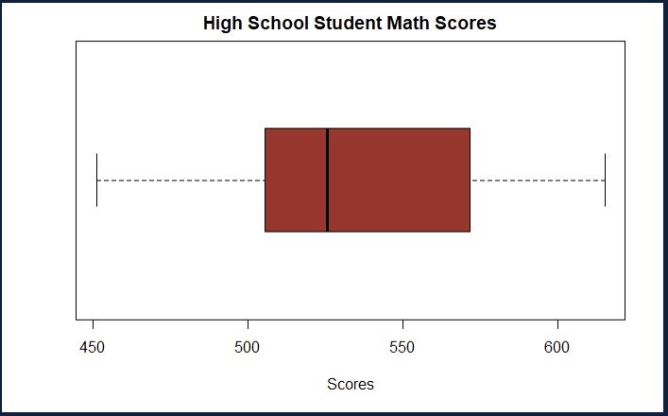

**R – Bullet Chart**

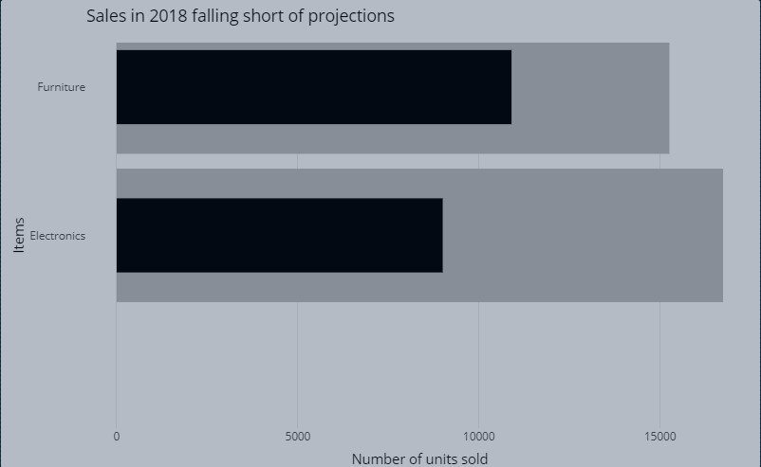

**R – Scatter Plot**

