Week 3-4 Graphs Assignment

Felipe Castillo

Catherine Williams

Data Presentation and Visualization

9/20/2022

**Tableau**

**Tableau – Line Chart**

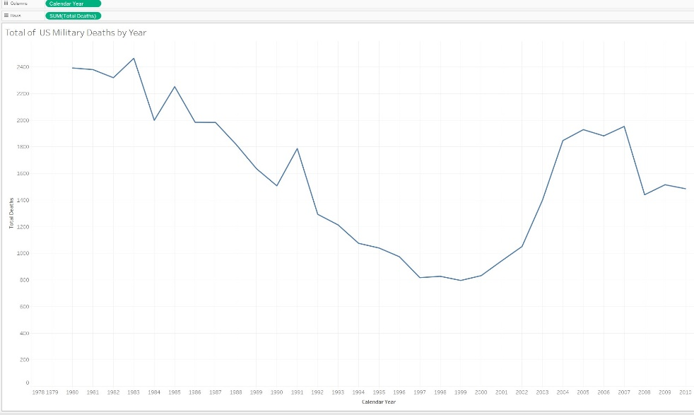

**Tableau – Step Chart**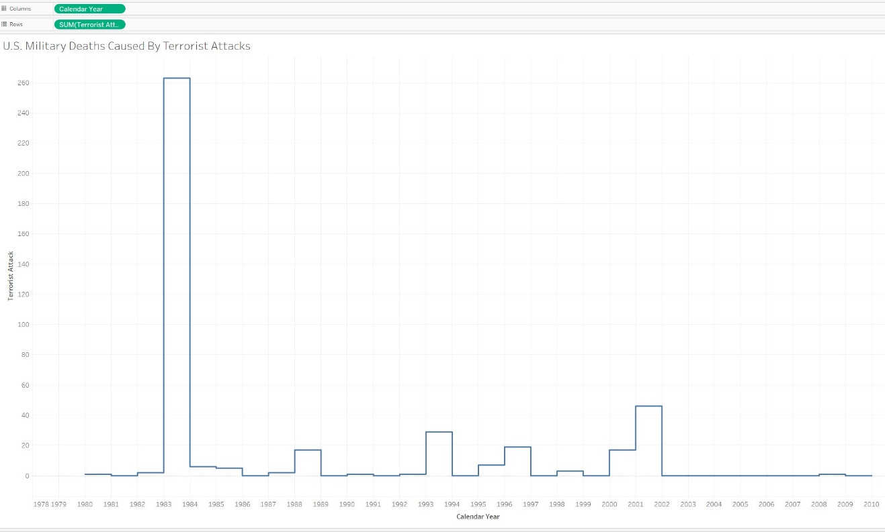

**Python**

**Python – Line Chart**

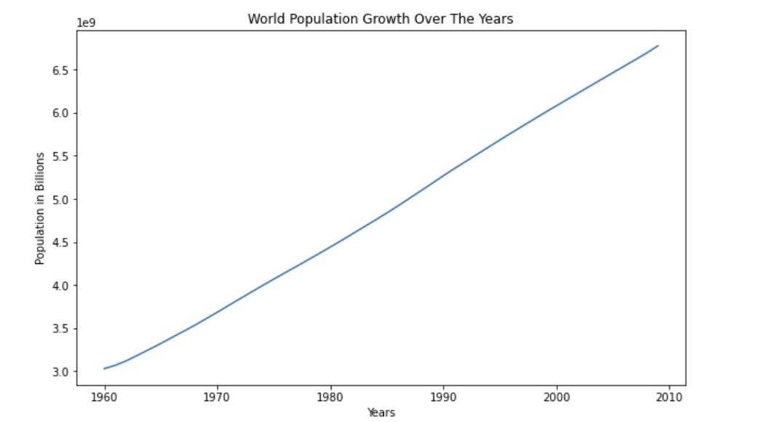

**Python – Step Chart**

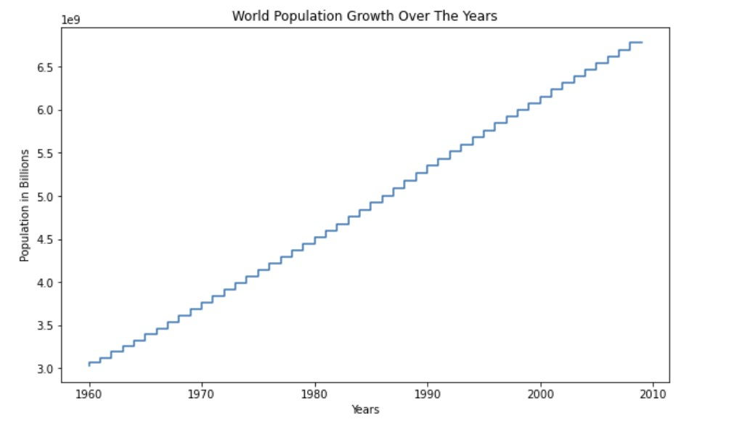

**R**

**R – Line Chart**

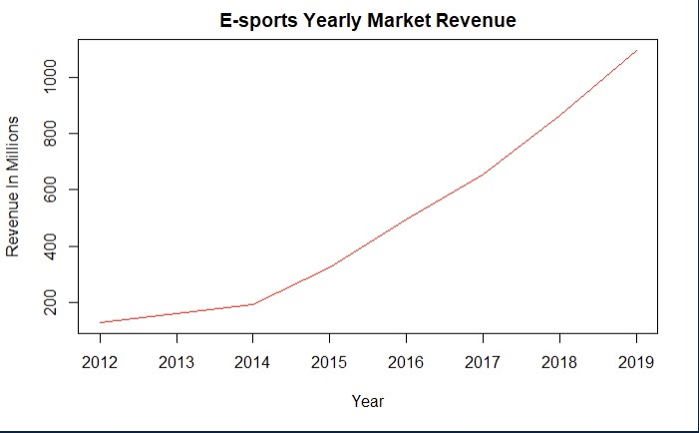

**R – Step Chart**

