Week 5-6 Graphs Assignment

Felipe Castillo

Catherine Williams

Data Presentation and Visualization

10/09/2022

**Tableau**

**Tableau – Tree Map Chart**

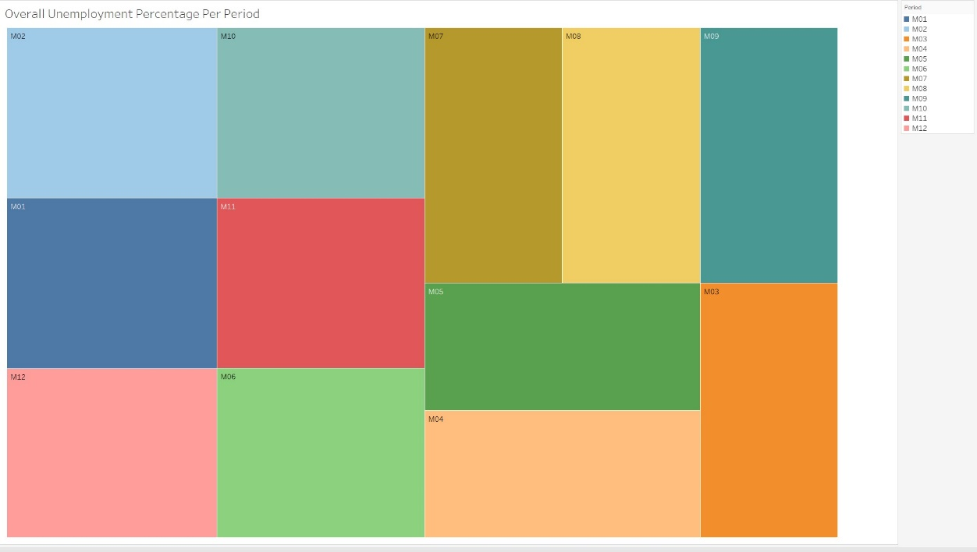

**Tableau – Area Chart**

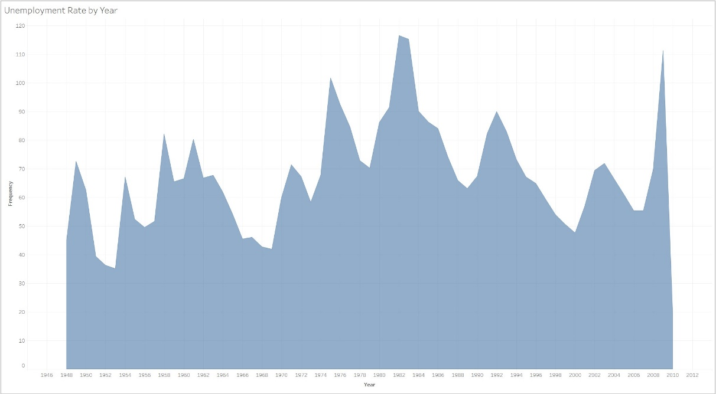

**Tableau – Stack Area Chart**

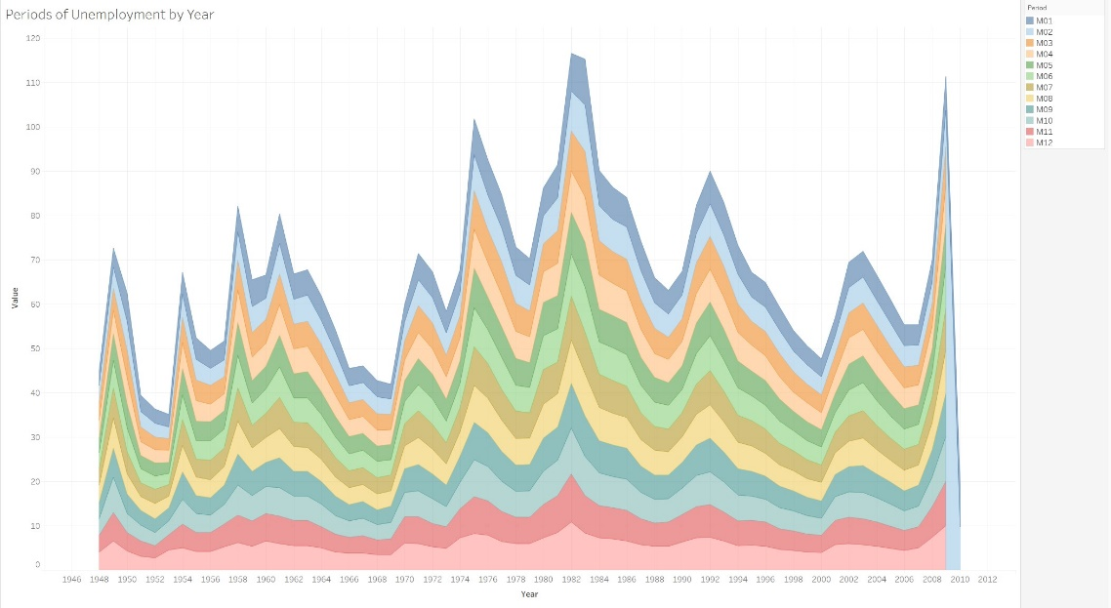

**Python**

**Python – Tree Map Chart**

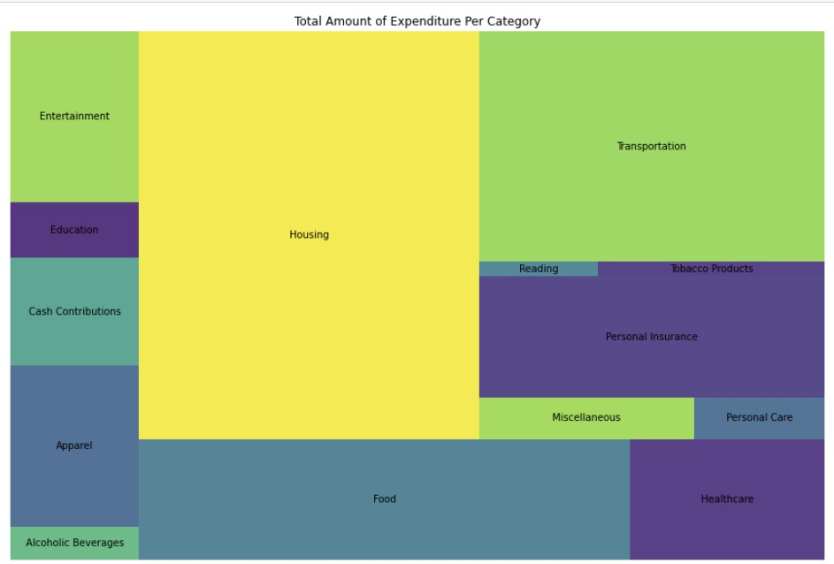

**Python – Area Chart**

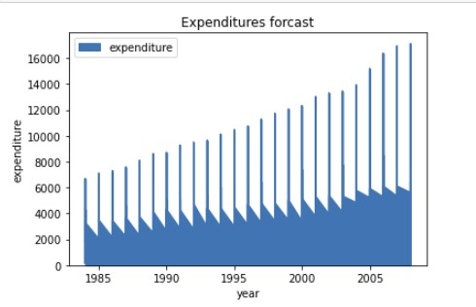

**Python – Stack Area Chart**

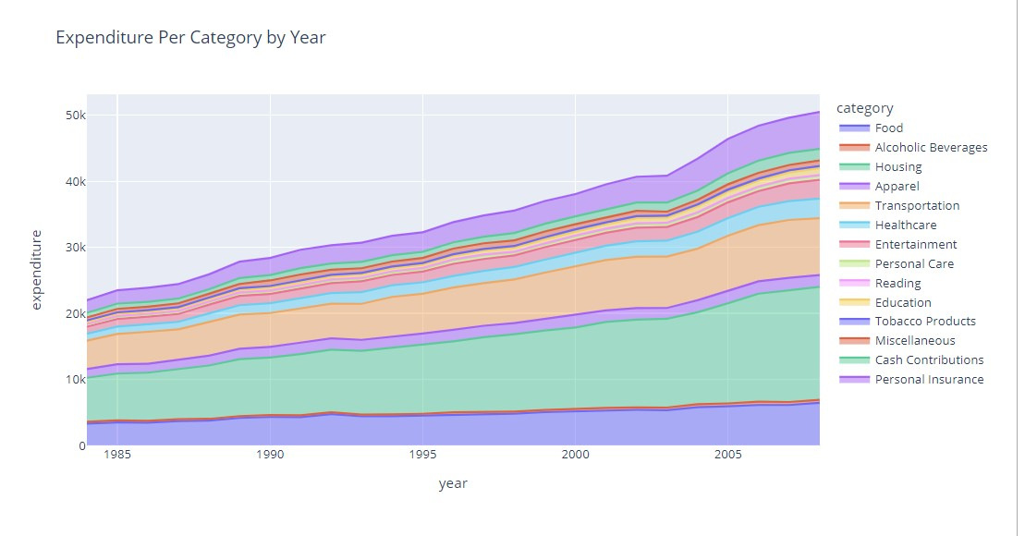

**R**

**R – Tree Map Chart**

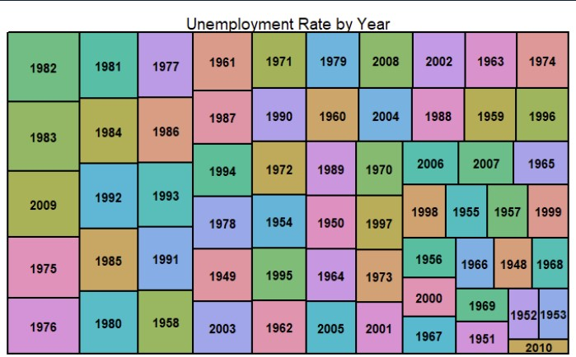

**R – Area Chart**

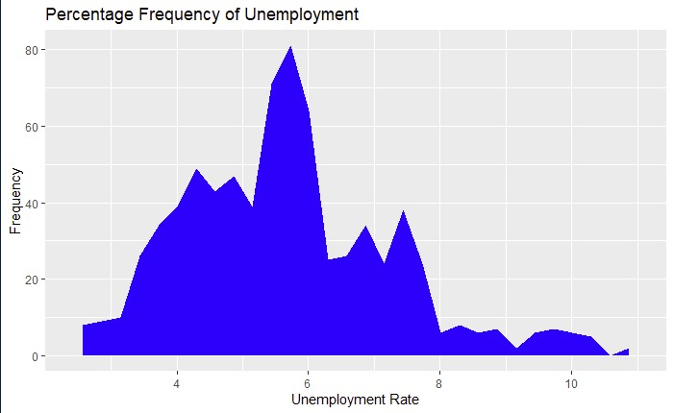

**R – Stack Area Chart**

