Week 7-8 Graphs Assignment

Felipe Castillo

Catherine Williams

Data Presentation and Visualization

10/23/2022

**Tableau**

**Tableau – Scatter Plot**

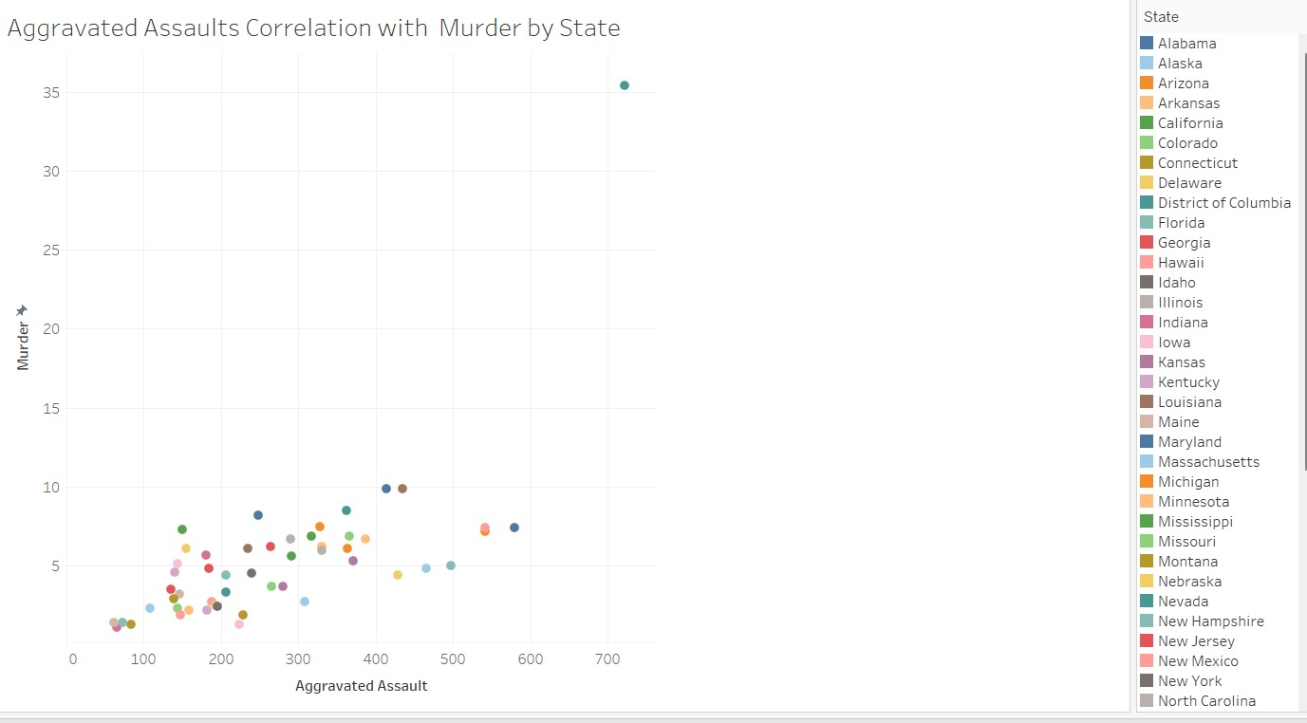

**Tableau – Bubble Chart**

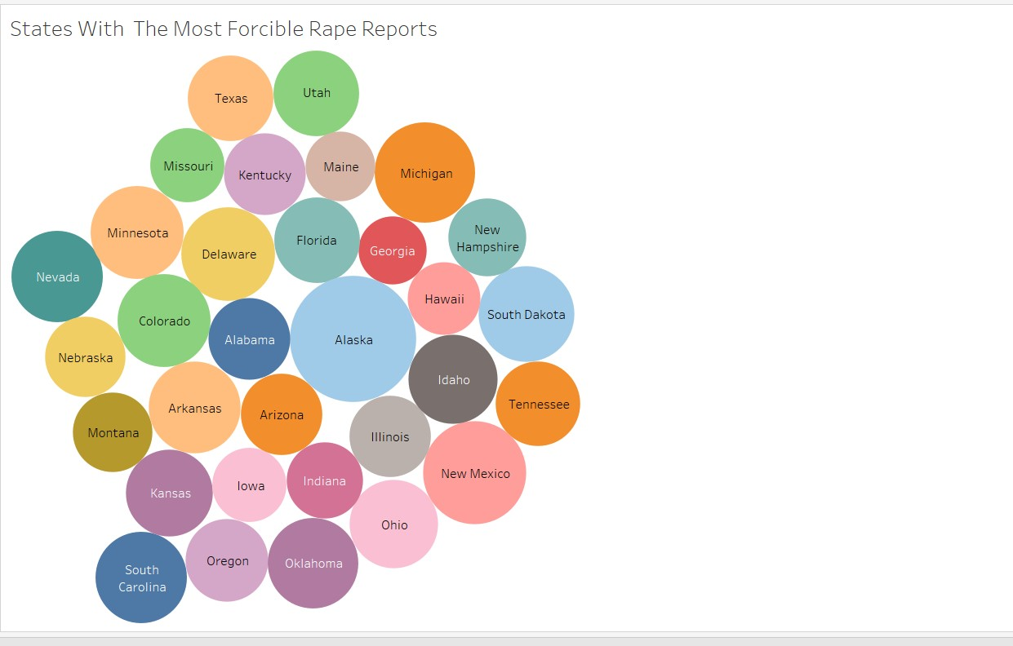

**Tableau – Density Plot** 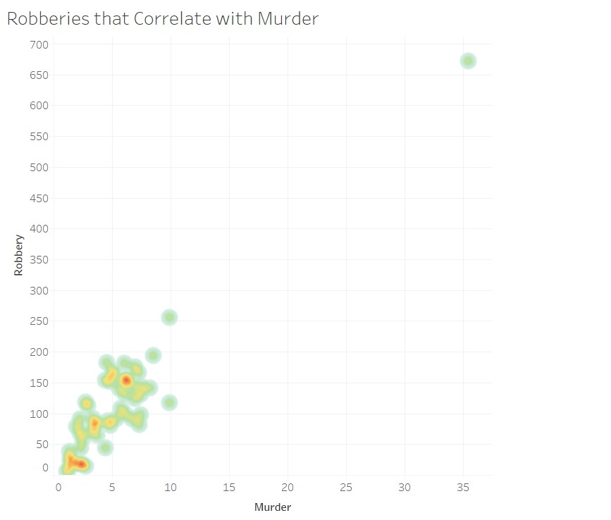

**Python**

**Python – Scatter Plot**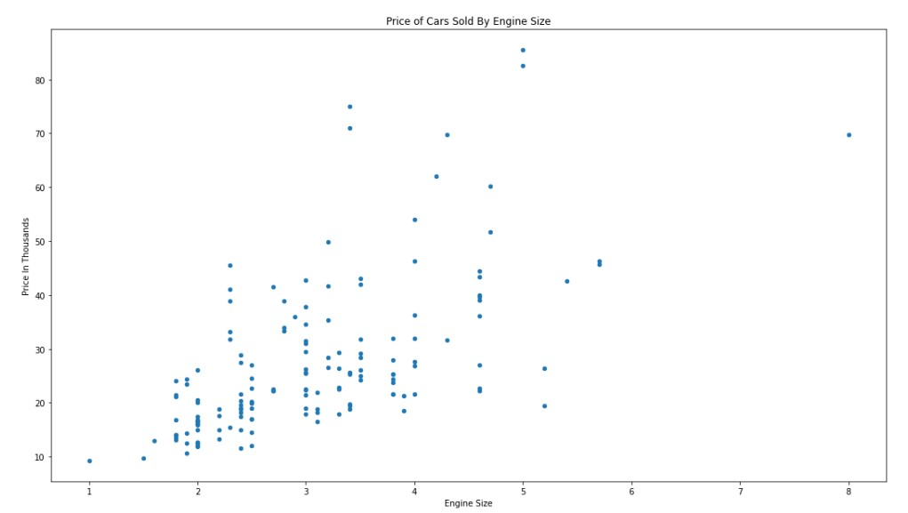

**Python – Bubble Chart**

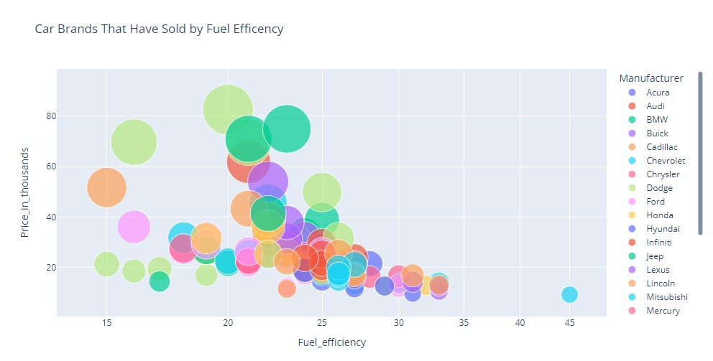

**Python – Density Plot**

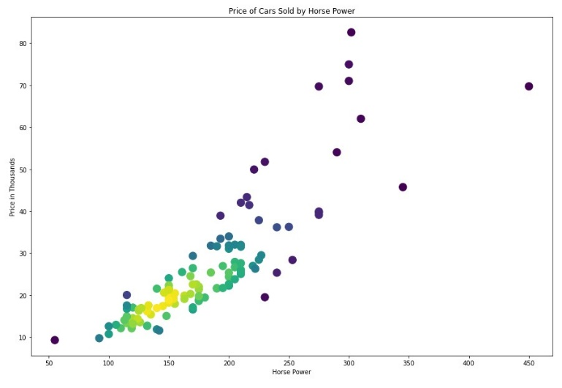

**R**

**R – Scatter Plot Chart**

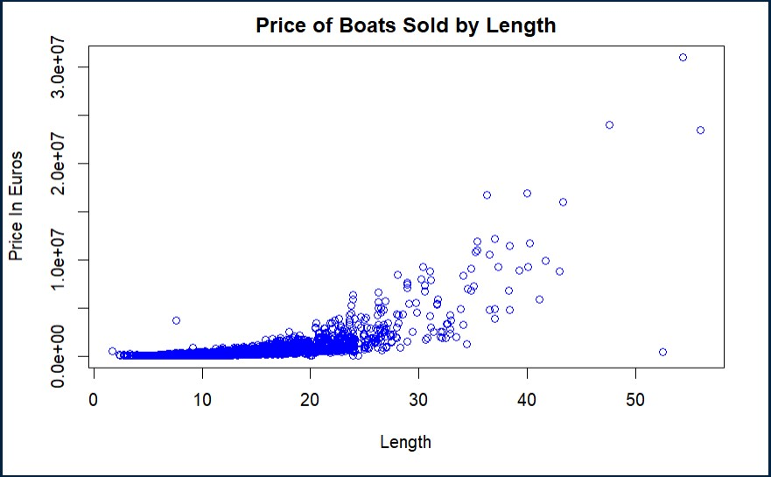

**R – Bubble Chart**

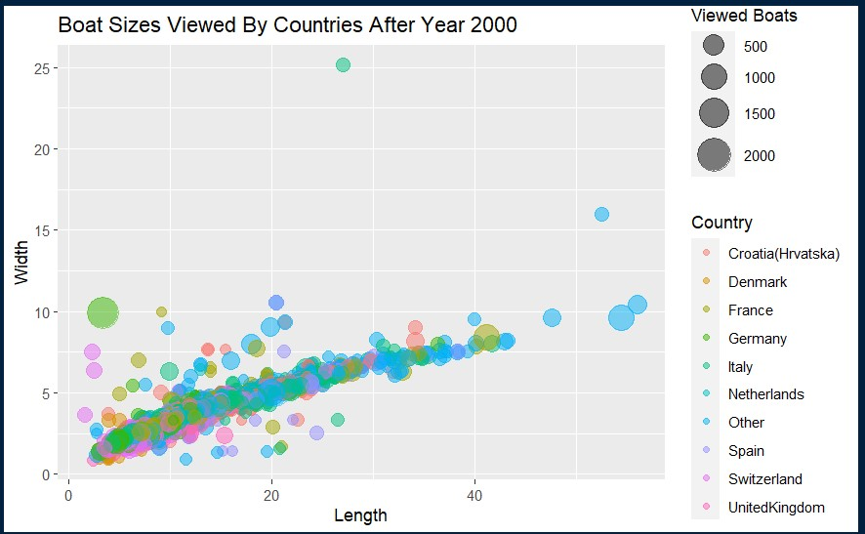

**R – Density Chart**

