Week 9-10 Graphs Assignment

Felipe Castillo

Catherine Williams

Data Presentation and Visualization

11/06/2022

**Tableau**

**Tableau – Heat Map**

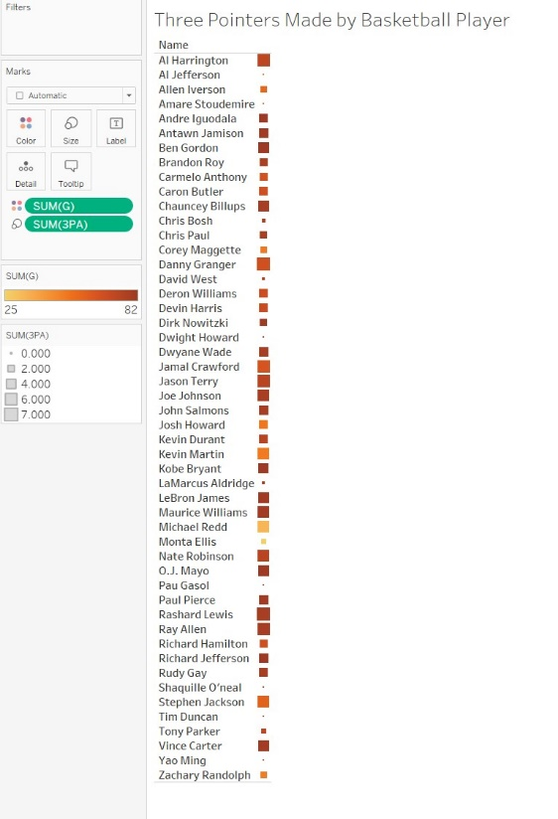

**Tableau – Spatial Chart**

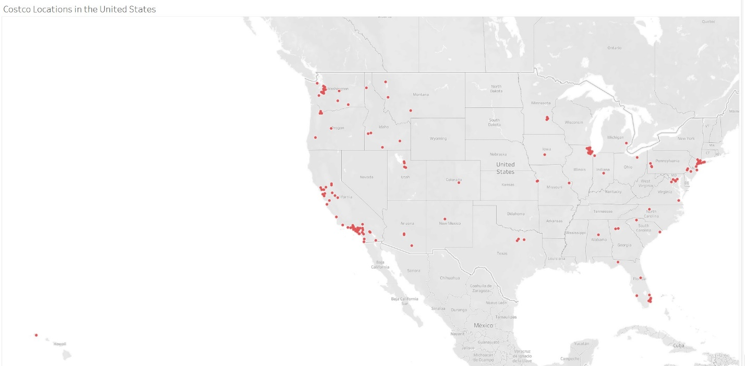

**Tableau – Funnel Chart**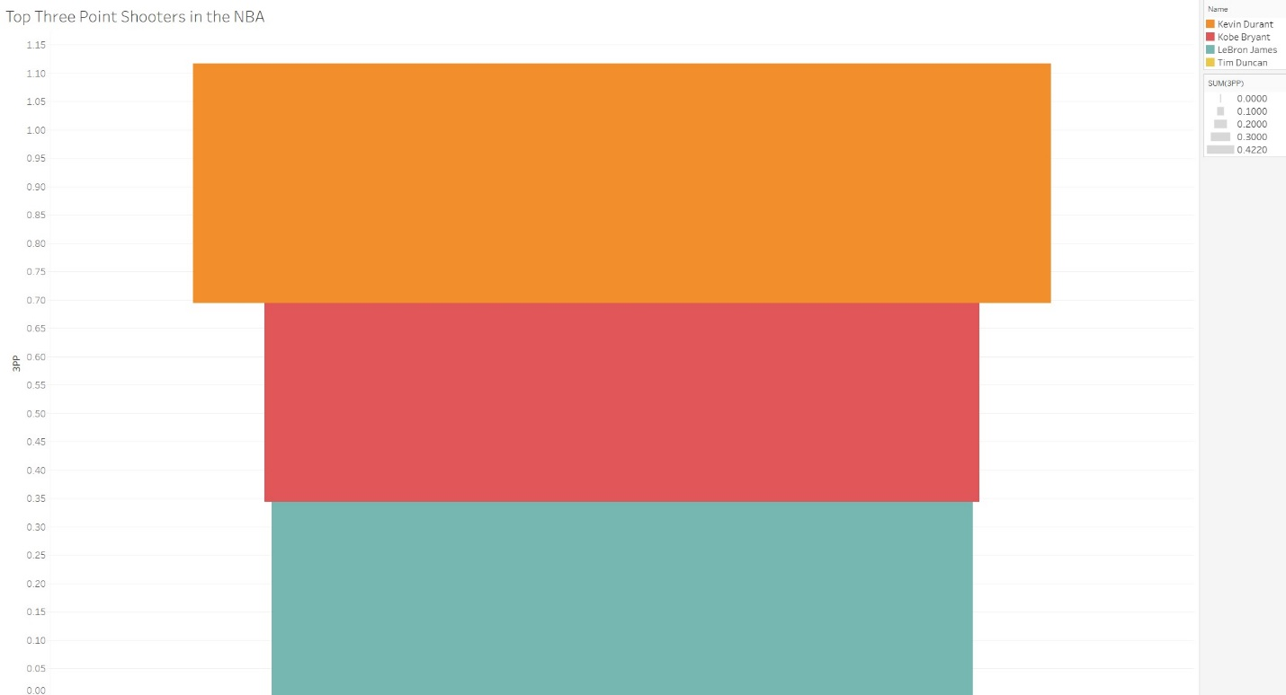

**Python**

**Python – Heat Map**

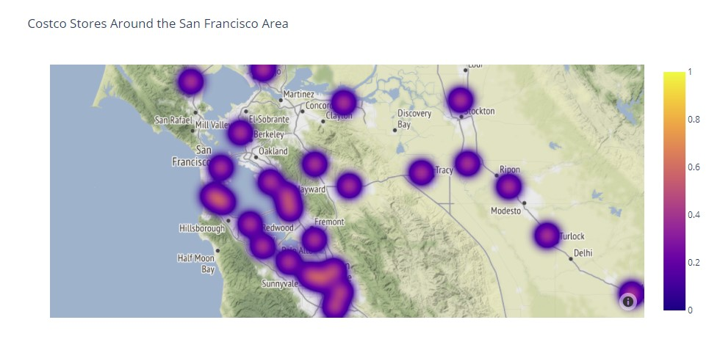

**Python – Spatial Chart**

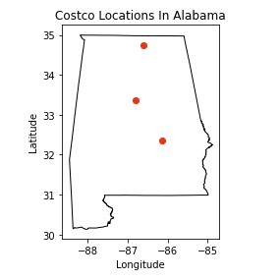

**Python – Contour Chart**

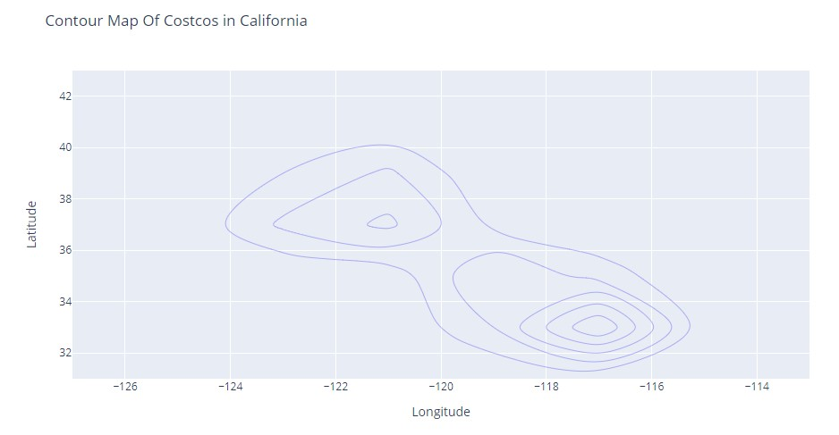

**R**

**R – Heat map**

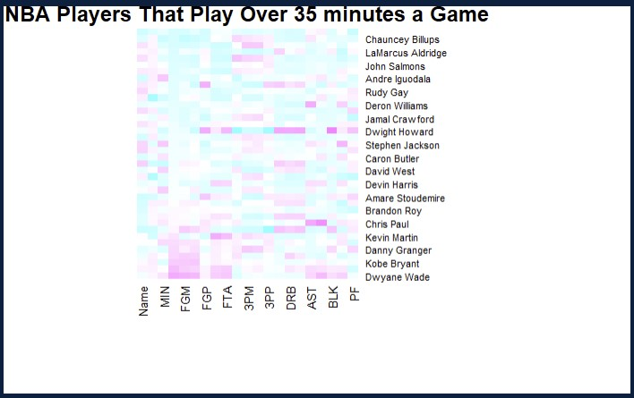

**R – Spatial Chart**

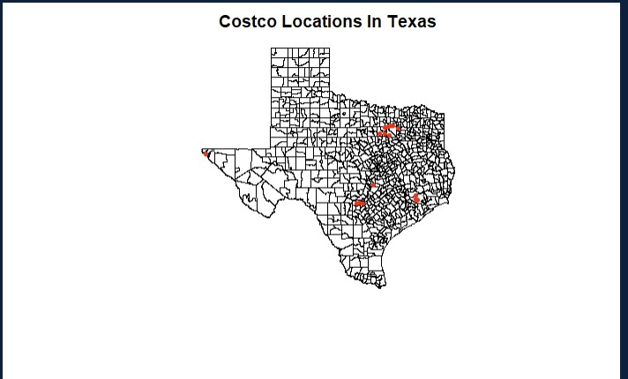

**R – Contour Chart**

