Birla Institute of Technology & Science, Pilani
Work Integrated Learning Programmes Division
Second Semester 2025-2026
M.Tech. in AIML
End-Semester Test
(EC-2 Regular Paper)

Course No. : AIMLCLZG525
Course Title : Natural Language Processing
Nature of Exam : Open Book
No. of Pages = 4
No. of Questions = 7
Weightage : 40%
Duration : 2.5 Hours
Date of Exam : 7th Sept 2025, 1PM
Note to Students:
- Please follow all the Instructions to Candidates given on the cover page of the answer book.
- All parts of a question should be answered consecutively. Each answer should start from a fresh page.
- Assumptions made if any, should be stated clearly at the beginning of your answer.

Question 1 (5 Marks)
- You are building a bigram language model. Your training corpus is very small and consists of the following three sentences: [2 Marks]
<s> cat sat </s>
<s> dog sat </s>
<s> cat ran </s>
You are given a new sentence for your test set: <s> dog ran </s>
Task: Calculate the perplexity of your bigram language model on the test sentence. Use Laplace (Add-One) Smoothing for your probability calculations.
- Our language model is designed to predict the next word based on the previous word, and its entire vocabulary contains only two words:”cat”,”sat”. [3 Marks]
The model has learned the following 2-dimensional embeddings for each word: cat: [0.8, 0.2] and
sat: [0.3, 0.7]. The neural network takes a word’s 2D embedding as input. It has a hidden layer with 2 neurons and an output layer with 2 neurons (one for each word in our tiny vocabulary).
Given: Input word:”cat”
Weights from input to hidden layer: w1 = 0.2, w2 = 0.4, w3 = 0.5, w4 = 0.1
Weights from hidden to output layer: w7 = 0.3, w8 = 0.2, w9 = 0.6, w10 = 0.4 Biases: bh = 0.1, bo = 0.2
Activation Functions: Hidden Layer: Sigmoid; Output Layer: Softmax
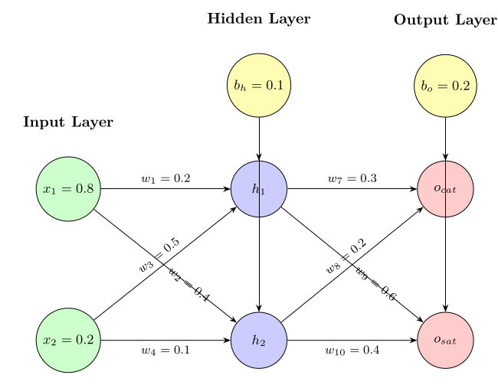
Task: Perform a forward pass through the network to calculate the probability for ”cat” and ”sat” being the next word after ”cat”. Which word does the model predict is most likely?

Q2 – 5 Marks
- A simple part-of-speech tagger has the following transition and emission probabilities:

Transition Probabilities:
Current / Next | DT (Determiner) | NN (Noun) | VB (Verb)
START | 0.5 | 0.3 | 0.2
DT | 0.1 | 0.8 | 0.1
NN | 0.1 | 0.2 | 0.7
VB | 0.4 | 0.5 | 0.1

Emission Probabilities:
Tag / Word | "the" | "cat" | "runs"
DT | 0.9 | 0.05 | 0.05
NN | 0.1 | 0.8 | 0.1
VB | 0.05 | 0.05 | 0.9
For the phrase "the cat runs", calculate the most likely POS tag sequence using the Viterbi algorithm. Show your work step by step. [3 Marks]
- A speech recognition system uses a Hidden Markov Model (HMM) with two hidden states:
- Vowel (V)
- Consonant (C)
The model parameters are as follows:

Initial Probabilities:
- P(V) = 0.6
- P(C) = 0.4

Transition Probabilities:
From / To | V | C
V | 0.7 | 0.3
C | 0.4 | 0.6

Emission Probabilities (Phoneme Observations):
Observation / State | Vowel (V) | Consonant (C)
"ah" | 0.9 | 0.2
"sh" | 0.1 | 0.8
If the system observes the phoneme "ah" at time step 1, what is the probability of each hidden state (Vowel or Consonant) at that point? [2 Marks]

Question 3. [6 Marks]
Consider this Probabilistic Context-Free Grammar (PCFG):
S→NP VP [1.0] 8. NP→Pron [0.3]
NP→Det N [0.4] 9. NP→NP PP [0.3]
VP→V NP [0.6] 10. VP→VP PP [0.4]
PP→P NP [1.0] 11. Pron→She [1.0]
Det→the [1.0] 12. N→dog [0.5]
N→stick [0.5] 13. V→chased [1.0]
P→with [1.0]
- List the distinct parses for “She chased the dog with the stick.” [3]
- Compute the probability of each parse by multiplying rule probabilities. [2]
- Which parse is most probable? [1]
Question 4. [6 Marks]
Consider the following sentences for training a context-aware embedding model:
1. "The bank of the river is muddy."
2. "I need to visit the bank to withdraw money."
3. "The river bank was flooded yesterday."
4. "She works at the central bank as an analyst."
5. "The steep bank made climbing difficult."
You need to create contextual embeddings for the word "bank" using a simplified transformer-based approach.

The word vectors in 2D are as follows
• "The": [1, 0]
• "bank": [0, 1]
• "of": [1, 1]
• "the": [1, 0]
• "river": [0, 2]
• "is": [2, 0]
• "muddy": [1, 2]
Note: These word vectors serve as Query, Key, and Value vectors.
- Identify the different senses of "bank" in the given sentences and explain how context helps in disambiguation. [2]
- For the sentence "The bank of the river is muddy", show how you would compute the attention weights for the word "bank" with respect to other words in the sentence. Include self-attention. [2]
- Calculate the final contextual embedding for "bank" using the attention mechanism. Show all intermediate steps and assume exp(0) = 1, exp(1) = 2.72, exp(2) = 7.39. [4]

Question 5 [3+3=6 marks]
- Consider the sentence: [3 Marks]
"I went to port to see the ships."
Determine the correct sense of the word "port" using the Lesk Algorithm
Assume the following Wikipedia disambiguation:
- Port (medicine): a small medical appliance installed in the body
- Port (computer networking): a virtual data connection between computer programs
- port (place): a place where ships load and unload goods
Briefly show your steps.
- You are given a dataset of research papers including authors, topics, and publication years. Describe how you would construct a knowledge graph from this data. Identify at least three node types and two relationship types. [3 Marks]

Question 6. [6 Marks]
Justify your answer. LLMs can present false or incorrect information when LLMs do not have the correct answer. How to address this issue by augmenting the generation with additional relevant information to the model. Illustrate this approach with its benefits. [6 Marks]

Question 7. [6 Marks]
You are tasked with summarizing the following multi-document set:
- Doc 1 (News Report): “On 15th March 2020, schools in Italy were shut down due to rising COVID-19 cases.”
- Doc 2 (News Blog): “In December 2019, Wuhan reported the first unusual pneumonia cases.”
- Doc 3 (Press Release): “By mid-2021, over 2 billion vaccine doses had been administered globally.”
- Doc 4 (Interview): “Doctors explained that the pandemic was officially declared by WHO in March 2020.”
a) Which ordering strategy (Chronological, Coherence, and Topical) would best represent the summary and give reason?
b) Why might the other two strategies fail here?
Note: Mark Distribution: [ 0.5 mark for correct answer and 0.5 mark for reasoning, 0.5 marks each for other two strategies reasoning ]
Q7.b). "When constructing an extractive summarization system for climate change news, redundancy is often a challenge. Given the following candidate sentences:
- S1: "Global temperatures hit a record high in July 2023, alarming scientists worldwide."
- S2: "Last July, scientists reported the highest global temperatures ever recorded."
- S3: "Rising sea levels threaten coastal cities, with millions at risk of flooding."
a) Which technique would you apply to prevent semantic duplication between S1 and S2 while ensuring the summary still conveys both the climate record event and the sea-level risk? [1 Mark]
b) Justify why this technique is more effective than simple frequency-based selection methods.[2 Marks]
c) Give the final non-redundant extractive summary. [1 Mark]

