Step Response Testing
Compare the experimental step response of a motor's angular velocity to the simulated step response of an open loop system modeling the motor.
Create empty array for motor data 1
Initialize motor model constants 1
Plot Motor Velocity and Simulation Velocity 1

Create empty array for motor data
Data was taken from the Arduino serial monitor. The motor was supplied a 50% PWM signal at time = 1 second. The 50% PWM signal meant an analog 4V was supplied to the motor from the battery. Data was copied into Excel, where it could easily be copied into MATLAB and written into an array.
motorData = [1.00,0.00; 1.05,2.08; 1.10,4.64; 1.15,5.78; 1.20,6.25;
1.25,6.57; 1.30,6.76; 1.35,6.84; 1.40,6.88; 1.45,6.80;
1.50,6.84; 1.55,6.80; 1.60,6.88; 1.65,6.84; 1.70,6.88;
1.75,6.80; 1.80,6.88; 1.85,6.84; 1.90,6.88; 1.95,6.88;
2.00,6.88; 2.05,6.73; 2.10,6.84; 2.15,6.88; 2.20,6.88;
2.25,6.88; 2.30,6.88; 2.35,6.76; 2.40,6.84; 2.45,6.88;
2.50,6.88; 2.55,6.92; 2.60,6.80; 2.65,6.73; 2.70,6.92;
2.75,6.88];

Initialize motor model constants
K and sigma were calculated following the first graph of Section 4.1 in the EENG 307 Lecture 15 handout. K was set equal to final velocity in rad/s and 1/sigma was set to the time where velocity equaled 0.64*K. Due to the error inherent in the measurement method we were required to use, the final velocity of the motor data was averaged, resulting in an angular velocity of 6.85 rads/s. The inverse of sigma was set equal to the time in seconds where velocity equaled 64% of its final value.
4V were supplied to the motor as the voltage step in the experiment, meaning in the simulation the step input signal needs to go through a gain of 4 to properly mimic the experiment. To offset this immediate input gain, the K value in the transfer function must be divided by 4.
K = 6.85/4;
sigma = 10;

Plot Motor Velocity and Simulation Velocity
Plot Motor Data
time = motorData(:,1);
velocity = motorData(:,2);
figure(1); plot(time, velocity);
xlabel("time [ms]");
ylabel("angular velocity [rads/s]");
% Run simulation and plot results of simulated step response against
% experimental motor data
out = sim('section4_6');
figure(2);
plot(out.simout1);
xlabel("time [s]"); ylabel("angular velocity [rads/s]");
hold on;
plot(time, velocity);
hold off;
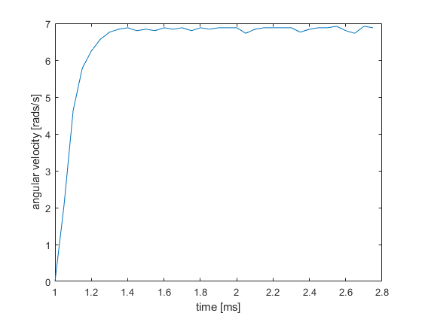
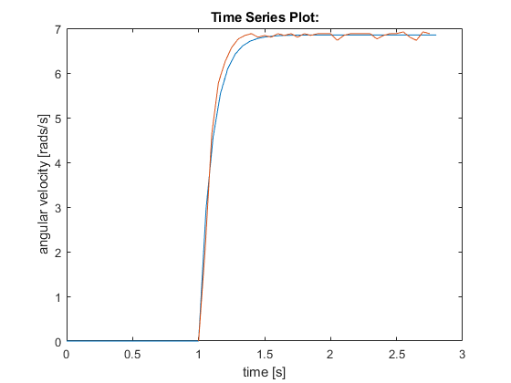
Published with MATLAB® R2020a

