Section 4.7
Run the simulation in section4_7.slx and plot results
To design the control system implemented on an Arduino, the PID tuner app provided by Simulink was used. The controller implemented in the demonstration was a PID controller. The PID tuner gave gain values for proportional, integral, and derivative gain as follows:
K_{p} = 1.25 [V/rad]
K_{i} = 0.84 [V/rad*s]
K_{d} = 0.03 [V/rad/s]
When used to control the real motor, these gain values did not produce the best motor response. The largest issue was the derivative gain needed to be significantly increased so the wheel could reach the correct position quickly. The implementation used to demo for the Mini Project Demonstration used a derivative gain around ten times larger than the simulated value. This introduced significant overshoot. Moving forward into Demonstration 1, the controller used to drive the motors will be changed to a PI controller instead of a PID controller, tuned to minimize overshoot while keeping a short rise time. Furthermore, during the documentation phase of the Mini Assignment, it was realized both simulations used an incorrect K value. Before the documentation phase, the K value was the average final angular velocity divided by 2.5, as a 50% duty cycle PWM signal results in a 2.5V analog signal from the digital output pin on the Arduino. The motor, however, is not driven by this voltage. The motor shield uses the PWM signal supplied by the Arduino to create a PWM wave of the external battery voltage, which in this case was a 50% duty cycle from an 8V source, leading to a 4V analog signal.
Initialize Variables for Motor Transfer Function 1
Run simulation and plot results 1

Initialize Variables for Motor Transfer Function
K = 6.85/4;
sigma = 10;

Run simulation and plot results
The input position to the system was 3.14 radians.
out = sim('section4_7');
figure(1);
plot(out.simout);
xlabel('time [s]'); ylabel('position [rads]')

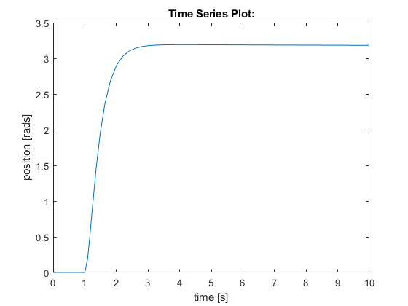
Published with MATLAB® R2020a

