ZhiWei Qiu 143304186

Zqiu12@myseneca.ca

**(WEB322) -Web Programming Tools and Frameworks**

Assignment4-6

Table of content

Overview

this project is based on previews assignment 1-3. The added functions include:

1. sign up a new user
2. log in as normal user or administrator
3. administrator mode can create a new room include basic information such as title, price, location, description and upload a picture. Also, the administrator can edit room information.
4. Normal user mode can book a room and view the booked rooms list
5. All user include normal user, administrator or visitor can see a room page which contains all rooms is uploaded.

Github: <https://github.com/castielqiu/web322_assignment4-6>

Heroku: https://airbnb4to6.herokuapp.com/

Sign up form

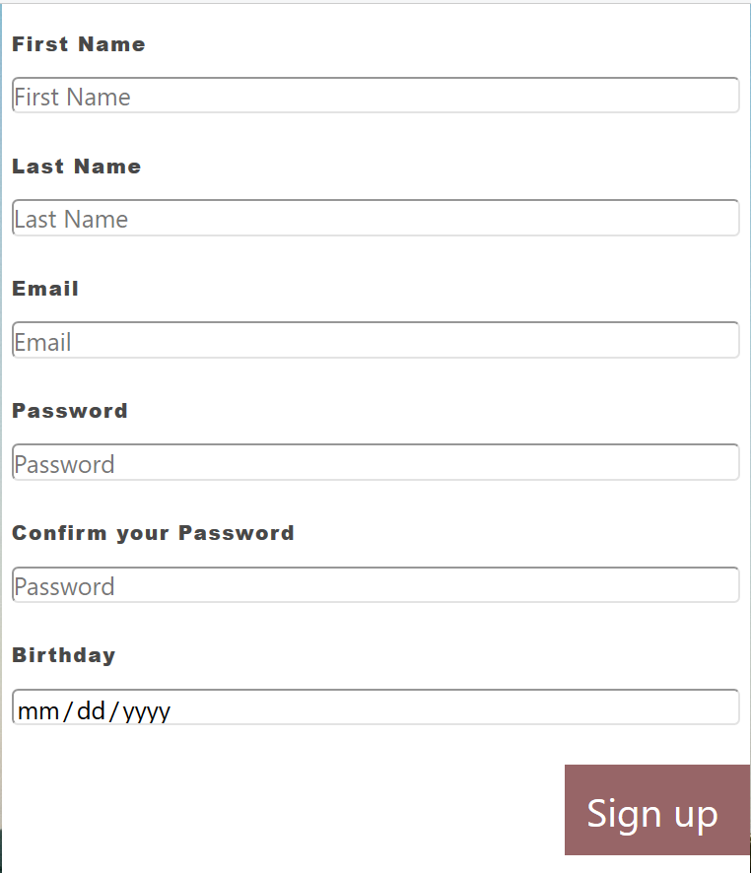

After click “Sign up”, the app will check:

1. all fields must be filled
2. Email address is unique to each user. If Email address has been used by previous user then new user needs a new Email address to register.
3. Password and confirm password must be the same

If either one of the rules not meet then will lead to error message for that field.

Below are error messages:

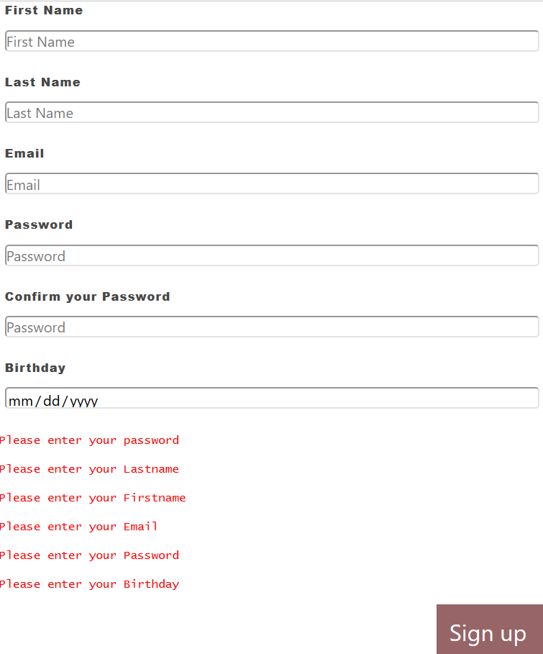

Error message2

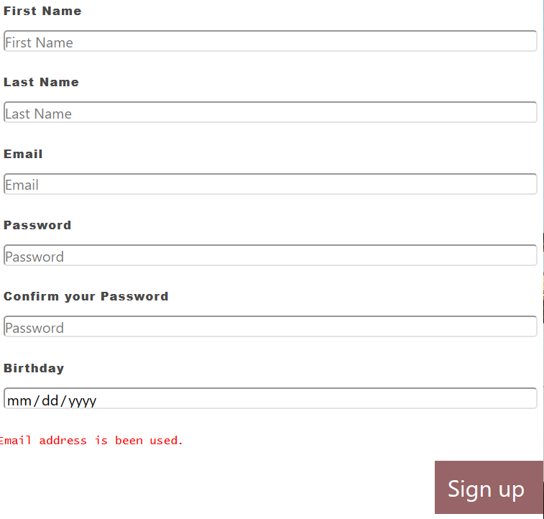 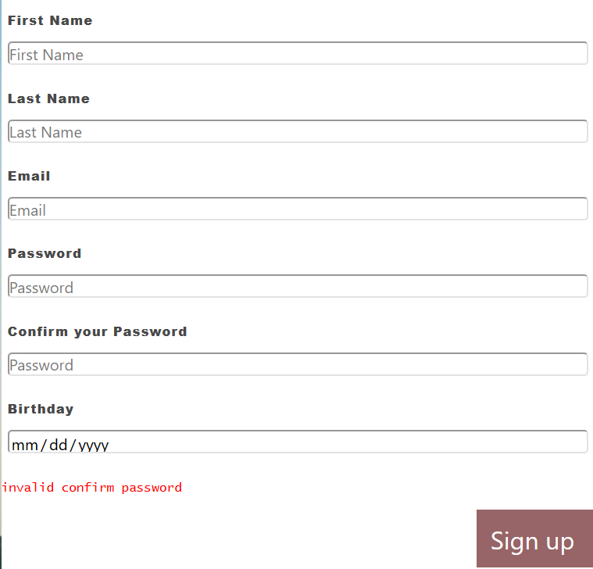

Once all requirements meet new user will add to database then direct to log in page.

Log in Form

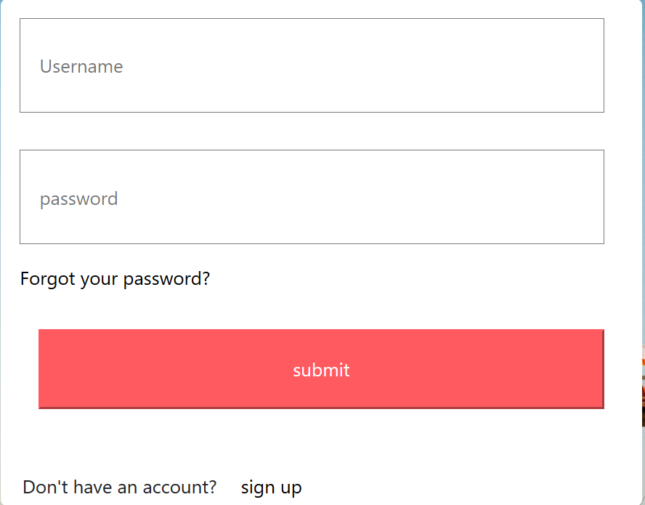

In this page user log in with their email and password. Either Email address or password is wrong,

the web page will show error message. 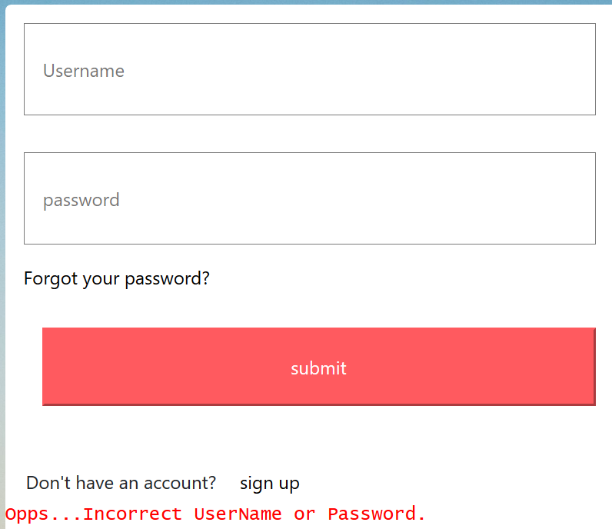

If visitor hasn’t register yet, the web page navigation bar will show “sign up” and “log in” on the right



Once user successful logged in, the navigation bar will show “log out”. The “sign up” and “log in” will disappear



If user pass the authentication then the web will direct user to either user page or administrator page

Administrator page

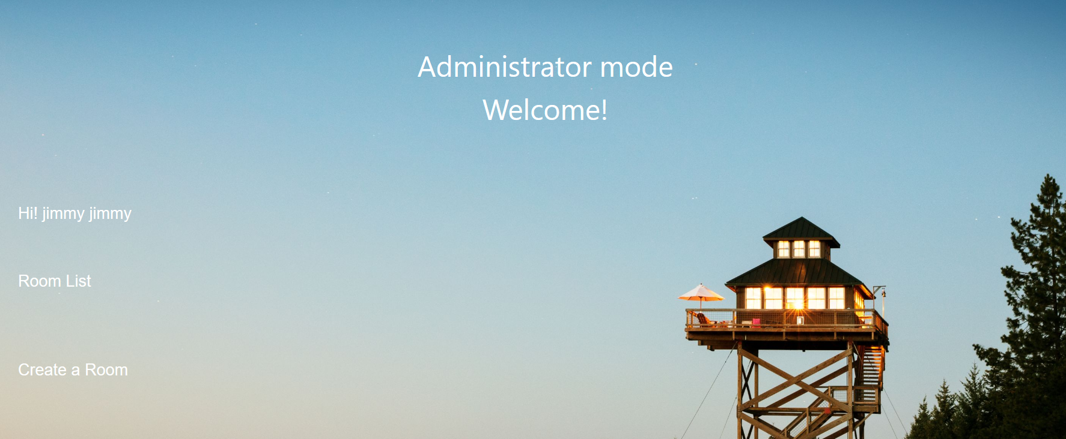this page contains 2 links.

“Room list” will direct to room page which contains all the uploaded room information.

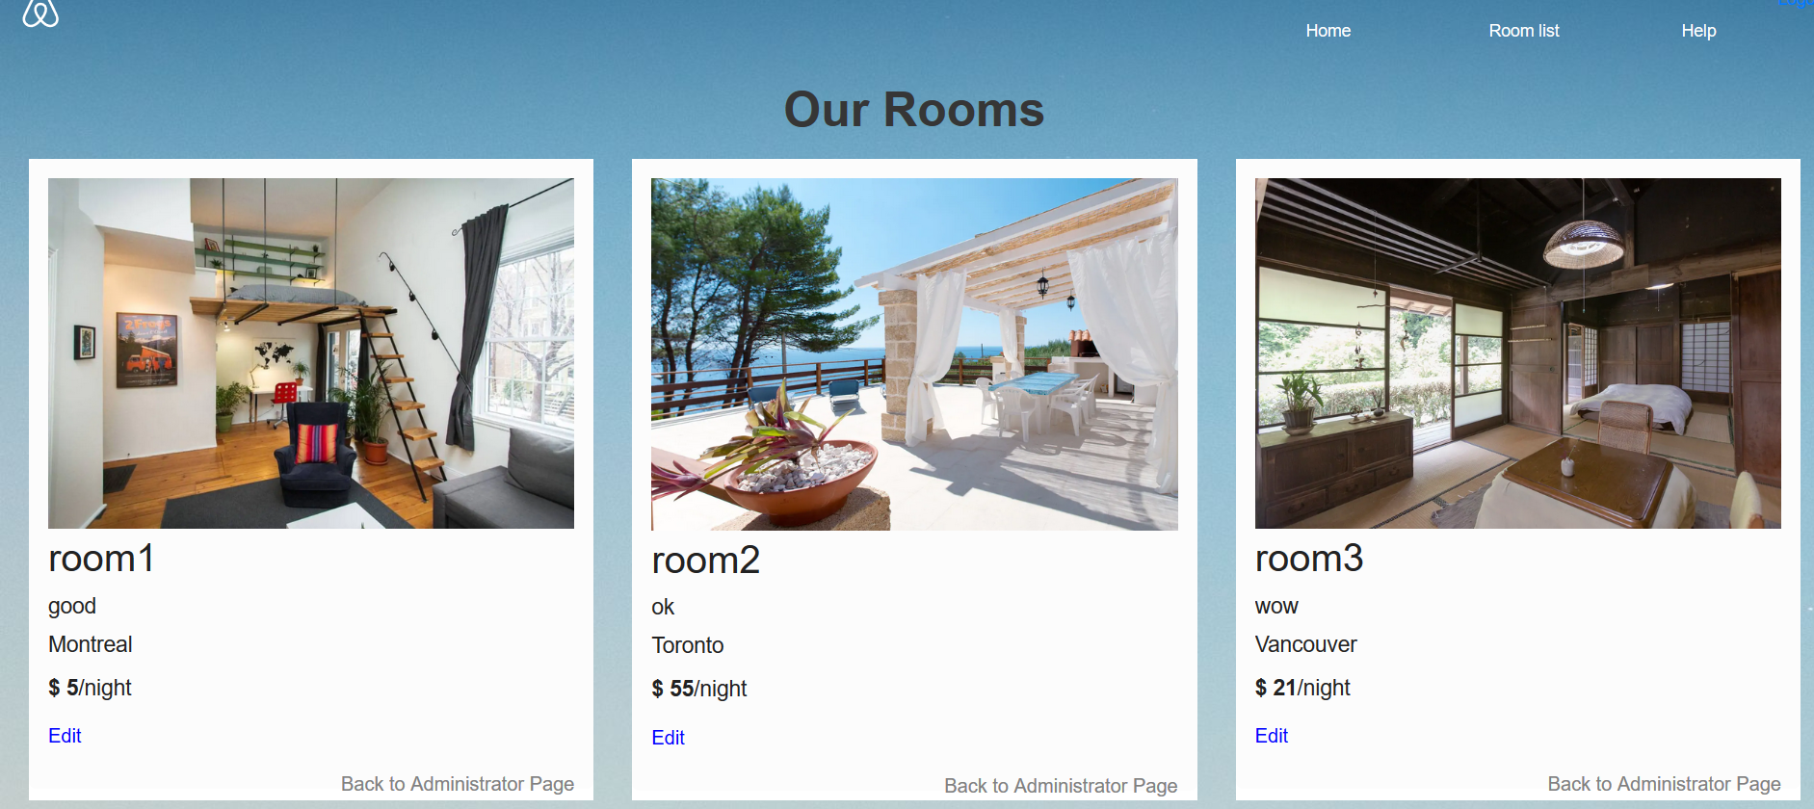

In this page, “Edit” will direct user to edit page

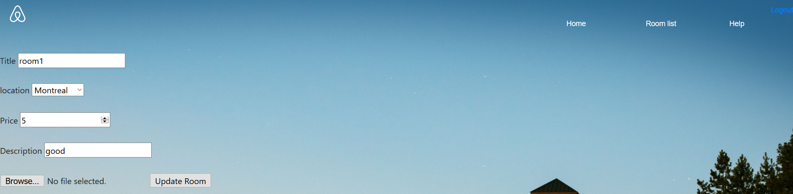

This page requires user re-upload picture and limit the types of file to upload.

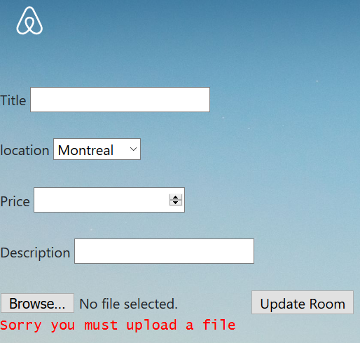

After edit room information and upload picture, click” update room”, web app will direct user back to room page and user can see the updated room information.