Newton’s Laws

Statement of the Laws

First Law
If the net force on an object is zero, its velocity is constant:
If i​Fi=0 ⇒ v=constant

Second Law
The mass times the acceleration of an object equals the sum of all forces acting on it:
ma=i​Fi

Third Law
When object A exerts a force on object B, object B exerts a force on object A that is equal in magnitude and opposite in direction. The law comes in two versions.
In the strong version, the two forces are equal and opposite and they act along the line that joins the two objects.
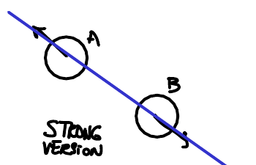
Strong version of the third law.
In the weak version, the two forces are still equal and opposite, but they do not have to act along the line that joins the two objects.
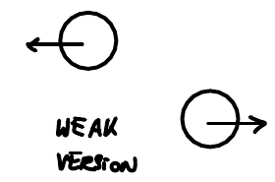
Weak version of the third law.

Friction
The kinds of friction and resistive forces are:
- Static friction: $\left|{\vec{F}}_{s}\right|≤μ_{s}N=μ_{s}F_{N}$. Static friction takes whatever value is needed so that the surfaces do not slide, up to the maximum $μ_{s}F_{N}$.
- Kinetic friction: $\left|{\vec{F}}_{k}\right|=μ_{k}N=μ_{k}F_{N}$, where $0≤μ_{k}≤μ_{s}$.
- Rolling friction: we ignore rolling friction in this class.
- Drag: $\left|\vec{F}\right|∝f\left(\vec{v}\right)$, that is, the drag force depends on the velocity.

Static Versus Kinetic Friction
When a block is pushed but does not slide, its velocity is zero ($\vec{v}=\vec{0}$) and the friction is static.
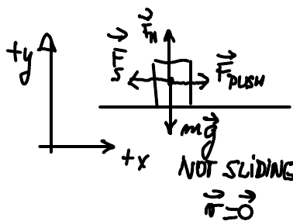
Not sliding: forces on a pushed block at rest, with static friction.
When the surfaces slide against each other, the friction is kinetic.
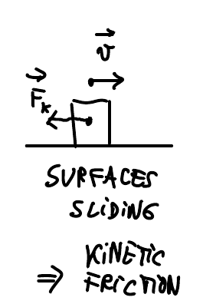
Surfaces sliding: kinetic friction on a moving block.

Newton’s 2nd Law for the Block That Is Not Sliding
Applying Newton’s 2nd law to the block that is pushed but not sliding, with $+x$ to the right and $+y$ upward, gives one equation for each direction.
In the $x$ direction:
$$0=ma_{x}=F_{\text{push}}−F_{s} \left(\text{I}\right) ⇒ F_{s}=F_{\text{push}}≤μ_{s}F_{N}$$
In the $y$ direction:
$$0=ma_{y}=F_{N}−mg \left(\text{II}\right) ⇒ F_{N}=mg$$
Combining the two results:
$$F_{s}≤μ_{s}mg$$
We could write, instead of (I), the equation
$$ma_{x}=F_{\text{push},x}+F_{s,x} \left(\text{I}′\right)$$
but (I′) is less useful because it does not tell us the signs of $F_{\text{push},x}$ and $F_{s,x}$.
For any vector, the components can be $≥0$ or $\text{<} 0$, but magnitudes are always $≥0$.

Drag Force
An object moving through a fluid with velocity $\vec{v}$ feels a drag force ${\vec{F}}_{D}$ that points opposite to the velocity.
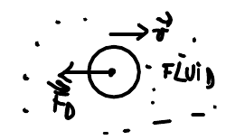
Drag force on an object moving through a fluid.
The form of the drag force depends on the speed:
- Slow (for example, in biology): ${\vec{F}}_{D}=−C\vec{v}$
- Fast (for example, an airplane or a car): $F_{D}∝Kv^{2}$

Example 1
In this example the string and the pulley are massless, the string is inextensible, and the pulley is frictionless.

(a) Setup
Two blocks sit on the two sides of a double incline and are connected by a string that runs over a pulley at the top. The left side makes angle $α$ with the horizontal, and the right side makes angle $β$. The surfaces are frictionless: $μ_{s}=0=μ_{k}$.
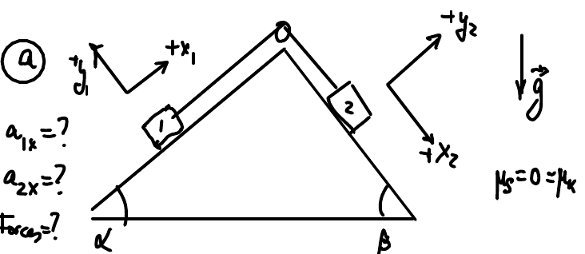
Example 1 setup: two blocks on a double incline connected over a pulley.
Each block has its own coordinate axes, tilted to match its incline:
Coordinate axes for each block in Example 1.
Block | Incline angle | $+x$ direction | $+y$ direction
Block 1 | $α$ | Up the left incline, toward the pulley | Perpendicular to the left incline, away from it
Block 2 | $β$ | Down the right incline, away from the pulley | Perpendicular to the right incline, away from it
We want to find:
- the acceleration $a_{1x}$ of block 1;
- the acceleration $a_{2x}$ of block 2;
- the forces.

(b1), (c1), (d1) Block 1
The free-body diagram of block 1 (b1) shows three forces: the normal force ${\vec{F}}_{N1}$, the tension ${\vec{F}}_{T1}$, and the weight $m_{1}\vec{g}$.
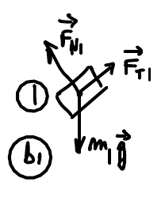
Free-body diagram of block 1.
To write the components (c1), we split the weight along the tilted axes. The angle between $m_{1}\vec{g}$ and the $−y_{1}$ axis equals the incline angle $α$.
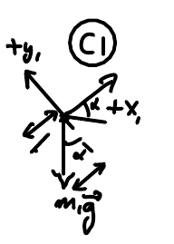
Components of the weight of block 1 along the tilted axes.
Using the right-triangle definitions,
$$sinα=\frac{\text{OPP}}{\text{HYP}}, cosα=\frac{\text{ADJ}}{\text{HYP}}$$
Newton’s 2nd law for block 1 (d1) then gives
$$m_{1}a_{1x}=F_{T}−m_{1}gsinα$$
$$0=m_{1}a_{1y}=F_{N1}−m_{1}gcosα$$

(b2), (d2) Block 2
The free-body diagram of block 2 (b2) shows the tension ${\vec{F}}_{T2}$, the normal force ${\vec{F}}_{N2}$, and the weight $m_{2}\vec{g}$. The weight is split along the tilted axes in the same way, and the angle between $m_{2}\vec{g}$ and the $−y_{2}$ axis equals $β$.
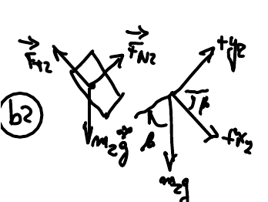
Free-body diagram of block 2 and the components of its weight.
Newton’s 2nd law for block 2 (d2) gives
$$m_{2}a_{2x}=−F_{T}+m_{2}gsinβ$$
$$0=m_{2}a_{2y}=F_{N2}−m_{2}gcosβ$$

Tension in the String
The tension $F_{T}$ is the same for block 1 and block 2 because the string is massless and the pulley is massless and frictionless.

August 26, 2026

Aside: A Massless String Has the Same Tension Everywhere
For a massless string, the tension is the same anywhere along the string. To see why, consider a small segment of string with $+x$ to the right. The tension ${\vec{T}}_{\text{LEFT}}$ pulls the left end to the left, and the tension ${\vec{T}}_{\text{RIGHT}}$ pulls the right end to the right.
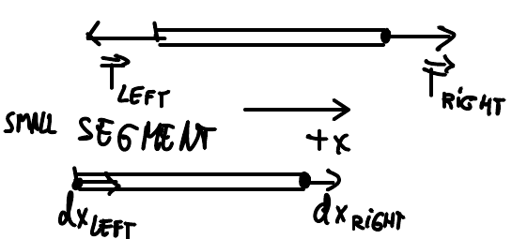
A small segment of string: tensions on its ends and displacements of its ends.
Because the segment has mass $m=0$, Newton’s 2nd law gives
$$0=ma_{x}=T_{\text{RIGHT}}−T_{\text{LEFT}} ⇒ T_{\text{RIGHT}}=T_{\text{LEFT}}$$
The same small segment also shows how the ends of an inextensible string move. If the right end moves by $dx_{\text{RIGHT}}$ and the left end by $dx_{\text{LEFT}}$, then at all times
$$dx_{\text{RIGHT}}=dx_{\text{LEFT}}$$
Dividing by $dt$, the two ends have the same velocity at all times:
$${\left.\frac{dx}{dt}\right|}_{R}={\left.\frac{dx}{dt}\right|}_{L} \left(v_{R}=v_{L}\right)$$
Taking one more time derivative, $\frac{d}{dt}$, the two ends have the same acceleration at all times:
$$a_{R}=a_{L}$$

