Homepage:

Welcome

The Dino-Source

A wonderful day beautiful human! We are “The Dino-Source”, or as we like to call ourselves, the group that procrastinates the most but still manages to utter useless words of complain and agitation. This group comprises of five members as we are speaking. We are named KC Bañas, Charles Moedin, Micah Abella, Hena Micah dela Cruz, and Narciso Geroche.

We would like our group to be remembered as a clan full of crazy and free-spirited people. We all have a lot of similarities. We all are students going to the same school, belonging in the same section, with the same class schedules, with the same teachers, with the same subjects that we are taking. You can call us like-minded in the aspect that we have simultaneous academic responsibilities that we have to fulfill. However, despite the similarities that each of us possess, there are some things worth mentioning that are beyond the superficial aspect of ourselves.

A lot of students are known to be hardworking and determined individuals. They are even known to carry a lot of weight in regards to their academic responsibilities and their personal lives. Given this fact, it is a no brainer that we are also experiencing this. There are definitely times where we feel drained and unmotivated to do our tasks. Sometimes it even gets to the point where we start questioning our purpose in life. Because life couldn’t just be about studying and complying to homeworks and projects right? It is however a relief to know that we have each other to comfort one another whenever we feel the world is too tiring to face and life too draining to go on.

What keeps us motivated? As stated above, we do sometimes question the meaning of life and our purpose in this world. Our greatest motivation of course is our goals and dreams, family, and God. These three usually are what keeps us inspired in doing what we are doing now. School is not always fun, that’s a known fact. School is not fun especially if you are continuously striving to be the best and not get the desired result. However, as we grew older, we realized that school really is not just all about being the best. In fact, life is not about being the best. Life is all about doing what you enjoy with your friends and making the most out of it. For this matter, doing programming and coding with them which constitutes to a lot of fun things to bond with.

We came to realize that as part of our growth, we are also learning a lot of things. For example, this project is not merely a project. This is an opportunity for us to showcase our skills in dealing with technology. This also an opportunity where we get to learn a lot of things when it comes to programming and computers. Maybe, this is also an opportunity for one of us discover that programming may be their passion. This is very useful because the world is becoming more and more modernized as time passes. Sooner or later, any practical activities may also be dealt with computers. It’s important to keep up with the trends these days and we think this project is perfect for it.

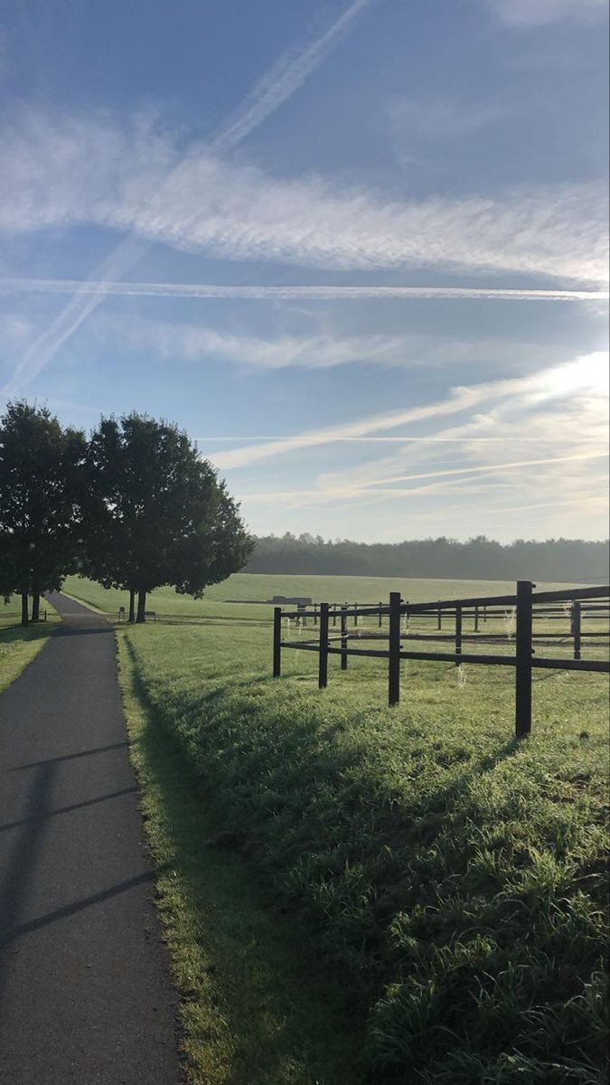

About us:

A wonderful day beautiful human! We are the Group 6, or as we like to call ourselves, the group that procrastinates the most but still manages to utter useless words of complain and agitation. This group comprises of five members as we are speaking. We are named KC Bañas, Charles Moedin, Micah Abella, Hena Micah dela Cruz, and Narciso Geroche. We are a group of Grade 10 students and we are very much ecstatic to share to you some facts about us. We all have life outside our academic responsibilities because gold kami (ngl lmao fr fr lol) rawr. Keep scrolling and find out more about us!

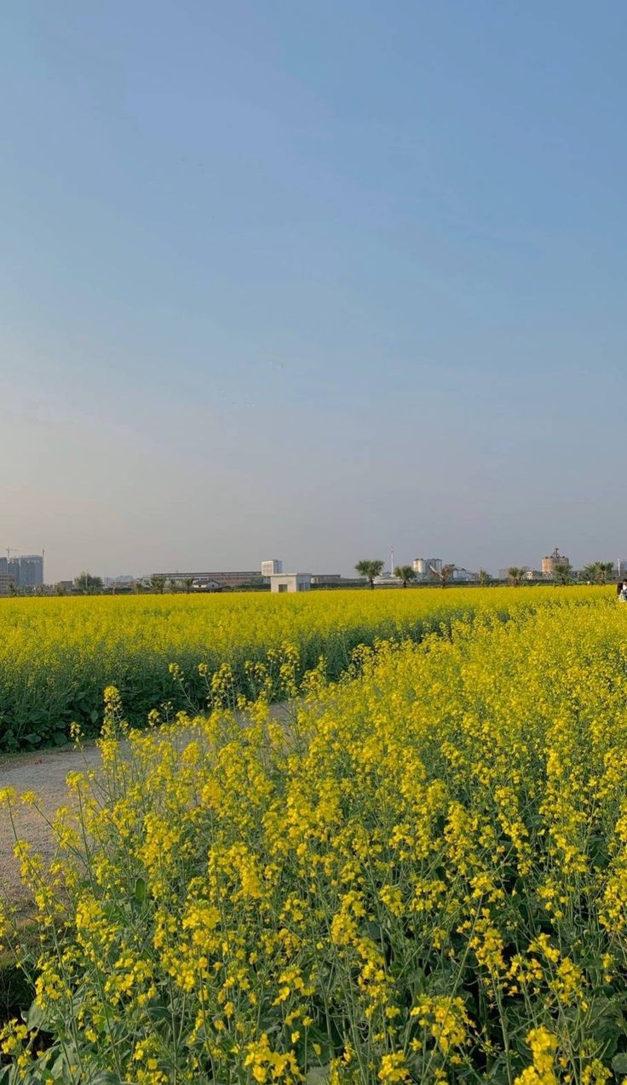

Name: KC Bañas

Age: 15

Zodiac Sign: Leo ♌️

Grade: 10

Section: Chrysoprasus

Hobby: Reading (historical/fantasy, romance), Cooking

Favorite Color: peach, sage & matcha green, white

Contacts: 09511327778

Motto: “if others can do it, then I’ll let them do it”

Photo:

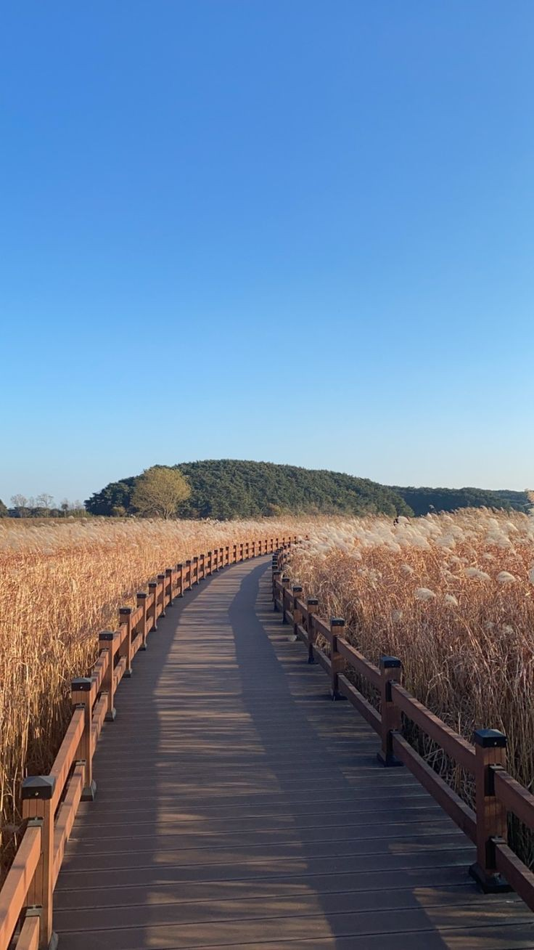BG:

Name: Charles Benedict Moedin

Age: 16

Zodiac: Pisces ♓️

Grade: 10

Section: ChrysopraSUS

Hobby: sports, gaming, playing instruments, watching movies, travel

Favorite color: black/white

Contacts:09687159989

Motto: “when nothin goes right….. go left”

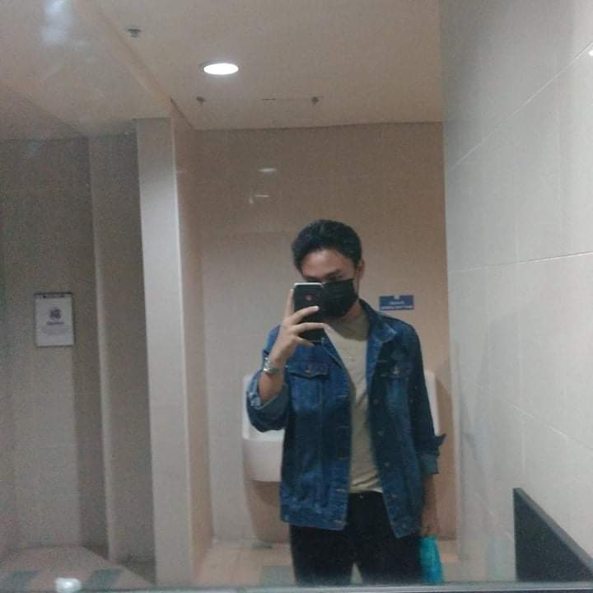Photo:

BG:

Name: Micah Abella

Age: 16

Zodiac sign: Scorpio ♏

Grade 10 – Chrysoprasus

Hobby: watch kdrama,watch enhypen contents,read

Favorite color:beige,black

Contacts:09077486599

Motto: “I’m not a dog, I’m a hotdog…in the freezer.”

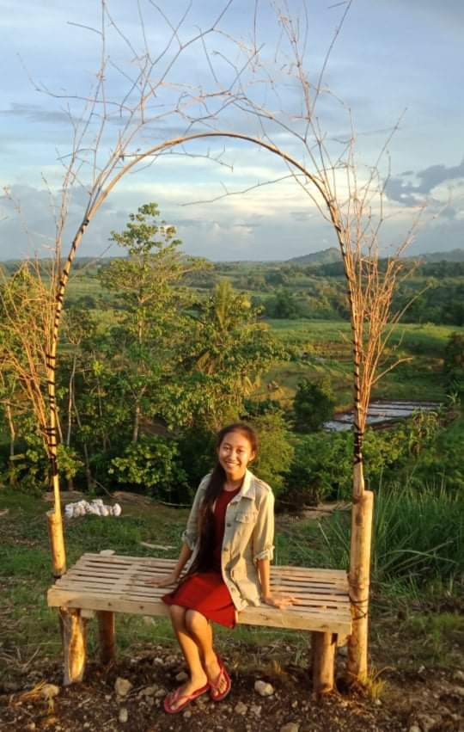Photo:

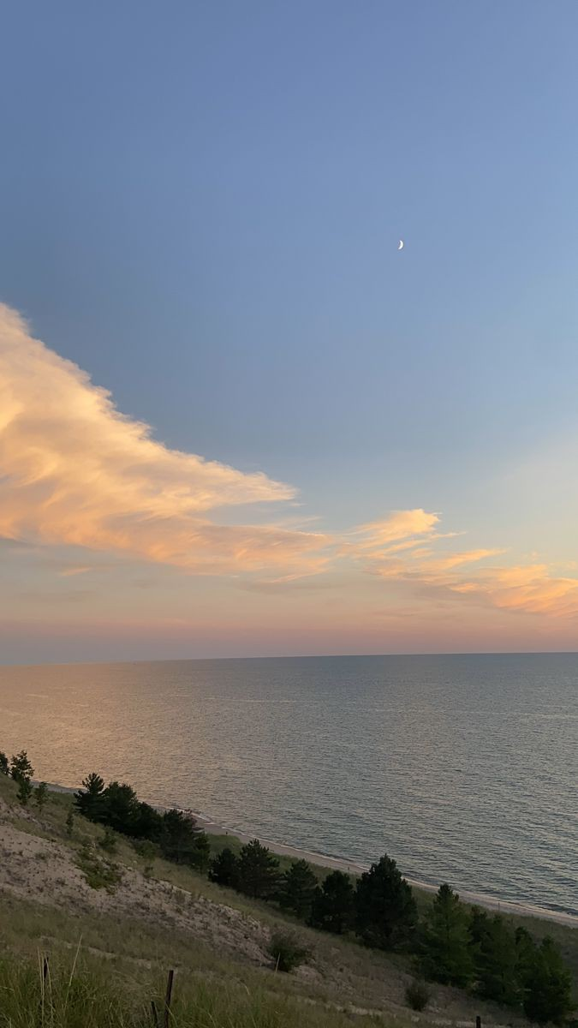BG:

Name: Hena Micah dela Cruz

Age: 16

Zodiac Sign: Virgo ♍️

Grade: 10

Section: Chrysoprasus

Hobby: Reading, Playing guitar/ukulele/piano, singing, writing

Favorite Color: Black

Contacts: 09619064456

Motto: “Procrastination is the key to productivity if tomorrow is the deadline”

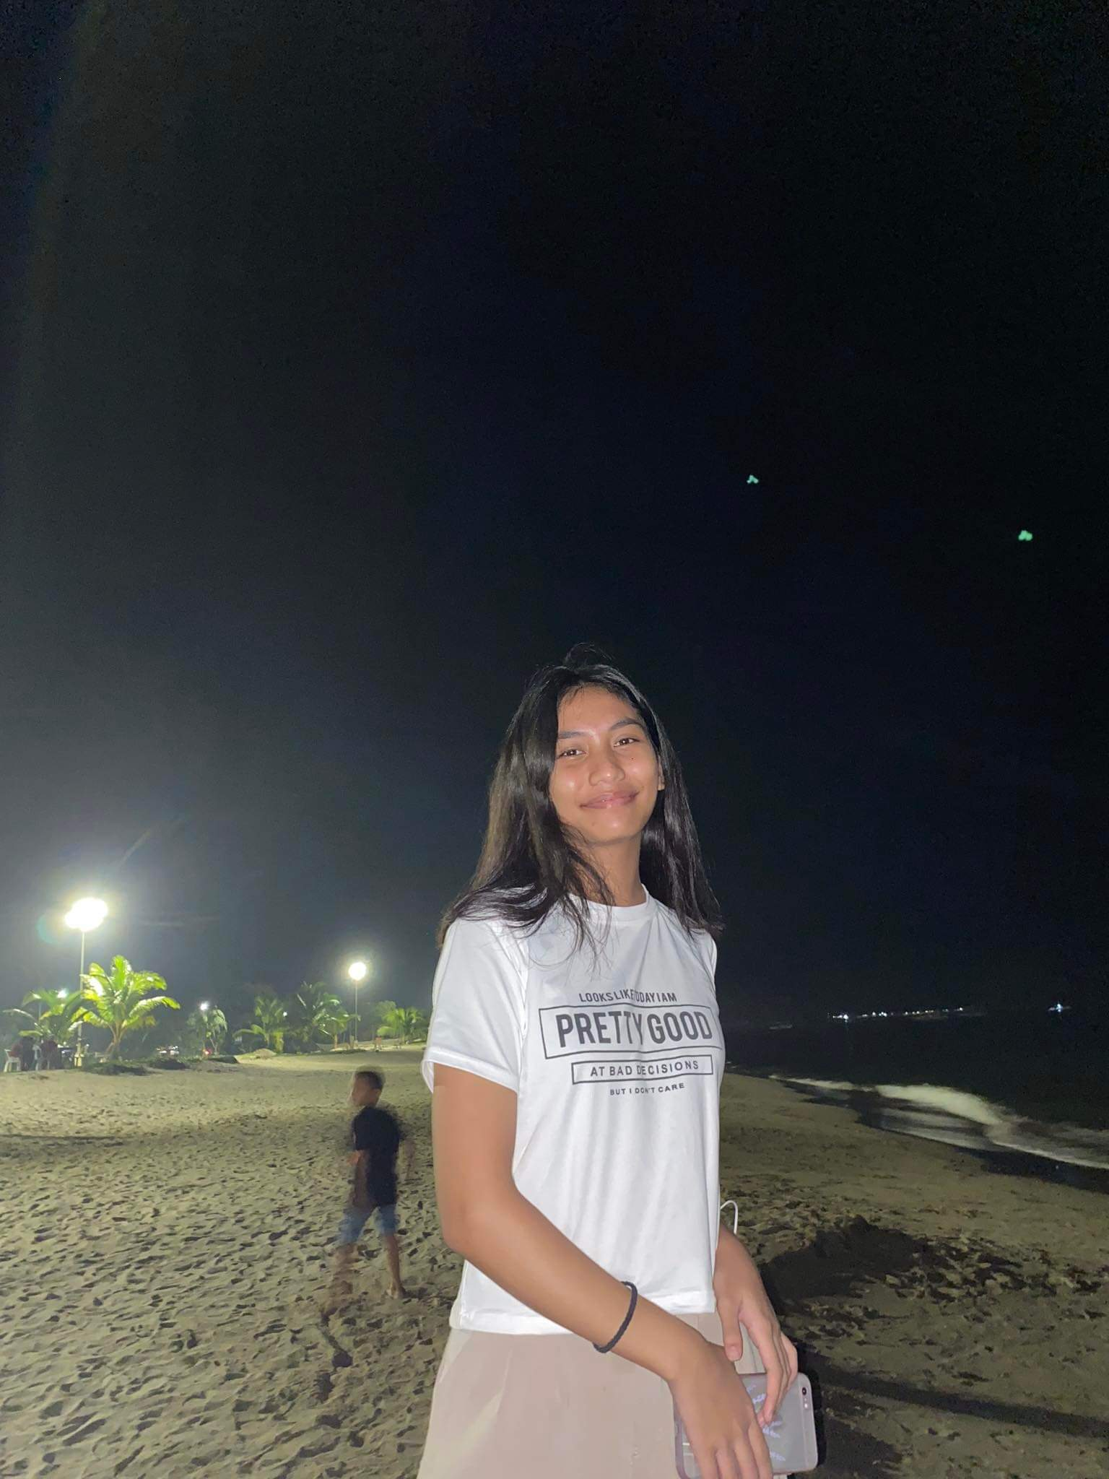Photo:

BG:

Name: Narciso D. Geroche lll

Age:15

Zodiac sign: Taurus ♉

Grade:10

Section: Chrysoprasus

Hobby: Playing basketball, sleeping

Favorite color: red

Contacts:09983118456

Motto: “Do the best you can until you know better. Then, when you know better, do better”

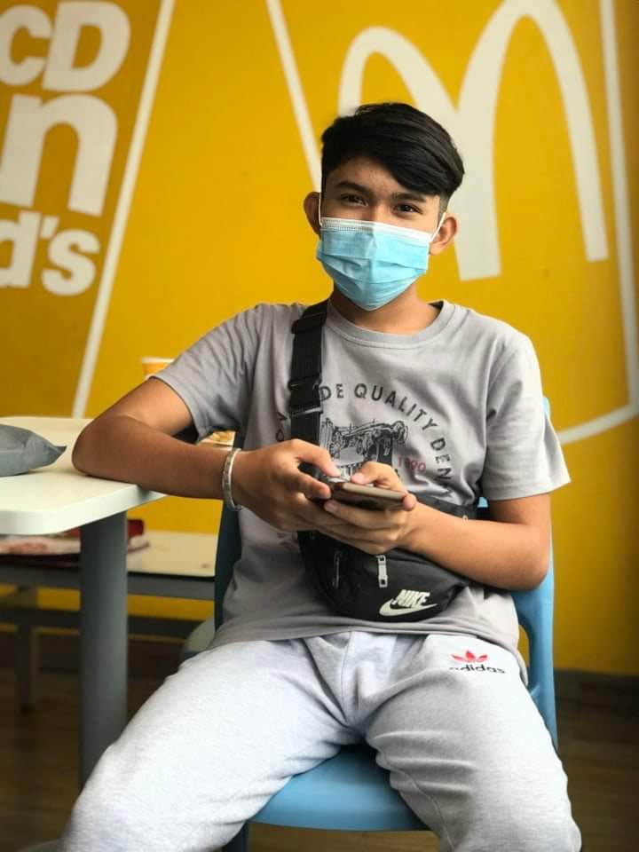Pic:

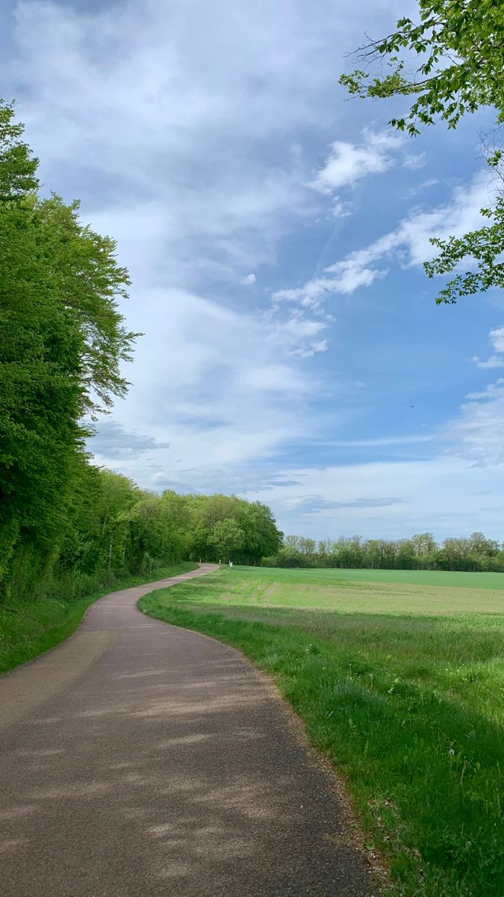BG:

Memories:

We love these memories that make us smile no matter what is going on in my life right now, even if it is a photograph. This is what we like about photographs, they’re proof that once even if just for a heartbeat, everything was perfect. A moment lasts for seconds but the memories lasts forever. They make us smile no matter what is going on in our present life. Despite the distance that separated us for a long time, through this activity, we were able to enjoy and relive our precious moments.

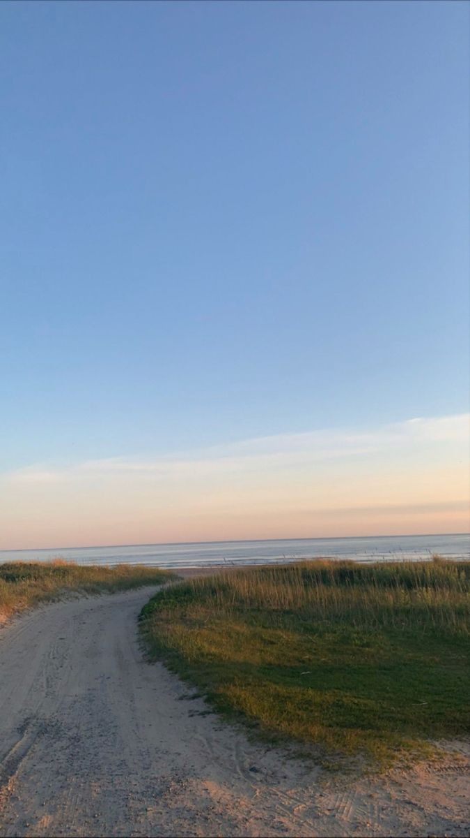BG: