Learning Notes
This project was meant to help me learn more about Rust and Azure Service Bus. I wanted to combine these 2 objectives. For Rust, I was interested in writing code with utilized other remote services. For Azure Service Bus, I was interested in learning more about the APIs and some of the options for interacting with Azure Service Bus.
In the past, I had looked at Azure Service Bus from C# and used higher level clients which hid some of the service interactions. These higher level SDK libraries involve setting up a processing function, and I was not always aware of how the library would handle exceptions and acknowledgments of processed messages.
I will point out some of the interesting things I noticed or learned so far:

Rust Azure SDK
https://mindflavor.github.io/AzureSDKForRust/
The Rust Azure SDK calls itself unofficial. I tried using it first but found that it was missing some features.
- AAD (Microsoft Entra ID) Application Authentication – I could not find support in the service bus client for application authentication. The function signatures seemed to support access keys. This seems like a good addition to the library. I would like to see if there are ways to add a more general way to plugin auth n/z for the library.
- Message Properties – Many of the APIs support a header BrokerProperties which give extra information and allow for extra options for processing messages. I did not see this available on the rust azure service bus SDK. This looks like it would be a helpful addition. https://learn.microsoft.com/en-us/rest/api/servicebus/send-message-to-queue
Because of those gaps, I decided to code my own client to learn the options better using the Reqwest library.

Coding Individual Operations Vs. High Level Processing Callback
When you look at articles and documentation for writing an Azure Service Bus listener, you may say examples which show setting a delegate or lambda function to process a message. This is very useful, but it does hide some of the details about how a message is processed.
https://learn.microsoft.com/en-us/azure/service-bus-messaging/service-bus-dotnet-get-started-with-queues?tabs=passwordless
Some of the key questions are:
- Is a message removed from the queue when it is received by the listener, or when it is confirmed as being processed?
- If there is a failure processing the message, will it be available in the queue again for retry?
- Are there locks which keep other listeners from processing the message?
By using the REST APIs directly, I was able to learn more about these interactions and see the capabilities offered by the service.
For example I wrote some code to consume messages using methods where each method called 1 individual service bus REST API. The first thing I noticed was that you have the option of a peek lock read, and a receive and delete read operation. The peek lock read which leave a lock on the message so that other listeners will not pick it up right away, while the receive and delete will dequeue the message. The different is that if you have an error processing with peek lock, is that the message is still in the queue and after some time or after an explicit unlock; it can be picked back up. While I knew these options where there before, I found it useful to see the code in action and explicitly use those APIs.
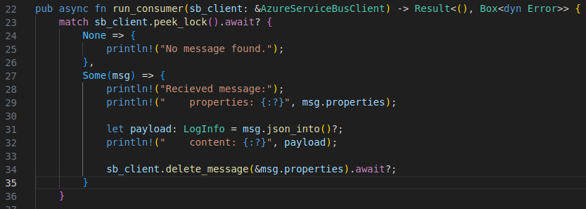
I also realized when coding the flow is that there are 3 actions I can take in responding to how a message is processed when using peek lock.
- You can delete the message indicating it was processed.
- You can unlock the message allowing it to be picked up right away.
- You can do nothing and allow the next listener to pick up the message when the lock expires.
This 3rd point wasn’t something I had thought about before. I did know you might use that option to handle the case when a processing system crashes, but you could also use this 3rd option as a way to defer re-processing for some period of time.

Azure Service Bus REST Read APIs Wait on Timeout
One of the questions I had about the REST API, was how it would deal with no messages. I was wondering if it would return immediately and I would end up with a busy/wait poll loop. I didn’t think that would be the case, but I didn’t find documentation saying what would happen. In practice, I noticed that the server seemed to wait about 5 seconds on the read message API, holding the connection open. If there was no new message after about 5 seconds, the API would return. It looked like some Azure documentation included an example passing a query parameter called timeout, which can change that, but I didn’t find official documentation on it. For most of the cases I have been considering Service Bus for this type of API interaction looks like it should work well. There are other options such as using an AMQP client, which seems to allow concurrent operations over a single open network connection.

Re-obtaining Message Locks
One of the questions I have had for some time, is how do I handle processing messages which take a long time to process. I might not want another listener to pick up the message when the initial lock times out. There is an API which allows you to reacquire a lock on the message.
https://learn.microsoft.com/en-us/rest/api/servicebus/renew-lock-for-a-message
You could write some library code which runs in the background and renews the lock if the message is still being processed. Conceptually this is easy, however one difficulty may be the case when you have code processing which will never return. Think of the case where the processing code had a dead lock. You might not ever return. If you had a background task renewing the lock while still waiting for processing, you could leave the message locked indefinitely. A case of the halting problem: https://en.wikipedia.org/wiki/Halting_problem

REST API vs. .Net Client
My initial assumption was that all options for the service would be exposed in the REST API. I was surprised to see that there are options in the .Net client which aren’t available in the REST API.
https://learn.microsoft.com/en-us/rest/api/servicebus/rest-dotnet-client-support
I am not sure what the reason for this is yet. I do wonder if the .Net client uses AMQP, takes advantage of non-public REST parameters, or if the options are part of a high level operations which combine API calls in interesting ways.

Calling REST APIs with Rust
I found making HTTP calls fairly easy with Rust using the reqwest library. One of the reasons I was interested in Rust was that it is a language I might be able to use where I would have typically wanted to use C++ over a managed language with a large runtime footprint. It has been a very long time since I programmed in C++ as part of my day job, but when I did, I found it difficult to pull in high level libraries. Perhaps it is easier today to find a good HTTPS client in C++. In Rust, it was very easy. Getting the client was as easy as cargo add reqwest. Note: on Linux I did have to install ssl-devel libraries too. Using the library was quite easy too, as the library had a fluent API style design.

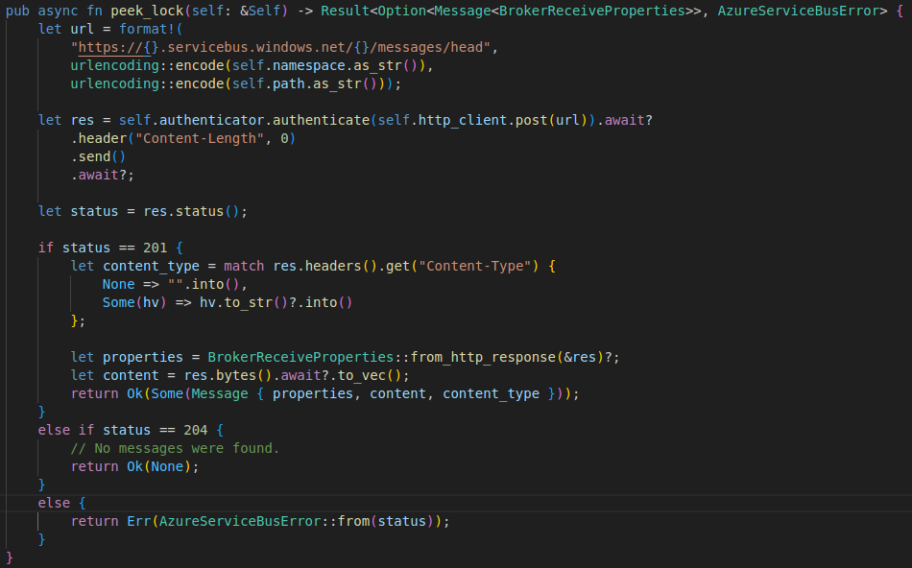

Pluggable Authentication With Rust – Traits and Async
One of the gaps of the the Rust sdk for Azure I looked at first was that it didn’t seem to support different methods of authentication. You might want to use a bearer token or an access key, for example.
My first thought was to create a trait which takes in an HTTP request builder. That way you could provide different implementations to the service bus client. One might communicate with AAD (Microsoft Entra ID) and supply a bearer token. The other might add access keys directly.
This is the trait definition I ended up with. Notice the async_trait attribute. This is a special macro which was needed and without it, I could not create traits with async functions/methods.
https://rust-lang.github.io/async-book/07_workarounds/05_async_in_traits.html
I was happy to see that there is a library create I could use to get around this issue. However, I still don’t fully understand what the issues with async methods in traits are. It will take me quite a bit more time to understand why and I feel like I need to understand this to really understand Rust.

Error Handling in Rust
If you have used Rust for a little bit you will know that Rust uses return types instead of exceptions. In Rust, if you have an error you will typically return a Result type. A Result type has 2 type parameters, the success type and error type.
One thing I like about the Result type is that for any function I use, the compiler knows what the error types are. In C#, you don’t really know what all the exception types are just from method signatures. In general, it didn’t bother me too much in C#, because while I did like using checked exceptions in Java, there were many cases where I found that checked exceptions in Java meant that you couldn’t easily write high-order functions where the checked exceptions could be parameterized. Rust seems to be able to represent errors in a more generic way, which allows you to have errors propagated through a high order function.
The other issues I had with checked exceptions in Java was that you were often forced to convert exceptions related to the interface into an exception related the public interface. For example, you might not want to expose a SQLException on your repository interface. The issue was that writing the code to handle that conversion was often tedious, had to be copied in lots of places, or you had to write some unnatural high order functions.
In Rust, you are able to write conversions between error types in a declarative way. You can do this by providing an implementation of the From trait for the error type you want to expose. I wrote the following conversions for my code.
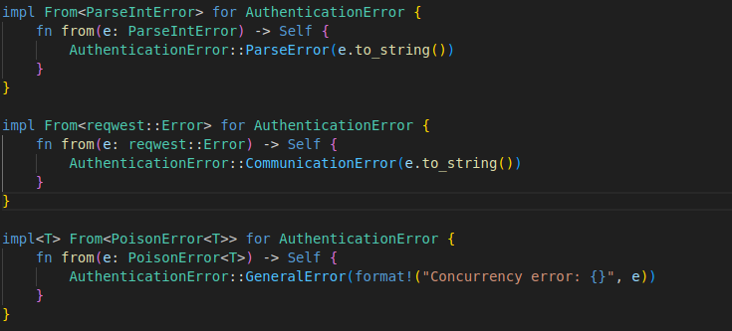
Then my implementation of a client could use the ? operator, to call conversions on error. I found this a convenient way to have compiler checked error types in function signatures, which can hide inner implementation error types, and have succinct code.

