**Agenda:** Create lambda function used for Lex bot validation and fulfilment

**We need to do following:**

Create a lambda function that can fulfil Lex responses

**Steps:**

1. Create a new lambda function with 2.7 python as Runtime language and Create new role

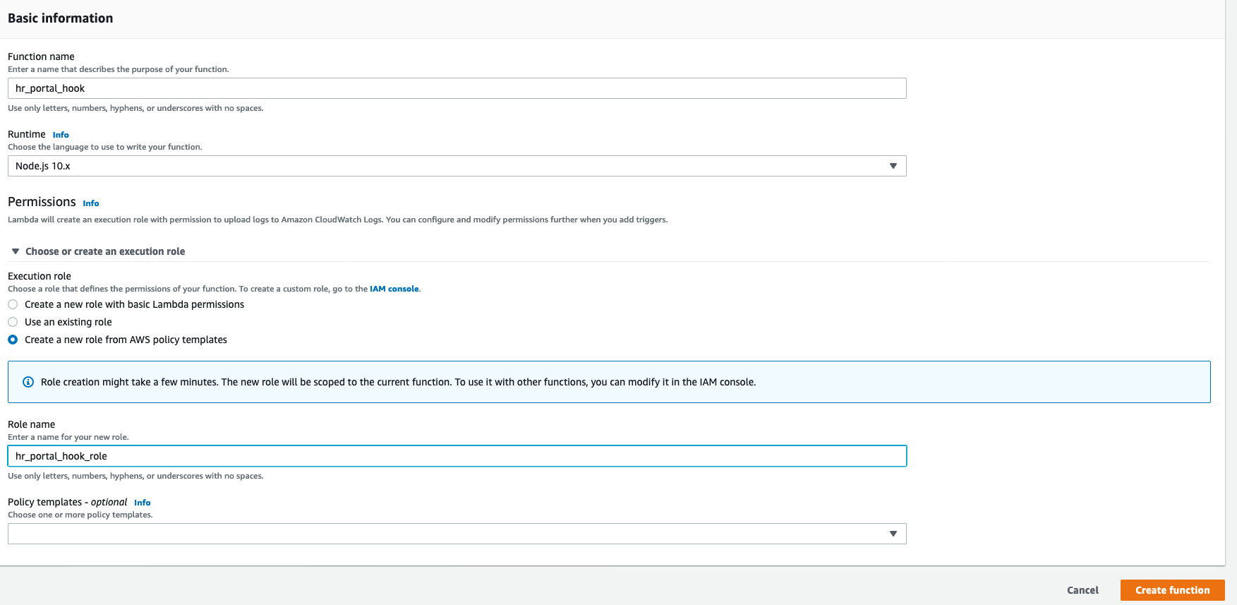

1. Create intent

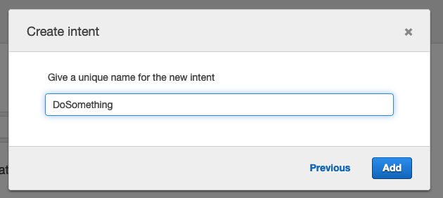

1. Create
2. Utterances
3. Slots
4. Fulfillment Lambda

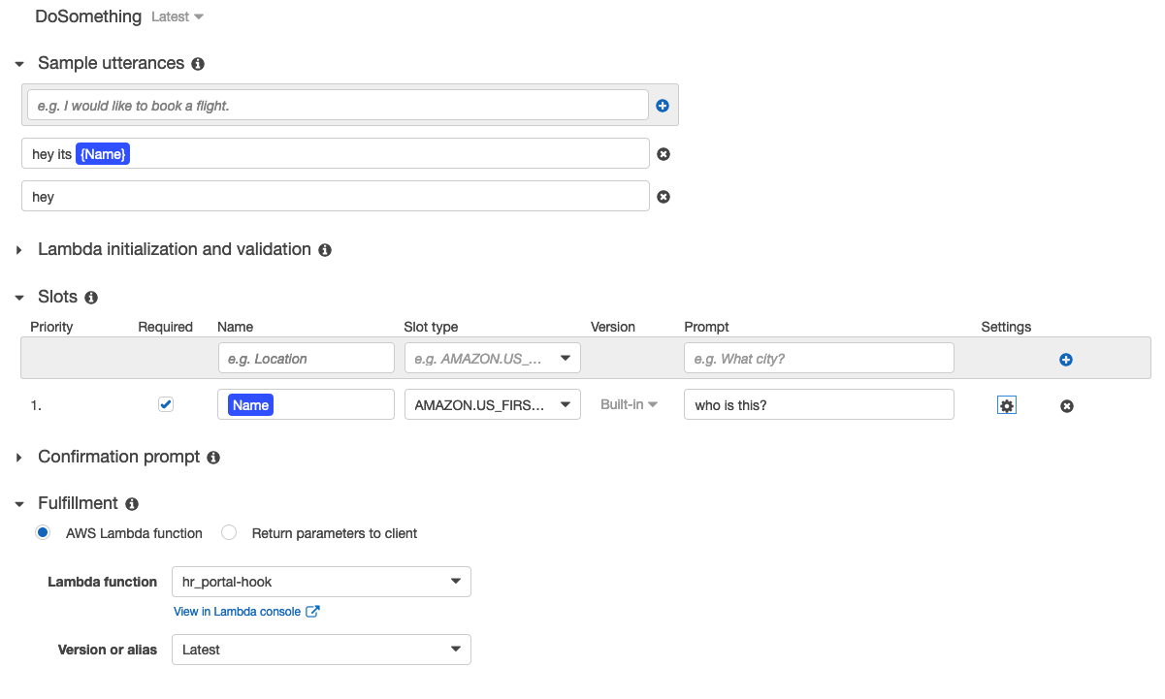

1. Edit Lambda code from lab1.py
2. Configure sample test event

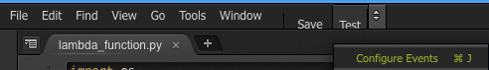

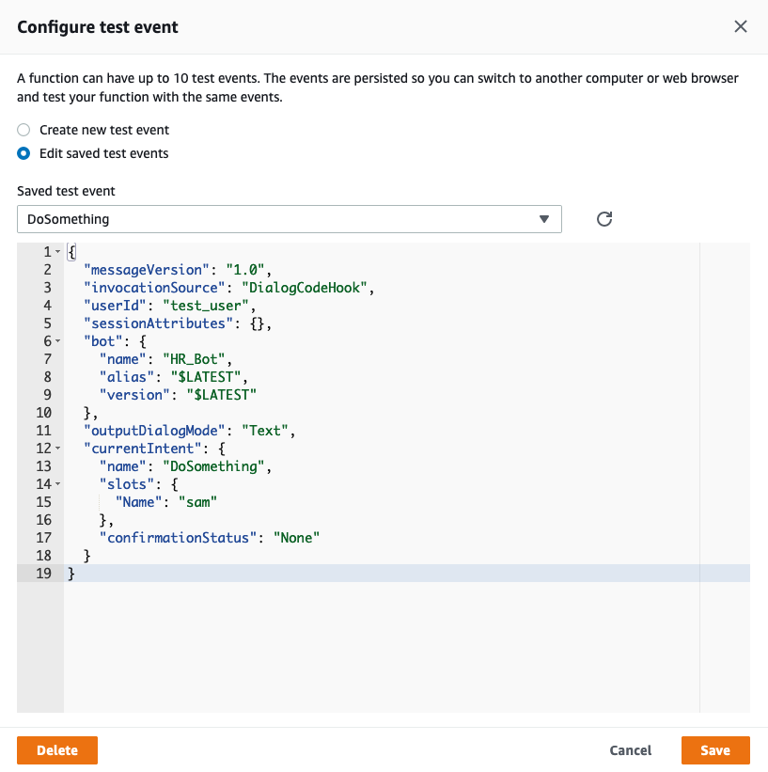

{

"messageVersion": "1.0",

"invocationSource": "DialogCodeHook",

"userId": "test_user",

"sessionAttributes": {},

"bot": {

"name": "HR_Bot",

"alias": "$LATEST",

"version": "$LATEST"

},

"outputDialogMode": "Text",

"currentIntent": {

"name": "DoSomething",

"slots": {

"Name": "Srinivas"

},

"confirmationStatus": "None"

}

}

Add more prompts and corresponding utterances to the slot, remember to BUILD again

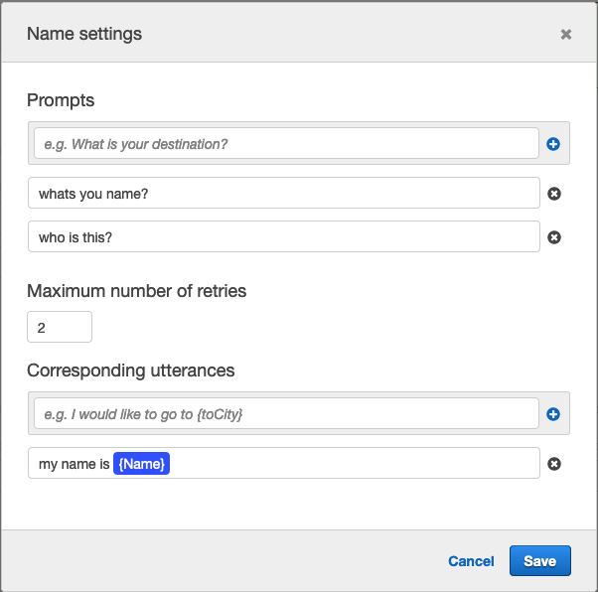

Test your bot and ask me questions☺

**Ref:** https://docs.aws.amazon.com/lex/latest/dg/lambda-input-response-format.html