Module2 - R Markdown Document 1

castler

2019/12/25

# This is a level 1 header

## R Markdown

### This is a level 3 header

This is an R Markdown document. Markdown is a simple formatting syntax for authoring HTML, PDF, and MS Word documents. For more details on using R Markdown see <http://rmarkdown.rstudio.com>.

Here is a link to [GOOGLE](https://google.com)

Here is a word in **bold** and another word in **bold**.

Here is a word in *italics* and another word in *italics*.

When we compile our document, we are using the rmarkdown package.

Here are some example R commands:

2+2  
mean(c(1,2,3,4,5))

This is a block quote. This paragraph has two lines.

Here is an example of nested blockquote:

This is a blockquote.

This text is nested.

hi

When you click the **Knit** button a document will be generated that includes both content as well as the output of any embedded R code chunks within the document. You can embed an R code chunk like this:

summary(cars)

## speed dist   
## Min. : 4.0 Min. : 2.00   
## 1st Qu.:12.0 1st Qu.: 26.00   
## Median :15.0 Median : 36.00   
## Mean :15.4 Mean : 42.98   
## 3rd Qu.:19.0 3rd Qu.: 56.00   
## Max. :25.0 Max. :120.00

## Including Plots

You can also embed plots, for example:



Note that the echo = FALSE parameter was added to the code chunk to prevent printing of the R code that generated the plot.

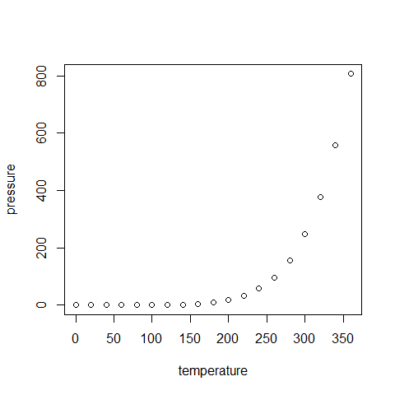

## Insert Tables

knitr::kable(head(cars))

|  |  |
| --- | --- |
| speed | dist |
| 4 | 2 |
| 4 | 10 |
| 7 | 4 |
| 7 | 22 |
| 8 | 16 |
| 9 | 10 |