AfricaAI: Runbook - CHEF – UBS
Summary | We are collecting data from the UBS fund's annual report
Source name | Pensionskasse der UBS - UBS
Link to the source | https://www.ubs.com/global/en/investor-relations/financial-information/annual-reporting.html
Dataset name | Switzerland (CHE) Funds - CHEF
Frequency | Annual
SLA | Exact dates of update of reports on the sources are not specified. The estimated period for updating annual reports is usually the beginning of April.  Start checking for new releases every week from next January. Since the beginning of March, the probability of updating reports increases, so checking for releases should be done daily.  Since the beginning of April, most of the releases are expected, so you need to check the updates on the resources very carefully every day.
Expected Time | NA

Do not contact the source. Escalate to Data Ops team with any issues in runbook execution that can't be completed with standard plays.
Instructions:
We are collecting data from the UBSfund's annual report
- Navigate to the source URL. Use google translate and open up the annual report
https://www.ubs.com/global/en/investor-relations/financial-information/annual-reporting.html
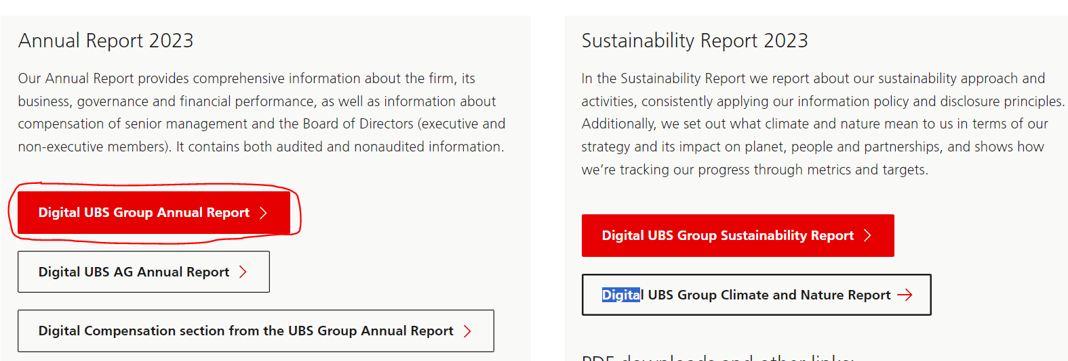
- Save full pdf report using button “Download full report (PDF)”
- We want to scrape one table from this report. Navigate to the "Post-employment benefit plans (continued)" table (scraping actual allocation). For each row item in this table, fix the Asset Allocation Plan % column.

Allocation % | Asset | Plan asset allocation %
Cash and cash equivalents | Cash | 2
Domestic | DomesticEquitySecurities | 0
Foreign | ForeignEquitySecurities | 4
Domestic, AAA to BBB– | NonInvestDomesticBonds | 0
Foreign, AAA to BBB– | NonInvestForeignBondsRated | 0
Domestic | DomesticRealEstate | 11
Foreign | ForeignRealEstate | 12
Domestic | DomesticEquities | 3
Foreign | ForeignEquities | 19
Domestic, AAA to BBB– | DomesticBonds | 15
Domestic, below BBB– | DomesticBondsJunk | 0
Foreign, AAA to BBB– | ForeignBondsRated | 25
Foreign, below BBB– | ForeignBondsJunk | 2
Domestic | DomesticRealEstateInvestments | 4
Foreign | ForeignRealEstateInvestments | 1
Other | Other | 10
Other Investments | OtherInvestments | 2
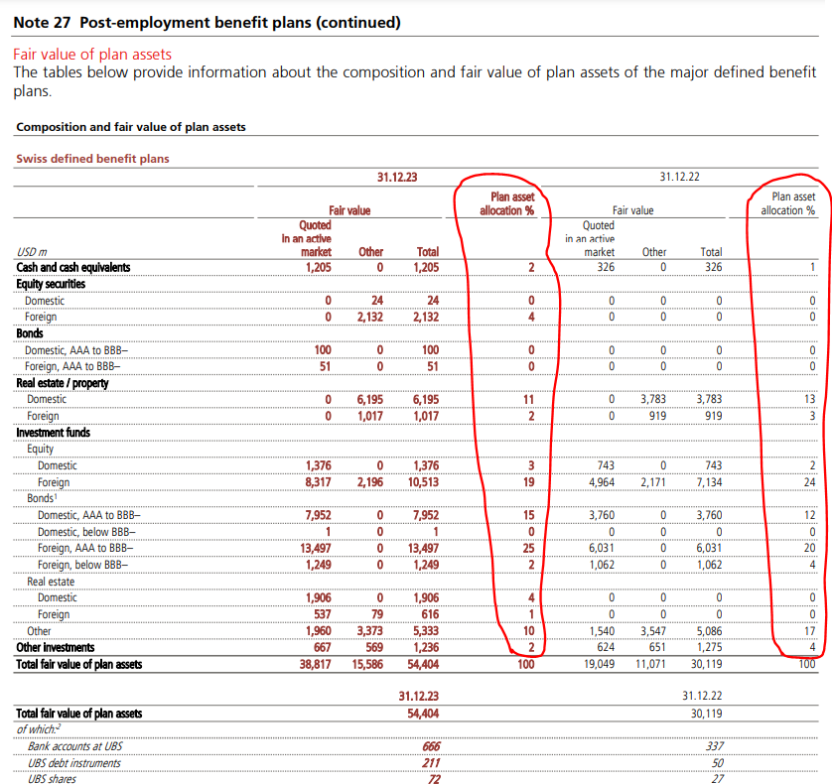
- From the same table, capture the total assets of the fund (Total fair value of plan assets):
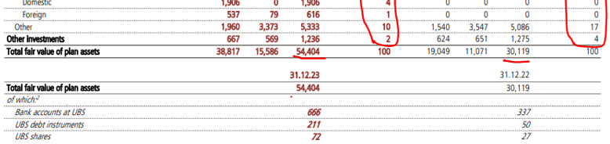

Collect data for both available reporting periods (for example above, it should be 2023 and 2022).
- Save data in CHEF_UBS_DATA_YYYYMMDD file.
Requirements to the data provided by AfricaAI
Data files format
For on-boarding new datasets and processing new releases the following requirements are applied:
- There should be one archive in .ZIP format that contains 2 files provided in .XLS format per one release - one file with DATA and one file with METADATA (both files are mandatory). Archive name should be as "DATASET_YYYYMMDD.ZIP"", where "DATASET" - specified abbreviation for a dataset, "YYYYMMDD" - timestamp when the file was created, where YYYY - year, MM - month number, DD – day;
- the files format is strictly defined and cannot be changed by AfricaAI team.

File with DATA
Template for file name: “DATASET_DATA_YYYYMMDD.xls”, i.e.” MEXPENFND_DATA_20220601.xls”
Requirements to the file with DATA:
- format - XLS, encoding - Unicode (UTF-8);
- file name: should follow pattern "DATASET_DATA_YYYYMMDD.xls", where "DATASET" - specified abbreviation for a dataset, "YYYYMMDD" - timestamp when the file was created, where YYYY - year, MM - month number, DD - day;
- file content:
  - for data with daily/ weekdaily frequency: YYYY-MM-DD, where YYYY - year, MM - month, DD – day;
  - for data with weekly frequency: YYYY-WW, where YYYY - year, WW - week number (should be two-digits, i.e. 2022-01, 2022-02, etc.). Week number is defined based on the reporting date: reporting date is considered the end of the week, i.e. if reporting date is Wednesday the week is calculated from Thursday till Wednesday – based on that rule the number of the week is defined;
  - for data with monthly frequency: YYYY-MM, MM - month number (should be two-digits, i.e. 2022-01, 2022-02, etc.);
  - for data with quarterly frequency: YYYY-QX, where YYYY - year, X - quarter number;
  - for data with annual frequency: YYYY, where YYYY – year;
  - if provider specifies for reported period that data is Not Available (that could provided in corresponding notes or other way) - fill in that data point with "NA" value;
  - if provider does not specify that data is Not Available and report Empty value for reported period - leave Empty cell;
  - if provider skips some of reporting period - skip it also in the file with data as well;
  - data is provided on one sheet only (multiple sheets are forbidden);
  - two-dimensional format where rows represent reported periods and columns contain timeseries values;
  - reported period(s) should be provided in the following format:
  - values to be provided in decimal format with "." as delimiter (number of digits after "." is limited only by provided value by the source). In order to interpret data correctly the following requirements are applied:
  - column names to be provided in two first rows: in the first row - timeseries ID (CODE), in the second row – timeseries description (description in DATA file is identical to description in file with METADATA).
NB! Timeseries with different frequencies could be provided within the same file as there are different patterns for providing reported periods

File with METADATA
Template for file name: “DATASET_META_YYYYMMDD.xls”, i.e.” MEXPENFND_META_20220601.xls”
Requirements to the file with METADATA:
- format - XLS, encoding - Unicode (UTF-8);
- file name: should follow pattern "DATASET_META_YYYYMMDD.xls", where "DATASET" - specified abbreviation for a dataset, "YYYYMMDD" - timestamp when the file was created, where YYYY - year, MM - month number, DD - day;
- file content: specified metadata attributes that are static unless provider changes something or new timeseries should be added. In case of new timeseries should be added/ updated/ changed - escalate that to Data Engineering team Special BWAT-DFAC Data Engineering <SpecialBWAT-DFACDataEngineering@epam.com> at and Cc: Data Operations team at Special BWAT-DFAC DataOps <SpecialBWAT-DFACDataOps@epam.com>

Notes on METADATA fields from file “DATASET_META_YYYYMMDD.xls”
- With every data release attach file with METADATA
- With every release change only on attribute in the file with METADATA in column “NEXT_RELEASE_DATE” – set “YYYY-MM_DDThh:mm:ss” (YYYY – year, MM – month, DD – day, hh – hour, mm – minutes, ss – seconds. Time should be provide in UTC time) to the time when the next release is going to be processed.

Saving ZIP archive on SFTP
Save the releases in specified per “DATASET” folder (you may create new folder for new DATASET in case of absence of such folder).
Details on SFTP are the following:
1) Dev env
Host: africaai.datadev.dfac.io
2) PRODVAL env
Host: africaai.prodval.data-factory.io
3) PRODHA env
Host: africaai.prodha.data-factory.io
Port: 22

