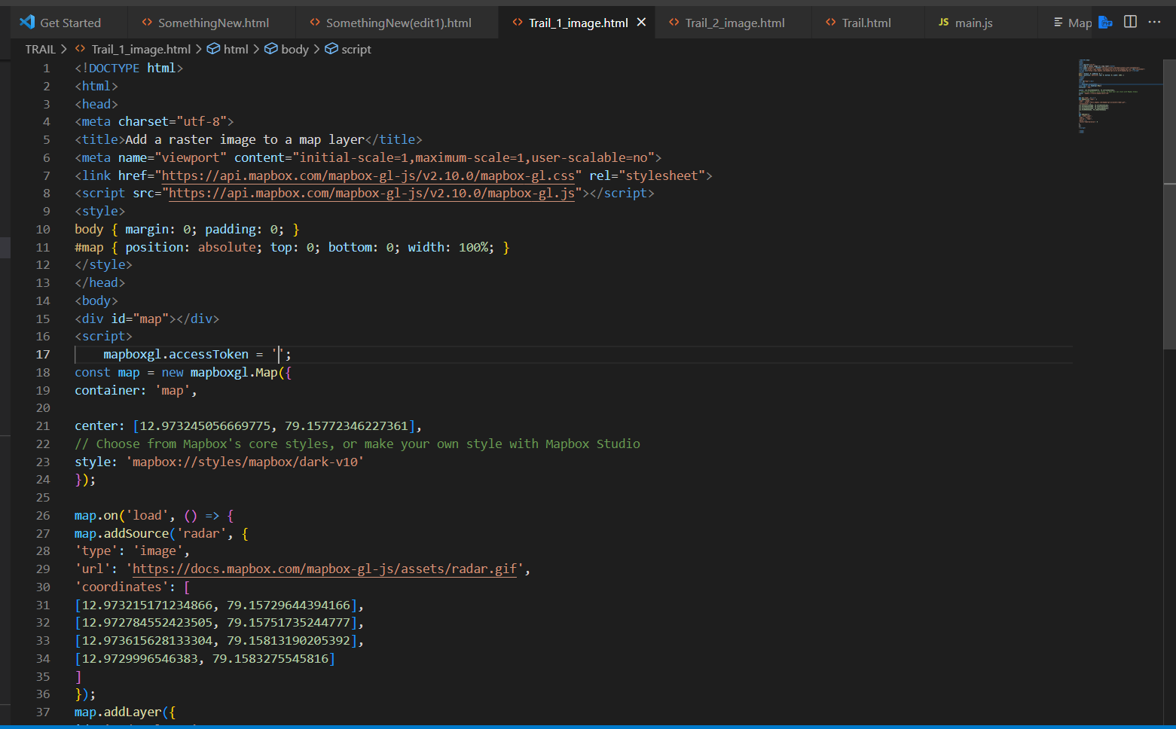

Insert a token for reduce workloads

File:MapToken