**Readme**

1. **Running the app**

springbootrestdemo> mvn clean install -U

springbootrestdemo> mvn spring-boot:run

1. **Full Search:** http://localhost:8080/locations/

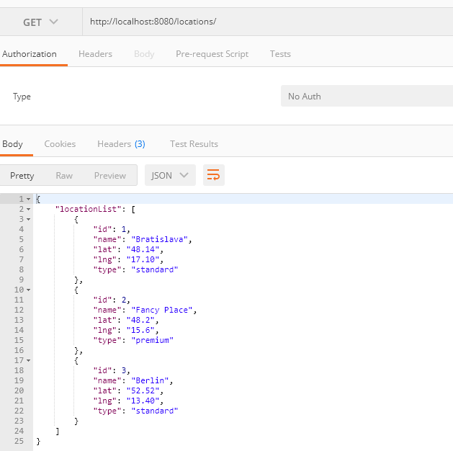

1. **Adding a Location:** http://localhost:8080/locations/

{

"name": "Vienna",

"lat": "48.21",

"lng": "16.36",

"type": "premium"

}

Result with the Id

{

"id": 4,

"name": "Vienna",

"lat": "48.21",

"lng": "16.36",

"type": "premium"

}

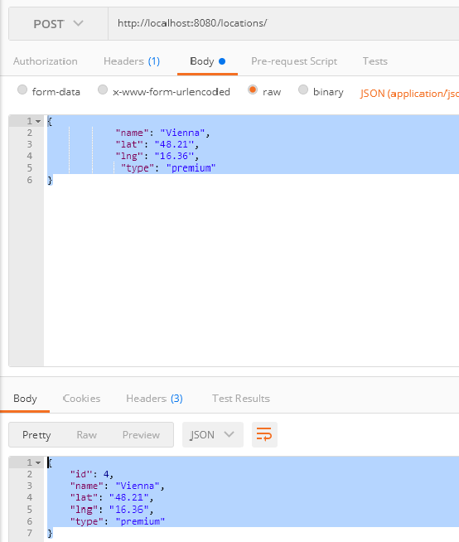

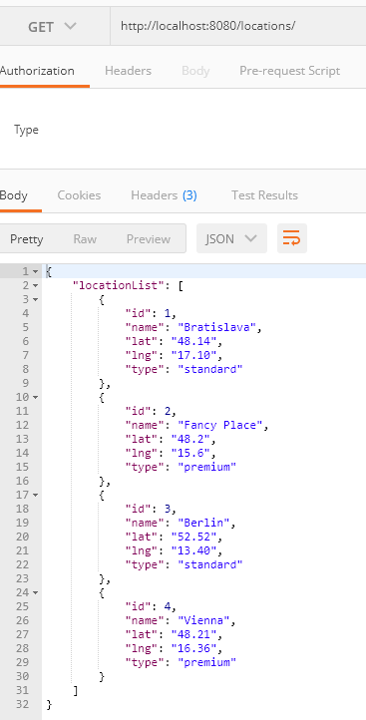

1. **Searching by Type**: http://localhost:8080/locations/search

{

"type": "premium"

}

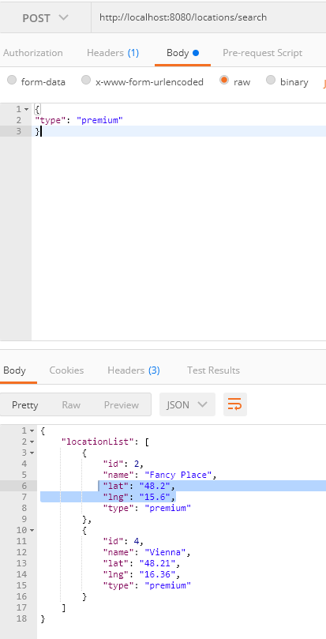

{

"type": "standard"

}

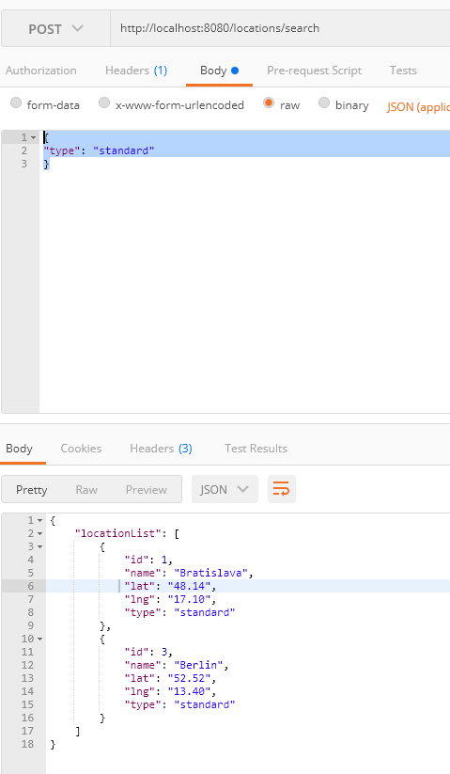

1. **Searching by Point:** http://localhost:8080/locations/search

{

"p1": "46.6, 15.4",

"p2":"48.5, 18"

}

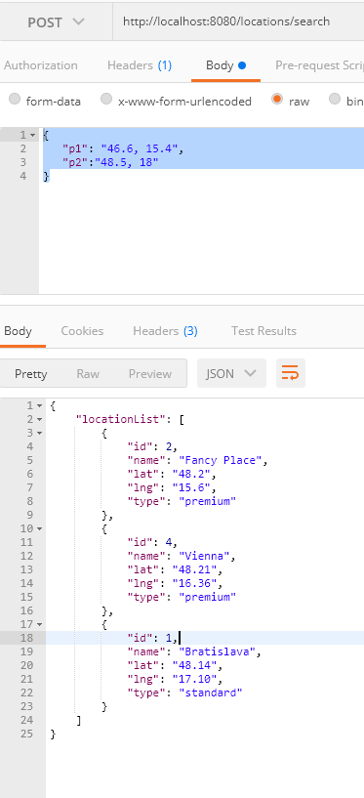

1. **Searching by all criterias:** http://localhost:8080/locations/search

{ "p1": "46.6, 15.4",

"p2": "49.8, 18.5",

"type": "premium",

"limit": "2"

}

