Review Guide: Designing Across Platforms
Let’s review some of the key ideas introduced in this unit. You can also download all this content by clicking on the attached file for future reference.

Key Definitions
- Device Agnostic: This suggests designing for communication to the user, not for any specific device.
- UX Design: A process to make each step in your page navigation as simple and clear as possible for users.
- Wireframe: Outline or sketch of the content areas of a page with an eye to focal point and hierarchy.
- Prototype: An early site model, either digital or analog, that can serve as the basis for research and design iterations.
- User Flow: Illustrates the primary and alternate paths you intend your user to take through the site, based upon user goals.
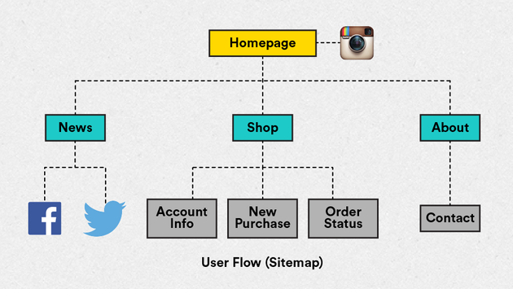
- Media Query: A technique used in CSS to detect the display size and subsequently activate different page styles.
- Hamburger Icon: A commonly used page element, consisting of three lines bounded by a rectangular block. Typically used as a link to the page menu or a vertical list. Here are two enlarged images showing what this symbol normally looks like:


Mobile First
The practice of mobile first design suggests first designing for a smaller screen size (i.e. smartphones) and then expanding the design to larger screen browsers.
The term "mobile first" was coined by Luke Wroblewski. Check out a presentation on the topic*here.*

Design Considerations for Mobile
Physical characteristics:
Different devices have different physical characteristics, i.e., screen size, screen resolution, and different guidelines for best practices.
Consider: Designing to suit the devices most frequently used by your audience.
User ergonomics:
Devices (tablet and phone) are held by hand and navigated by hand. Usage may be single, or in some cases double-handed, with finger(s) as the primary input device.
Consider: The context in which your site might be viewed (e.g., a crowded train vs a quiet bedroom). Is your mobile site easy to navigate / use?
User navigation via touch:
On mobile, the finger acts as a mouse hitting buttons and links. Often, users will “drive with one thumb and one eye.”
Consider: Designing controls that are within reach and with enough contrast to surrounding elements.
Gestures:
Familiarity with standard gestures is key to designing interactions already familiar to users (ease of use) and creating engaging experiences.
Consider: Gestures may or may not be of concern for basic websites. While gestures are dominant in app design, basic sites may just require tap to click. Still, an awareness of common gestures helps designers understand their users' mindsets.

Mobile Websites vs. Responsive Websites
Mobile websites:
Sites that are specifically coded for mobile devices. Generally speaking, such sites are made in addition to a standard desktop site and are often used on sites where the mobile experience needs to be incredibly different from the standard desktop experience.
Responsive websites:
Sites that “respond” to changes in the size of the browser on which they’re being viewed. This allows creators to only build and maintain one site and provide a fully cohesive experience to their users.

Questions to Ask Your Mentor
- Is Mobile First an approach I should always use?
- What are the differences between mobile design and app design that I should be aware of?
- Where can I find guidelines for designing to mobile interface standards?
- What are the steps I should take in order to plan a mobile site?
- How can I possibly design for every mobile device?
- Where can I find guidelines for designing to mobile interface standards?
- What is UX design and where does it fit in the process?

Further Reading
Presentation on Mobile First
http://www.lukew.com/resources/mobilefirst.asp
Apple Human Interface Guidelines
https://developer.apple.com/library/iOS/documentation/userexperience/conceptual/mobilehig/
Planning and Production Tools
http://shop.oreilly.com/product/0636920001133.do
http://www.adobe.com/products/illustrator.html
http://www.adobe.com/products/indesign.html
http://www.axure.com
http://bohemiancoding.com/sketch/
http://balsamiq.com
Adobe Digital Publishing Report
http://www.canerel.com.tr/v2/images/publication/201301AdobeDPSshoppingSURVEY.pdf
← →

Downloads
Summary

