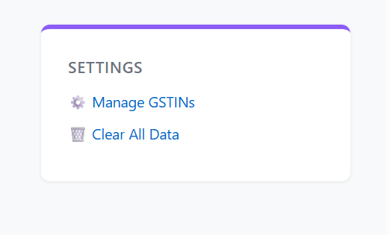
Make this as one module in line with home and reports. But place it in right side of the same line.

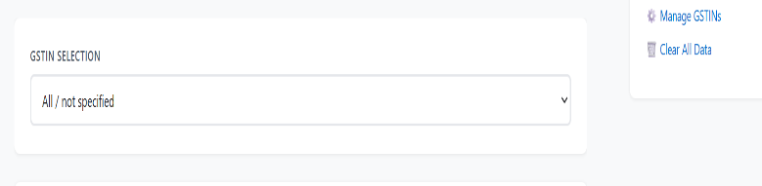
Then use the space efficiently to show GSTIN and Name of the entity.

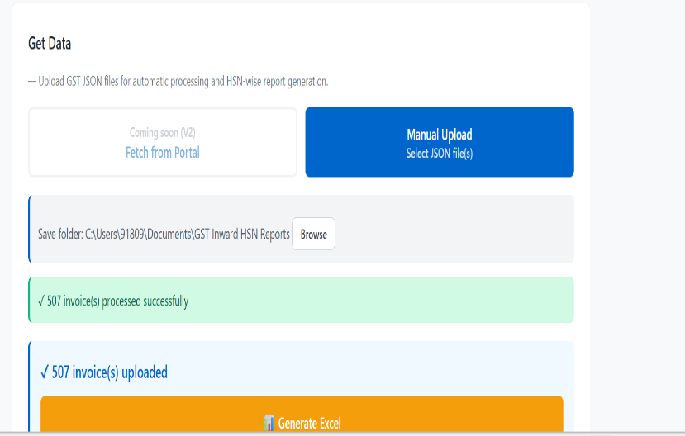
then the right space is to be used. Now move the folder picker tp save files on right side.
Below that move generate excel button also.
And then live status move up. Keeping everything on page without scrolling down.

