ECE 661 Fall 2026: Homework 1
En-Yu Fan
fan474@purdue.edu
AI Assistant Usage
AI Usage: 45%

Task 1 (a)
Coordinate-reading Tool Used – GIMP
Recorded Coordinates (all up->down, left->right)
 | Start | End
Tile rows | (297, 115) | (1281, 509)
Tile rows | (270, 358) | (1496, 811)
Tile rows | (99, 514) | (1304, 927)
Tile columns | (549, 215) | (47, 942)
Tile columns | (711, 233) | (621, 1107)
Tile columns | (901, 298) | (1268, 1132)
Tile diagonals | (364, 161) | (1387, 884)
Tile diagonals | (173, 274) | (1071, 1070)
Tile diagonals | (60, 342) | (881, 1182)
Point Overlay Check & Code Snippet
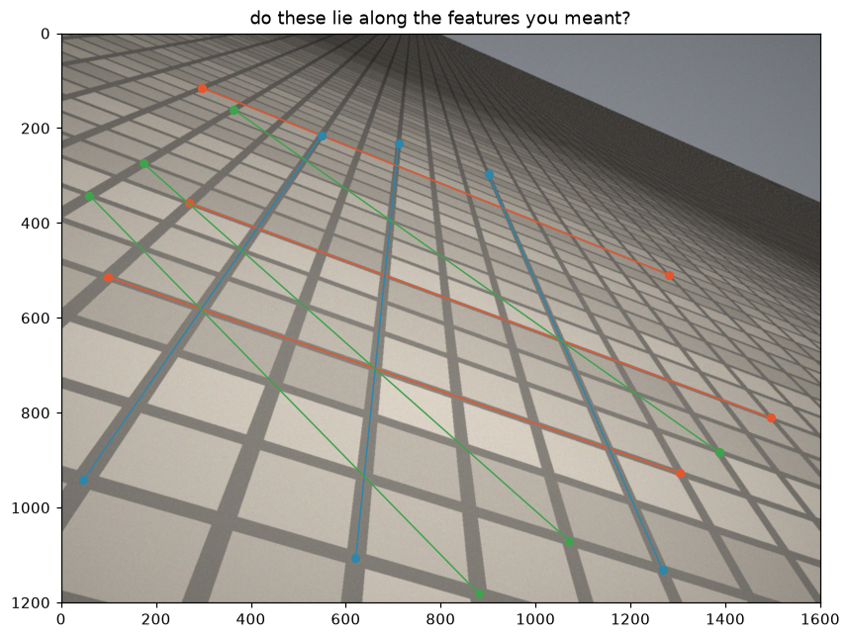
The recorded points align with intended tile-row, tile-column, and tile-diagonal features
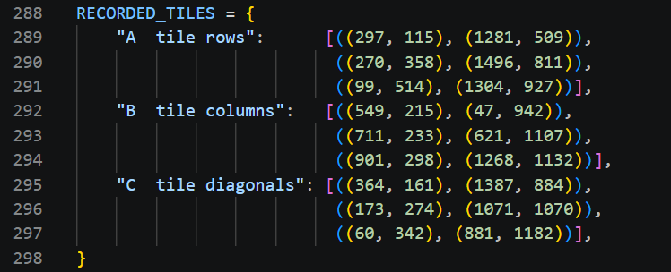
Task 1(a) Code Snippet

Task 1 (b)
Prediction Before Computation
Before computation, I predicted that Family A (tile rows) would give the least reliable vanishing point. Since their projected lines appear closest to parallel in the image, their intersections should be far from the image. As a result, small errors in the recorded points can cause large changes in the estimated vanishing point.
Method
Following the procedure in the homework instruction, I made vanishing_point_estimates() to process one family at a time. It uses join() to construct three lines, then loops through the 3 line pairs. For each pair, meet() computes the intersection and dehom() converts it to Cartesian coordinates. Eventually, three estimates and their arithmetic mean are returned.
In task_1(), I looped through the three families, using bounding_box_diagonal() to calculate each spread, and use np.linalg.norm() to calculate the distance from each mean VP to center point (800, 600). Finally, I compare the spreads and check whether my prediction held.
Vanishing-Point Results (in pixels)
Family | Estimate line 1&2 | Estimate line 1&3 | Estimate line 2&3 | Spread | Mean VP | Distance from (800,600)
A | (8480.70, 3391.81) | (8392.70, 3356.57) | (8291.03, 3321.73) | 202.20 | (8388.14, 3356.70) | 8073.37
B | (741.57, −63.88) | (741.68, −64.04) | (741.61, −64.22) | 0.35 | (741.62, −64.05) | 666.61
C | (−1207.25, −949.47) | (−1191.12, −938.07) | (−1169.92, −916.38) | 49.88 | (−1189.43, −934.64) | 2512.56
Prediction Check
Family A (tile rows) did have the largest spread at 202.20 pixels and farthest mean vanishing point from the image center. This is consistent with the observation that its nearly parallel lines make the intersection more sensitive to small point-selection errors.
Output & Code
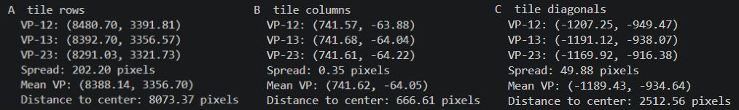
Task 1(b) output
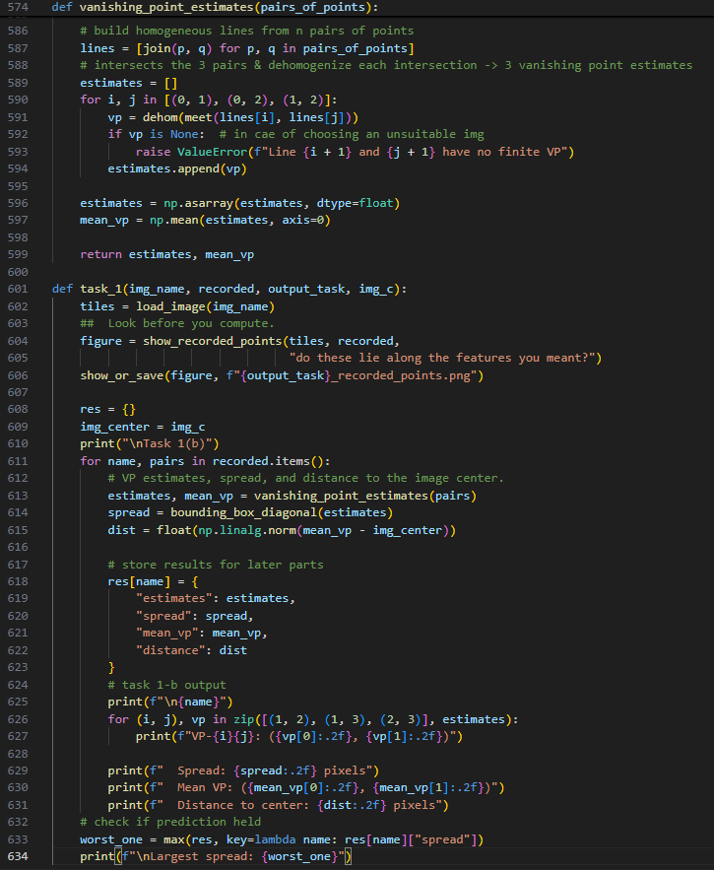
Task 1(b) Code Snippet

Task 1(c)
Method
Following the TODO hint, I ordered the families by increasing spread and retrieved their mean vanishing points from the result obtained by 1(b) and used join() to construct the line through the two best-determined points. Finally, I calculated the perpendicular distance from the worst-determined mean VP to this line.
Order by spread (smallest -> largest)
Order | Family | Spread(pixels)
1 | B: Tile columns | 0.35
2 | C: Tile diagonals | 49.88
3 | A: Tile rows | 202.20
Discussion
The spread order from smallest to largest was B -> C -> A. Since A was the worst-determined family, I constructed the line through the mean VPs of B and C. The perpendicular distance from A’s mean VP to this line was 24.25 pixels. This distance measures A’s deviation from collinearity in image pixels.
Although a zero determinant can test exact collinearity, its magnitude is not meaningful since multiplying a homogeneous VP by 10^6 leaves the point unchanged while multiplying the determinant by 10^6. However, the perpendicular distance has interpretable pixel units and remains unchanged when the homogeneous line coefficients are rescaled.
The 24.25-pixel residual is small relative to the observed VP variation and therefore supports the claim that the three VPs share a vanishing line. However, a large residual that remained after careful re-recording would have falsified the claim.
Output & Code
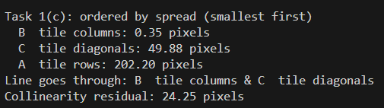
Task 1(c) output
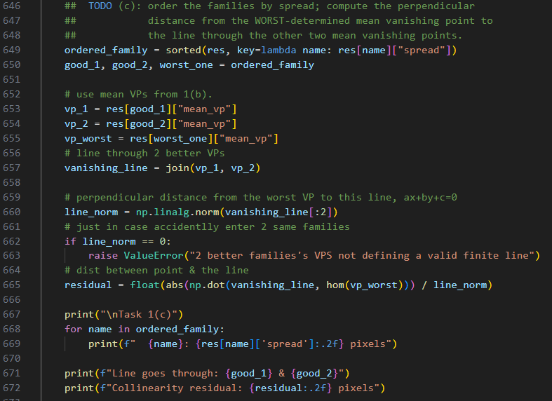
Task 1(c) Code Snippet

Task 1(d)
Method
Following the TODO hint, I retrieved the mean VPs of two best-determined families (B and C) from the results of 1(b), and the vanishing line from 1(c). The normalized line coefficients are “a: 0.4110”, “b: -0.9116”, “c: -363.1961”.
In two_panel_figure() for plotting the original image, I used np.linalg.norm() to sort 3 VPs by their distances from the image center. The near-view axis limits are modified to include the image and the two nearer VPs with an additional margin, while the wide view included all three VPs. In addition, I use axis.axline() to extend each of the nine recorded lines across the entire panel, along with some space arrangement to avoid covering VP A. Finally, I plotted the original image, recorded points, nine extended lines, three mean VPs, and the vanishing line using the two-panel format.
Figure
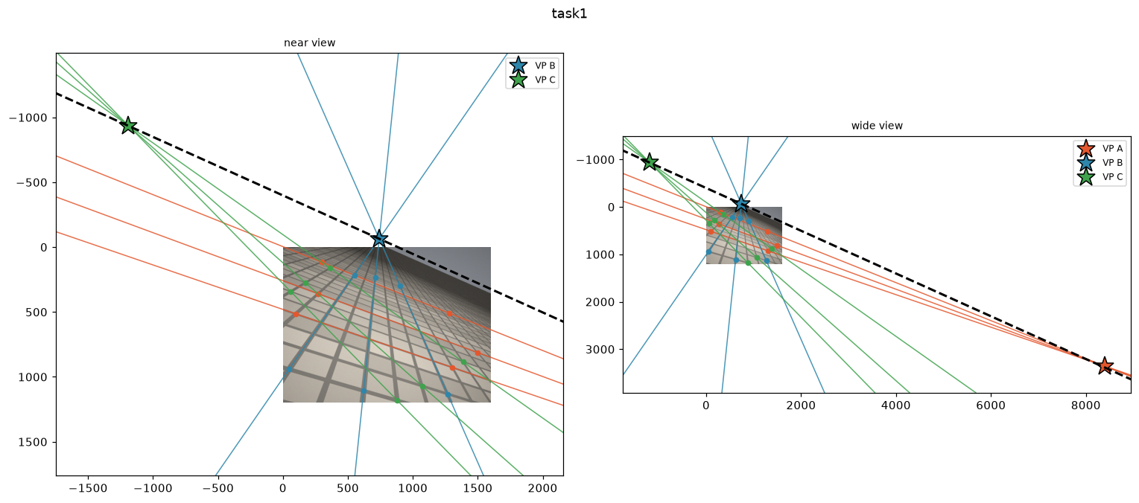
Near and wide views of the recorded points, nine extended lines, mean VPs, and vanishing line. The black dashed line is the vanishing line through mean VPs of B and C.
Discussion
A Cartesian implementation must special-case two distinct image lines that are exactly parallel. Their intersection is an ideal point at infinity, so it cannot be represented by finite Cartesian coordinates. A vanishing point that is only far away is still finite and does not require this special treatment.
The cross-product handles with no special case because it represents the intersection of parallel lines as a homogeneous point with a third coordinate of zero.
As a result, test is still needed in dehom() before dividing by that coordinate. This shows that the difficulty lies in converting an ideal point to Cartesian coordinates, rather than in computing the intersection with the cross product.
Output & Code
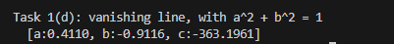
Task 1(d) Output
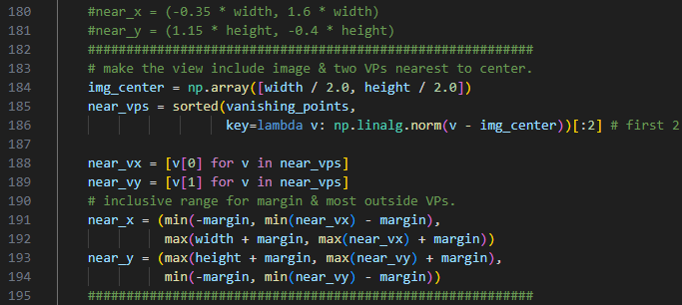
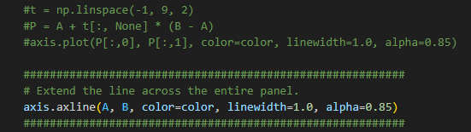
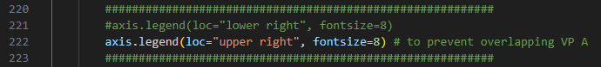
two_panel_figure() modification
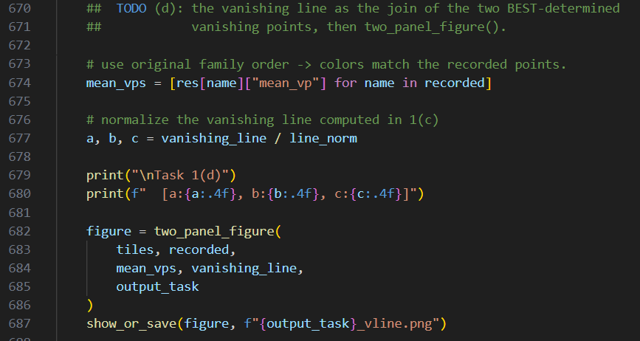
Task 1(d) Code Snippet

Task 1(e)
My photograph & Code & recorded coordinate table
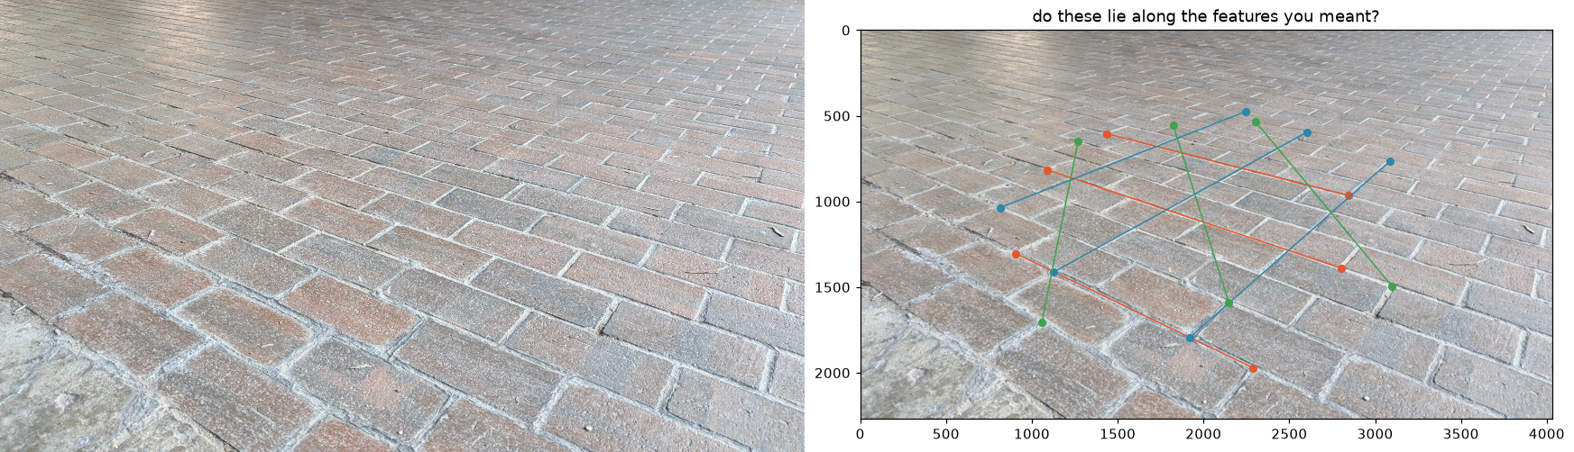
I basically do the same thing to this photograph, including the code. But due to its original size(4032x2268), I modified the image center to (2016, 1134) temporarily
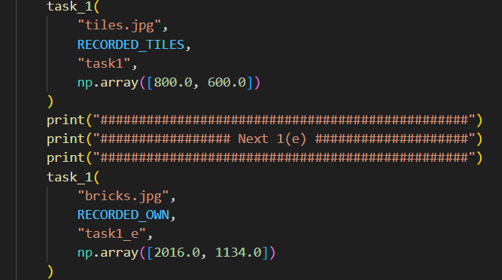
I modify the structure of task1(), passing the recorded points sets & corresponding image center to enable faster printing without uncommenting something.
 | Start | End
Tile rows | (1436, 605) | (2847, 966)
Tile rows | (1091, 816) | (2801, 1389)
Tile rows | (908, 1305) | (2290, 1972)
Tile columns | (2243, 476) | (815, 1036)
Tile columns | (2603, 595) | (1126, 1413)
Tile columns | (3088, 763) | (1921, 1793)
Tile diagonals | (2305, 536) | (3098, 1495)
Tile diagonals | (1823, 554) | (2147, 1590)
Tile diagonals | (1269, 651) | (1058, 1703)

Prediction and vanishing-point estimates
Before computing the vanishing points, I expected the brick-column family to be the least reliable, which is always because they seem to be most parallel among the 3 families.
The results are below, the largest spread is obtained by B and consistent with my prediction.
Family | Estimate line 1&2 | Estimate line 1&3 | Estimate line 2&3 | Spread | Mean VP | Distance from (2016,1134)
A | (−2685.68, −449.52) | (−2774.25, −472.18) | (-2821.82, -495.14) | 143.58 | (-2760.59, -472.28) | 5039.44
B | (4212.32, -296.28) | (4348.83, -349.82) | (4415.96, -409.06) | 232.78 | (4325.70,  -351.72) | 2746.29
C | (1520.77, -412.40) | (1489.80, -449.85) | (1497.32, -487.36) | 81.11 | (1502.63,  -449.87) | 1664.99

Spread and collinearity residual
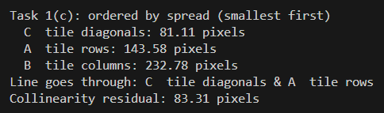
The families in increasing order of spread are C -> A -> B, so I use the mean VPs of C and A to define the vanishing line. The perpendicular distance from the mean VP of B to this line is 83.31 pixels.

Vanishing-line result
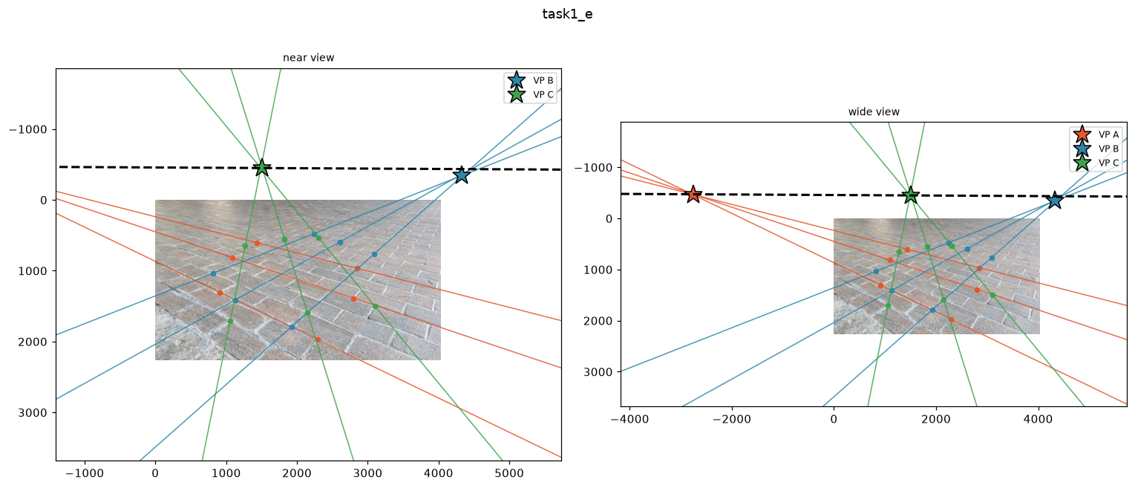
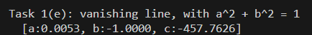
The normalized vanishing-line coefficients are around (0.0053, −1.0000, −457.7626). All 3 VPs are outside the 4032 × 2268 image frame. Two panels are still required for showing all three vanishing points.
Discussion
The collinearity residual for my photograph is 83.31 pixels, which is much larger than that of tiles.jpg (24.25 pixels). One possible lens-related cause is radial lens distortion from my phone camera. It can make straight brick edges appear slightly curved, especially near the image boundaries. Lines recorded from different parts of the photograph may therefore fail to meet at exactly consistent vanishing points.
To distinguish lens distortion from recording error, I would check whether the deviations follow a consistent spatial pattern. Lens distortion should produce larger, systematic deviations near the image edges, while point-recording errors should be more random.

Task 2 (a)
Recorded Coordinates (start from the leftmost point, clockwise)
[488, 651] | [613, 508] | [800, 430] | [1021, 426]
[1076, 616] | [939, 721] | [752, 780] | [586, 777]
Point Overlay Check & Code Snippet
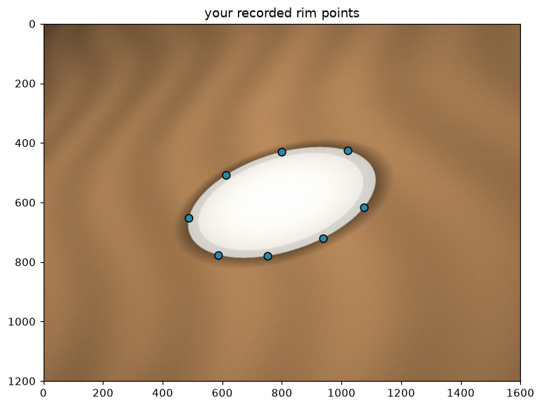
Point Overlay
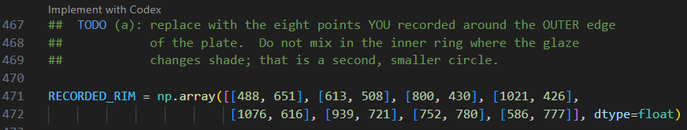
Task 2(a) Code Snippet

Task 2 (b)
Method
The fit_conic() formed an 8x6 design matrix A from the 8 recorded rim points. For each point (x,y), a row of A is constructed as [x², xy, y², x, y, 1] then applied with numpy.linalg.svd(). I use the last row of Vt, which is the right singular vector corresponding to the smallest singular value, as the six conic coefficients. The coefficients are then convert into symmetric conic matrix C by coefficients_to_matrix(), which is divided by its Frobenius norm to fix its scale (||C||_{F} =1).
Finally, I converted each recorded point to homogeneous form by hom() and evaluated |x^{T}_{i}Cx_{i}|. The largest value among the eight points was reported as the maximum algebraic residual.
Results
The fitted conic matrix, normalized so that ||C||_{F}=1, is:
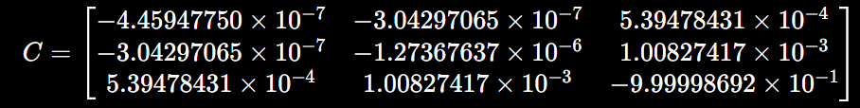
The maximum algebraic residual over the 8 recorded points is 2.673255×10⁻⁴
Discussion
Fixing the scale of C is necessary because multiplying C by any nonzero scalar represents the same conic. However, x^{T}_{i}Cx_{i} changes by the same scalar. Without (||C||_{F} =1), the reported residual could be made arbitrarily large or small without changing the fitted conic.
The reported number is the largest absolute algebraic residual among the 8 recorded points. It measures the worst disagreement with the normalized implicit conic equation. It is not a distance in pixels because it is the output of a quadratic equation, not the shortest Euclidean distance from a point to the fitted conic. Its value also depends on the local gradient of the conic.
Output & Code
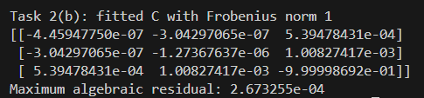
Task 2(b) output
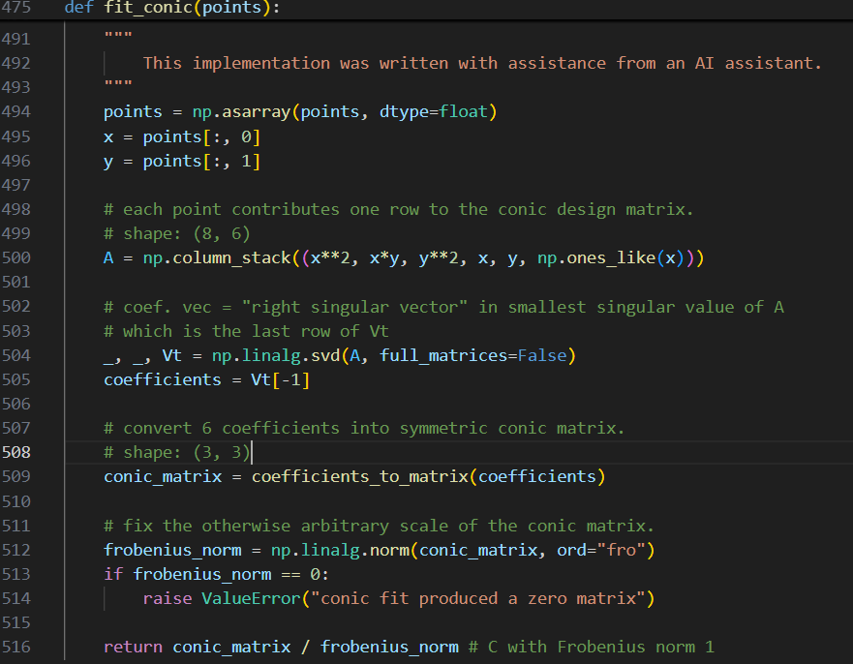
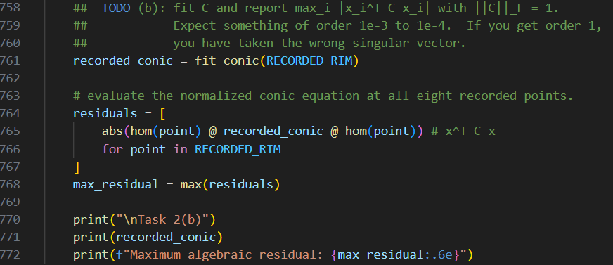
Task 2(b) Code Snippet

Task 2 (c)
Method
I reconstructed the coefficient vector from the symmetric matrix C, including multiplying 2 for the off-diagonal terms. I then divided all 6 coefficients by the norm of the 3 quadratic coefficients [a,b,c], so that a²+b²+c²=1. Finally, I computed the discriminant and classified the fitted conic from its sign.
Output results
Quantity | a | b | c | a²+b²+c² | b²-4ac | Classification
Value | -0.3012 | -0.4111 | −0.8604 | 1.0000 | −0.8677 | Ellipse
Discussion
My normalized discriminant is -0.8677. Since it is negative, the fitted conic is an ellipse. It is also close to the expected -0.86, rather than -2, 0, or other positive values. This shows that a general conic was fitted, the normalization used only [a, b, c], and the recorded points were sufficiently distributed around the rim. Despite the fact that the plate is a circle in the world, the fitted image conic does not satisfy the circle constraints, since the b≠0, and a≠c.
A general camera view produces a projective transformation of the plate’s plane, which mixes the coordinates and therefore also mixes the individual entries of C, so relations such as b=0, and a=c are not generally preserved. However, its boundary remained a nondegenerate conic. Point incidence and tangency were also preserved.
Output & Code
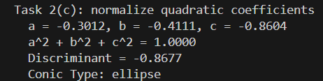
Task 2(c) output
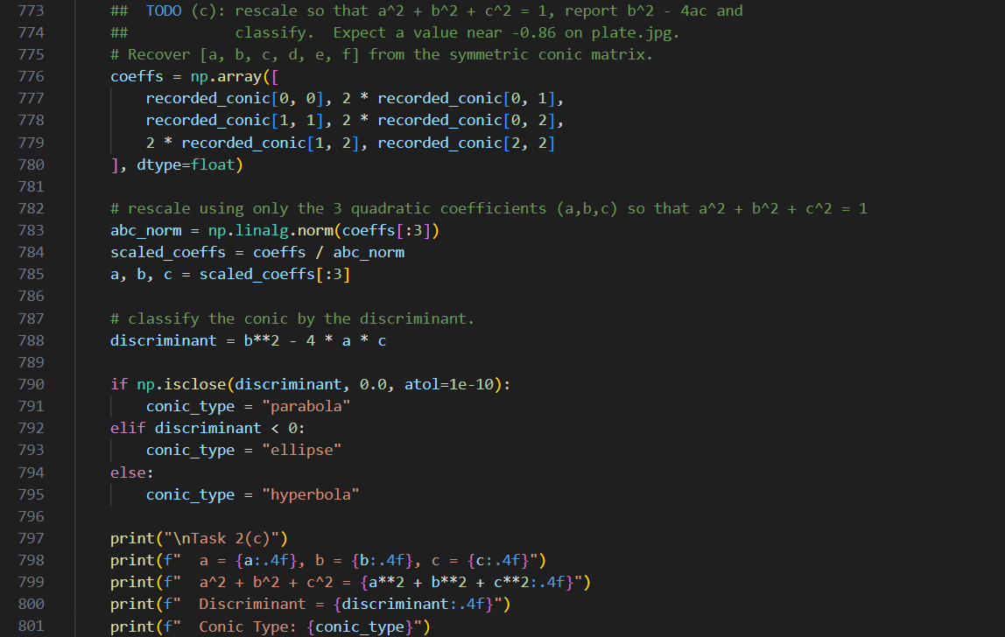
Task 2(c) code snippet

Task 2 (d)
Method
I choose the point (800,430) and convert it to homogeneous coordinates, since its tangent is not close to vertical and can therefore be drawn reliably with draw_line_across(). The tangent line is computed as l = Cp using the fitted conic matrix from 2(b). I then used draw_line_across() and draw_conic() to overlay the fitted conic, the 8 recorded points, and the tangent on the image. Then I used a second panel to show enlarged region around the chosen point p. Finally, I evaluate p^{T}Cp and l^{T} p using the same point and conic matrix.
Results & Figure
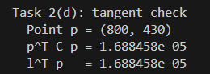
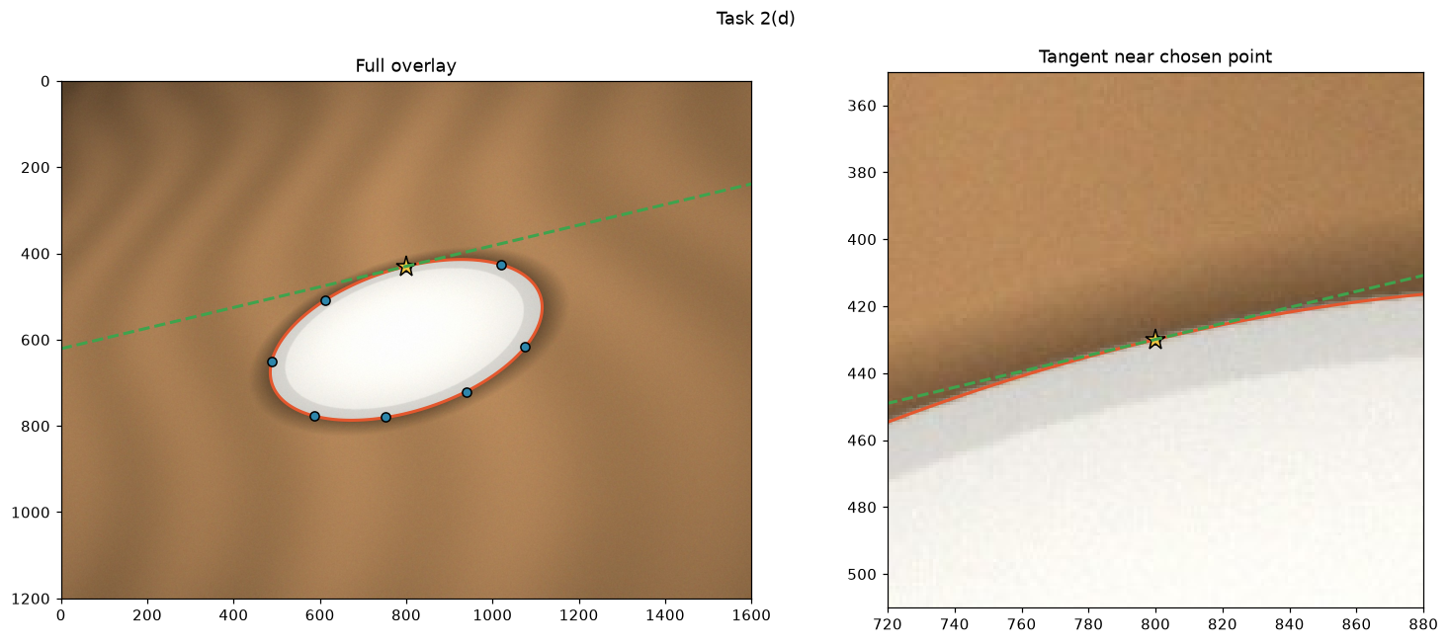
Discussion
The full overlay I get has the fitted conic following the outer rim of the plate. In the enlarged view, the tangent line touches the conic at the chosen point without crossing it. This visual check supports that the fitted C is consistent with the plate rim.
The two computed values are
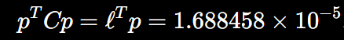
They must agree because l = Cp, which leads to
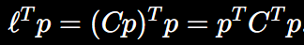
Since C is symmetric, we can know
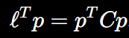
This agreement does not show that the conic fit is right, since this equality follows automatically from l = Cp and the symmetry of C. It would still hold for an incorrectly fitted symmetric matrix. The quality of the fit is instead checked by the image overlay, such as “the conic should follow the plate rim”, and “the tangent should touch the curve at the selected point without crossing” as the instruction says.
Output & Code
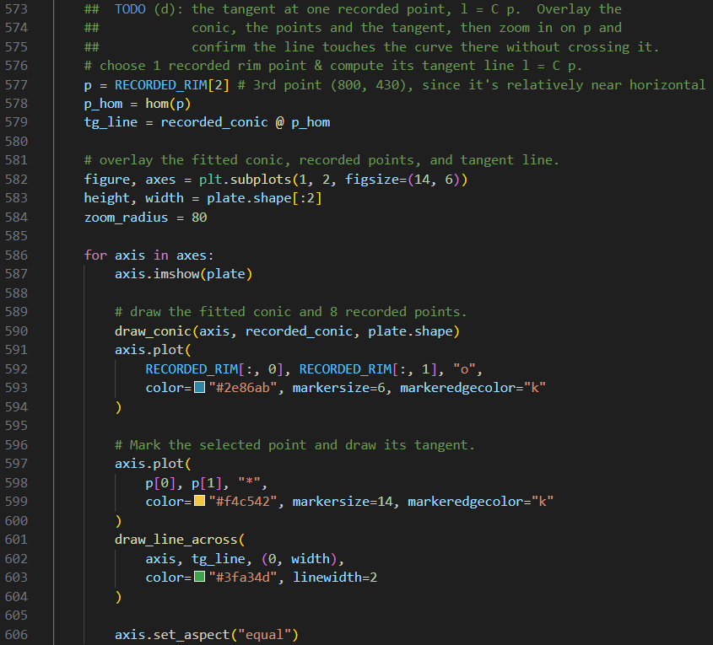
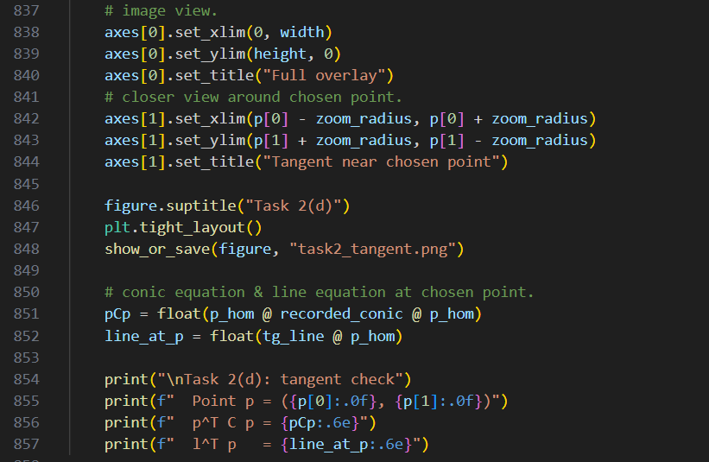
Task 2(d) code snippet

Bonus (a)
Method
The aiming line was constructed by joining the origin with the unit direction point (cos α, sin α). Then I computed the endpoint angles of each segment with atan2(), mapped them to [0°, 360°), and returned the shorter angular interval by subtended_interval(), including the case where it crosses 0°. Eventually, return the shorter angular interval.
The target boundary rays were then evaluated at y = 4 to check whether the crossed the armour. Finally, the aiming line was met with l∞, and the resulting ideal point was normalized for reporting.
Results & Discussion
The homogeneous aiming line obtained by joining [0, 0, 1]ᵀ and [cos α, sin α, 1]ᵀ is:
l(α) = [−sin α, cos α, 0]ᵀ. As a result, the α appears in the first two entries.
The angular intervals were:
Segment | Angular interval
Target | 69.4440° to 82.8750°
Armour | 38.6598° to 84.2894°
In addition to the target interval being contained within the armour interval, the target rays cross y = 4 over x = 0.5000 to 1.5000, which is inside the armour range x = 0.4000 to 5.0000. Since the armour is at y = 4 and the target is at y = 8, an upward ray reaches the armour first and no direct shot exists.
When meeting at aiming line with l∞ = [0, 0, 1]ᵀ, it gives l(α) × l∞ = [cos α, sin α, 0]ᵀ, up to a nonzero scale. This is the ideal point representing the aiming direction.
Output & Code
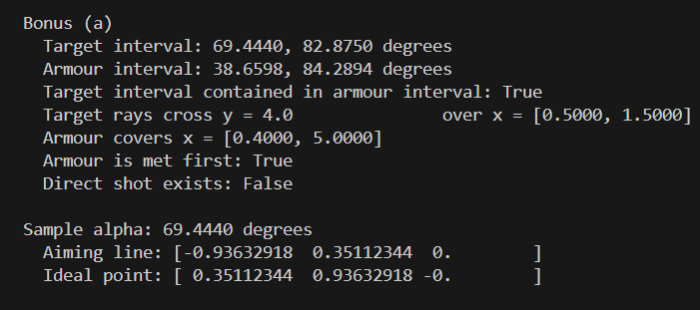
Bonus(a) output
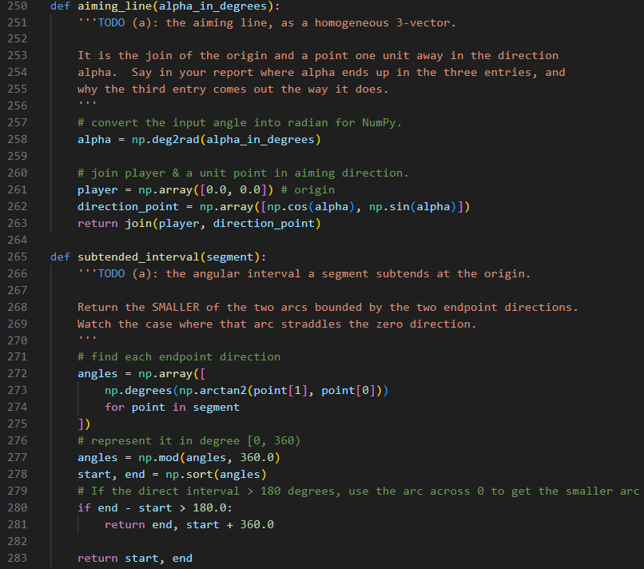
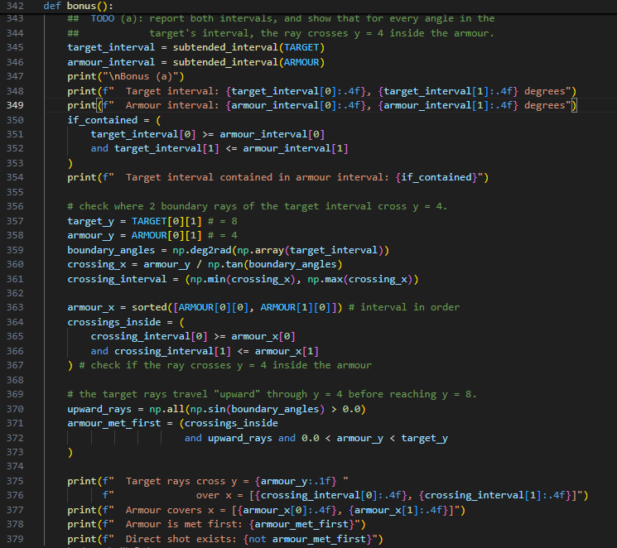
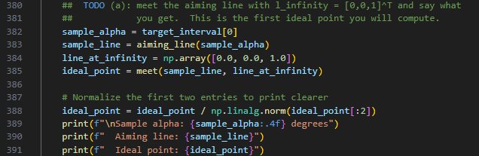

Bonus (b)
Method
I first made strikes_segment() compute the meet q between aiming line and the line containing the segment, then checked if q falls between the segment endpoints. An ideal meet is rejected because it is not a finite point on the segment. Since the meet already lies on the segment’s supporting line, its coordinates are compared with the endpoint bounds, using a small tolerance for rounding error.
strikes_segment() then optionally applies the ray-direction test dᵀq > 0. In bonus(), it is first called at α = 250° with the direction test disabled to get the naive result. The meet q and dᵀq are computed for report later, than strikes_segment( is called again with the direction test enabled to obtain the corrected result.
Results & Discussion
At α = 250°, the meet with the target line was q = (2.9118, 8.0000). Since this point lies between the target endpoints, the naive test reported a hit. A homogeneous line has no direction, so 250° and 70° describe the same infinite line even though they point in opposite directions.
However, the direction was d = (−0.3420, −0.9397)ᵀ, and dᵀq = −8.5134. The negative result shows that q lies behind player along the same undirected aiming line. The missing condition is thus dᵀq > 0, this is strict because dᵀq = 0 would give no positive travel distance from the player. After adding this condition, the corrected test showed that the target was not hit.
Output & Code
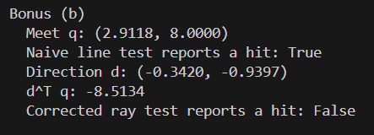
Bonus(b) output
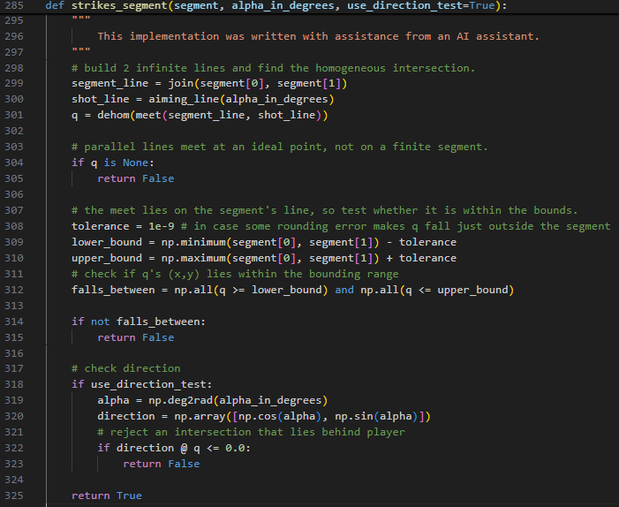
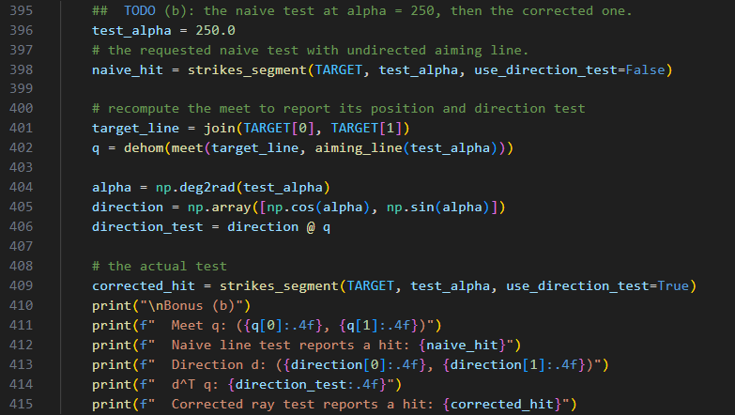
Bonus(b) code snippet

Bonus (c)
Method
I represented the wall x = 7 by the normalized homogeneous line l = [1, 0, −7]ᵀ. reflection_in_line() used this wall line to construct M = I − 2ñlᵀ. I then computed M² and used np.allclose() to compare it with the 3 × 3 identity matrix.
Results & Discussion
For the wall x = 7, the reflection matrix was
M = [[−1, 0, 14],
[0, 1, 0],
[0, 0, 1]].
Squaring this matrix gave
M² = [[1, 0, 0],
[0, 1, 0],
[0, 0, 1]] = I,
and the numerical comparison returned True. This had to be true because reflecting a point across the same line twice returns it to its original position.
Output & Code
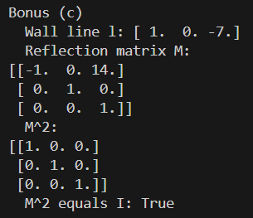
Bonus(c) output
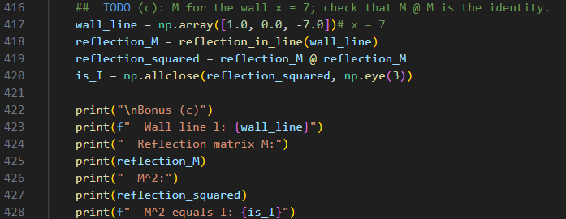
Bonus(c) code snippet

Bonus (d)
Method
I reflected both target endpoints with reflection_M and averaged the reflected points to obtain the mirror-image center. The aiming angle was computed with atan2(), and aiming_line() constructed the incoming path.
I traced this path by meeting it with armour and wall lines, while strikes_segment() checked whether it hit the finite segments. The incoming direction was represented by its ideal point and reflected by reflection_M. I then constructed the return line through the wall hit point in the reflected direction, met it with the target line, and checked if the landing point fell within the target bounds
Results & Discussion
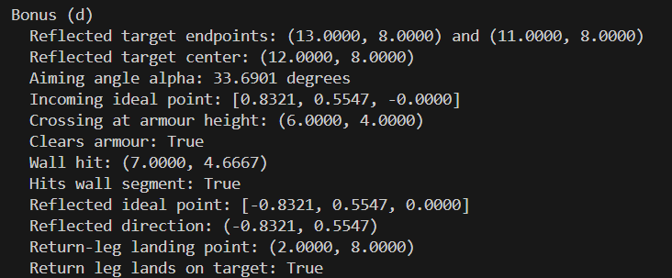
Bonus(d) output
The reflected target centre was (12.0000, 8.0000), giving an aiming angle of 33.6901°. The incoming path crossed y = 4 at x = 6.0000, which is beyond the armour endpoint at x = 5.0000, so it cleared the armour. It then hit the wall at (7.0000, 4.6667), within the wall’s y-range from 0 to 6.
Applying reflection_M to the incoming ideal point changed the direction to (−0.8321, 0.5547). Its third coordinate was zero, so the translation part of the matrix did not affect the direction. The return leg landed at (2.0000, 8.0000), which lies on the target bar between x = 1 and x = 3.
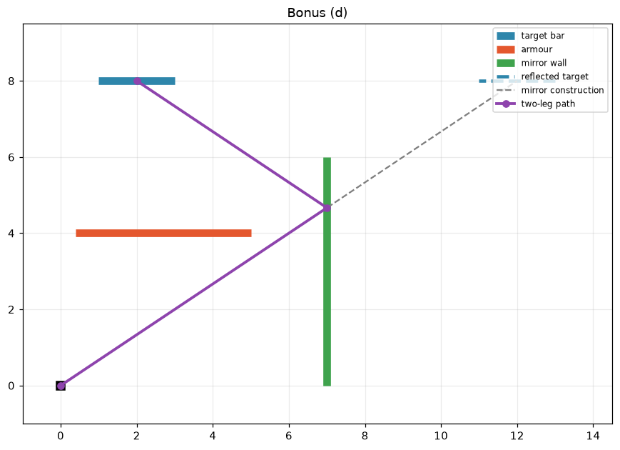
Mirror-image construction and the traced two-leg path. The incoming path clears the armour and strikes the wall at (7.0000, 4.6667), while the reflected path lands on the target at (2.0000, 8.0000).
Code
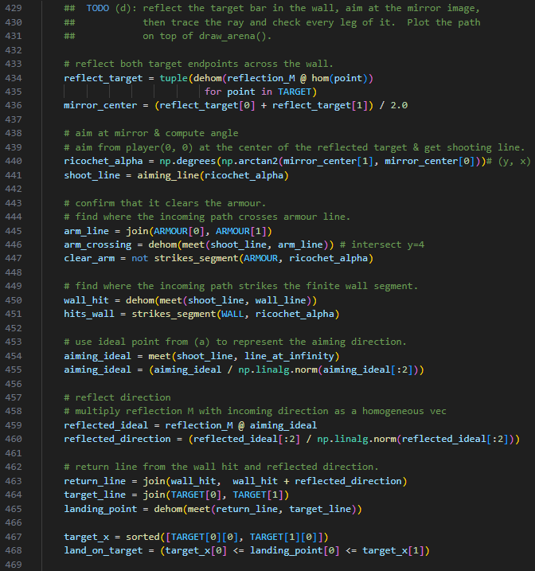
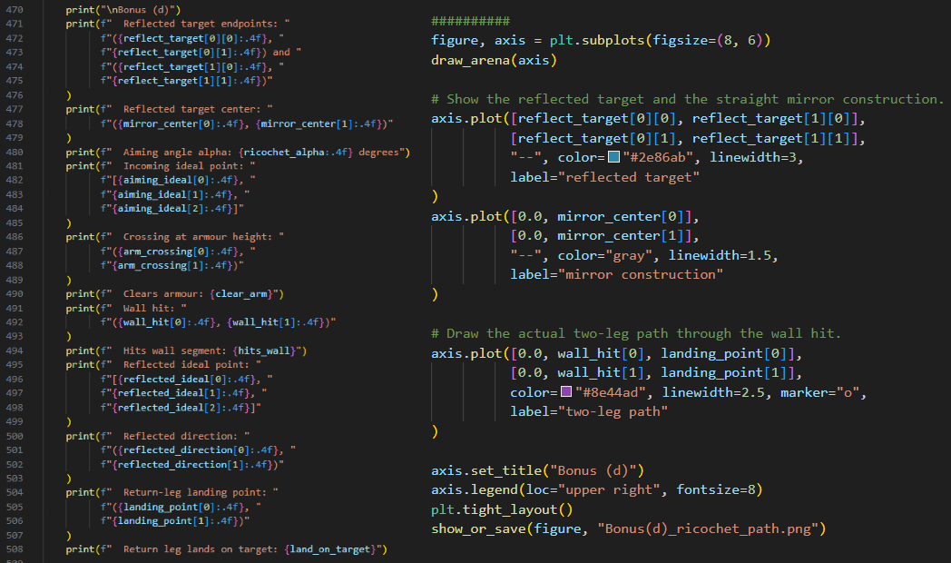
Bonus(d) code snippet

