

Practices for Secure Software Report

Table of Contents
Practices for Secure Software Report 1
Document Revision History 3
Client 3
Developer 4
1. Algorithm Cipher 4
2. Certificate Generation 5
3. Deploy Cipher 6
4. Secure Communications 7
5. Secondary Testing 8
6. Functional Testing 9
7. Summary 9
8. Industry Standard Best Practices 10

Document Revision History

Version | Date | Author | Comments
1.0 | 6.21.26 | Cassie Carlisle | Initial submission — added SHA-256 checksum endpoint, HTTPS configuration, and secure software report

Client



Developer
Cassie Z. Carlisle

Algorithm Cipher

SHA-256 (Secure Hash Algorithm 256-bit) was selected as the cryptographic hash algorithm for this project. SHA-256 is a member of the SHA-2 family, standardized by the National Institute of Standards and Technology (NIST) in 2001. It is a one-way cryptographic hash function that transforms an input of arbitrary length into a fixed-size 256-bit (32-byte) output called a message digest. SHA-256 is widely used in TLS/SSL certificates, digital signatures, blockchain, and file integrity verification because of its collision resistance and broad industry support.

Hash Functions and Bit Levels: SHA-256 produces a 256-bit hash, represented as a 64-character hexadecimal string. It processes input data in 512-bit blocks through 64 rounds of compression. It provides pre-image resistance, second pre-image resistance, and collision resistance. The three resistances make it infeasible to reverse the hash, find a different input producing the same hash, and infeasible to find two inputs with the same hash. The 2²⁵⁶ possible output space makes brute-force attacks computationally impractical.

Random Numbers, Symmetric vs. Non-Symmetric Keys: SHA-256 is a hashing algorithm and does not use encryption keys or random numbers in its core operation. It uses deterministic mathematical transformations. However, it works alongside symmetric encryption and asymmetric encryption. In TLS, used in this project to enable HTTPS, SHA-256 is used within the handshake and certificate signing to ensure data integrity. It can also be combined with a secret key in HMAC (Hash-based Message Authentication Code) to provide both integrity and authentication.

History and Current State of Encryption Algorithms: MD5 was once widely used but has been cryptographically broken, collision attacks are easily achievable today. SHA-1 produces a 160-bit hash and was deprecated after Google’s Project Zero demonstrated a practical collision attack in 2017. The SHA-2 family, including SHA-256, remains the current NIST-recommended standard and is used in TLS 1.3, code signing, and certificate authorities. SHA-3, based on the Keccak algorithm, provides a structurally different alternative but is not yet as widely deployed. SHA-256 was chosen for this project because it is the industry standard, is natively supported in Java’s java.security.MessageDigest API, and provides strong security with no known practical vulnerabilities.

Certificate Generation

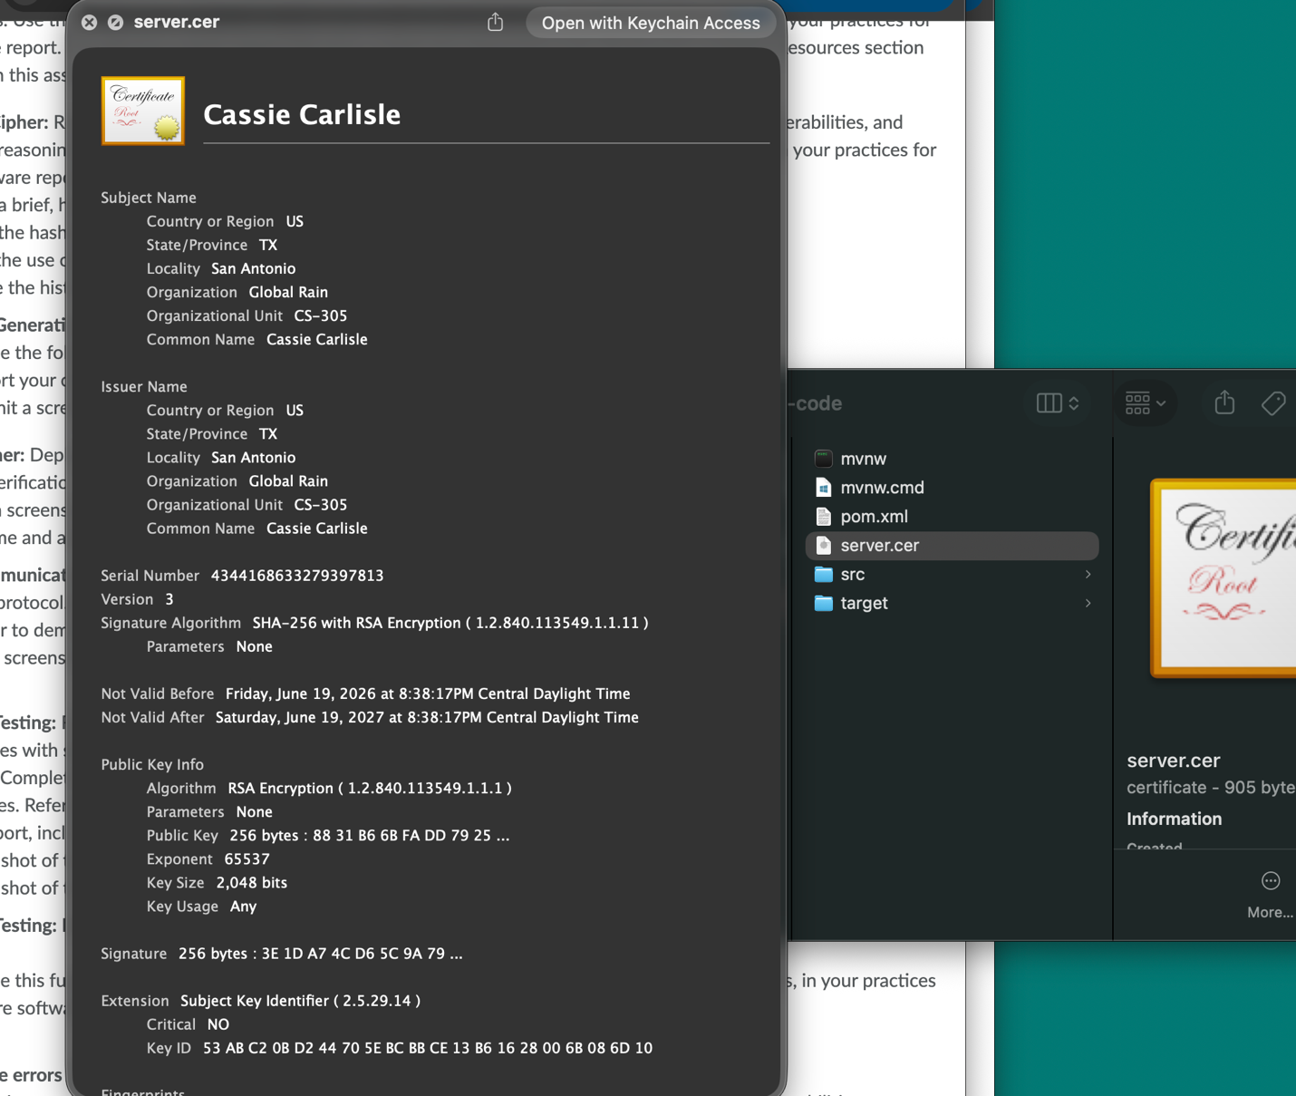

Deploy Cipher
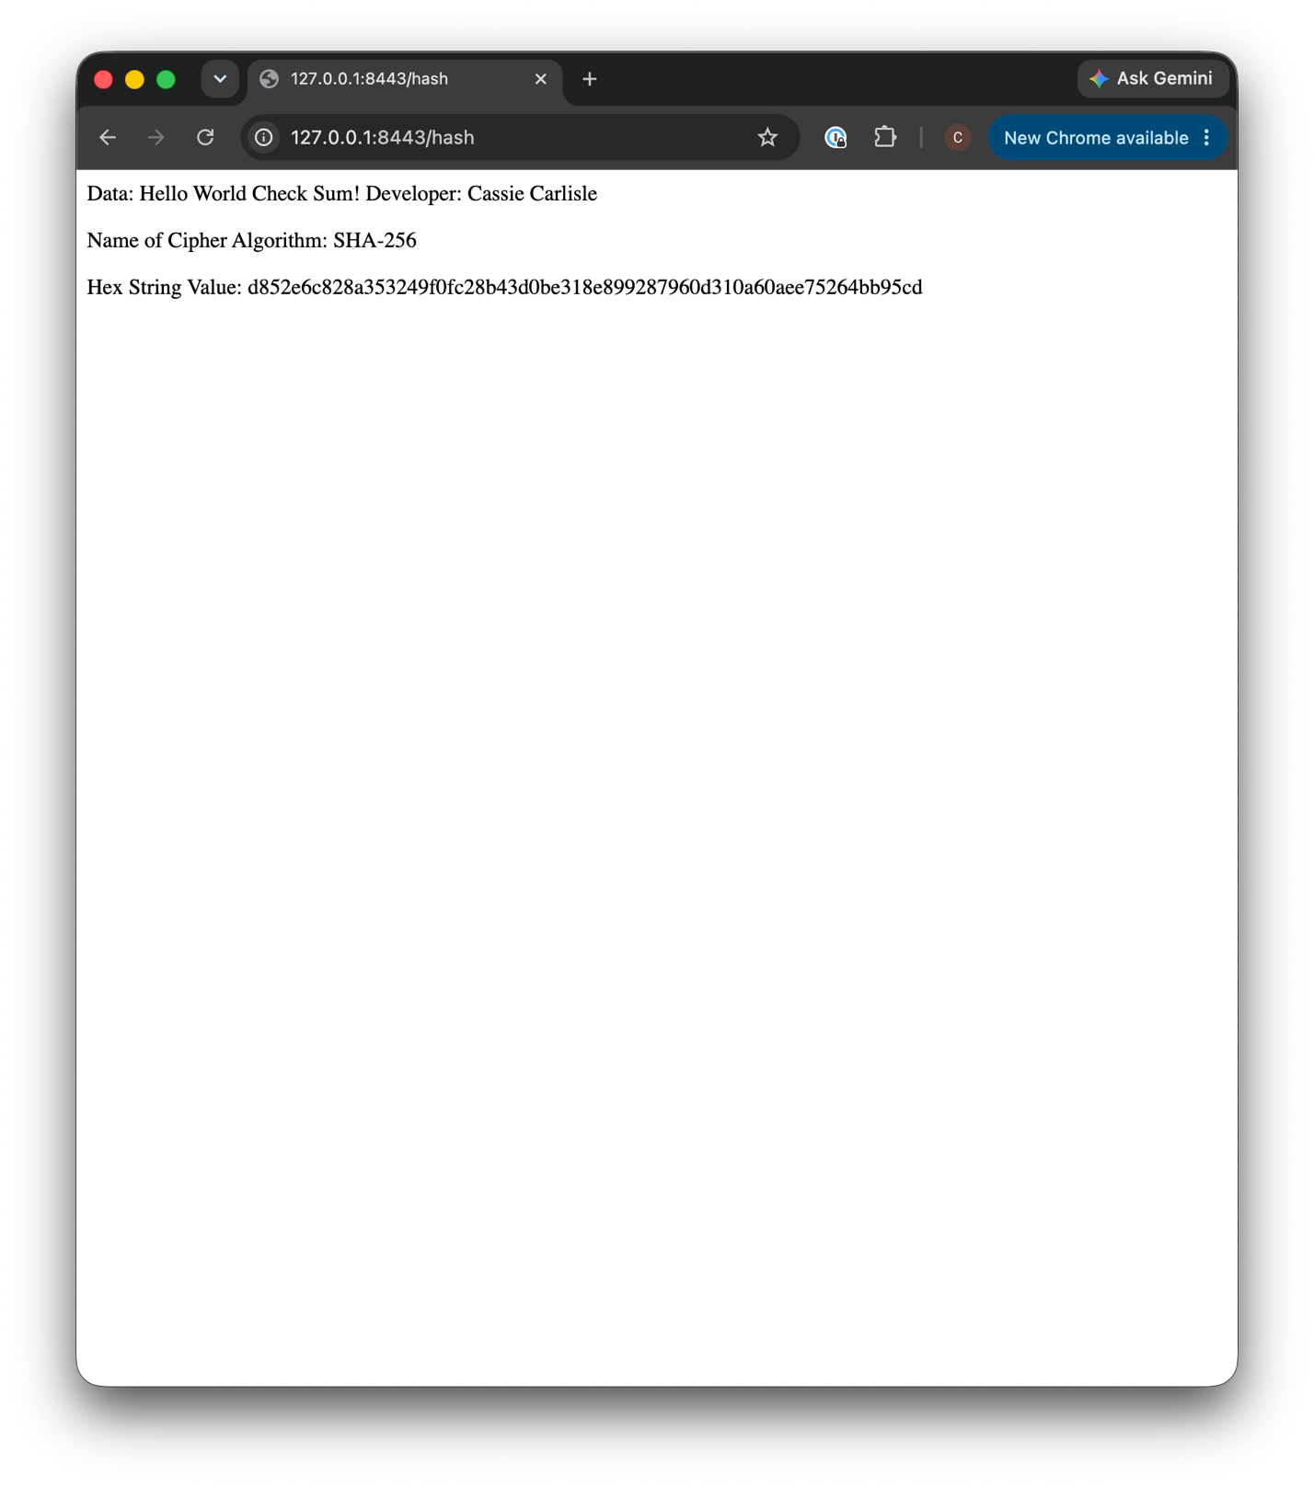

Secure Communications
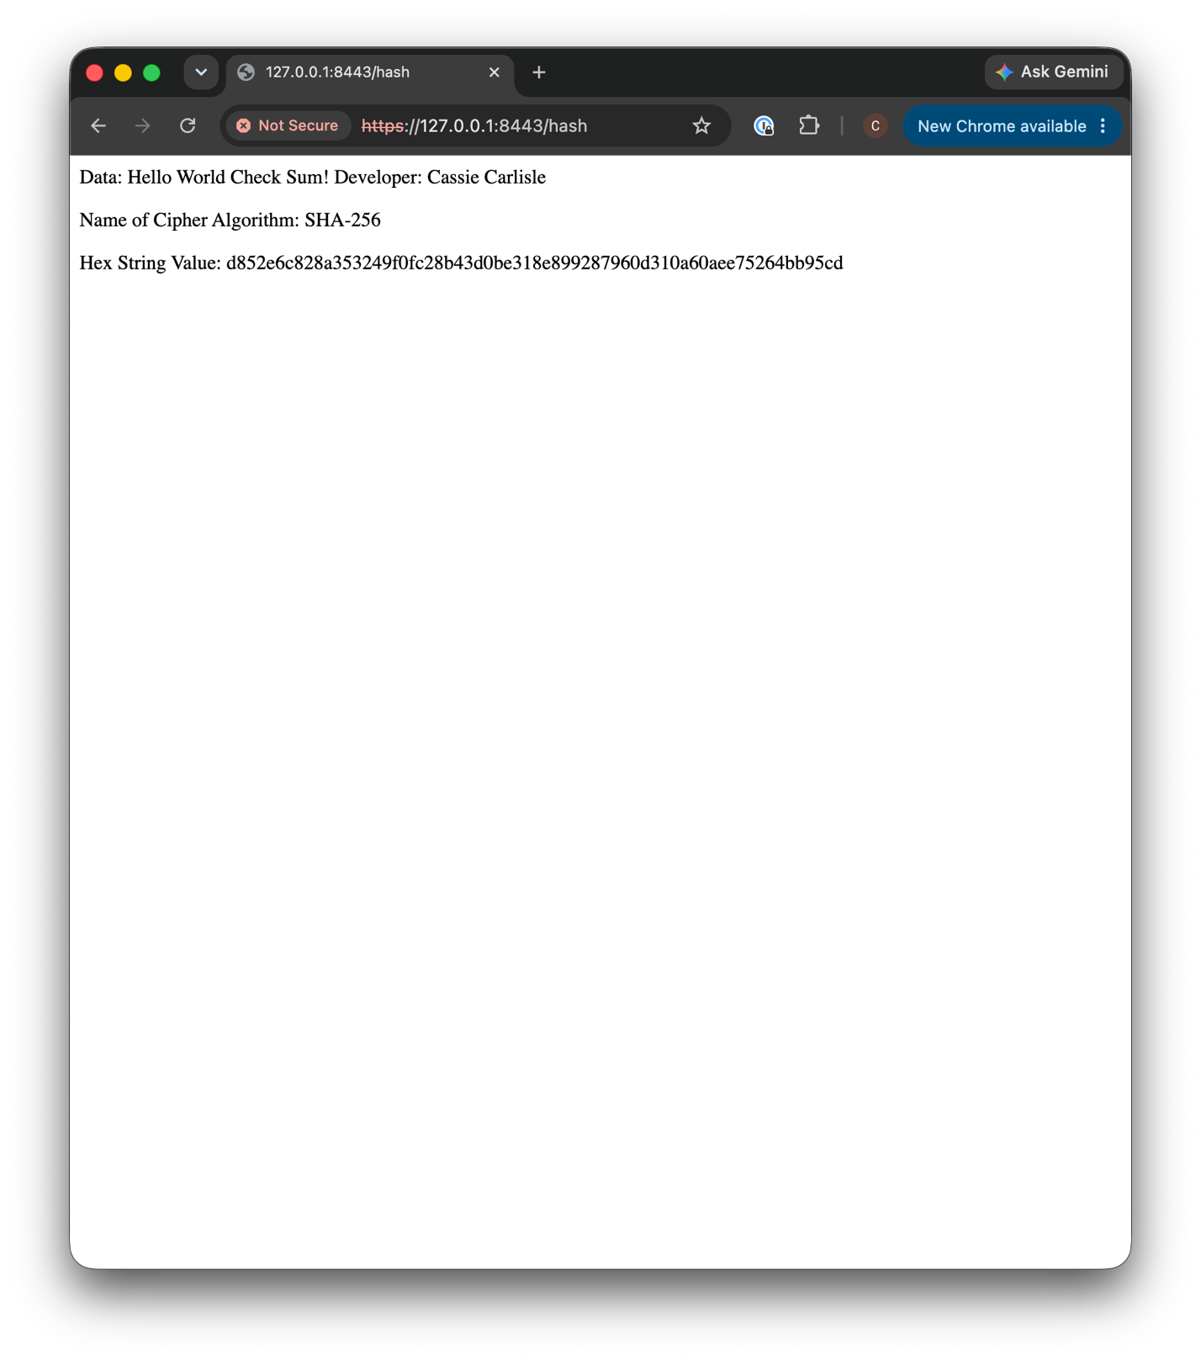

Secondary Testing
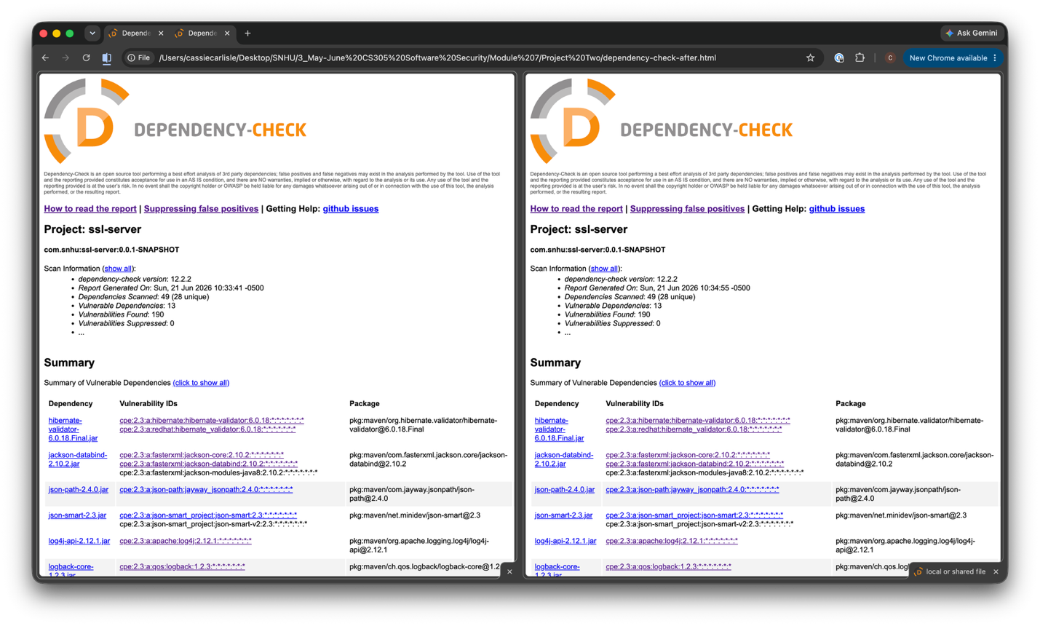

Functional Testing

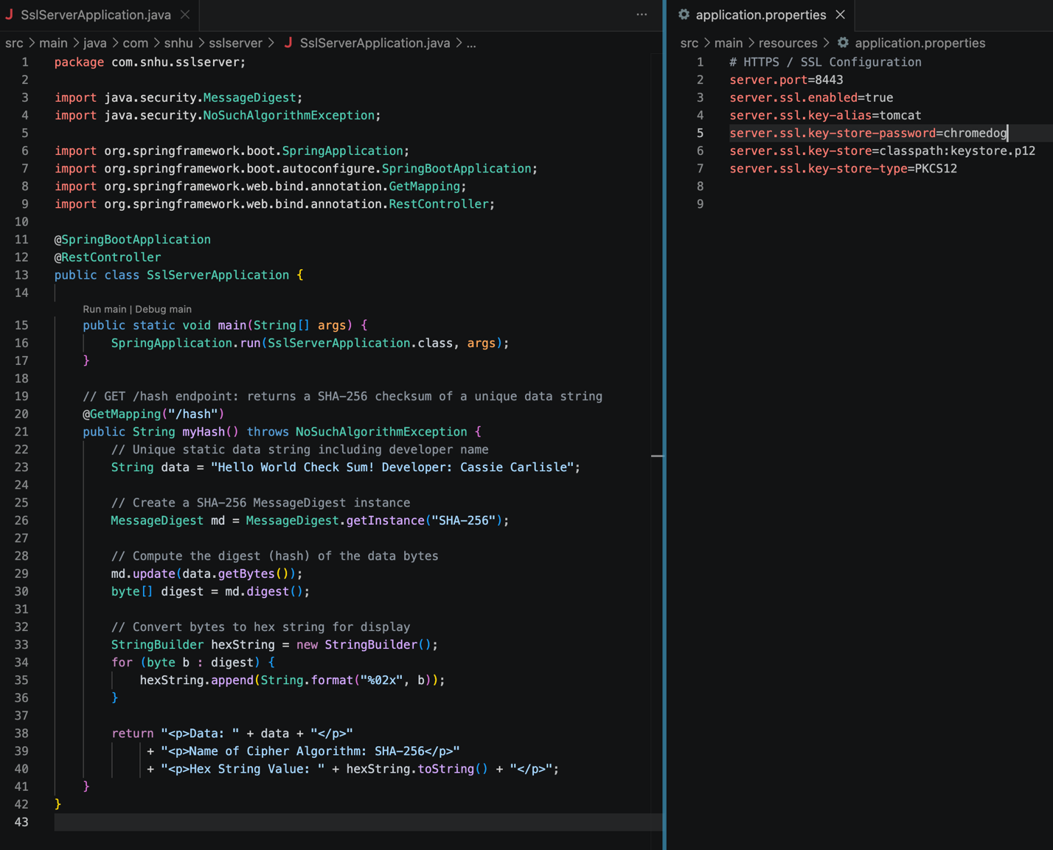

Summary

The refactoring of the Artemis Financial web application successfully addressed the company’s software security requirements by adding cryptographic checksum verification and enabling HTTPS communication. Referring to the Vulnerability Assessment Process Flow diagram, the following security areas were addressed:

Architecture Review: The Spring Boot application architecture was analyzed before changes were made. The existing Maven project structure, dependencies, and configuration files were reviewed to determine where to integrate the checksum endpoint and SSL configuration.

Cryptography: The most significant area of focus. A SHA-256 hash function was implemented using Java’s MessageDigest API. The selection of SHA-256 was based on its status as a NIST-approved, industry-standard algorithm with strong collision resistance. SSL/TLS was configured to encrypt all data in transit.

Client/Server: Secure distributed communication was established by migrating from HTTP to HTTPS on port 8443 using a PKCS12 keystore, ensuring all data exchanged between the client and server is encrypted.

Code Quality and Code Review: The refactored code follows secure coding practices, including the use of built-in Java security libraries, avoidance of deprecated algorithms, and a clean, maintainable code structure. The new @GetMapping(“/hash”) controller endpoint was reviewed for correctness and security compliance.

Layers of security added include:
(1) Transport Layer Security via HTTPS encrypting all traffic and preventing man-in-the-middle attacks
(2) SHA-256 cryptographic integrity verification through the checksum endpoint
(3) a 2048-bit RSA self-signed certificate for server authentication during TLS handshakes
(4) OWASP Dependency-Check scanning to confirm no new vulnerabilities were introduced during refactoring.

Industry Standard Best Practices

The following industry standard best practices were applied to maintain and enhance the application’s existing security.
- First, NIST-approved algorithms were used exclusively. SHA-256 is recommended by NIST for secure hashing, and deprecated algorithms such as MD5 and SHA-1, both of which have known collision vulnerabilities, were deliberately avoided.
- Second, HTTPS enforcement was implemented, aligning with OWASP Top 10, which identifies failure to encrypt data in transit as a critical vulnerability.
- Third, the principle of least functionality was applied: the /hash endpoint accepts no user input and performs only a single, well-defined operation, minimizing the attack surface.
- Fourth, Java’s built-in java.security.MessageDigest library was used rather than any custom cryptographic implementation, which reduces the risk of implementation errors.
- Fifth, OWASP Dependency-Check was integrated into the Maven build process, supporting a DevSecOps approach by scanning dependencies for known CVEs before deployment.

Applying these best practices provides significant value to Artemis Financial’s overall well-being. The company handles sensitive personal and financial data and encrypting data in transit with HTTPS and verifying integrity with SHA-256 directly reduces the risk of data breaches that could harm clients and expose the company to regulatory liability. Beyond compliance, maintaining a strong security posture protects client trust, which is critical for a financial consulting firm. Proactively addressing security vulnerabilities during development is also significantly less expensive than remediating breaches after deployment. The secure coding patterns established in this project provide a scalable foundation that strengthens the company’s security as the application grows.

