PIJA CO Point Counts:
Link: https://survey123.arcgis.app/?itemID=fcd445d10a914e1dacada935f3b8e066
QRCode:
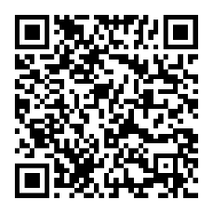
PIJA CO Colony Survey:
Link: https://survey123.arcgis.app/?itemID=656f300c5d844334bf7e4d58b04361fd
QRCode:
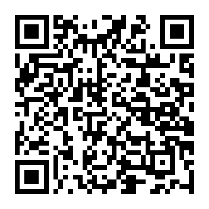
PIJA CO Incidentals:
Link: https://survey123.arcgis.app/?itemID=3387193dea0a43db95722be39378675b
QRCode:
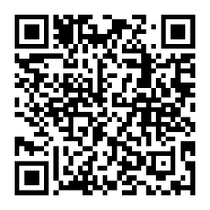
PIJA CO Nests:
Link: https://survey123.arcgis.app/?itemID=ba2c7208b46a43ad9f11ab96ff35872a
QRCode:
