## Adds a player to a team

### Status 200 – Returns ID

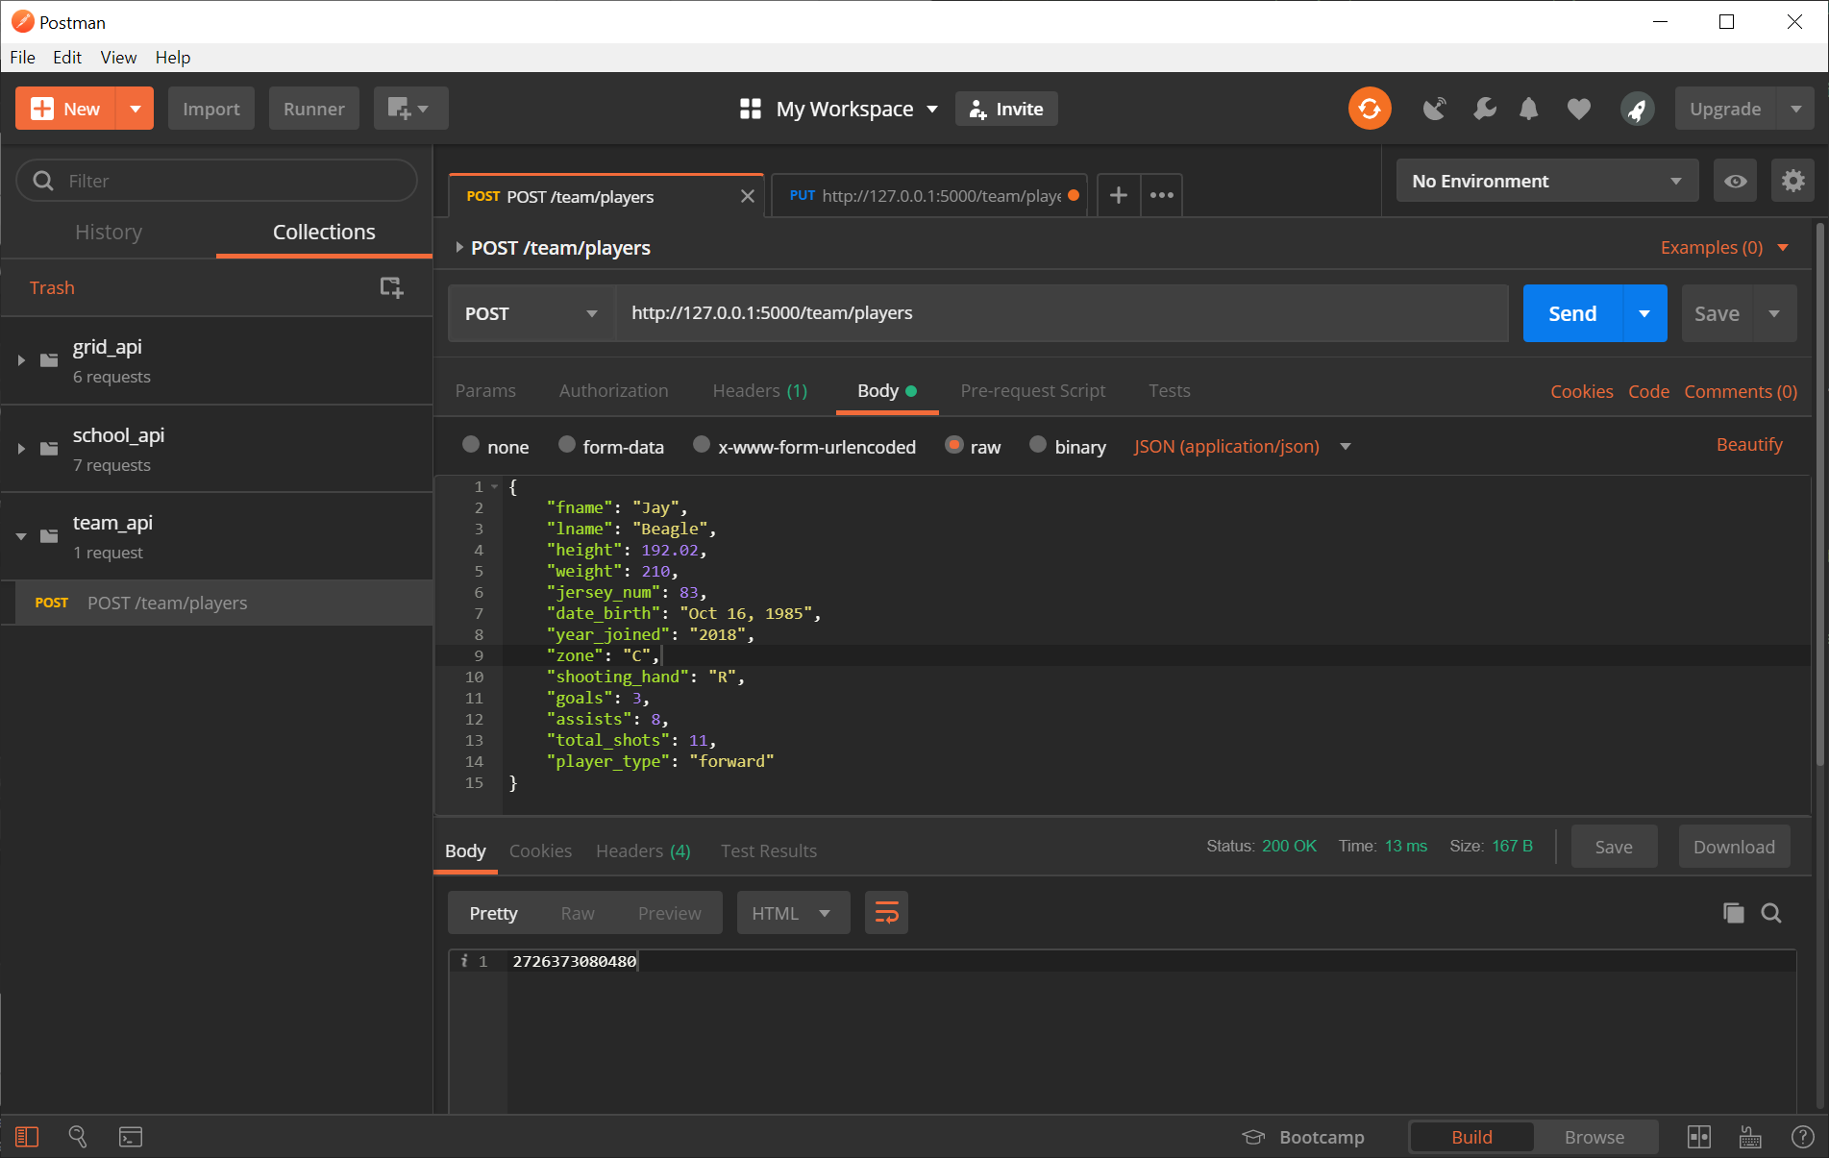

### Status 400 – Error Message

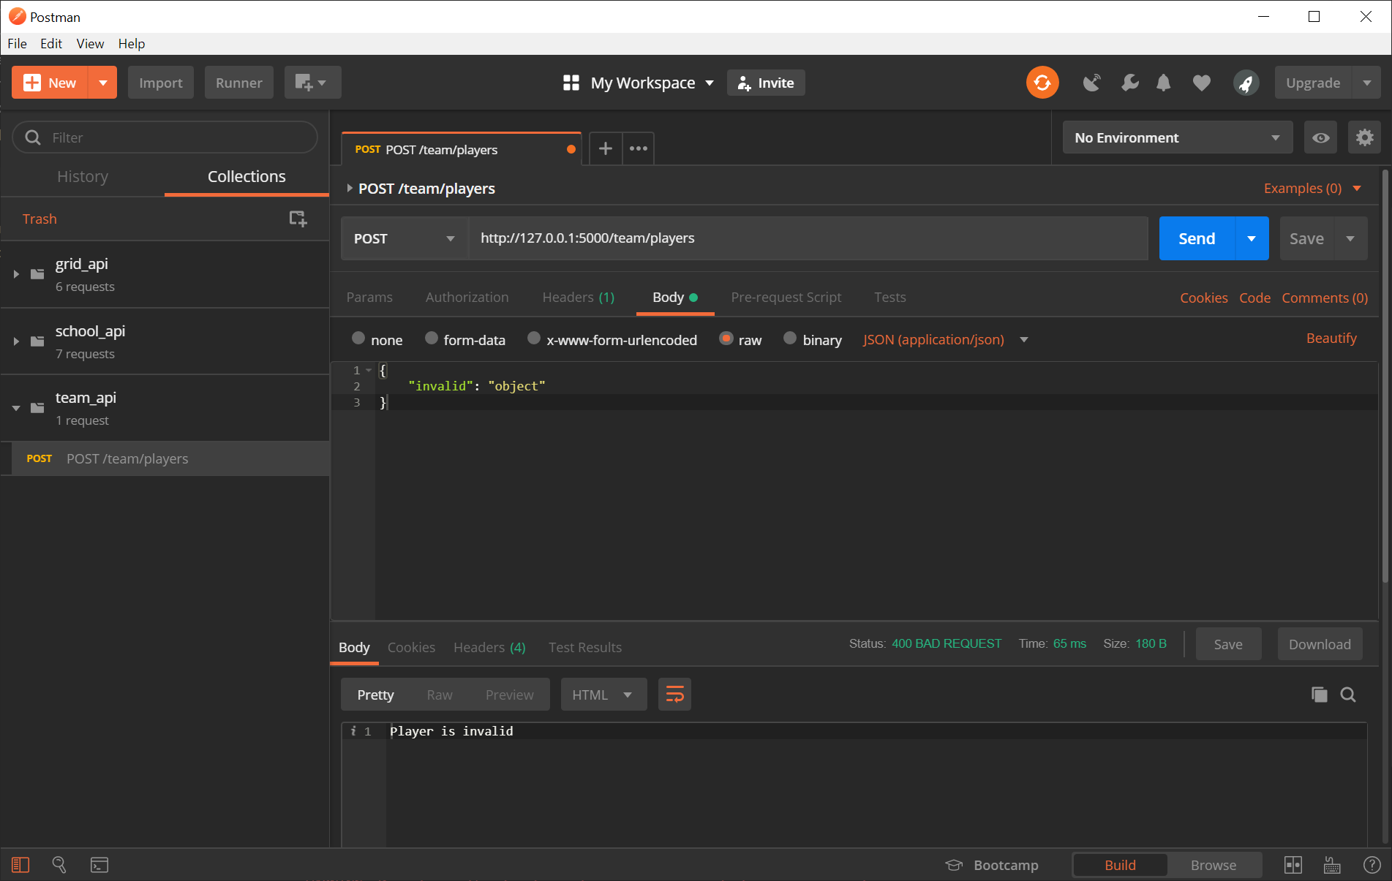

## Updates a player in the team with a given ID

## Status 200

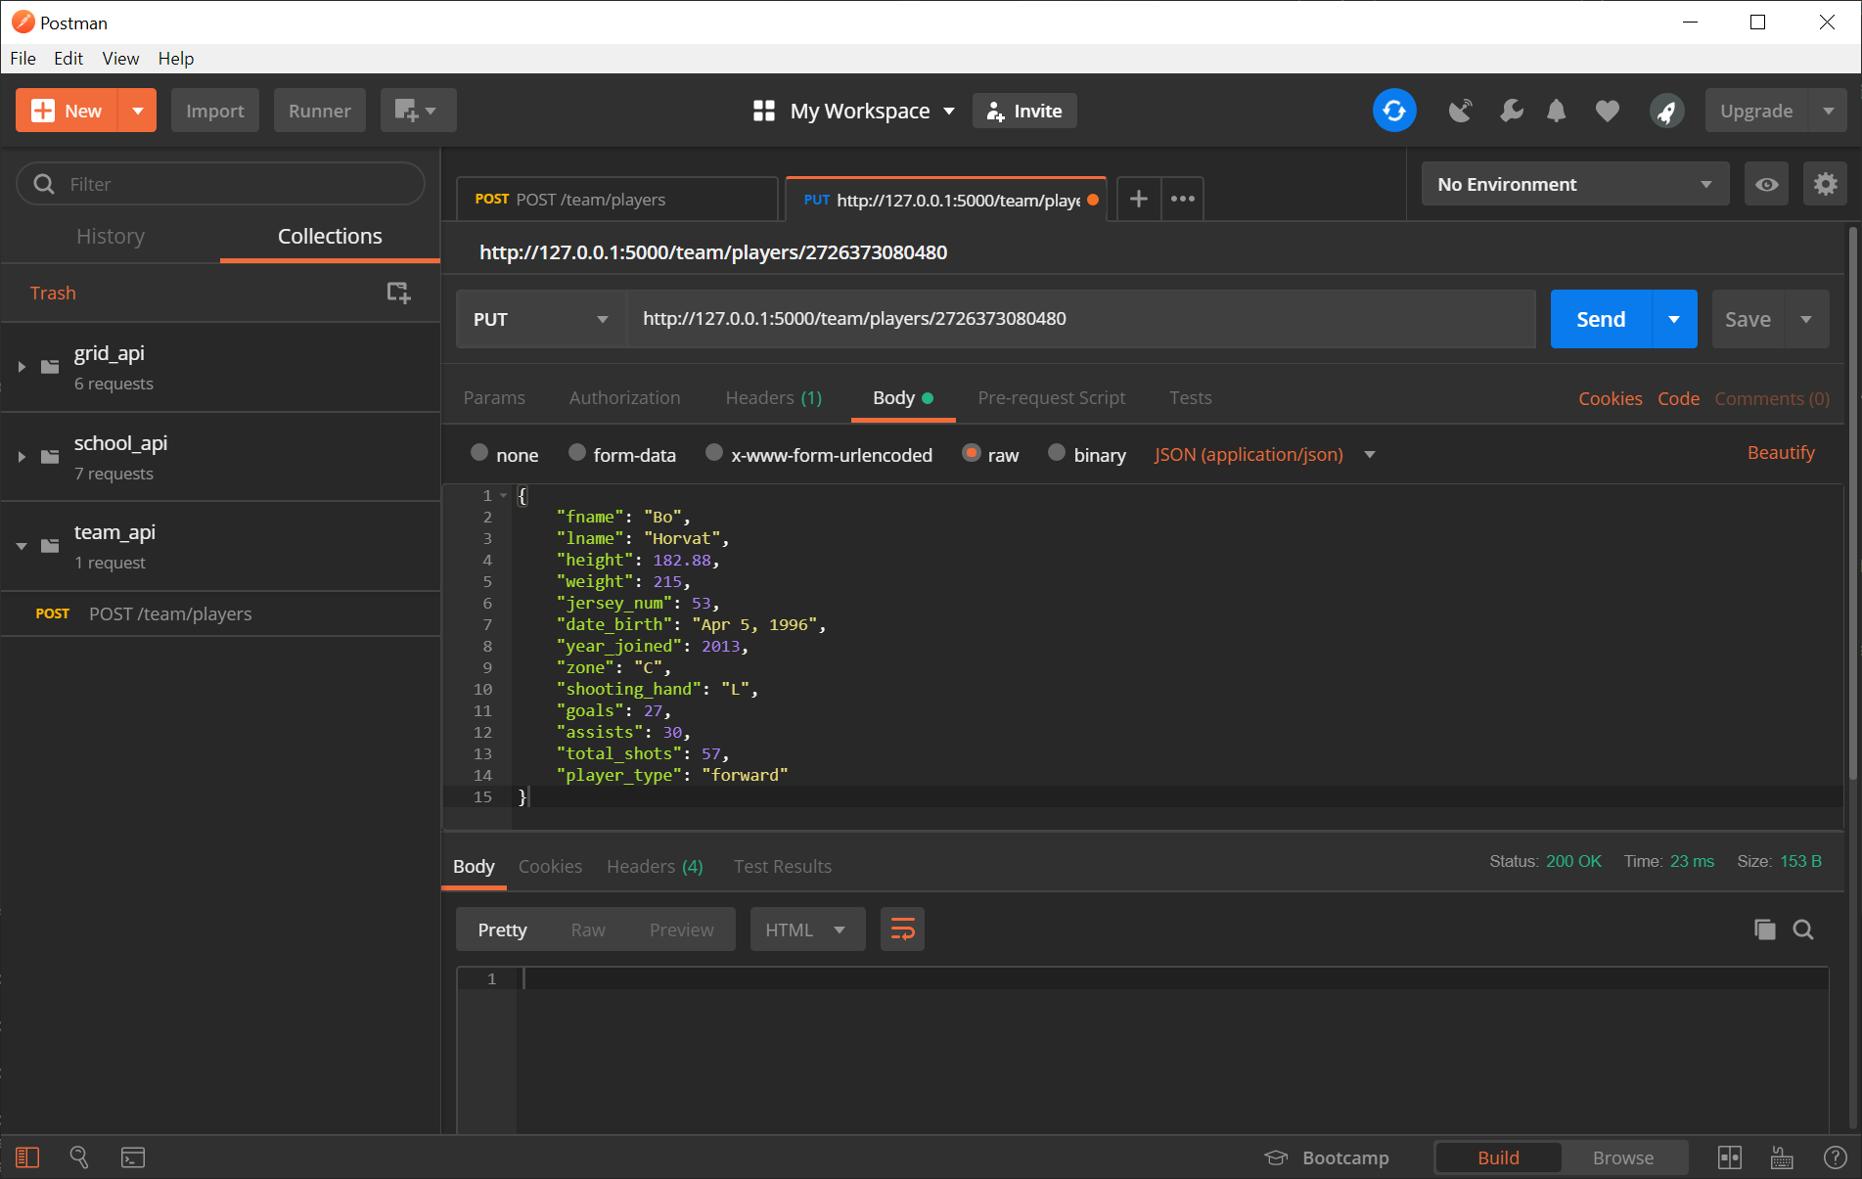

### Status 404 – Player ID not found

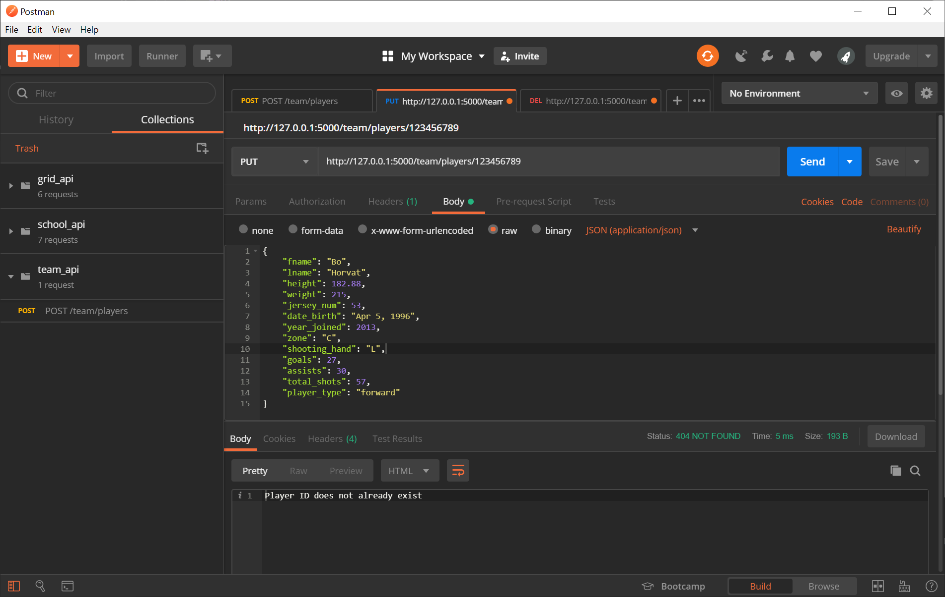

## Deletes a player in the team with a given ID

### Status 200

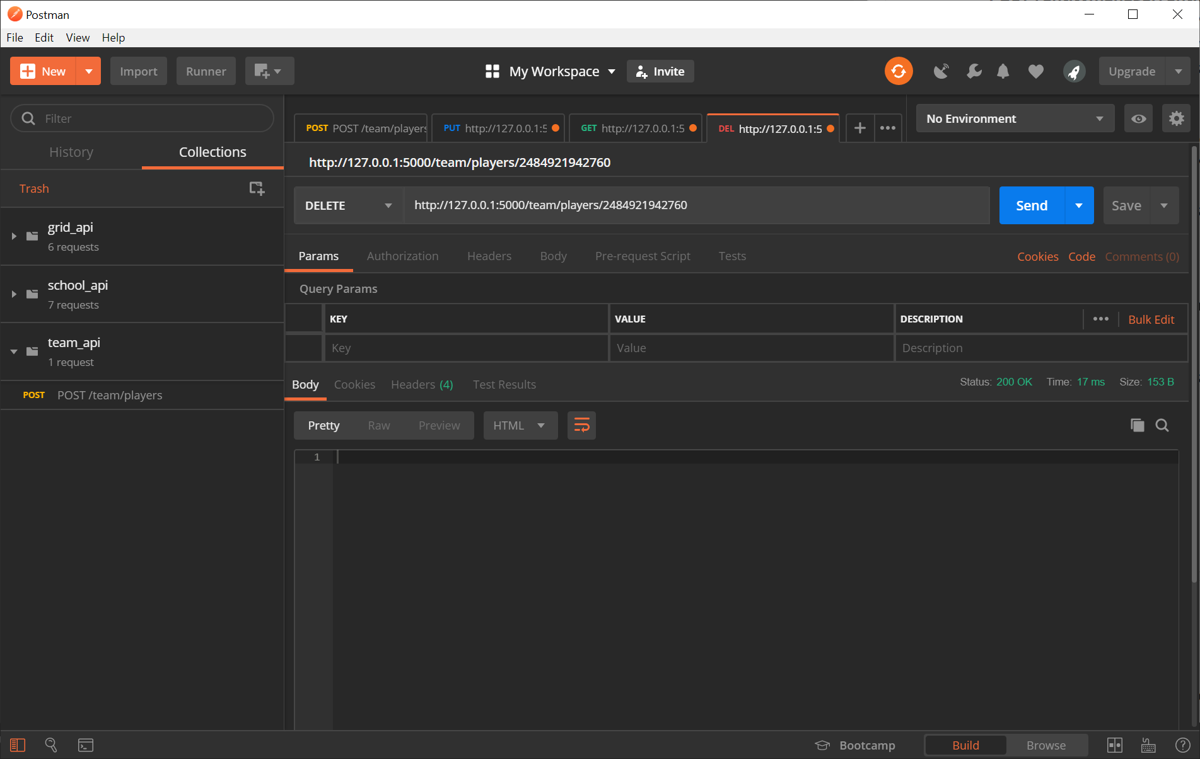

### Status 404

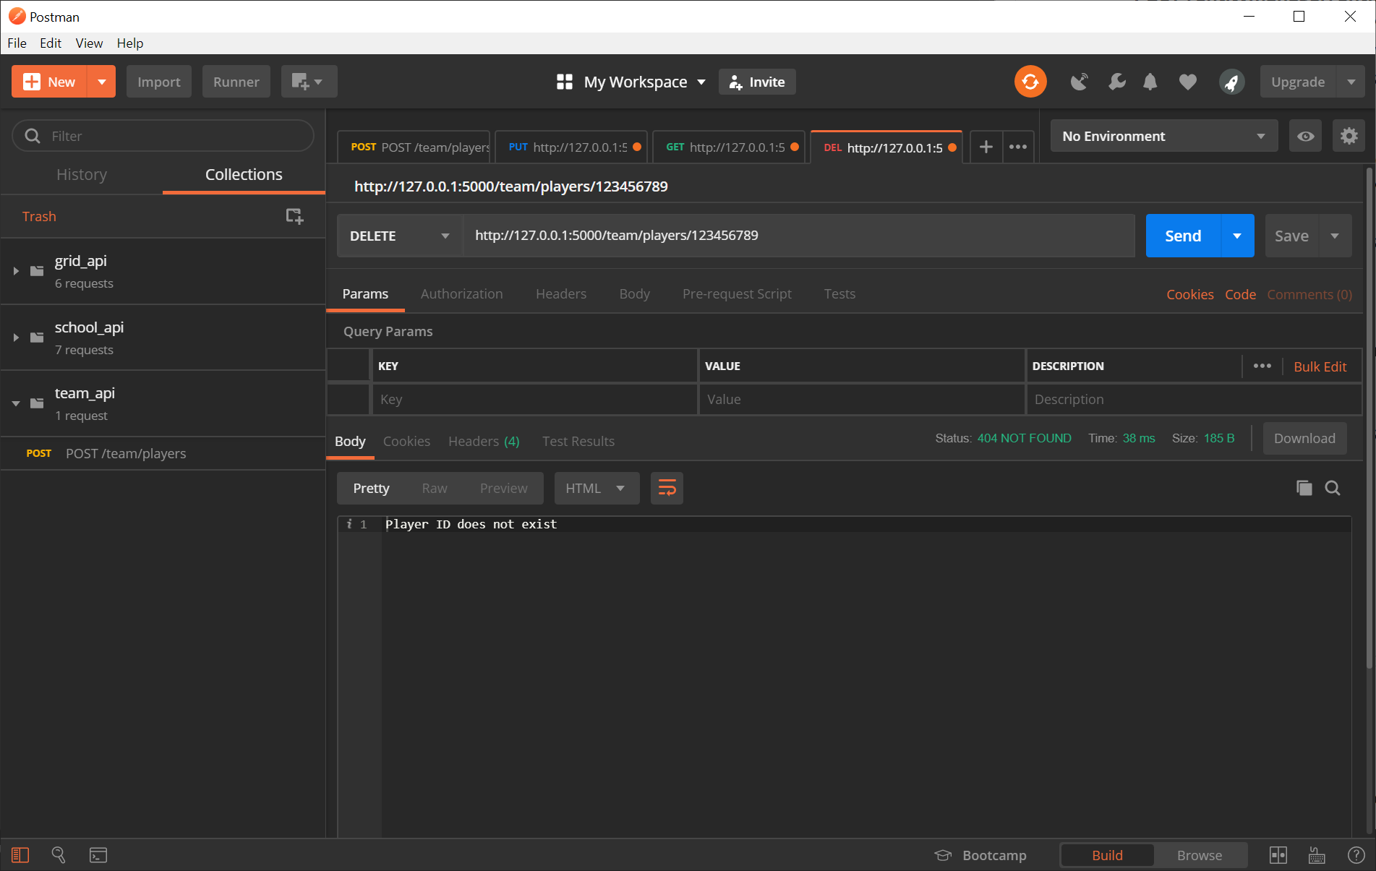

## Gets details of a player

### Status 200 – Details in JSON format

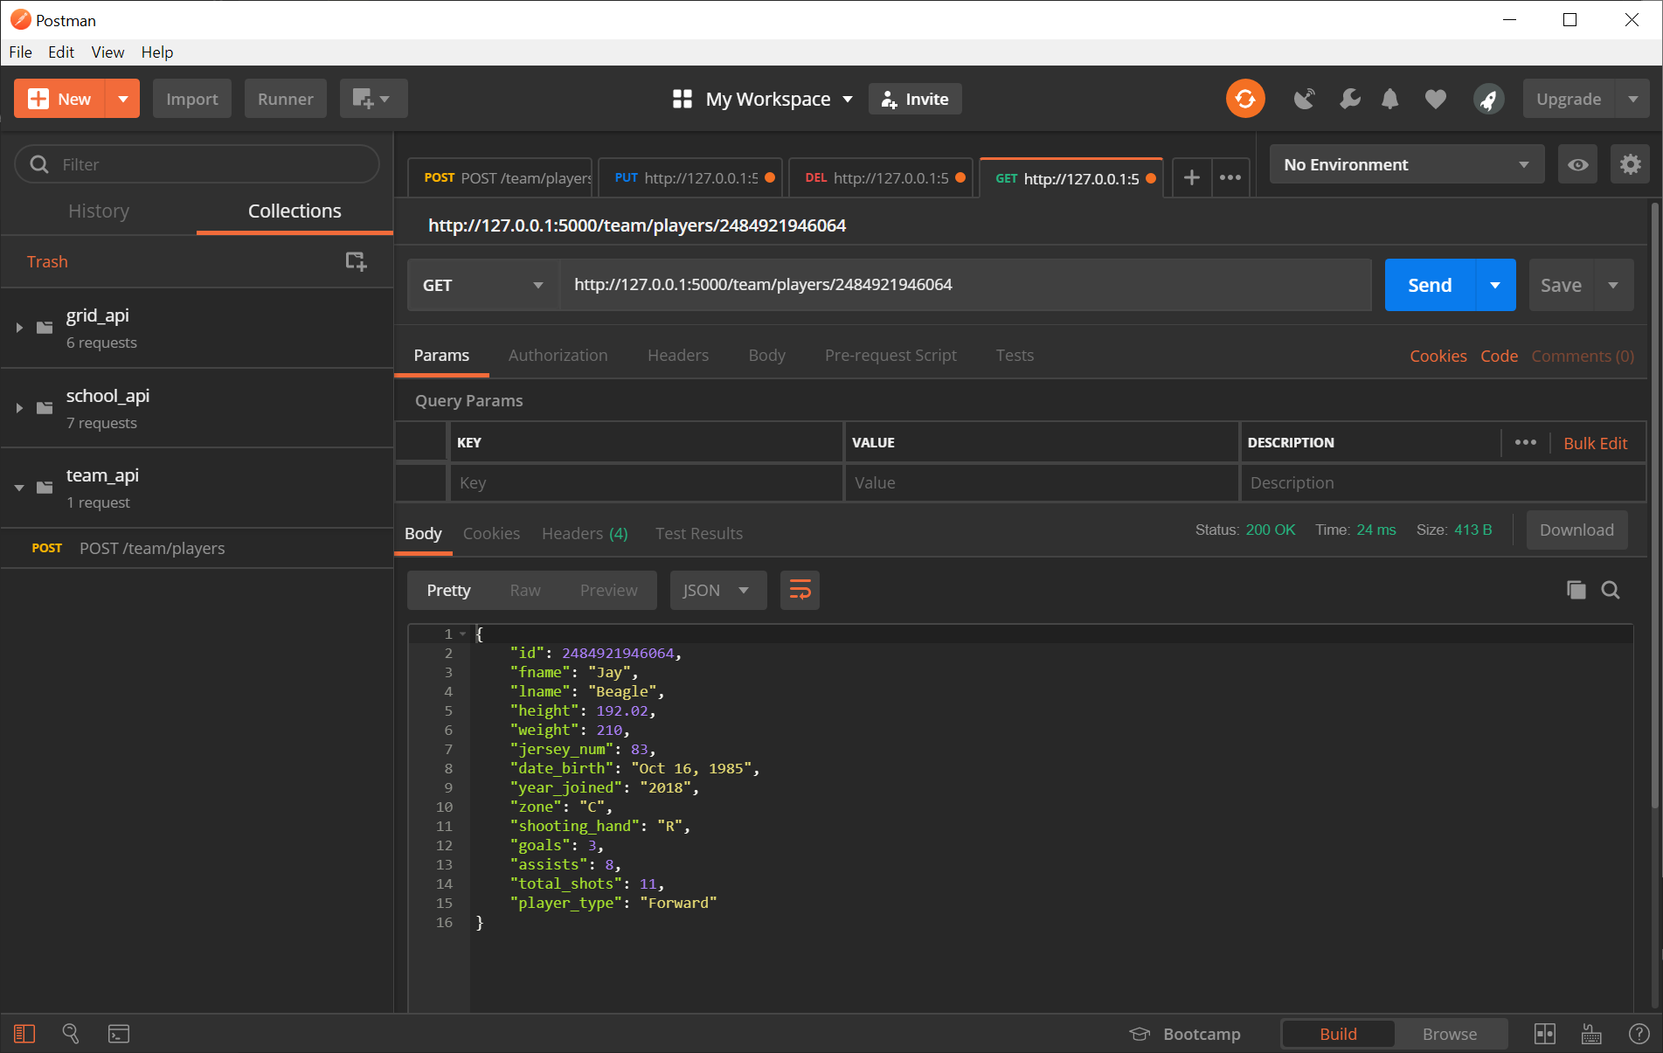

### Status 404 – Error message

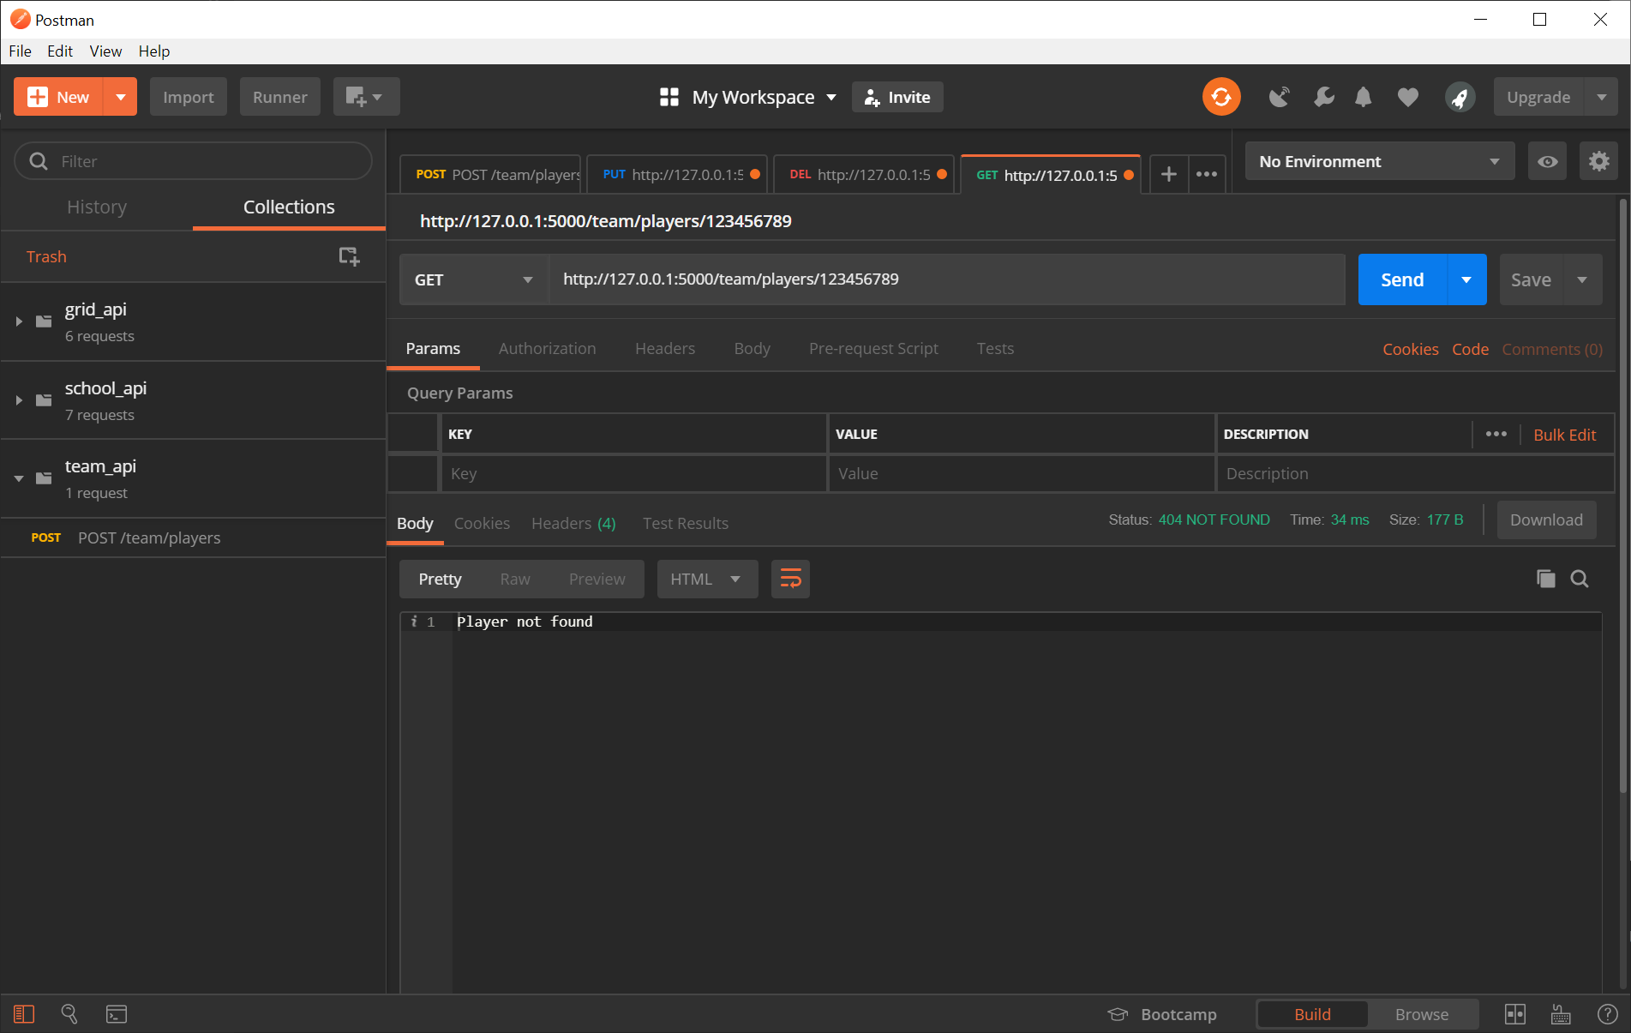

## Gets details of all players

### Status 200

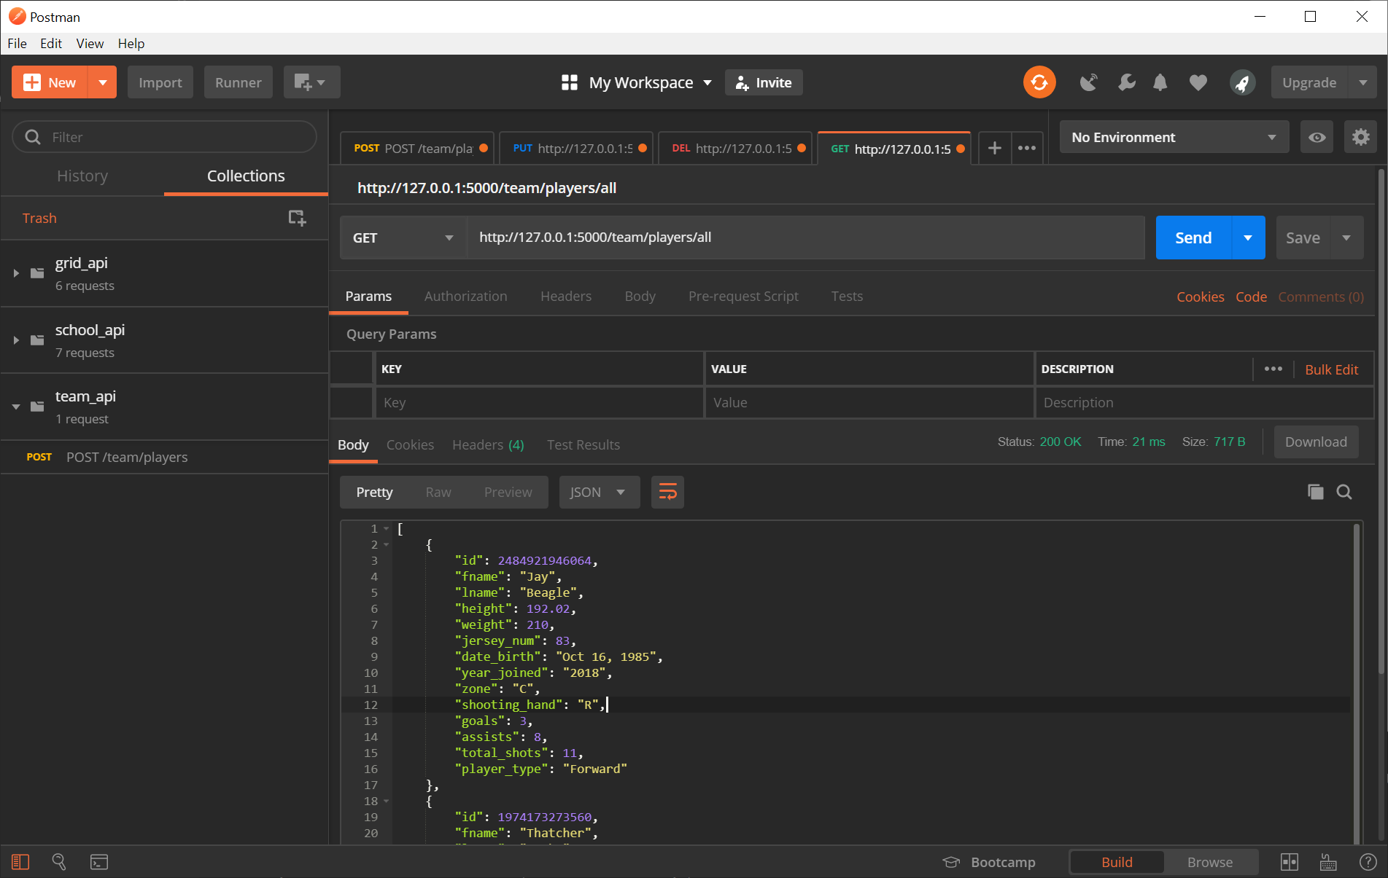

## Gets details of players of a certain type

### Status 200

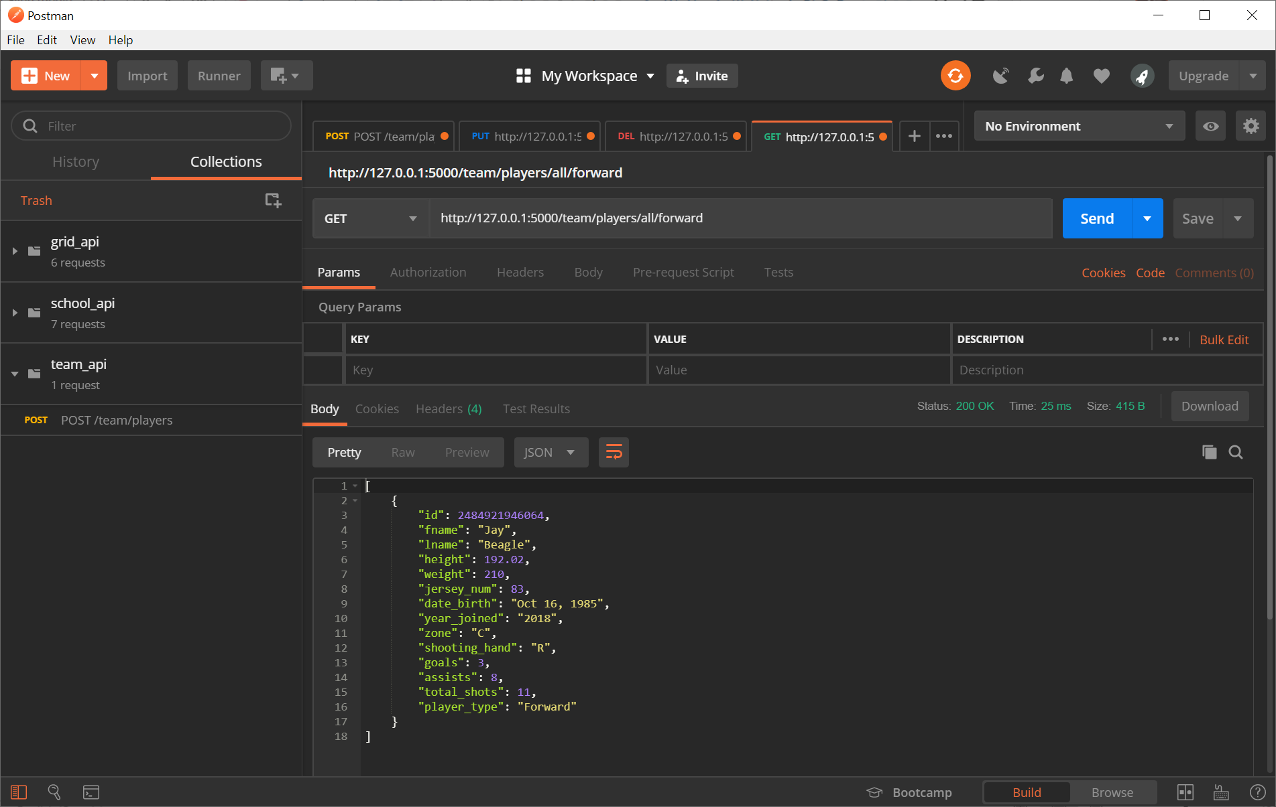

### Status 400

