Project Requirements Specification

Course: CS 474 Object-Oriented Design

Project Name: RADIS

Team Members
Andrew McClellan
Austin Traverse
Kelsey Hilton

Client Contact: <contact name, organization name>

Professor: Rob Byrd, iSchool, Abilene Christian University

Last updated: 30 March 2012

Document Revision Number: 1

NOTES:

- All project documents must have a cover page like this one. Every revision of this document must have all the information shown on this sample cover page.
- Please remove the word <Template> and all other text within brackets and template instructions (like this one) from your project document. Also, please remove all the blank forms at the end of this document. All this information is for your benefit, but should NOT appear in your own project document.
- I suggest that you save two copies of this document, one with the full set of instructions, and one in which you delete all the template materials and instructions, which you can use for your own project document.
- In other words, your final project document should look and read like a real requirements document as you would submit it to a business client. So, it must have a businesslike appearance, including: well formatted graphics and tables, clear and concise text that is readable, informational and free of typos and grammatical errors.
- The sections in the document must be numbered (consistent with this template) to facilitate communication with your client (and your professor) about the specifics of your document.
RADIS

Table of Contents & Status Report
Project Component | % Done
- Introduction
System Concept
- Business Case and Project Vision
- Stakeholders
System Requirements
- System Actors
- Scope of Work
- Functional Requirements
- Non-Functional Requirements
- Mandated Constraints
- Relevant Facts and Assumptions
Database Design
- Data Entities and Relationships
- Data Model
- Visual Interface and iRise Simulation
Appendices
  - Glossary of Terms and Acronyms
  - Actor Cards
  - Business Process Model
  - Use Case Diagram
  - Transitional Matrix: BPM and Use Cases
  - Use Cases: Functional Requirements
  - Data Model
  - Transitional Matrix: CRUD

<Your document must contain a table of contents in the second page, right after the cover page. Your table of contents must be numbered and the numbers must match the numbers of the corresponding sections. I suggest using page numbers in the document, but not in the table of contents because they will change frequently (unless you use the outline feature that maintains the table of contents automatically). It always helps to tell the reader what they should expect to find in the document. It is very hard to read a document when there is no roadmap upfront because you don’t know what to expect. The % Done column is to indicate the progress on each component. This will help your client figure out what has changed since the prior deliverable.>
<Please note that several sections of this template have been adopted and adapted from the “Volere Requirements Template” (posted on Blackboard) recommended by the Atlantic Systems Guild, Inc. company, fully described by Suzane Robertson and James Robertson in their book: “Mastering the Requirements Process” (please note that Tom DeMarco, one of the most influential members of the software engineering community, is a principal of this company). The Volere process is a popular requirements process used by several companies. We will not use this process for this project because we will be following both, the Unified Process (UP) of system development, which is a more standard process used these days, and the use case Process recommended by Frank Armour in his textbook, which is consistent with the UP. However, the Volere process includes a very useful requirements template that shows how a typical requirements document should be structured. Because this template is voluminous, the requirements template we will use for this course (subject of this document) is an adapted and simplified version of the Volere template. You can learn more about the “Volere” Requirements Process and associated resources at http://www.volere.co.uk/.>

- Introduction

In this document we describe the requirements for a Radiological Application for diagnostic Imaging and Storage, which we will here by refer to by RADIS. First we describe the system concept and define its scope. Then we provided detailed requirements defined by user stories, constraints, and client specifications.
<In this document we describe the requirements for the system <insert your project name here>. We first describe the system concept and vision, followed by a description of actors, system boundary and scope of the system. We then provide more detailed requirements using use cases, followed by a description of non-functional requirements for the system. Finally we provide a data model and other information management specifications. Please refer to Appendix A for a glossary of terms and acronyms used in this document.>
<IMPORTANT NOTE: students often make the mistake of writing this specification document in future tense (e.g., the system will allow users to withdraw cash). This has two problems. First, it increases the amount of work you have to do because once the system is finished you will use this document as part of the technical documentation of your system, which needs to be in present tense. Second, it makes the document harder to read. A well written document in present tense will help you accomplish the main goal of this document: to clearly and concisely document system requirements. So, please write in present tense.>

SYSTEM CONCEPT

- Business Case & Project Vision <see Armour, Ch.3: The “Vision Document”>

<This section of your document should clearly articulate and justify why the system will be developed. At minimum, it should contain a clear and concise description of: (a) who your client is; (b) the goals and objectives of the system; (c) the business problems/needs of your client, which the system will address or solve; (d) what the system will do; (e) and how the system will solve/address your client business problems/needs add value to the business; and any other useful background information.>

- Stakeholders <see Armour, Ch.6: “Preparing for Use Case Modeling”>
<A stakeholder is are anyone who will be affected by, or who have an interest (economic, technical, political, legal, etc.) in the system. It includes clients (i.e., who hired you to do the work), investors (i.e., who is paying for the development of the system), users (i.e., those who will be interacting with the system), and any other person or entity that has an interest in the system (e.g., regulators, key vendors, financing sources) or who will be affected by the system (e.g., managers, technical support groups, users/administrators of related systems that will interact with your system, users of prior versions, etc.). >
<IMPORTANT NOTE: please note that the goal of the stakeholder analysis goal is NOT to identify who the future users of the system will be, but who you will need to interview (hypothetically) in order to gather requirements. Many stakeholders may never use the system. Anyone who has an interest or who will be affected by the system should be interviewed (if you were doing this for real). When you are done with this section, you should have a very clear idea of who you need to talk to in order to gather requirements.>

SYSTEM REQUIREMENTS

- System Actors <see Armour, Ch.1: “Actors”>

<In this section you should list each human and external system actor that will interact with your system. It is best to list the human primary actors first because your system needs to fulfill the goals of these actors. You can then list all human secondary actors, followed by all external system actors. Note: you need to identify your primary human actors early in the requirements process. Secondary and system actors are usually discovered as the requirements are elaborated and refined, and can thus be added later. For each actor you identify and list in this section, please give a one-liner description of the actor in this section of the document, and then fully describe the actor in Appendix B using an Actor card (all blank forms can be found at the end of this document). IMPORTANT: all detailed actor cards must be included in Appendix B, not in the main body of the text.>

<At the end of this section, please include some text like this: “Actors are all the entities that interact with the system. Actors can be human (i.e., users) or external systems that need to interact with our system. In this section we provide a list of actors with brief descriptions. Please refer to Appendix B for the corresponding actor cards with full details.”>

- Scope of Work
<There are several artifacts you could use to describe the scope of work for your system. For this project you will prepare a high level business process model (BPM). This model should NOT contain a lot of details, but should give the reader a broad overview of the business processes related to this implementation. Your BPM should include a functional band (i.e., swim lane) for each key function, division or role associated with the process. However, since the BPM will be used to help you identify the functionality of the system to be built, it will be very useful to use one functional band (i.e., swim lane) for each primary actor (i.e., role) in your system. Remember, this is a model of the key business processes and not a system model. Therefore, you need to model what people do, not what the system does or will do. These diagrams are useful to foster clear communication with your client (and professor) and to develop a shared conceptualization of the work to be done within your team. Note: these models often contain several pages and diagrams, but you only need to prepare one diagram for this project. If you feel that you need more than one diagram, try to limit your model to no more than two diagrams. Please include your BPM diagram in Appendix C.>

<The main text should provide a 10 to 15 line broad description of the BPM and then end with some text like: “For further details on the BPM, please refer to Appendix C. This model shows a high level representation of the main business process this system will automate.”>

- Functional Requirements <see Armour, Chs. 2, 7, 8, 9 and 10>

<In this section you need to provide: (1) an all inclusive list of all use cases that you have identified in your requirements analysis. For each use case, please give a one-liner description of what the use case does; (2) also, prepare the corresponding use case diagram and include it in Appendix D; (3) then, prepare a BPM/use case transitional artifact and include it in Appendix E; (4) fully describe each use case using the appropriate form (all blank use case forms can be found at the end of this document) and include all use cases in Appendix F. IMPORTANT: all detailed use cases must be included in Appendix F, not in the main body of the text. The use cases and actors in your use case diagram must match the use cases listed in this section, the use cases described in Appendix F, and the actors listed in the Actor cards and context diagram. In other words, all your requirements and design artifacts must be consistent with each other.>

<At the end of this section, please include some text like this: “The use case diagram for these functional requirements is illustrated in Appendix D, which shows how actors interact with each of these use cases. Arrows from an actor to a use case indicate that the actor triggers the use case, whereas arrows from the system to an actor indicate that the system triggers the use case. Appendix E shows which use cases support which business process steps. Please also refer to Appendix F for the corresponding use cases with full details.”>

- Non-Functional Requirements <see Armour, Ch.11 “Supplemental Information>

<Non-functional requirements are an extremely important part of your requirements analysis. They have no effect whatsoever on what the system does, but it does affect how the system does it and the overall capabilities of the system. Non-functional requirements often have a substantial impact on the system’s implementation cost. For example, a system that is up and running and available 99.999% of the time, with redundant servers running on multiple cities, with data replication and synchronization, and capable of handling 5 million hits a day, will cost substantially more than a comparable system with identical functional requirements that runs in a standalone PC handling 100 hits per day. But both systems may have similar functionality. Requirements come in many forms and flavors. The Volere template has an excellent reference list of various requirement types, so please refer to that template. Each type of non-functional requirement needs to be listed as a sub-section in this section. Please use the sub-sections listed below only if appropriate and then delete any sub-sections you don’t need and add any new ones you need. Please don’t make up non-functional requirements just to fill this section because they reduce the credibility of your document. >

<Please only list non-functional requirements that are required by your client and those that you think are important for your system to operate properly in the environment in which it will be implemented. Don’t just list requirements to fill this section. Also, please make your non-functional requirements as specific and measurable as possible. Non-functional requirements that are not measurable (e.g., system must be fast and reliable) are totally useless in requirements documents because they cannot be enforced contractually. More specific and measurable non-functional requirements (e.g., system must be available 99.9% of the time and handle 100,000 transactions per day) are more useful. Finally, be mindful of who is paying for these capabilities. Students often make the mistake of stating the highest quality, speed and reliability they can think of, but if you are responsible for delivering this system for a fixed price, then will be hurting yourself financially.>

  - Look and Feel Requirements

  - Usability Requirements

  - Performance Requirements

  - Operational Requirements

  - Maintainability and Portability Requirements

  - Security Requirements

  - Cultural and Political Requirements

  - Legal Requirements

- Mandated Constraints

<You need to describe in this section any constraint imposed by your client on the system requirements. Only list those constraints that are important to document for your system. Mandated constraints are indistinguishable from design decisions that a system designer might make, except that these are required by your client. For example, as a system designer, you may decide to implement the system using an Oracle database management system DBMS). Such as design decision SHOULD NOT be included in a requirements specifications like this one. These decisions come later during the design phase. However, if your client wants to implement the system using an Oracle DBMS, then this is not a design decision, but a mandated constraint and, therefore, SHOULD be included in the requirements specification. Please do not make up mandated constraints just to fill this section and only list mandated requirements mentioned by your client or those that are necessary for your system to operate. If you have not identified mandated constraints, please write in this section something like this “No mandated constraints have been identified at this point.”>

- Relevant Facts and Assumptions

  - Facts

<Facts and assumptions are NOT the same thing. Students often make the mistake of commingling facts and assumptions. Facts are real, whereas assumptions are things you don’t know but want to state in writing. Facts are like mandated constraints, except that they are not imposed by your client, but by the reality of your system environment (e.g., the system must support English, Spanish and French speaking users), and they are generally discovered as you gather requirements. Please do not make up facts just to fill this section and only list real facts uncovered as you gathered requirements, facts mentioned by your client, or those that are necessary for your system to operate. If you have not identified any relevant facts, please write in this section something like this “No relevant facts affecting the system have been identified at this point.”>

  - Assumptions

<Stating assumptions protect yourself contractually so, when in doubt, please clearly articulate your assumptions (e.g., the company’s Internet connection must be operating, all users can interact in English). In contrast to mandated constraints and facts, it is OK to make up assumptions because you are the one making these assumptions. At the same time, please do not make up assumptions just to fill this section and only list assumptions that you think are necessary for your system to operate. If you have not identified any assumptions you want to make, please write in this section something like this “No assumptions about the system have been identified at this point.”>

INFORMATION MODEL

- Data Entities and Relationships <see Armour, Ch. 12 “Map Use Cases to Object Models>

<In this section you need to list all the data entities that you have identified in your requirements analysis. For each entity (i.e., database table) that you have identified and listed, you need to briefly describe the data that will be recorded in that table. You need to need to do this by describing the data that will be contained in a typical record in that table and the most important fields that will be contained in the table (e.g., Orders Table: contains a record for each order placed by a customer, recording the order number, client ID, order date, and order status, among other attributes).>

<Similarly, since some of your clients may not know how to read a data model, so please provide a brief text description for EACH relationship in your data model. This is done more effectively by listing the two tables involved in the relationship and describing their cardinality on both sides, but using plain English (e.g., Clients-Orders: a client can place many orders and each order can only be associated with one client)>

<After your brief description of your entities and relationships you should point your readers to the data model with text like this: “The data entities listed in this section and how these tables related to each other is illustrated in the data model in Appendix G.>

<Finally, include a CRUD matrix in Appendix H mapping which use cases manipulate data in which data entities. The data objects listed in the CRUD matrix need to match the data entities listed in this section. Also, since your clients may not be familiar with CRUD matrices, you need to include text like this: “The interaction between the use cases described in the Functional Requirements above and the database tables listed in this section is represented in the CRUD matrix in Appendix H. This matrix lists one row (or column, depending on your layout) for every use case and a column (or row, depending on your layout) for every database table. The cells contain the letters C, R, U or F, depending on whether the use case creates, reads, updates and/or deletes records in the corresponding table.”>

APPENDIX A
Glossary of Terms and Acronyms

APPENDIX B
Actor Cards

<Actor cards that are shorter than one page need to be shown on the same page. If the next actor card doesn’t fit on the same page, please add a page break and start the next actor card at the top of the new page. Only actor cards that span more than one page can be broken into the next page, but they must start at the beginning of a page>

APPENDIX C
Scope of Work: Business Process Model <example>

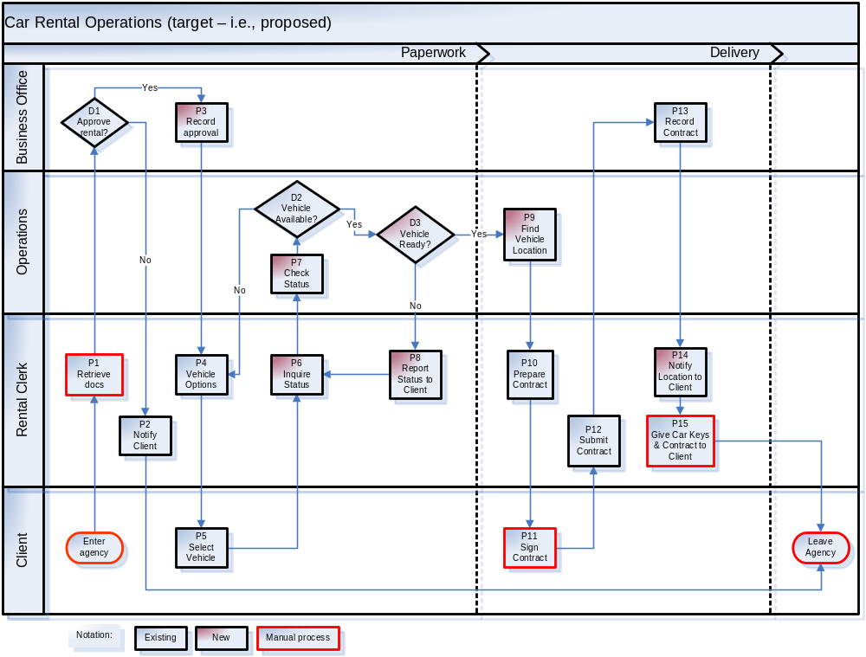
APPENDIX D
Use Case Diagram

<Include your system’s use case diagram in this appendix. The use case diagram should contain the same actors as the context diagram – please ensure that your diagrams are consistent with each other. In contrast to the context diagram, a use case diagram represents the system as a box with all the use cases inside the box represented as ovals, as illustrated in the example below. Also, the meaning of the arrows in use case diagrams is different than those of the context diagram. Arrows in context diagrams represent the direction of information or data flows, whereas arrows in the use case diagram indicate who triggers/initiates the use case. If the actor triggers the use case, the arrow head points to the use case, whereas if the system triggers the use case, the arrow points to the actor. Also, although the diagram below doesn’t show it, it helps the reader (your client and professor) if you include use case numbers in the respective ovals, which need to match the respective numbers in the actual use cases.>

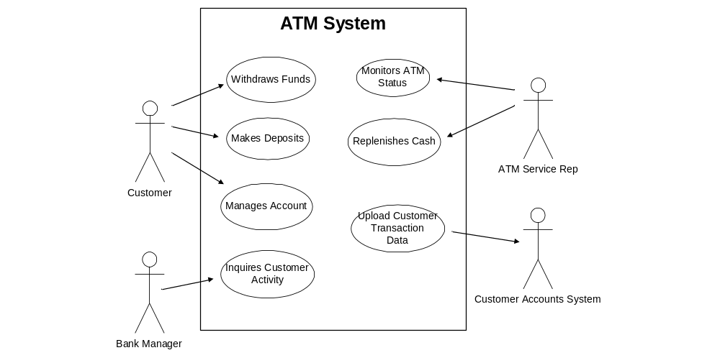

APPENDIX E
Transitional Matrix: BPM and Use Cases

<Provide a table that has all your BPM steps as rows and your use cases as columns. In the respective cells place an X to indicate with process steps are handled by which use case. >
APPENDIX F
Use Cases: Functional Requirements

<Use cases that are shorter than one page need to be shown on the same page. If the next use case doesn’t fit on the same page, please add a page break and start the next use case at the top of the new page. Only use cases that span more than one page can be broken into the next page, but they must start at the beginning of a page>
APPENDIX G
Data Model

APPENDIX G
Transitional Matrix: CRUD (Create, Read, Update and Delete)

<Provide a table that has all your data entities (i.e., database tables) as rows and your use cases as columns. In the respective cells place a C, R, U and/or D to indicate if the respective use case (C) creates data (inserts records), (R) reads data, (U) updates data or (D) deletes records in the respective data table. >

BLANK FORMS
Actor Cards

Actor Specification
Actor Name:
Type: (Primary/Secondary) | Personality: (I, E, R or F) | Abstract: (Yes/No)
Role Description:

Actor Goals:

Use Cases Involved with:

Use Cases

Initial Use Case Form
(Use case is described with a text narrative)

Use Case ID | (prefix your Use Case IDs with UC, to distinguish them from other models)
Use Case
Elaboration | Initial use case description
Actors
Description
Priority | (High, Medium or Low)
Non-Functional Requirements | (only those associated with this use case, if any)
Assumptions
Source

Base Use Case Form
(Use case is described with sequential flows of events
for sunny-day scenarios only – no conditional flows should be included)

Use Case ID | (prefix your Use Case IDs with UC, to distinguish them from other models)
Use Case
Elaboration | Base use case
Actors
Description | (brief)
Pre-conditions
Flow of Events | - etc.
Post-conditions
Alternative Flows | (briefly describe alternative flows here for base Use Cases; extend this into complete conditional flows of events in the corresponding Elaborated Use Cases)
Priority | (High, Medium or Low)
Non-Functional Requirements | (only those associated with this use case, if any)
Assumptions
Outstanding Issues
Source

Elaborated Use Case Form
(Use case is described with sequential flows of events
for both sunny-day and rainy-day scenarios – start all-rainy day scenarios with “if” and “else” statements and then list the corresponding flows as either: conditional flows within this form; or as alternative flows in a separate form for alternative flows)

Use Case ID | (prefix your Use Case IDs with UC, to distinguish them from other models)
Use Case
Elaboration | Elaborated use case
Actors
Description | (brief)
Pre-conditions
Flow of Events  (include conditional flows here as they occur) | - If xxx  - Else  - etc.
Post-conditions
Alternative Flows | (briefly describe alternative flows here for base Use Cases; extend this into complete flow of events for Elaborated Use Cases, either here or in the next template)
Priority | (High, Medium or Low)
Non-Functional Requirements | (only those associated with this use case, if any)
Assumptions
Outstanding Issues
Source

Alternative Elaborated Use Case Form
(Use case is described with sequential flows of events
for sunny-day scenarios – and then listing all conditional flows or rainy day scenarios in a different section below. start all-rainy day scenarios with “if” and “else” statements
Use Case: UC-03 Eligibility Evaluation
Elaboration | Elaborated use case
Actors
Pre-conditions
Optimistic Flow of Events
Conditional Flows
Post-conditions
Elaborated Use Case Form w/Business Steps
(This is the same form as the prior Elaborated Use Case form, but it has two columns where you can differentiate system steps from business steps. Use cases normally only have system steps, but describing business steps may provide important context information for your application. It is important that developers can differentiate system actions from business actions in your use cases.)

Use Case ID | (prefix your Use Case IDs with UC, to distinguish them from other models)
Use Case
Elaboration | Elaborated use case
Actors
Description | (brief)
 | System Steps | Business Steps
Pre-conditions
Flow of Events  (include conditional flows here as they occur) | - If xxx  - Else  etc. | - If xxx  - Else  etc.
Post-conditions
Alternative Flows | (briefly describe alternative flows here for base Use Cases; extend this into complete flow of events for Elaborated Use Cases, either here or in the next template)
Priority | (High, Medium or Low)
Non-Functional Requirements | (only those associated with this use case, if any)
Assumptions
Outstanding Issues
Source
Use Case Form for Alternative Flows
(An Alternative Use Case MUST be associated with an existing Elaborated Use Case)

Use Case ID | (same ID as the base Use Case ID, but with suffix A1, A2, etc., for each alternative flow Use Case)
Use Case
Elaboration | (indicate whether it’s initial, base or elaborated use case)
Actors
Description | (brief)
Insertion Point | (step in Base Use Case where this alternative flow should be inserted)
Pre-conditions | (clearly indicate under which conditions the alternative flow is triggered)
Alternative Flow of Events
Post-conditions
Priority | (High, Medium or Low)
Non-Functional Requirements | (only those associated with this use case, if any)
Assumptions
Outstanding Issues
Source

Form for Extending Use Cases
(An Extending Use Case MUST be associated with an existing Elaborated Use Case)

Use Case ID | (same ID as the base Use Case ID, but with suffix E1, E2, etc., for each extending Use Case)
Use Case
Elaboration | (indicate whether it’s initial, base or elaborated use case)
Additional Actors | (only list actors not listed in the extended use case)
Description | (brief)
Extended Use Case | (ID and name)
Extension Point | (step in Base Use Case where it is extended)
Guard Condition | (pre-condition in the extended Use Case that causes it to execute)
Flow of Events
Conditional Flows
Post-conditions
Alternative Flows | (briefly describe alternative flows here for the Extending Use Case; extend this into complete flow of events in an Alternative Use Case form if needed)
Priority | (High, Medium or Low)
Non-Functional Requirements | (only those associated with this use case, if any)
Assumptions
Outstanding Issues
Source

Form for Included Use Cases
(An Included Use Case is generic and can be re-used and included in any other Use Case,
so it does not need to be associated with a specific Use Case)

Use Case ID | (prefix your Use Case IDs with IUC, to distinguish them from other Use Cases)
Use Case
Elaboration | (indicate whether it’s initial, base or elaborated use case)
Description | (brief)
Including Use Cases | (list all Use Cases that use this Included Use Case)
Pre-conditions
Flow of Events
Conditional Flows
Post-conditions
Alternative Flows | (briefly describe alternative flows here for the Included Use Case; extend this into complete flow of events in an Alternative Use Case form if needed)
Priority | (High, Medium or Low)
Non-Functional Requirements | (only those associated with this use case, if any)
Assumptions
Outstanding Issues
Source

Form for CRUD-Type Use Cases
(Some Use Cases do very little processing and a lot of data management; these use cases don’t have a lot of detailed flows to describe, but instead they contain a lot of data management steps – e.g., create, read, update and/or delete data; since database application developers know exactly what to do in such cases, it is often simpler to specify your flows broken down by CRUD activities and using simpler flows; since you will later need to use these use cases to identify data objects, the following use case format is appropriate for these use cases)

Use Case ID | (prefix your Use Case IDs with UC)
Use Case
Elaboration | (indicate whether it’s initial, base or elaborated use case)
Actors | (prefix actors with [P] for primary and [S] for secondary)
Description | (brief – but you may also want to say something like “this use case handles standard data management events for etc.)
Pre-conditions
Flow of Events | Create Data  C1.  C2. etc.  Read Data  R1.  R2. etc.  Update Data  U1.  U2. etc.  Delete Data  D1.  D2. etc.
Conditional Flows
Post-conditions
Alternative Flows | (briefly describe alternative flows here for base Use Cases; extend this into complete flow of events for Elaborated Use Cases, either here or in the next template)
Priority | (High, Medium or Low)
Non-Functional Requirements | (only those associated with this use case, if any)
Assumptions
Outstanding Issues
Source

BPM/Use Case Transitional Matrix Form

BPM |  |  | Use Case
Step | Name | Type | UC 1 | UC 2 | UC 3 | Etc.
P1
P2
P3
Etc.

CRUD Matrix Form
(Create, Read, Update, Delete)

Entity | Use Case
Entity | UC 1 | UC 2 | UC 3 | Etc.
Entity 1
Entity 2
Etc.

Requirements Shell (RS) Cards
Not required for this project, but many requirements analysts find them useful to take field notes while you are gathering requirements. Fill one RS card for anything that a stakeholder describes that sounds like a requirement (functional or non-functional). One RS card may generate zero, one or many use cases or many RS cards may be consolidated into one use case. Think of an RS card as an organized way to take field notes when you are gathering requirements (i.e., “trawling for knowledge”).

Requirement Shell
Requirement No.: | Requirement Type: |  | Use Cases:
Description:

Rationale:

Source:
Fit Criterion:

Customer Satisfaction Rating: |  | Customer Dissatisfaction Rating:
Dependencies: |  | Conflicts:
History: |  | Supporting Materials:

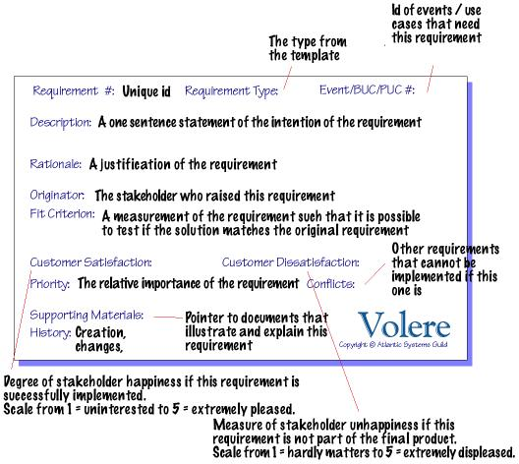
© The Atlantic Systems Guild Limited

