Project Requirements Specification

Course: CS 474 Object-Oriented Design

Project Name: RADIS

Team Members
Andrew McClellan
Austin Traverse
Kelsey Hilton

Client Contact: <contact name, organization name>

Professor: Rob Byrd, iSchool, Abilene Christian University

Last updated: 7 April 2012

Document Revision Number: 3

RADIS

Table of Contents & Status Report
Project Component | % Done
- Introduction
System Concept
- Business Case and Project Vision
- Stakeholders
System Requirements
- System Actors
- Scope of Work
- Functional Requirements
- Non-Functional Requirements
- Mandated Constraints
- Relevant Facts and Assumptions
Database Design
- Data Entities and Relationships
- Data Model
- Visual Interface and iRise Simulation
Appendices
  - Glossary of Terms and Acronyms
  - Actor Cards
  - Business Process Model
  - Use Case Diagram
  - Transitional Matrix: BPM and Use Cases
  - Use Cases: Functional Requirements
  - Data Model
  - Transitional Matrix: CRUD

- Introduction

In this document we describe the requirements for a Radiological Application for diagnostic Imaging and Storage, which we will here by refer to by RADIS. First we describe the system concept and define its scope. Then we provide detailed requirements derived from user stories, constraints, and client specifications. Finally we provide a data model and other information management specifications. Refer to Appendix A for a glossary of terms and acronyms used in this document.

SYSTEM CONCEPT

- Business Case & Project Vision
For the purposes of our project we are assuming that Hendrick Medical System, the client, has a need for a Radiological Application for Diagnostic Imaging and Storage. The application is intended for use by radiology specialists as a diagnostic assistant. RADIS is a type of electronic health record (EHR) system. It will maintain a database of patient history but also have image processing capabilities to aid radiologists and physicians in making a diagnosis and treating patients. RADIS will analyze images and use doctor confirmed patient history to provide a possible diagnosis. The system will also list alternate diagnoses which will be ranked on probability of correctness.

RADIS will use past history, and standard data compiled over time from a variety of patients to compare to patient data and confirm a diagnosis or come up with an alternate diagnosis that may have otherwise been missed. An accurate diagnosis means that the patient won’t need to return when symptoms persist as a result of an inaccurate diagnosis. There will be fewer frustrated patients who are more likely to return and/or recommend Hendrick Medical System.

- Stakeholders
Stakeholders include:
Rob Byrd, our professor, who defined the goal, guides the design, and assigns a grade.
Radiologists, the primary users of the application.
Hendrick Medical Center, the client for whom the application is being developed.

SYSTEM REQUIREMENTS

- System Actors
Radiologists: the primary user of RADIS.
Patients: the secondary user of the system.

Actors represent anything that interacts with the system; they can be human or external systems. This section lists of actors and brief descriptions. Refer to Appendix B for actor cards with full details.

- Scope of Work
Starts with a patient needing to be diagnosed.
The patient explains symptoms.
Radiologist enters symptoms into patient history.
Radiologist determines if a scan is necessary.
Assistant takes images of patient with medical imaging equipment.
Image is processed and returns a result.
A report generated from image result and patient history suggests a diagnosis.
The radiologist confirms a diagnosis.
Diagnosis is saved in the patient’s history.

<There are several artifacts you could use to describe the scope of work for your system. For this project you will prepare a high level business process model (BPM). This model should NOT contain a lot of details, but should give the reader a broad overview of the business processes related to this implementation. Your BPM should include a functional band (i.e., swim lane) for each key function, division or role associated with the process. However, since the BPM will be used to help you identify the functionality of the system to be built, it will be very useful to use one functional band (i.e., swim lane) for each primary actor (i.e., role) in your system. Remember, this is a model of the key business processes and not a system model. Therefore, you need to model what people do, not what the system does or will do. These diagrams are useful to foster clear communication with your client (and professor) and to develop a shared conceptualization of the work to be done within your team. Note: these models often contain several pages and diagrams, but you only need to prepare one diagram for this project. If you feel that you need more than one diagram, try to limit your model to no more than two diagrams. Please include your BPM diagram in Appendix C.>

<The main text should provide a 10 to 15 line broad description of the BPM and then end with some text like: “For further details on the BPM, please refer to Appendix C. This model shows a high level representation of the main business process this system will automate.”>

- Functional Requirements
- The user should be able to create a new patient object in a database.
- The user should be able to input patient history.
- The user should be able to input an image.
- The user should be able to select what type of image is to be processesed.
- The system should return a result from the image processing.
- The result should be in the form: “normal or abnormal”
- The system should interpret the image result and patient history to come up with a diagnosis.
- The application should produce a report.
  - The report should include all previous history.
  - The report should include the original image
  - The report should include the processed image.
  - The result should include the result of the processed image.
  - The report should include a diagnosis.
  - The report should include a list of alternate diagnoses.
    - The list of alternate diagnoses should be ordered by probability of correctness.
- All diagnoses should be presented with justification.
  - The justification should list matching symptoms and matching image indications.

<In this section you need to provide: (1) an all inclusive list of all use cases that you have identified in your requirements analysis. For each use case, please give a one-liner description of what the use case does; (2) also, prepare the corresponding use case diagram and include it in Appendix D; (3) then, prepare a BPM/use case transitional artifact and include it in Appendix E; (4) fully describe each use case using the appropriate form (all blank use case forms can be found at the end of this document) and include all use cases in Appendix F. IMPORTANT: all detailed use cases must be included in Appendix F, not in the main body of the text. The use cases and actors in your use case diagram must match the use cases listed in this section, the use cases described in Appendix F, and the actors listed in the Actor cards and context diagram. In other words, all your requirements and design artifacts must be consistent with each other.>

<At the end of this section, please include some text like this: “The use case diagram for these functional requirements is illustrated in Appendix D, which shows how actors interact with each of these use cases. Arrows from an actor to a use case indicate that the actor triggers the use case, whereas arrows from the system to an actor indicate that the system triggers the use case. Appendix E shows which use cases support which business process steps. Please also refer to Appendix F for the corresponding use cases with full details.”>

- Non-Functional Requirements

<Non-functional requirements are an extremely important part of your requirements analysis. They have no effect whatsoever on what the system does, but it does affect how the system does it and the overall capabilities of the system. Non-functional requirements often have a substantial impact on the system’s implementation cost. For example, a system that is up and running and available 99.999% of the time, with redundant servers running on multiple cities, with data replication and synchronization, and capable of handling 5 million hits a day, will cost substantially more than a comparable system with identical functional requirements that runs in a standalone PC handling 100 hits per day. But both systems may have similar functionality. Requirements come in many forms and flavors. Please don’t make up non-functional requirements just to fill this section because they reduce the credibility of your document. >

<Please only list non-functional requirements that are required by your client and those that you think are important for your system to operate properly in the environment in which it will be implemented. Don’t just list requirements to fill this section. Also, please make your non-functional requirements as specific and measurable as possible. Non-functional requirements that are not measurable (e.g., system must be fast and reliable) are totally useless in requirements documents because they cannot be enforced contractually. More specific and measurable non-functional requirements (e.g., system must be available 99.9% of the time and handle 100,000 transactions per day) are more useful. Finally, be mindful of who is paying for these capabilities. Students often make the mistake of stating the highest quality, speed and reliability they can think of, but if you are responsible for delivering this system for a fixed price, then will be hurting yourself financially.>

  - Look and Feel Requirements

  - Usability Requirements

  - Performance Requirements

  - Operational Requirements

  - Maintainability and Portability Requirements

  - Security Requirements

  - Cultural and Political Requirements

  - Legal Requirements

- Mandated Constraints

The application will work on Visual Studio.
The library is programmed in the C language.

No more constraints have been identified at this time.

- Relevant Facts and Assumptions

  - Facts

<Facts and assumptions are NOT the same thing. Students often make the mistake of commingling facts and assumptions. Facts are real, whereas assumptions are things you don’t know but want to state in writing. Facts are like mandated constraints, except that they are not imposed by your client, but by the reality of your system environment (e.g., the system must support English, Spanish and French speaking users), and they are generally discovered as you gather requirements. Please do not make up facts just to fill this section and only list real facts uncovered as you gathered requirements, facts mentioned by your client, or those that are necessary for your system to operate. If you have not identified any relevant facts, please write in this section something like this “No relevant facts affecting the system have been identified at this point.”>

  - Assumptions
    - The computers must run a Windows platform and have Visual Studio installed.

INFORMATION MODEL

- Data Entities and Relationships

<In this section you need to list all the data entities that you have identified in your requirements analysis. For each entity (i.e., database table) that you have identified and listed, you need to briefly describe the data that will be recorded in that table. You need to need to do this by describing the data that will be contained in a typical record in that table and the most important fields that will be contained in the table (e.g., Orders Table: contains a record for each order placed by a customer, recording the order number, client ID, order date, and order status, among other attributes).>

<Similarly, since some of your clients may not know how to read a data model, so please provide a brief text description for EACH relationship in your data model. This is done more effectively by listing the two tables involved in the relationship and describing their cardinality on both sides, but using plain English (e.g., Clients-Orders: a client can place many orders and each order can only be associated with one client)>

<After your brief description of your entities and relationships you should point your readers to the data model with text like this: “The data entities listed in this section and how these tables related to each other is illustrated in the data model in Appendix G.>

The interaction between the use cases described in the Functional Requirements above and the database tables listed in this section is represented in the matrix in Appendix H. This matrix lists one column for every use case and a row for every database table. The cells contain the letters C, R, U or D, depending on whether the use case creates, reads, updates and/or deletes records in the corresponding table.

APPENDIX A
Glossary of Terms and Acronyms

CVIP: Computer Vision Image Processing, the foundational API for this project.

CRUD: C, R, U or D, depending on whether a use case creates, reads updates and/or deletes data.

APPENDIX B
Actor Cards

<Actor cards that are shorter than one page need to be shown on the same page. If the next actor card doesn’t fit on the same page, please add a page break and start the next actor card at the top of the new page. Only actor cards that span more than one page can be broken into the next page, but they must start at the beginning of a page>

APPENDIX C
Scope of Work: Business Process Model <example>

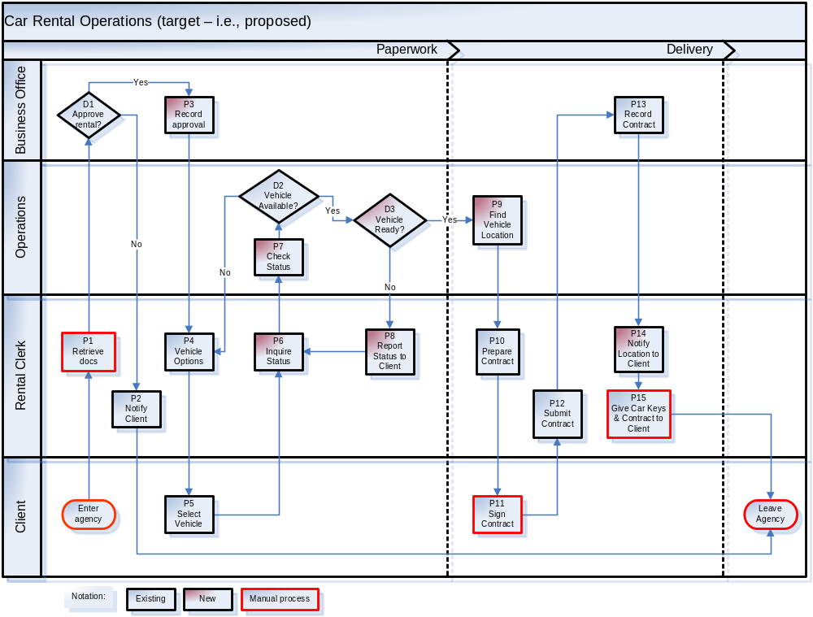
APPENDIX D
Use Case Diagram

<Include your system’s use case diagram in this appendix. The use case diagram should contain the same actors as the context diagram – please ensure that your diagrams are consistent with each other. In contrast to the context diagram, a use case diagram represents the system as a box with all the use cases inside the box represented as ovals, as illustrated in the example below. Also, the meaning of the arrows in use case diagrams is different than those of the context diagram. Arrows in context diagrams represent the direction of information or data flows, whereas arrows in the use case diagram indicate who triggers/initiates the use case. If the actor triggers the use case, the arrow head points to the use case, whereas if the system triggers the use case, the arrow points to the actor. Also, although the diagram below doesn’t show it, it helps the reader (your client and professor) if you include use case numbers in the respective ovals, which need to match the respective numbers in the actual use cases.>

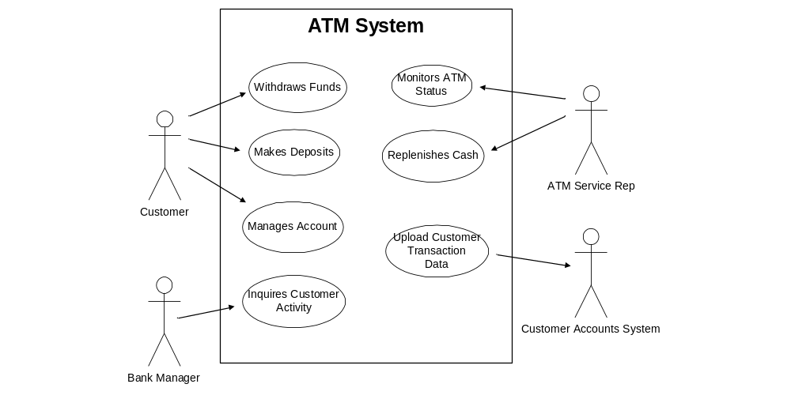

APPENDIX E
Transitional Matrix: BPM and Use Cases

<Provide a table that has all your BPM steps as rows and your use cases as columns. In the respective cells place an X to indicate with process steps are handled by which use case. >
APPENDIX F
Use Cases: Functional Requirements

<Use cases that are shorter than one page need to be shown on the same page. If the next use case doesn’t fit on the same page, please add a page break and start the next use case at the top of the new page. Only use cases that span more than one page can be broken into the next page, but they must start at the beginning of a page>
APPENDIX G
Data Model

APPENDIX G
Transitional Matrix: CRUD (Create, Read, Update and Delete)

<Provide a table that has all your data entities (i.e., database tables) as rows and your use cases as columns. In the respective cells place a C, R, U and/or D to indicate if the respective use case (C) creates data (inserts records), (R) reads data, (U) updates data or (D) deletes records in the respective data table. >

Entity | Use Case
Entity | UC 1 | UC 2 | UC 3 | Etc.
Entity 1
Entity 2
Etc.

Use Cases

Use Case ID | UC1
Use Case | Simplified Exam
Elaboration | Basic flow of an exam
Actors | Patient, Physician
Description | A patient comes into the office for an exam. The physician enters patient data into the diagnostic assistant application and it returns a probable diagnosis. The physician confirms the diagnosis. The diagnosis is saved in patient’s history. The physician treats the patient.
Priority | High
Non-Functional Requirements | (only those associated with this use case, if any)
Assumptions
Source

Use Case ID | UC2
Use Case | Add Patient
Elaboration | Base use case
Actors | Physician, Patient
Description | Add patient to database
Pre-conditions | The patient is a new patient
Flow of Events | - Click add patient button  - Enter first name, last name, date of birth, physician  - Automatically assign patient ID number  - Enter family history  - Enter past history  - Enter present medical problems  - Enter allergies  - Enter current medications  - Save patient to database and return to main
Post-conditions | Patient history is stored in database
Alternative Flows
Priority | High
Non-Functional Requirements | (only those associated with this use case, if any)
Assumptions | No one has the same name.
Outstanding Issues | Given time constraints there will not be an actual database

Use Case ID | UC3
Use Case | Data entry
Elaboration | Base use case
Actors | Physician, Patient
Description | Describe reason for visit and enter data necessary for diagnosis
Pre-conditions | The patient exists in the database.
Flow of Events | - Find Patient in database  - Enter date of exam  - Enter name of physician  - Enter symptoms  - Upload image
Post-conditions | The reason for visit is recorded
Priority | High
Non-Functional Requirements | (only those associated with this use case, if any)
Assumptions | Symptoms will match exactly with those stored in database. Every entry is required except the image.

Use Case ID | UC4
Use Case | Exam Form
Elaboration | Base use case
Actors | Physician, Patient
Description | Describe reason for visit prepare for diagnosis
Pre-conditions | The patient exists in the database.
Flow of Events | - Find Patient in database  - Enter first name, last name, date of birth, physician  - Automatically assign patient ID number  - Enter family history  - Enter past history  - Enter present medical problems  - Enter allergies  - Enter current medications  - Save patient to database and return to main
Post-conditions | Patient history is stored in database
Alternative Flows
Priority | High
Non-Functional Requirements | (only those associated with this use case, if any)
Assumptions | No one has the same name. Capitalization matters.

Use Case ID | UC5
Use Case | In-depth exam
Elaboration | Elaborated use case
Actors | Physician, Patient
Description | The physician goes through the exam recording symptoms and adding images to be processed. The information is then analyzed and results are displayed in a report.
Pre-conditions | A patient comes into the office for an exam
Flow of Events | - Enter Patient name  - If patient does not exist in database  - Add new patient  - Enter date of Exam  - Enter reason for visit  - Enter symptoms  - If an image is needed for diagnosis  - Upload image  - Save and copy original image  - Process image copy  - Save processed image  - Return image result as a symptom  - Click generate report button to find a diagnosis  - Display report with original and processed images as well as a diagnosis and a list of alternatives  - Have physician confirm diagnosis  - Save diagnosis and images to patient history
Post-conditions | Patient is diagnosed and the diagnosis and images are saved in patient history.
Alternative Flows | 1. An image may not be necessary depending on the reason for visit in which case the upload should be ignored.  2. A physician may not agree with any of the provided diagnoses in which case he should be allowed to enter his own.
Priority | High
Non-Functional Requirements | (only those associated with this use case, if any)
Assumptions | Necessary images already exist.

Use Case ID | (same ID as the base Use Case ID, but with suffix A1, A2, etc., for each alternative flow Use Case)
Use Case
Elaboration | (indicate whether it’s initial, base or elaborated use case)
Actors
Description | (brief)
Insertion Point | (step in Base Use Case where this alternative flow should be inserted)
Pre-conditions | (clearly indicate under which conditions the alternative flow is triggered)
Alternative Flow of Events
Post-conditions
Priority | (High, Medium or Low)
Non-Functional Requirements | (only those associated with this use case, if any)
Assumptions
Outstanding Issues
Source

Form for Extending Use Cases
(An Extending Use Case MUST be associated with an existing Elaborated Use Case)

Use Case ID | (same ID as the base Use Case ID, but with suffix E1, E2, etc., for each extending Use Case)
Use Case
Elaboration | (indicate whether it’s initial, base or elaborated use case)
Additional Actors | (only list actors not listed in the extended use case)
Description | (brief)
Extended Use Case | (ID and name)
Extension Point | (step in Base Use Case where it is extended)
Guard Condition | (pre-condition in the extended Use Case that causes it to execute)
Flow of Events
Conditional Flows
Post-conditions
Alternative Flows | (briefly describe alternative flows here for the Extending Use Case; extend this into complete flow of events in an Alternative Use Case form if needed)
Priority | (High, Medium or Low)
Non-Functional Requirements | (only those associated with this use case, if any)
Assumptions
Outstanding Issues
Source

Use Case ID | UC4
Use Case | Image Processing
Elaboration | Base use case
Actors | Physician, Computer
Description | This use case handles standard data management events for image processing
Pre-conditions | A patient history and image exist
Flow of Events | Create Data  C1. Physician uploads image  C2. The original image is saved  C3. The image is copied  C3. The copied image is normalized(grayscale, number of pixels, contrast)  C4. Preform histogram features, and edge detection  Read Data  R1. Compare numerical values to values that are considered standard values for the image type. These standard values exist in a database.  R2. If the values are similar, return “normal” as a symptom  R2.1 Else return “abnormal” as a symptom  R3. Compare the patient’s symptoms, which now include the result of the image processing, and compare to the diagnosis database. Return the diagnosis with the highest number of matching symptoms.  R4. Return a list of alternate diagnoses ordered by the number of matching symptoms.  R5. Physician confirms or enters his own diagnosis  Update Data  U1. Save the original and processed image to patient history.  U2. Save diagnosis to patient history.  Delete Data  D1. Delete any intermediate copies of the processed image.
Post-conditions | An image is processed and saved in patient history
Priority | High
Assumptions | An existing API contains image processing functions

Use Case ID | UC4
Use Case | Image Processing
Elaboration | Base use case
Actors | Physician, Computer
Description | This use case handles standard data management events for image processing
Pre-conditions
Flow of Events | Create Data  C1. Physician uploads image  C2. The original image is saved  C3. The image is copied  C3. The copied image is normalized(grayscale, number of pixels, contrast)  C4. Preform histogram features, and edge detection  Read Data  R1. Compare numerical values to values that are considered standard values for the image type. These standard values exist in a database.  R2. If the values are similar, return “normal” as a symptom  R2.1 Else return “abnormal” as a symptom  R3. Compare the patient’s symptoms, which now include the result of the image processing, and compare to the diagnosis database. Return the diagnosis with the highest number of matching symptoms.  R4. Return a list of alternate diagnoses ordered by the number of matching symptoms.  R5. Physician confirms or enters his own diagnosis  Update Data  U1. Save the original and processed image to patient history.  U2. Save diagnosis to patient history.  Delete Data  D1. Delete any intermediate copies of the processed image.
Conditional Flows
Post-conditions | An image is processed and saved in patient history
Alternative Flows | (briefly describe alternative flows here for base Use Cases; extend this into complete flow of events for Elaborated Use Cases, either here or in the next template)
Priority | High
Non-Functional Requirements | (only those associated with this use case, if any)
Assumptions | An existing API contains image processing functions

