Gamma Commissioning report for AutoEPID V5

# Introduction

Recently issues associated with the Gamma report in AutoEPID V3 were identified, debugged and fixed. The Gamma function used in AutoEPID was benchmarked against the ones used in TomoExit and OminIMRTPro. The purpose of the report is to summarize the procedure and benchmark results.

# Materials and methods

## Comparison without registration.

If the user chooses the option of no-registration in AutoEPID, there is a different meaning for VMAT and IMRT. For IMRT beams, it means that there is no translation between TPS dose image and EPID dose images, but the rotation is applied to the EPID image if the collimator is zero. For VMAT beams, no rotation and translation between EPID image and TPS dose image if no-registration is selected.

To remove the effect of registration on Gamma map and reporting, all the comparison between different gamma functions used in different software were performed without registration.

## Generation of Gamma report using AutoEPID without registration

As shown in figure Figure **1**, to generate gamma map without registration, simply just choose the option ‘ no registration’ for VMAT beam and make sure the collimator is zero for IMRT beam.

## Comparison between Gamma used in AutoEPID and TomoExit

For the comparison purpose, the gamma function used in TomoExit was also integrated into AutoEPID. The gamma function used in TomoExit and AutoEPID was implemented independently by different persons.

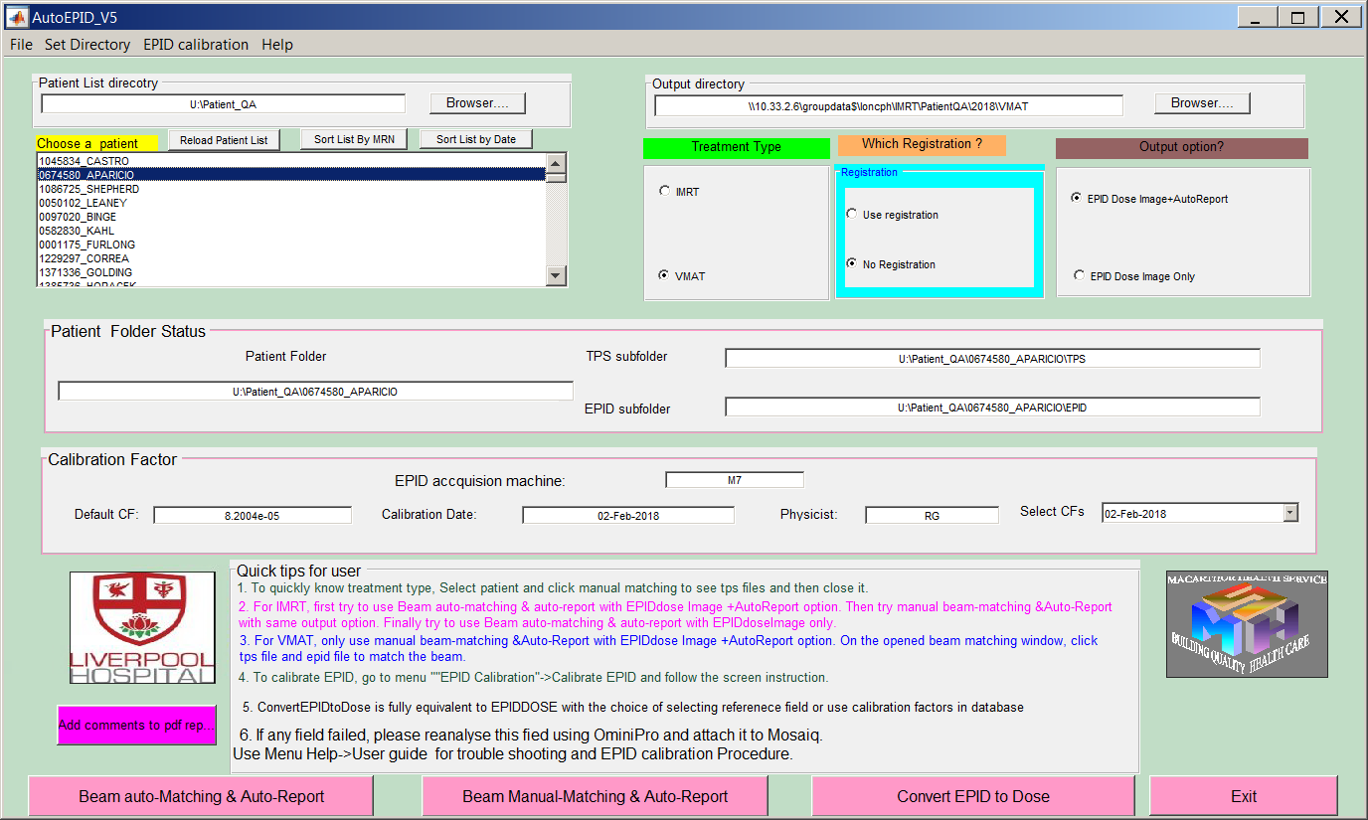

Figure 1 Use no-registration to generate Gamma report for comparison.

## Generation of the gamma report in OminiIMRTPro without registration.

Load TPS and EPID as described in the AutoEPID user guide or OminIMRTPro, then directly calculate, as shown in Figure **2**.

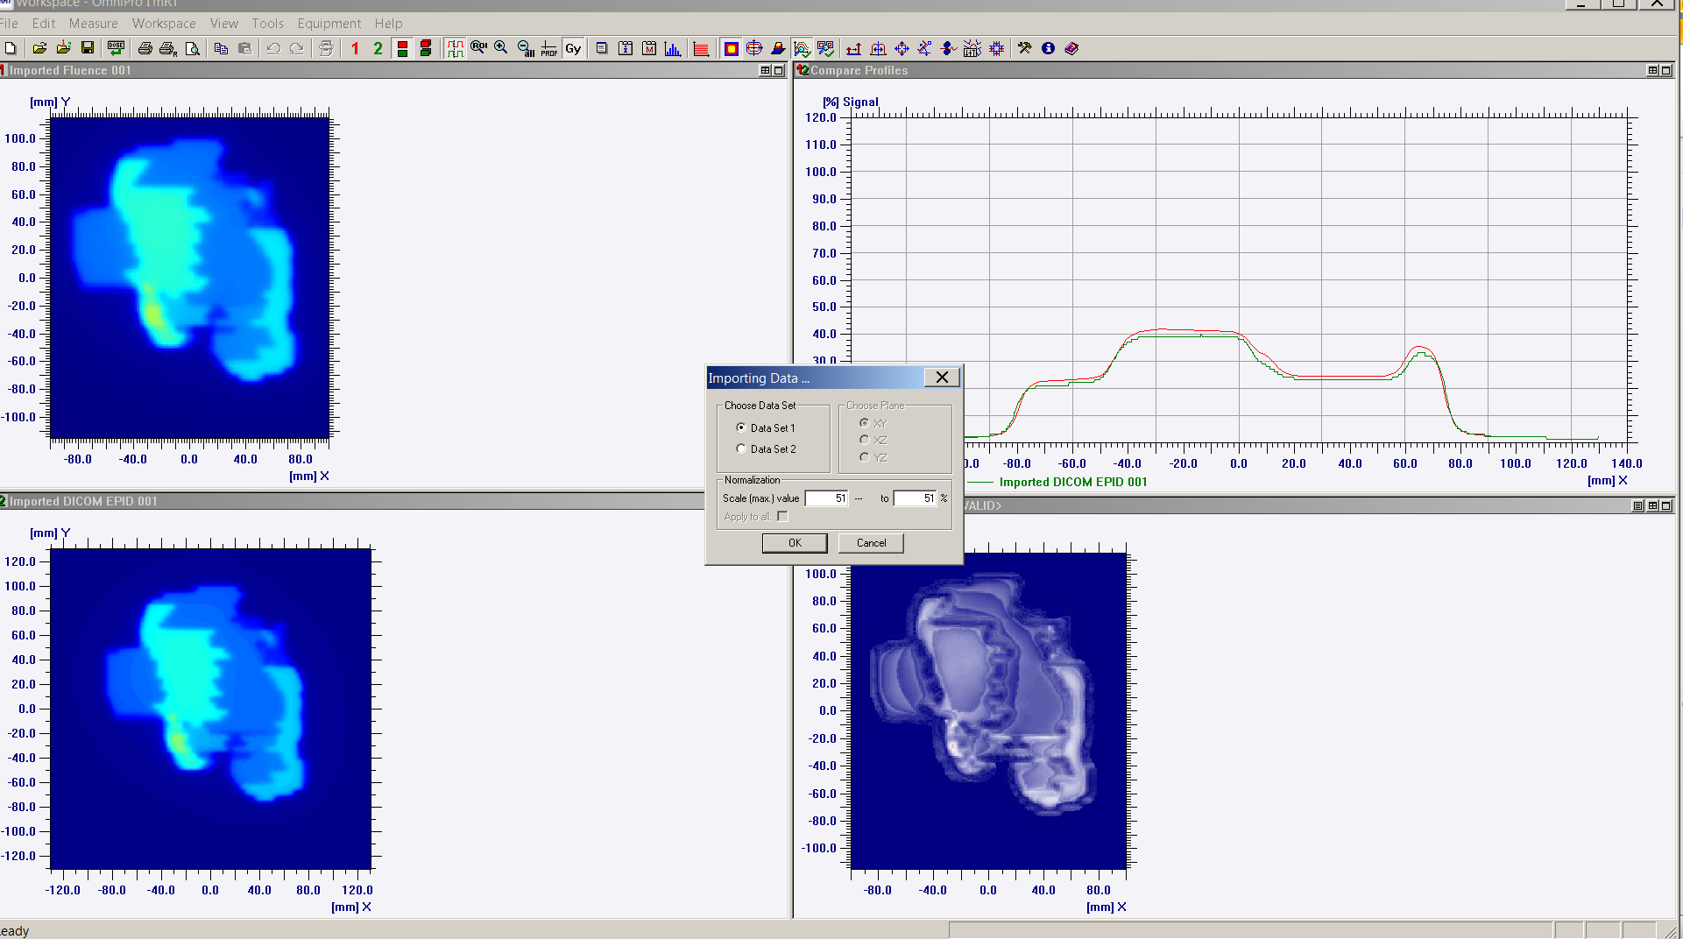

Figure 2 Load TPS and EPID dose image and then calculate gamma without any other process.

## Selection of patients for comparison

A series of patients were selected from the list of clinical patients and a list of patients identified by Alison. The comparison also performed for a different combination of VMAT/IMRT and registration/no-registration.

# Results and discussion

## Gamma calculated with TomoExit Gamma and AutoEPID

The gamma map calculated using TomoExit Gamma and are considered to be the same despite the slight difference at the edge of the gamma map due to the different application. The Gamma pass rates agree with each other with 1%. As an example, showed a gamma map calculated using both gamma functions without registration.

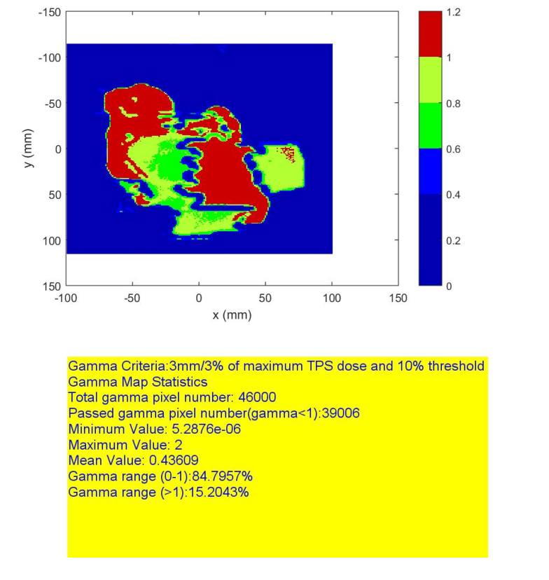

(a)

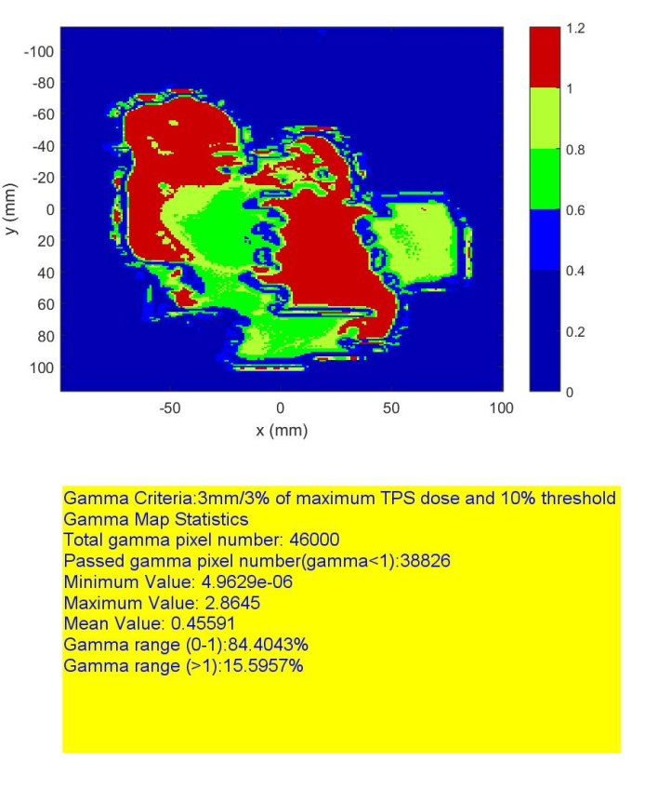

(b)

Figure 3 The gamma map and gamma statistics calculated using gamma function for one IMRT beam used in TomoExit (a) and AutoEPID (b).

## Gamma calculated AutoEPID and OminIMRTPro

The gamma maps calculated within OminIMRTPo and ones calculated with AutoEPID are equivalent in term of (1) the pass and failing areas are the same ; (2) the gamma pass rate is approximately equivalent and differ by a few percentages. This is due to the different implementation of the Gamma function in OminiIMRTPro and AutoEPID. As an example, the **Figure 4**, **Figure 6** and Figure **6**showed gamma map calculated by two software tools for some IMRT and VMAT beams.

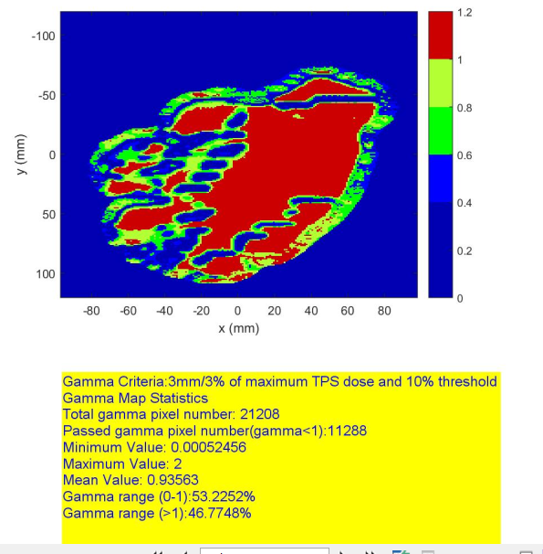

(a)

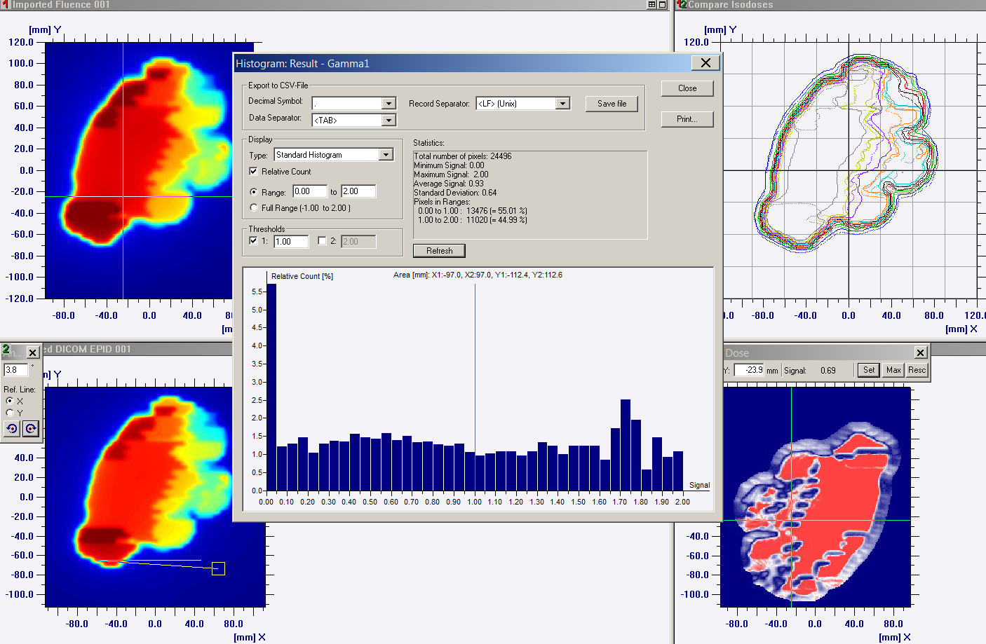

(b)

Figure 4 The Gamma map and gamma statistics calculated with AutoEPID (a) and OminIMRTPro (b) for one IMRT beam selected from the list of patients with problems.

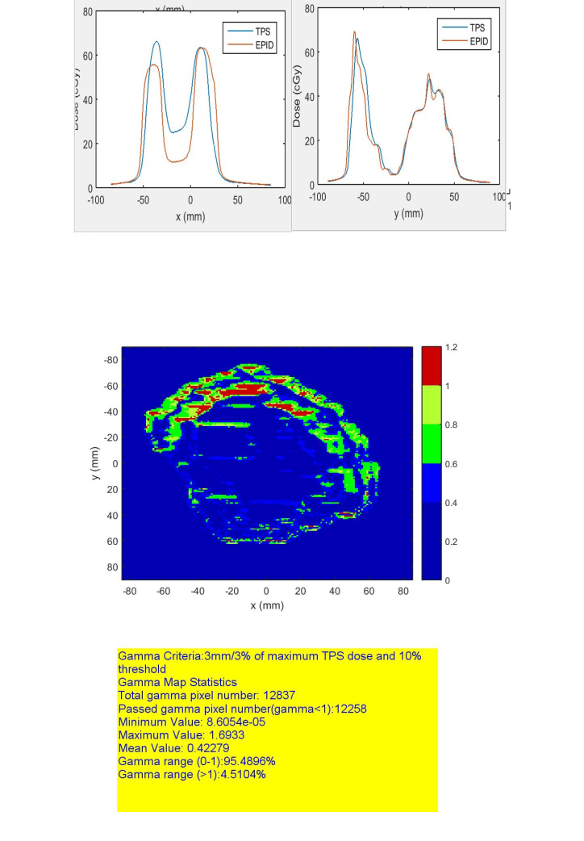

(a)

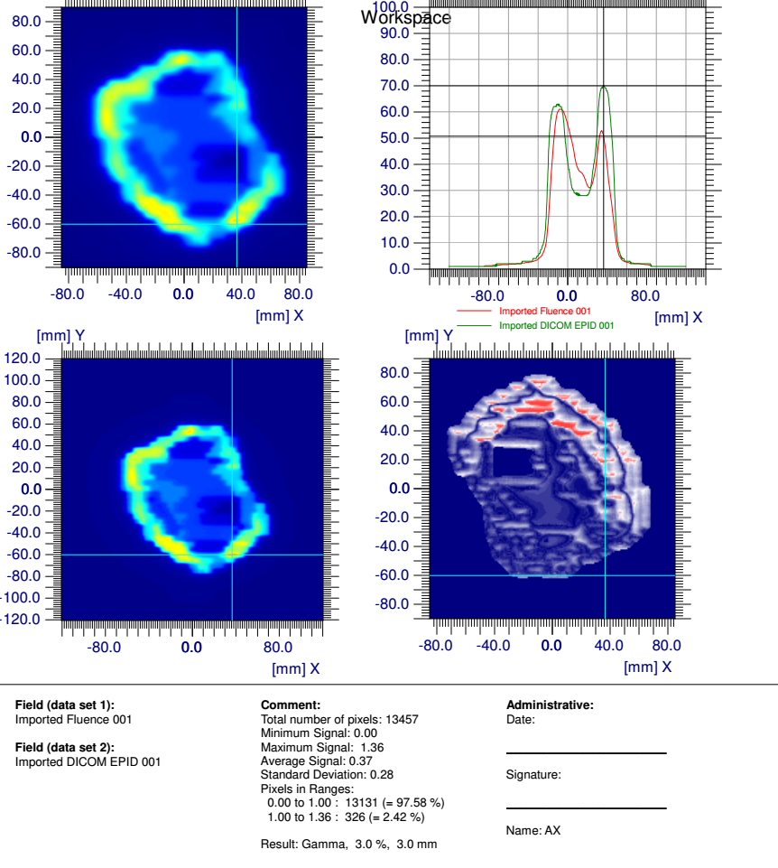

(b)

Figure 5 The Gamma map and gamma statistics calculated with AutoEPID (a) and OminIMRTPro (b) for another IMRT beam selected from one clinical patient.

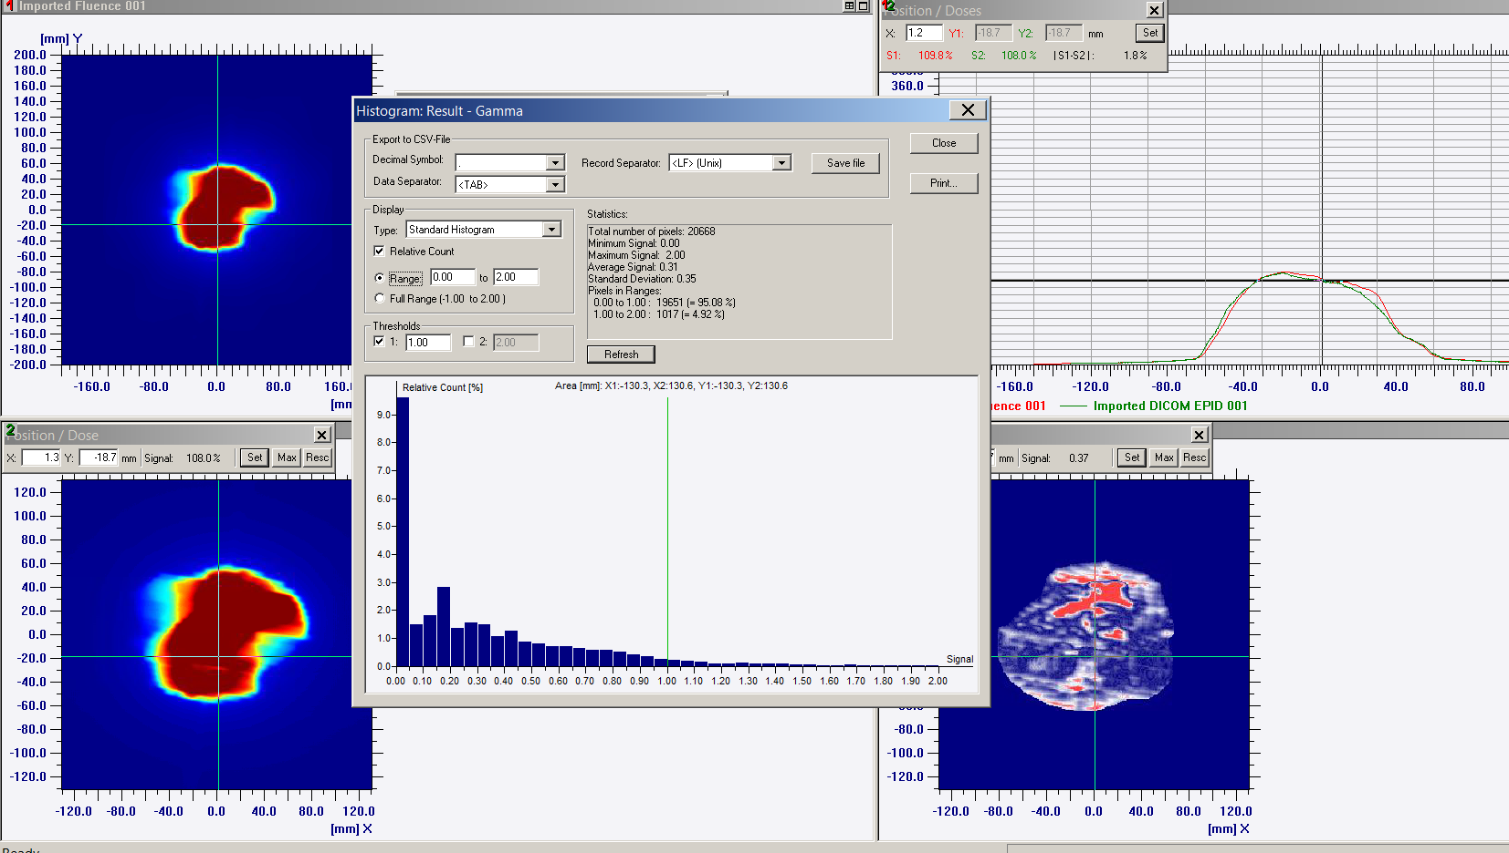

(a)

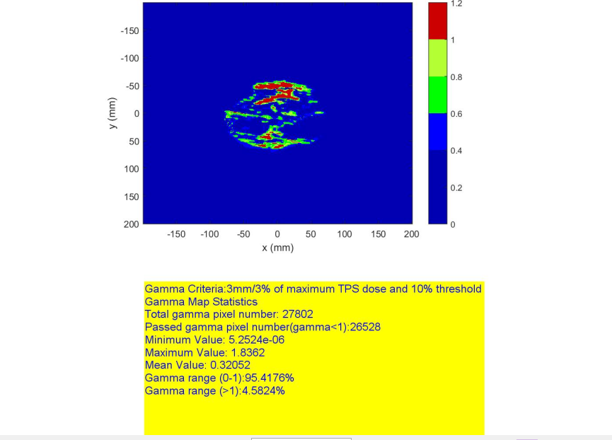

Figure 6 The Gamma map and gamma statistics calculated with AutoEPID (a) and OminIMRTPro (b) for one VMAT beam.

# Conclusions

The gamma function used in AutoEPID was compared with one used in TomoExit and OminIMRTPro after debugging and issues fixed. The Gamma map and Gamma report from AutoEPID are same or equivalent with OminiIMRTPro and TomoExit considering the difference caused by different gamma function implementation in three software tools.

# Appendix

Figure 7 The Gamma function used in TomExit.

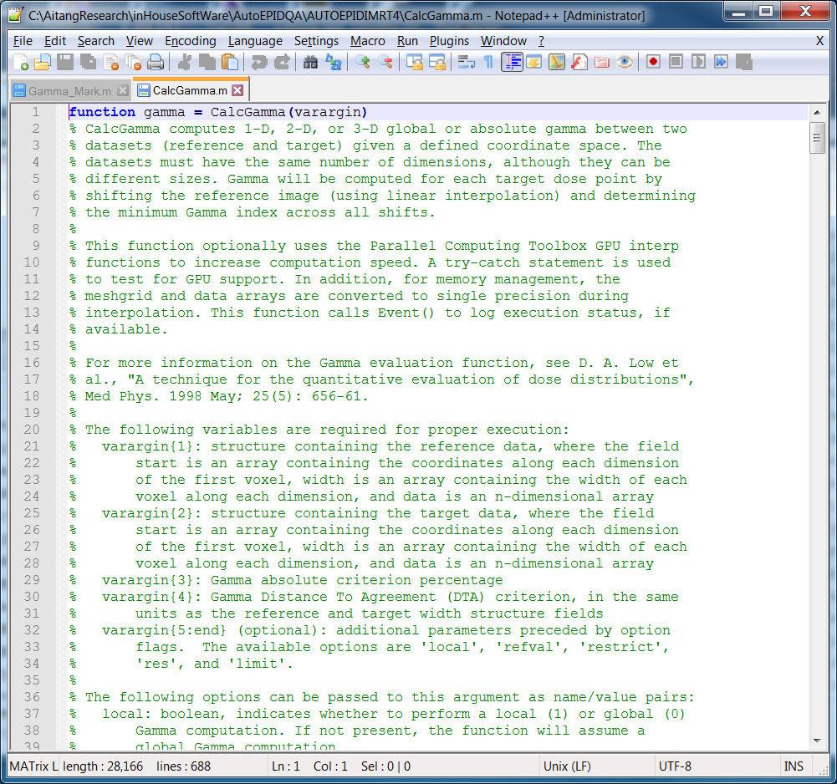

Figure 8 The Gamma function used in AutoEPID.

