Word Layout Stress Test
01 Layout and Display | Observable checks for every case
Synthetic test data | Version 1.0 | October 30, 2026

LAY-01 Mixed Font Runs
Check letters, digits and punctuation for missing glyphs, overlap or font substitution.
Serif sample: The quick brown fox jumps. English: AV fi fl office 0123456789 Bold text
Punctuation: , . ; : "quotes" <title> [brackets] (parentheses) -- ellipsis... H₂O / x² / CO₂

LAY-02 Color and Character Decoration
Check underline, strikethrough, highlighting, letter spacing and baseline offsets.
Underline Strikethrough Highlight Letter spacing 2pt Raised baseline 3pt
Edge cases: nonbreaking space A B; soft hyphen inter­operability; digits 123; long links follow.
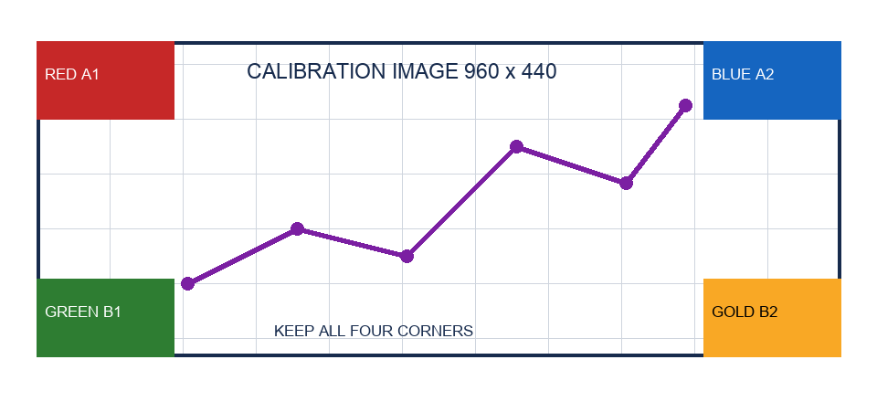
LAY-IMAGE-01 Keep all four color blocks, all borders and the image aspect ratio.

LAY-P02 Line Spacing Tabs and Numbering
LAY-03: Line 2 includes 22pt text. A uses an exact 18pt line box to test clipping; B uses at least 18pt and should grow; C uses 1.5 line spacing. Compare with the Word reference.
LAY-03A First line in English
Line 2 contains 22pt text
Line 3 returns to the normal font size
LAY-03B First line in English
Line 2 contains 22pt text
Line 3 returns to the normal font size
LAY-03C First line in English
Line 2 contains 22pt text
Line 3 returns to the normal font size
LAY-04 Hanging indent: the first line extends left. All remaining lines should share the same left edge. This repeated sentence provides enough text to verify consistent wrapping and alignment across several lines.
Name Quantity Unit price
Item Alpha 12 1234.50
Item Beta 3 9.75
- LAY-05 First top-level item
  - Second level a
    - Third level i
  - Second level b
- Second top-level item
- Separate numbering starts at 7
- Separate numbering continues at 8

LAY-P03 Nested Tables and Merged Cells
LAY-06 Check horizontal merges, vertical merges and a real nested table. Keep the inner table intact.
Group | Object | Result
GROUP-A | Horizontal merge
 | NESTED-TABLE-HOST | R2C3
  NEST-1-1 | NEST-1-2
  NEST-2-1 | NEST-2-2
  NEST-3-1 | NEST-3-2
GROUP-B | Normal row | R3C3
GROUP-B | Normal row | R4C3
GROUP-C | Addressable after merging | R5C3
LAY-07 Column 2 has a fixed width. Long text, URLs and multiline cells must stay inside their borders.
ID | Content | Value
T-01 | Multiline content line 1  Line 2  Line 3 | 100.25
T-02 | https://example.org/a-very-long-path/with-many-segments/benchmark | −0.125
T-03 | Long table text must wrap without pushing the table beyond the right page margin. | 1234567.89

LAY-P04 Floating Images and Text Boxes
LAY-08 A right-floating image is anchored here. Text should wrap on its left, then return to full width.
Wrapping paragraph 1: Keep the image near its anchor. Text must not overlap the image. Mixed text 123 remains intact as the following paragraphs flow naturally.
Wrapping paragraph 2: Keep the image near its anchor. Text must not overlap the image. Mixed text 123 remains intact as the following paragraphs flow naturally.
Wrapping paragraph 3: Keep the image near its anchor. Text must not overlap the image. Mixed text 123 remains intact as the following paragraphs flow naturally.
Wrapping paragraph 4: Keep the image near its anchor. Text must not overlap the image. Mixed text 123 remains intact as the following paragraphs flow naturally.
Wrapping paragraph 5: Keep the image near its anchor. Text must not overlap the image. Mixed text 123 remains intact as the following paragraphs flow naturally.
LAY-09 The independent VML text box below must retain its text outside the main text flow.
TEXTBOX_KEEP_01 All English text inside this box must be preserved.
LAY-AFTER-BOX Body text after the text box must remain editable.

LAY-P05 Landscape Section and Wide Table
LAY-10 This section is landscape A4; surrounding sections are portrait. All 12 columns must remain visible.
ID | C01 | C02 | C03 | C04 | C05 | C06 | C07 | C08 | C09 | C10 | C11
W01 | 101 | 102 | 103 | 104 | 105 | 106 | 107 | 108 | 109 | 110 | 111
W02 | 201 | 202 | 203 | 204 | 205 | 206 | 207 | 208 | 209 | 210 | 211
W03 | 301 | 302 | 303 | 304 | 305 | 306 | 307 | 308 | 309 | 310 | 311
W04 | 401 | 402 | 403 | 404 | 405 | 406 | 407 | 408 | 409 | 410 | 411
W05 | 501 | 502 | 503 | 504 | 505 | 506 | 507 | 508 | 509 | 510 | 511
W06 | 601 | 602 | 603 | 604 | 605 | 606 | 607 | 608 | 609 | 610 | 611
W07 | 701 | 702 | 703 | 704 | 705 | 706 | 707 | 708 | 709 | 710 | 711
W08 | 801 | 802 | 803 | 804 | 805 | 806 | 807 | 808 | 809 | 810 | 811
W09 | 901 | 902 | 903 | 904 | 905 | 906 | 907 | 908 | 909 | 910 | 911
W10 | 1001 | 1002 | 1003 | 1004 | 1005 | 1006 | 1007 | 1008 | 1009 | 1010 | 1011
W11 | 1101 | 1102 | 1103 | 1104 | 1105 | 1106 | 1107 | 1108 | 1109 | 1110 | 1111
W12 | 1201 | 1202 | 1203 | 1204 | 1205 | 1206 | 1207 | 1208 | 1209 | 1210 | 1211
W13 | 1301 | 1302 | 1303 | 1304 | 1305 | 1306 | 1307 | 1308 | 1309 | 1310 | 1311
W14 | 1401 | 1402 | 1403 | 1404 | 1405 | 1406 | 1407 | 1408 | 1409 | 1410 | 1411
W15 | 1501 | 1502 | 1503 | 1504 | 1505 | 1506 | 1507 | 1508 | 1509 | 1510 | 1511
W16 | 1601 | 1602 | 1603 | 1604 | 1605 | 1606 | 1607 | 1608 | 1609 | 1610 | 1611

LAY-P06 Two Columns and Explicit Column Breaks
LEFT-COLUMN-01 Two-column layout test. Preserve each column width and the gap. Paragraphs must wrap within their own column rather than extending across both columns.
LEFT-COLUMN-02 Two-column layout test. Preserve each column width and the gap. Paragraphs must wrap within their own column rather than extending across both columns.
LEFT-COLUMN-03 Two-column layout test. Preserve each column width and the gap. Paragraphs must wrap within their own column rather than extending across both columns.
LEFT-COLUMN-04 Two-column layout test. Preserve each column width and the gap. Paragraphs must wrap within their own column rather than extending across both columns.

RIGHT-COLUMN-01 Start in the right column. Preserve the explicit column break; the next section returns to one column. Test commas, "quotes" and digits 1234567890.
RIGHT-COLUMN-02 Start in the right column. Preserve the explicit column break; the next section returns to one column. Test commas, "quotes" and digits 1234567890.
RIGHT-COLUMN-03 Start in the right column. Preserve the explicit column break; the next section returns to one column. Test commas, "quotes" and digits 1234567890.
RIGHT-COLUMN-04 Start in the right column. Preserve the explicit column break; the next section returns to one column. Test commas, "quotes" and digits 1234567890.

LAY-P07 Long Table and Repeated Headers
LAY-11 The table spans pages with repeated headers and unsplit rows. Compare pagination with a Word export on the same machine.
Row | Required content marker | Status
ROW-001 | LONG_TABLE_KEEP_001 English content for row 1 | PASS
ROW-002 | LONG_TABLE_KEEP_002 English content for row 2 | PASS
ROW-003 | LONG_TABLE_KEEP_003 English content for row 3 | PASS
ROW-004 | LONG_TABLE_KEEP_004 English content for row 4 | PASS
ROW-005 | LONG_TABLE_KEEP_005 English content for row 5 | PASS
ROW-006 | LONG_TABLE_KEEP_006 English content for row 6 | PASS
ROW-007 | LONG_TABLE_KEEP_007 English content for row 7 | PASS
ROW-008 | LONG_TABLE_KEEP_008 English content for row 8 | PASS
ROW-009 | LONG_TABLE_KEEP_009 English content for row 9 | PASS
ROW-010 | LONG_TABLE_KEEP_010 English content for row 10 | PASS
ROW-011 | LONG_TABLE_KEEP_011 English content for row 11 | PASS
ROW-012 | LONG_TABLE_KEEP_012 English content for row 12 | PASS
ROW-013 | LONG_TABLE_KEEP_013 English content for row 13 | PASS
ROW-014 | LONG_TABLE_KEEP_014 English content for row 14 | PASS
ROW-015 | LONG_TABLE_KEEP_015 English content for row 15 | PASS
ROW-016 | LONG_TABLE_KEEP_016 English content for row 16 | PASS
ROW-017 | LONG_TABLE_KEEP_017 English content for row 17 | PASS
ROW-018 | LONG_TABLE_KEEP_018 English content for row 18 | PASS
ROW-019 | LONG_TABLE_KEEP_019 English content for row 19 | PASS
ROW-020 | LONG_TABLE_KEEP_020 English content for row 20 | PASS
ROW-021 | LONG_TABLE_KEEP_021 English content for row 21 | PASS
ROW-022 | LONG_TABLE_KEEP_022 English content for row 22 | PASS
ROW-023 | LONG_TABLE_KEEP_023 English content for row 23 | PASS
ROW-024 | LONG_TABLE_KEEP_024 English content for row 24 | PASS
ROW-025 | LONG_TABLE_KEEP_025 English content for row 25 | PASS
ROW-026 | LONG_TABLE_KEEP_026 English content for row 26 | PASS
ROW-027 | LONG_TABLE_KEEP_027 English content for row 27 | PASS
ROW-028 | LONG_TABLE_KEEP_028 English content for row 28 | PASS
ROW-029 | LONG_TABLE_KEEP_029 English content for row 29 | PASS
ROW-030 | LONG_TABLE_KEEP_030 English content for row 30 | PASS
ROW-031 | LONG_TABLE_KEEP_031 English content for row 31 | PASS
ROW-032 | LONG_TABLE_KEEP_032 English content for row 32 | PASS
ROW-033 | LONG_TABLE_KEEP_033 English content for row 33 | PASS
ROW-034 | LONG_TABLE_KEEP_034 English content for row 34 | PASS
ROW-035 | LONG_TABLE_KEEP_035 English content for row 35 | PASS
ROW-036 | LONG_TABLE_KEEP_036 English content for row 36 | PASS
ROW-037 | LONG_TABLE_KEEP_037 English content for row 37 | PASS
ROW-038 | LONG_TABLE_KEEP_038 English content for row 38 | PASS
ROW-039 | LONG_TABLE_KEEP_039 English content for row 39 | PASS
ROW-040 | LONG_TABLE_KEEP_040 English content for row 40 | PASS
ROW-041 | LONG_TABLE_KEEP_041 English content for row 41 | PASS
ROW-042 | LONG_TABLE_KEEP_042 English content for row 42 | PASS

