DOCUMENTATION

ASSIGNMENT 1-Polynomial calculator

STUDENT NAME: Robotin George Cătălin
GROUP: 30422

CONTENTS
DOCUMENTATION 1
ASSIGNMENT 1-Polynomial calculator 1
CONTENTS 2
1. Assignment Objective 3
2. Problem Analysis, Modeling, Scenarios, Use Cases 3
3. Design 4
4. Implementation 6
5. Results 7
6. Conclusions 8
7. Bibliography 9

Assignment Objective
The main objective of the assignment is to implement a polynomial calculator, where the two polynomials are taken as strings and the result is displayed, according to the selected operation.

Sub objectives:
- Correct implementation of the operations
- Using maps to model the polynomial data structure
- Having an intuitive user interface
- Treating edge cases accordingly
- Implementing an OOP design for the application

Problem Analysis, Modeling, Scenarios, Use Cases
In this case, the functional requirements are self-explanatory. Given the two polynomials and the selected operation, we should display the corresponding result.

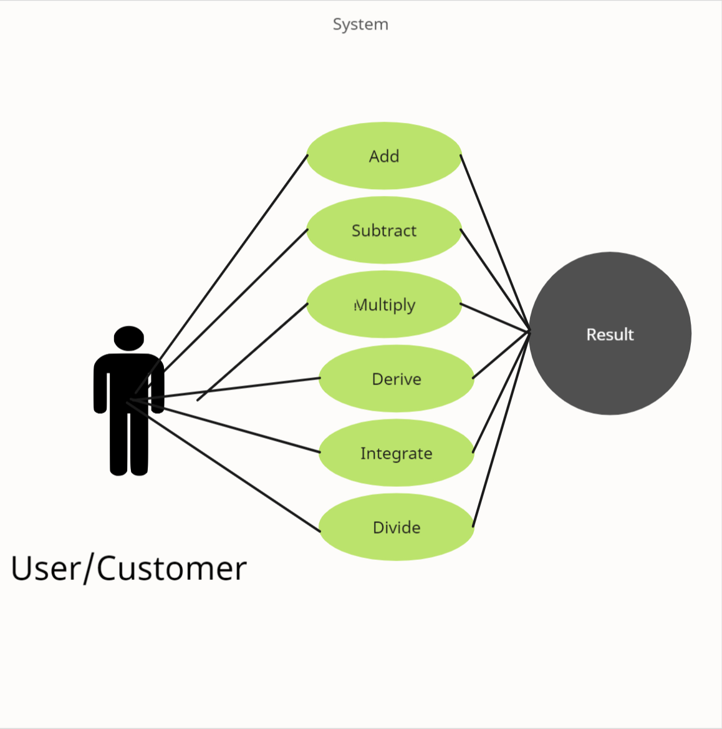
Figure 1: Use case diagram
In this case, there is only one possible actor, the user, who inputs the two polynomials and is given the result via a popup message, after selecting the operation and pressing the compute button.

Successful usage scenario:
- The user inputs the two polynomials from the keyboard, each term having the form [coefficient]x[^][exponent], or a simple digit for the last term (terms between [] are optional)
- He selects the operation he wants from the dropdown menu, the presses compute
- The result is displayed via a popup message box

Unsuccessful usage scenario:
- The input from the user is wrong
  - The format is wrong
  - The operation can’t be executed (like division by 0)
- A corresponding error message will be displayed

The non-functional requirements include:
- Having a user-friendly ui
- Security of the used data, although it is not really necessary for our use case
- Performance, which is adequate considering the size of the inputs and the used data type(hash map)

Design
The application abides OOP principles, as it is split into classes and packages, each modeling certain aspects of the app itself.
The polynomial class defines the model used to represent the data, namely a hash map, where the coefficient is the value and the exponent is the key. It also includes getters and setters, according to OOP principles, as well as overriding the toString() method, in order to be displayed in a nicer manner. It is included in the data model package.
The other two packages also contain single classes, dealing with the business logic and the user interface for the application.
Apart from these, there is also a Test package, with its TestOp class, which only deals with testing each of the operations manually, using Junit tests.
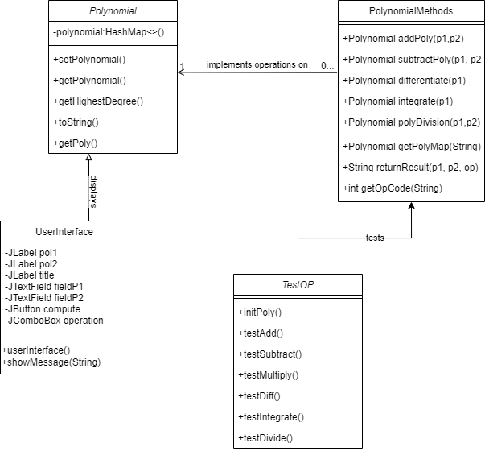
Figure 2:UML class diagram

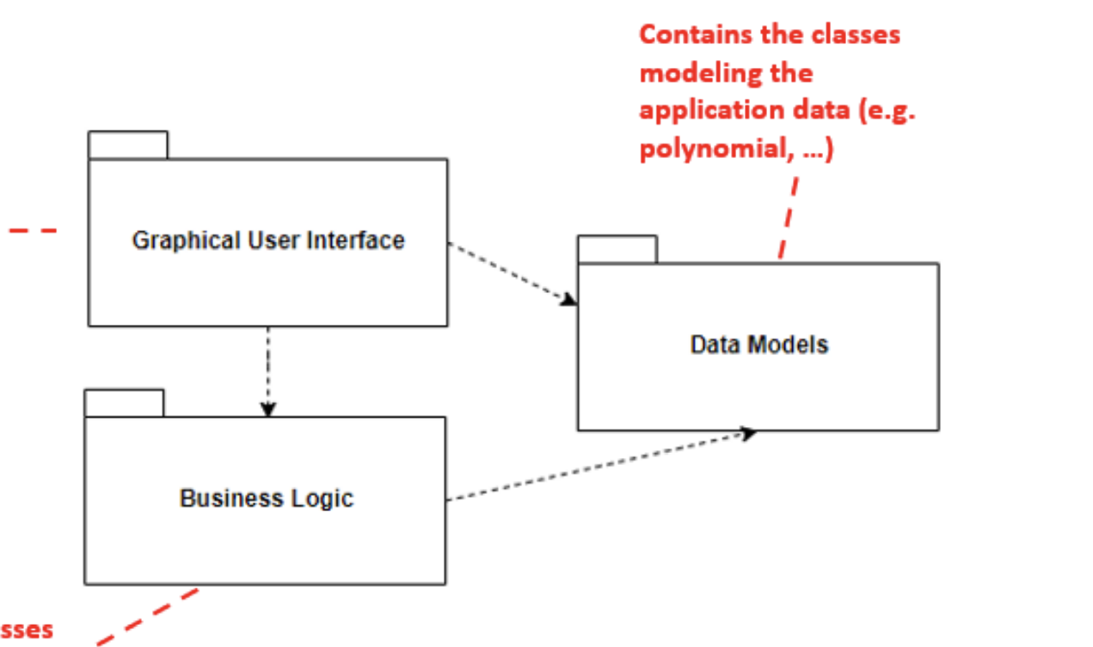
Figure 3:UML package diagram

Implementation
Polynomial class:
- One class member: polynomial, used to model the polynomials, comprising of a HashMap, where the key is an integer and it represents the degree of the elements(the exponent) and the value is a double, representing the coefficient.
- Private member, accessible only through getters and setters and instantiable through a constructor
- Overridden the toString() method, to display it in a readable manner
PolynomialMethods class:
- No actual class members
- All done by iterating through one/both polynomials
- Contains only static methods, dealing with the implementation of the operations on the polynomials, as well as some other useful functions for extracting the polynomial maps from the input string, and for interaction with the gui
  - addPoly()/subtractPoly() -Use the mathematical method to implement said operations, while taking advantage of the benefits of using the map collection, i.e. accessing elements based on the keys/values. Only common powers should be added/subtracted from each other, and the others should only be appended with the corresponding sign to the result polynomial
  - multiplyPoly()-multiply each monomial with all others, i.e. add the exponents and multiply the coefficients
  - differentiate()-use mathematical rules, i.e. coefficient is multiplied by the exponent and the exponent decreases by 1
  - integrate()-coefficient is divided by (exponent+1) and exponent is increased by 1
  - polyDivision()-
  - getPolyMap()-parses the input string, using a regular expression, in order to retrieve the keys and values to be stored in the map of the polynomial
  - getOpCode()-selects which operation to be executed, based on the selection in the dialog box of the gui
  - validatePoly()-checks whether input string can represent a polynomial or not, using a regular expression, adapted from ³
UserInterface class:
- Contains private members for each ui element, i.e. text fields, labels, one combo box and one button
- Implements only one action listener, for the “compute” button (hence why it is implemented in a single class, the same one as the interface itself), which takes the values in the text fields, and based on the selected operation from the combo box, displays a popup message containing either the result(in a successful use case scenario), or a specific error message, based on the user’s misinput
- Everything is instantiated in the constructor, so when creating the ui object everything works, and cannot be modified. I used a null interface, in order to be able to position the elements manually, for a more neat look
- Added helper methods:
  - refresh()-in order to clear the text fields and return the combo box to its initial state after executing each operation
  - showMessage()-to show the popup message after the computation
TestOp class:
- performs individual tests for each operation, in order to validate their functionality
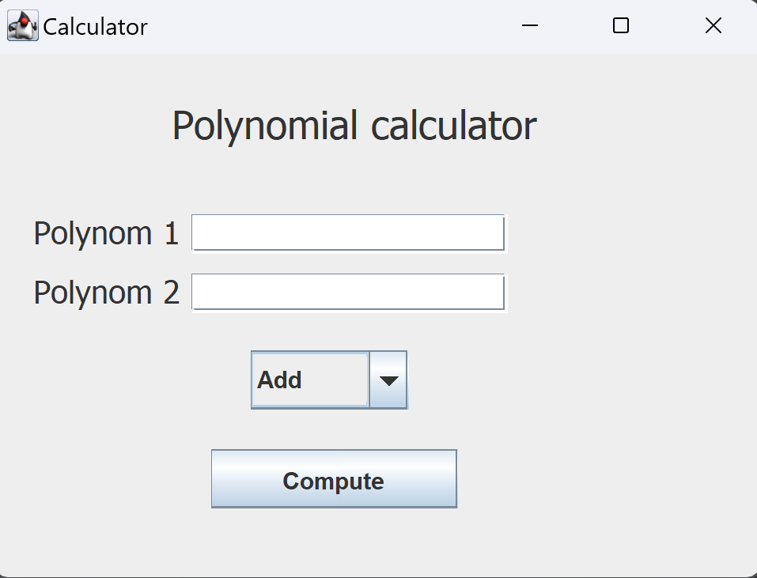
Figure 4: GUI

Results
In order to prove the working condition of the implemented operations, each of them has been tested using the Junit framework, as well as a polynomial calculator online¹, to double check the results.
Apart from the logic of the operations themselves, the toString() functionality has also been tested. For all the operations, apart from division, the same two polynomials have been loaded, using the @BeforeEach annotation. The tests provide edge cases, where one term is reduced during subtraction, and the terms have common exponents.
Here, we can see that for each test, the first polynomial has been initialized as 6.0x^2+6.0x^5, and the second as 6.0x^2+x^5:
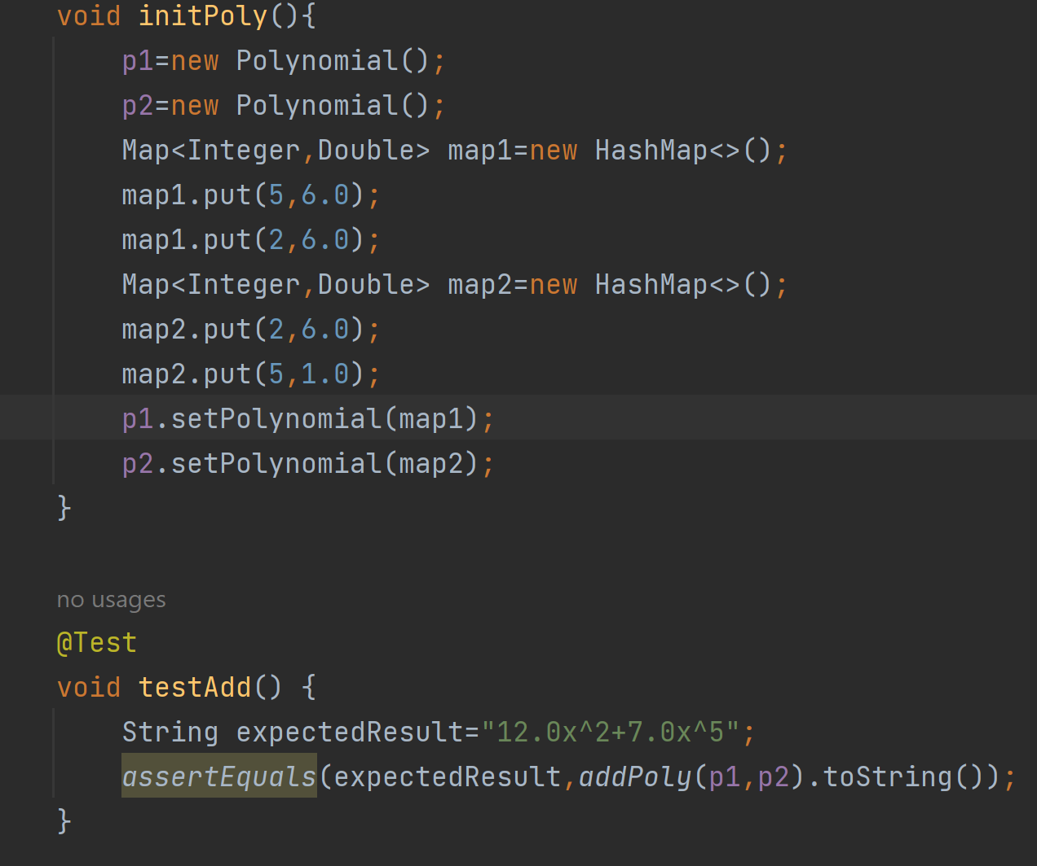
Figure 5:Test initialization and example
The results of the tests are presented via the TestOp class, which implements JUnit tests, using the @Test annotation. The results show that all operations work as expected:
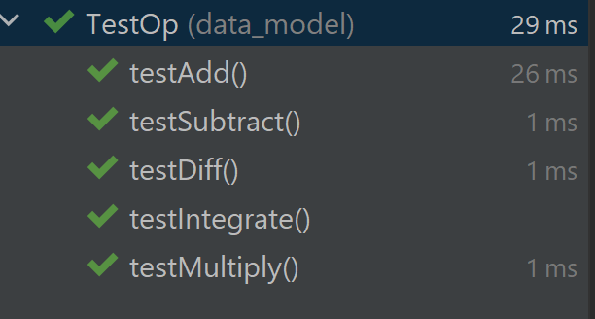
Figure 6:JUnit results

Conclusions
Implementing this app, I learned:
- how to use the map collection and its benefits
- how to use a regular expression in java, in order to validate a string
- how to use the JUnit framework for small test cases
- the utility of a layered design for the application, i.e. splitting it into the model, business logic and gui packages, to make use of an OOP design
Future developments:
- make the toString() method display the results in a nicer fashion for some cases
- make it work for any variable name, not only x
- perform other testing to ensure everything works as expected, even in the most edge cases
- add some operands on the app screen, in order to not need a keyboard for input
- implement other useful polynomial operations, such as finding poles and their order
In conclusion, developing this calculator has been a useful experience, for understanding both broad OOP principles, as well as getting accustomed to the Map interface and Java Colllections as a whole.

Bibliography
- https://www.mathway.com/Algebra
- https://flexbooks.ck12.org/cbook/ck-12-cbse-math-class-10/section/2.4/primary/lesson/division-algorithm-for-polynomials/
- https://stackoverflow.com/questions/36490757/regex-for-polynomial-expression
- https://regex101.com/r/nI5oA5/1

