MDC Student Managed Investment Fund – Q3 2025 Report

The MDC Student Managed Investment Fund is an experiential learning activity designed to provide students with hands-on experience in portfolio management and investment analysis. All positions and trading activity within the fund are conducted for educational purposes and do not represent investment advice.

Portfolio Summary as of 09/30/25
The total portfolio value as of September 30, 2025, is $96,475.54. This represents an increase from the Q2 ending value of $90,647.67.

Portfolio Holdings as of 09/30/2025 Close

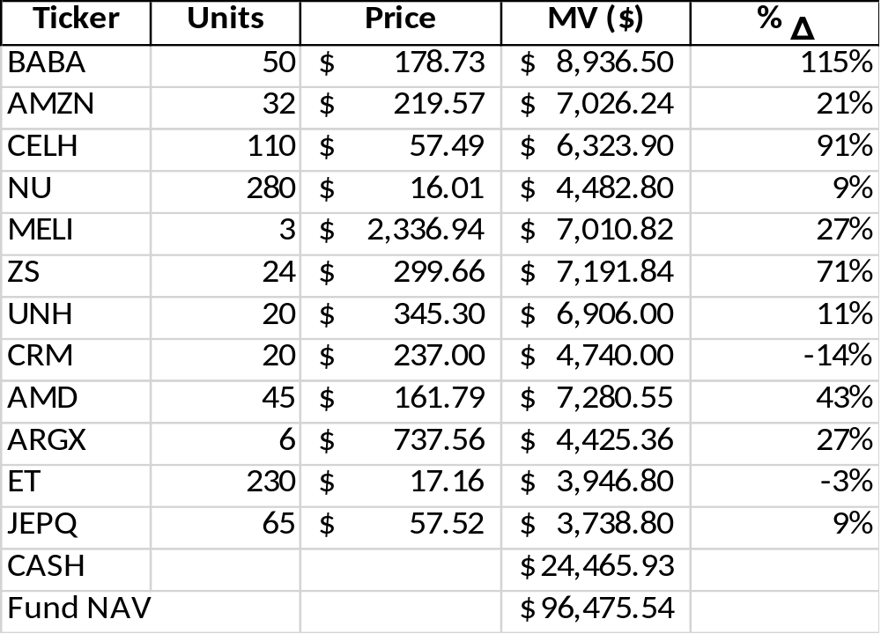

Performance Commentary – Q3 2025
No portfolio transactions occurred over Q3 2025. For this period, the MDC Student Managed Investment Fund achieved a portfolio return of 6.41%, increasing NAV from $90,647.67 at the end of Q2 to $96,475.54 at the end of Q3. Top performers in the MDC Student Managed Investment Fund were Celsius Holdings (CELH), Alibaba Group (BABA), and UnitedHealth Group (UNH). CELH led, likely driven by robust sales growth and expanding market share in the energy drink segment. BABA followed, benefiting from renewed investor confidence in Chinese tech and signs of economic recovery. UNH posted recent gains, reflecting stable earnings and appeal as a defensive healthcare stock amid market volatility. In comparison, the S&P 500 Index posted a return of 8.12% over the same period. The fund’s return lagged the benchmark by 1.71 percentage points, primarily due to a 26% cash allocation and underperformance in NU, MELI, and CRM.
The portfolio's Value at Risk (VaR) of 24% indicates that, under normal market conditions, there is a 5% chance the portfolio could lose 24% or more of its value over the specified time horizon. This metric reflects the fund’s exposure to market volatility and helps frame risk in probabilistic terms.

Sector Allocation

Summary
Despite the shortfall relative to the index, the fund maintains a diversified posture and remains committed to long-term value creation. Through disciplined portfolio management and experiential learning, the fund continues to position itself for sustainable performance in future quarters.

