**2. Overall Description**

**2.1 Product Perspective**

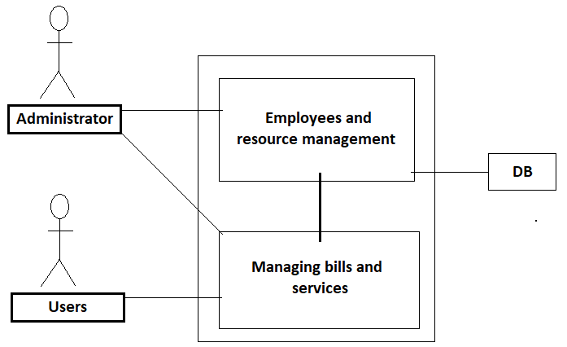

The “Sistem informatic distribuit pentru gestionarea activitatii unei asociatii de proprietari” is a virtually self-contained managing system; however, it will require users to have access to a web browser on their workstation computer. This means that the users of the system do not need to invest in any other software to get the most out of this software system.

**2.2 Product Function**

* **Login**
* **User interface**
* **Administrator/employee interface**
* **Income and expenses report**
* **Poll for different services**
* **Total debt and overdue payments**
* **Monthly report for income**
* **The user can modify the data about his apartment(no. of tenants/ownership etc)**

**2.3 User Classes and Characteristics**

The application users will be employees which will have administrator privileges and tenants which will have regular member accounts.

**2.4 Operating Environment**

As mentioned before the app will require users to have access to a web browser on their workstation computer like Google Chrome(v 82.0) or Mozilla Firefox(v 73.0), Internet Explorer(v 11, 10, 9), Edge(v 80.0.361.62)

**2.5 Design and Implementation Constraints**

Creating a user interface which is both effective and easily navigable will pose a difficult challenge. Other constraints such as a weak web-host and slow internet browsers (“Internet Explorer”) are also worth considering. Our app is meant to be quick and responsive, even when dealing with large groups and transactions, so each feature must be designed and implemented with efficiency in mind.

Backend language: C#

Frontend: HTML, CSS, Typescript

Framework: Angular, ASP.NET Core

**2.6 User Documentation**

NA

**2.7 Assumptions and Dependencies**

The web application assumes that the user has a computer with an Internet connection and a web browser to access the app. The system may not behave correctly when used with internet browsers other than Firefox and Google Chrome.