Pricing Desk — Requirements by section
Oct 23, 2026 · @Catalina
Pricing Desk is where Verizon Connect sets up what Valu Cal sells with: product prices, promotions, the rules for custom promotions, and the approvals they trigger. This draft reorganizes the "MSA Price Desk requirements" document received on 2026-10-23 into four sections and keeps what fits. It is the base for the first prototype.
Everything here is a first draft built from that document, our working sessions and some assumptions; the next step is to walk through it together to find what is missing or wrong.

At a glance
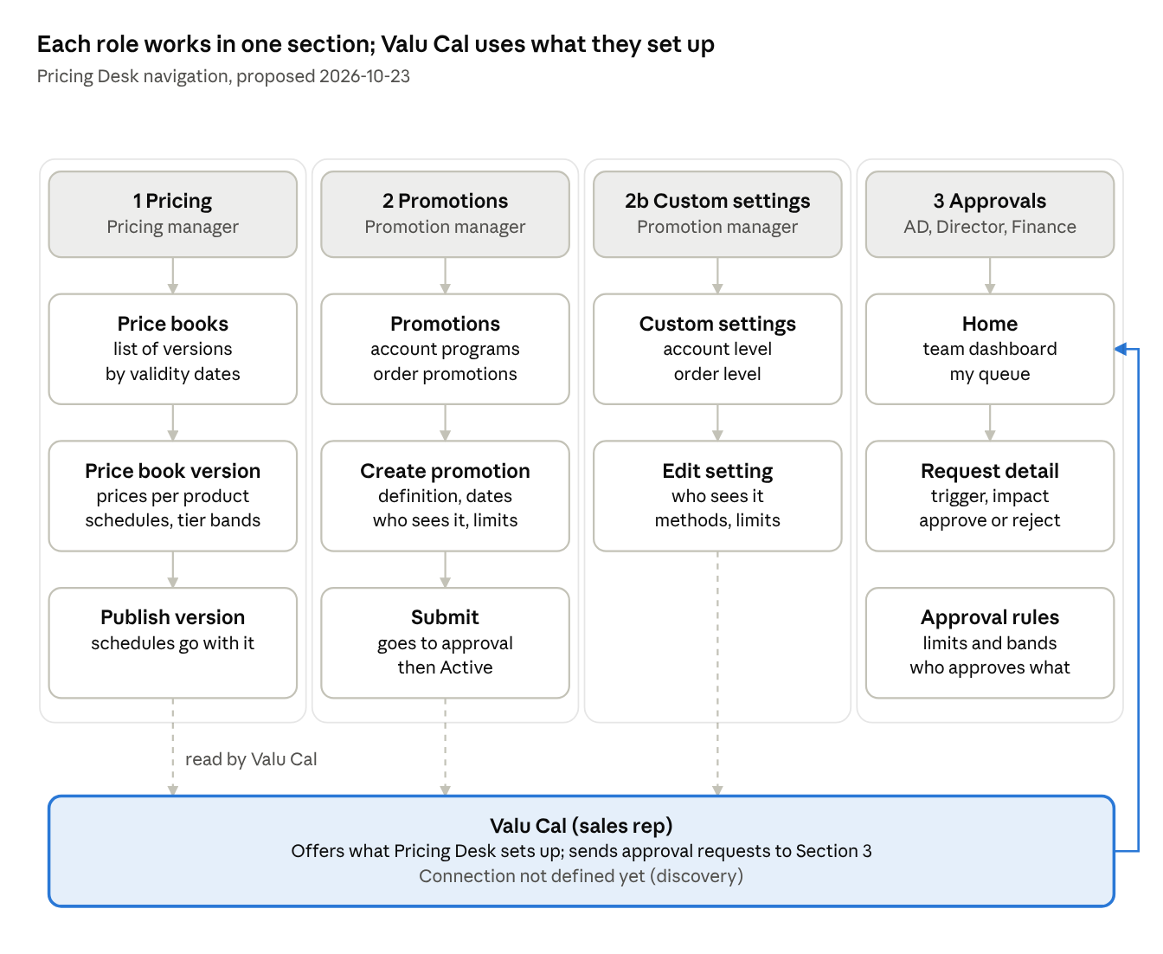
Pricing Desk navigation · 4 sections, 1 per role
Each section is a navigation item shown only to its role. What sections 1, 2 and 2b set up is what Valu Cal offers the rep; Valu Cal's approval requests land in the approver's queue, and new promotions are submitted for approval too.

Who uses Pricing Desk
Roles are taken from the first Pricing Desk prototype, plus a pricing manager for Section 1. Each role sees only its own section(s).
Role | Works in | What they do
Pricing manager (new) | 1 Pricing | Gives Salesforce products their prices, discount schedules and tier bands; publishes price book versions
Promotion manager (Alicia) | 2 Promotions, 2b Custom promotion settings | Creates Account Discount programs and Order Discount promotions, says who sees them, and maintains the custom promotion settings
Associate Director (AD) | 3 Approvals | Approves or rejects requests routed to them; sees their team's dashboard
Director | 3 Approvals | Same, for their segment
Pricing & Finance | 3 Approvals | Same, for the whole organization; maintains the approval rules (limits, bands, approvers and backups)
Sales rep | Valu Cal; in Pricing Desk only their own requests and performance (read-only) | Applies promotions and builds custom promotions in a proposal; sends approval requests

Section 1 — Pricing
The pricing manager picks a product that already exists in Salesforce and gives it prices; products are never created or edited in Pricing Desk.
The product attributes that affect pricing (weight for the tier count, schedule group, seasonal flag, instalments allowed) are maintained in Salesforce; Pricing Desk only reads them.
Price books
- A price book has versions; each version has a validity date range and a published date. Ranges of the same price book never overlap, and a published version is never edited: a change is a new version.
- There is one standard price book plus one per public schedule (e.g. GSA, Sourcewell).
- Publishing a price book version publishes its discount schedules with it.
Prices per product (one row per combination)
Field | Values
Product | Selected from Salesforce (read-only)
Sale mode | OPEX, CAPEX
Component | Subscription, Hardware (CAPEX only), Installation
Installation method | Any, VMI, CMI (a VMI or CMI row overrides Any)
List price | 0 or more
Under OPEX a product has one monthly price that includes the hardware (plus an installation price used only for extra installations). Under CAPEX it has a monthly subscription price plus a hardware price and an installation price (by VMI or CMI), charged separately. Whether the hardware can be paid in instalments, and over how many months, comes from the product in Salesforce.
Discount schedules and tiers
- A discount schedule belongs to a price book version and a schedule group: a matrix of term (12, 24, 36, 48, 60 months) by tier, each cell a percentage from 0 to 100. The same schedule applies under OPEX and CAPEX.
- Tier bands are configurable and versioned: each tier has a minimum weighted quantity and an optional maximum, with no overlaps. Valu Cal uses placeholder bands today (1–9, 10–19, 20–49, 50–99, 100+).
Notes
- Publishing a new price does not change MSA customers who already ordered that product: their price is frozen for the term. Suggestion: say so on the publish screen.
- The account's frozen prices are shown in Valu Cal's Price List, not in Pricing Desk.

Section 2 — Promotions
The promotion manager creates ready-made promotions that reps pick from in Valu Cal, and decides who sees each one when creating it.
Two levels, named as in Valu Cal's Discounts & Promotions drawer
- Account Discount (Discretionary): the account discount programs, a % on the MSA, that the rep picks in Valu Cal's Account Discount tab. Valu Cal shows them only for MSA-level transactions.
- Order Discount (Promotions): the promotions and packages the rep applies to an order in Valu Cal's Order Discount tab.
Creating a promotion
- Definition: code, name, description, owner; type percentage (0–100) or amount, value, and the resulting monthly benefit per unit; products or schedule groups it applies to, sale modes, installation methods.
- Dates: the offer window (when orders can receive it) and the benefit duration in months, capped at the MSA term end; the screen shows the cap.
- Who sees it: conditions on the account, the deal and the user, combined with AND / OR, or all accounts; the full list is in "Who sees it: conditions" below.
- Fixed exclusions, shown and locked: public schedules; seasonal lines.
- Optional limits: maximum units per order, per account or in total; maximum budget. When a limit is reached the promotion is no longer offered.
- What happens to it later, shown read-only at the end of creation: it lasts at most as long as the order and the MSA term; it is dropped at renewal, rewrap and reactivation; promoted units never exceed subscribed units; on cancellation, units without a promotion go first; the early-cancellation fee uses the full contracted price.
- Submit for approval (see Section 3).
Who sees it: conditions (every field named in the source document, multi-select)
On | Conditions
Account | Specific accounts to include; accounts to exclude (always wins); VTZ Segment; segment; Platform; Brands; Family; Account Type; Industry; Lead Source; Region; customer group; owning sales team; account sale type (OPEX, CAPEX, MIXED); product type (bundle, à la carte, mixed); agreement type (standard MSA, custom MSA); legacy origin (Fixed, Flex); new or existing customer
Deal / order | Transaction type (Initial Sale, Expansion, Feature Upsell, Downgrade, Swap, Renewal, Rewrap, Reactivation); term (12–60 months); tier; weighted quantity; product; schedule group; product quantity; sale mode; installation method; seasonal or not; order total at list price
User | Team; role; specific users (grant or deny)
Lifecycle: Draft, Pending approval, Active, Expired, Retired. Once active, only the end of the offer window can be brought forward, or the promotion retired; promotions already applied keep running.
Account Discount (Discretionary) programs: what they also define
- A percentage from 0 to 100 on the MSA term. It applies to every account the MSA covers and to every item's subscription charge, not to hardware or installation.
- Offered only at Initial Sale, Renewal, Rewrap and Reactivation; never on auto-renewal, never per order line, not carried over to the next term, and never for public schedules.
- Who may offer how much: the maximum % a rep can give without approval, and the approval bands above it by role (e.g. up to X % the Associate Director, up to Y % the Director, above that Pricing & Finance). The business sets the band values; the bands feed the approval rules in Section 3.
- Deal conditions can raise or lower that maximum: term, tier, weighted quantity, transaction type, product mix.
- When several programs match a deal, the highest-priority one wins; each program has a unique priority.
- A program can't be combined with a Custom Discount on the same MSA (as in Valu Cal today).
- Simulation per item: list price, then tier %, then discretionary %, each step rounded to the cent, plus the total discount over the term. The contracted price = list × (1 − tier %) × (1 − discretionary %).
- Changes go through approval; a new version applies only to deals submitted after it becomes active.
Nice to have: preview how many accounts match today; simulate the promotion on a sample deal (monthly lines and total cost to term end).
Several promotions can be available for the same product, but the rep applies only one per order in Valu Cal; promotions never stack on each other. An order promotion applies on top of the Account Discount, so Pricing Desk needs no "combinable" setting.

Section 2b — Custom promotion settings
This section configures the custom promotion builder that reps already use in Valu Cal. It follows Valu Cal's model, not the source document: the document says order-level custom prices don't exist, which is outdated.
What reps can build in Valu Cal today
Level | What the rep builds | Methods | Other settings
Account (MSA) | Custom Discount, per subscription; only on MSA-level transactions | %, $, Target price | --
Order | Custom Promotion, per subscription; not combinable with a package | %, $, Target price, Tier price (1 or 2 tiers above, whole order) | Duration in months, up to the contract term
Today every custom with a value needs approval, and that rule is hard-coded.
What the settings would control (proposed: Valu Cal's model plus the limits idea from the source document)
- Who sees it: which accounts, deals and users get the custom builder, per level (same conditions as Section 2).
- Methods: which methods are enabled per level.
- Limits: minimum and maximum per method, possibly per product; a floor price per product for Target price; how many tiers up Tier price can go; which durations are offered.
- Approval: up to which value it is approved automatically, and above that, which band goes to which approver. These rules live in Section 3.
The first prototype uses this model; the screen itself is designed in the UX step.

Section 3 — Approvals
Approvers do their work in Pricing Desk: a request sent from Valu Cal lands in the queue of the person it is routed to, next to a dashboard of their team. The model comes from the first Pricing Desk prototype (reference only, rebuilt with VDS).
Approver home: one page per role, with the same shape and a different scope
Role | Scope
Associate Director | Their team
Director | Their segment
Pricing & Finance | The whole organization
Sales rep | Their own requests and performance, read-only
- Dashboard: how many requests are pending, approved and rejected, how long decisions take, and the team's margin against its goals: MRR, Direct Margin %, EBITDA % and NPV, as in the first prototype.
- Queue: only the requests routed to this person. A "review all" view is a later idea.
Request detail
- Why it needs approval: the trigger (e.g. "discretionary discount above the auto-approval limit") plus the rep's reason, justification and attachment, as sent from Valu Cal today.
- The proposal and option, with links to the Salesforce opportunity and quote.
- The approval chain (Rep → Associate Director → Director → Pricing & Finance), showing where it is now, and a dated history (submitted, information requested, decided).
- Impact before approving: what approving this does to the team's margin against its goal.
- Actions: Approve, Reject, Request information.
Approval rules (what triggers an approval and where it goes)
- Today in Valu Cal: any custom discount or custom promotion with a value; a discretionary discount above the auto-approval limit for the term and tier, routed to an Associate Director or a Director by level.
- To configure here: auto-approval limits and bands per approver level, for custom promotions (2b) and discretionary discounts.
- More triggers are expected, e.g. a 60- or 90-day ramp-up period (MSA definition).
Notes
- Margin needs product cost data per product; the first prototype's cost tables were placeholders, not mapped to Salesforce products.
- New promotions and changes to the custom promotion settings go through approval by Pricing & Finance; publishing a price book version needs no approval.

Sources
- "MSA Price Desk requirements" (received 2026-10-23): repo PricingDesk/docs/agent-flow/transcripts/2026-10-23-msa-price-desk.txt.
- Line-by-line analysis of that document (49 requirements, follow-ups): repo PricingDesk/docs/agent-flow/requirements/2026-10-23-msa-price-desk-requirements.md.
- Valu Cal prototype (custom promotions, Account Discount tab, approval rule): repo ValuCal-MSA/, assets-shared/.
- First Pricing Desk prototype (approvals model, reference only): repo _historico/pricing-desk-poc/.
- MSA master definition (ramp-up approval): project doc msa-master-definition.md.

