Semaphore/Spotlight Project

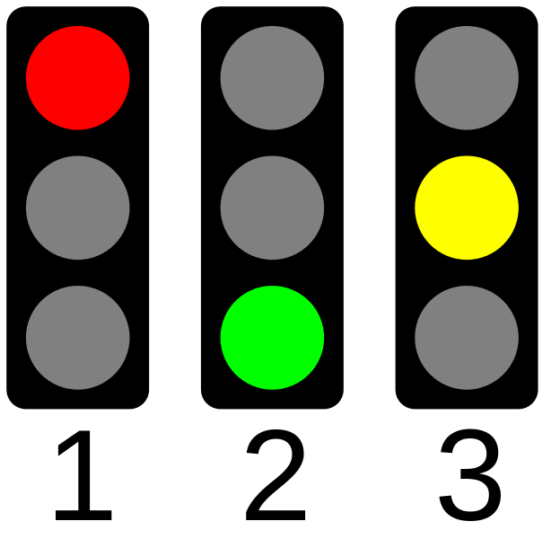

Taking in account the photo from above , I ve tried to represent in Multimedia Logic how does a semaphore or system of semaphores works for an intersection with 3 lanes work. A picture containing screenshot

For the implementation I ve used the class example for one semaphore and added 3 more. I ve used 2 sets of flip flops , one for the left semaphore , one for the right one.

And a look example:

Nichita Andrei-Catalin

1222A