# Практическая работа № 12. Классы-коллекции, создаваемые пользователем

Цель работы: Получить практические навыки создания классов, реализующих коллекции.

## Постановка задачи

### 2.1. Задание 1.

1. Сформировать двунаправленный список, в информационное поле записать объекты из иерархии классов лабораторной работы №10.
2. Распечатать полученный список.
3. Выполнить обработку списка в соответствии с заданием.
4. Распечатать полученный список.
5. Удалить список из памяти.

### 2.2. Задание 2.

1. Сформировать идеально сбалансированное бинарное дерево, в информационное поле записать объекты из иерархии классов лабораторной работы №10.
2. Распечатать полученное дерево.
3. Выполнить обработку дерева в соответствии с заданием, вывести полученный результат.
4. Преобразовать идеально сбалансированное дерево в дерево поиска.
5. Распечатать полученное дерево.
6. Удалить дерево из памяти.

### 2.3. Задание 3

1. Создать хеш-таблицу и заполнить ее элементами.
2. Выполнить поиск элемента в хеш-таблице
3. Удалить найденный элемент из хеш-таблицы.
4. Выполнить поиск элемента в хеш-таблице
5. Показать, что будет при добавлении элемента в хеш-таблицу, если в таблице уже находится максимальное число элементов (для метода открытой адресации, для метода цепочек просто показать добавление в таблицу).

### 2.4. Задание 4

Реализовать обобщенную коллекцию, указанную в варианте. Для этого:

1. Реализовать конструкторы:

* public MyCollection() - предназначен для создания пустой коллекции.
* public MyCollection (int capacity*)* - создает пустую коллекцию с начальной емкостью, заданной параметром capacity.
* public MyCollection (MyCollection c) - служит для создания коллекции, которая инициализируется элементами и емкостью коллекции, заданной параметром с.

1. Для всех коллекций реализовать:
   * свойство Count, позволяющее получить количество элементов в коллекции;
   * методы для добавления одного или нескольких элементов в коллекцию;
   * методы для удаления одного или нескольких элементов из коллекции (кроме деревьев);[1]
   * метод для поиска элемента по значению;
   * метод для клонирования коллекции;
   * метод для поверхностного копирования;
   * метод для удаления коллекции из памяти.
2. Реализовать интерфейсы IEnumerable и IEnumerator (если это необходимо).
3. Написать демонстрационную программу, в которой создаются коллекции, и демонстрируется работа всех реализованных методов, в том числе, перебор коллекции циклом foreach.

При работе с коллекцией использовать объекты из иерархии классов, разработанной в работе №10.

|  |  |  |  |  |
| --- | --- | --- | --- | --- |
| №  варианта | Двунаправленный список | Бинарное дерево | Хеш-таблица | Коллекция |
| 7 | Удалить из списка первый элемент с заданным информационным полем (например, с заданным именем). | Найти количество элементов дерева, у которых поле (например, имя) начинается с заданного символа. | Открытая адресация, поиск и удаление по ключу | Очередь на базе однонаправленного списка |

### **Задание 1.**

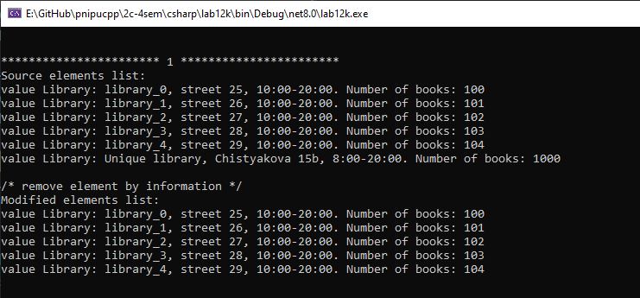

**Задание 2.**

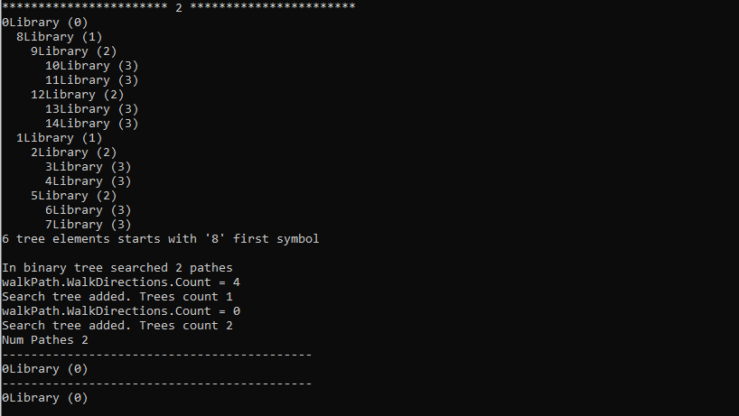

**Задание 3**

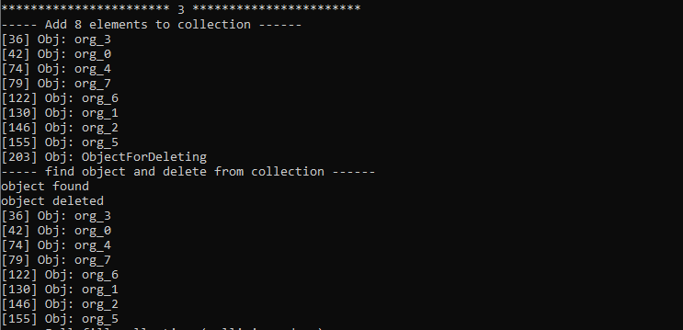

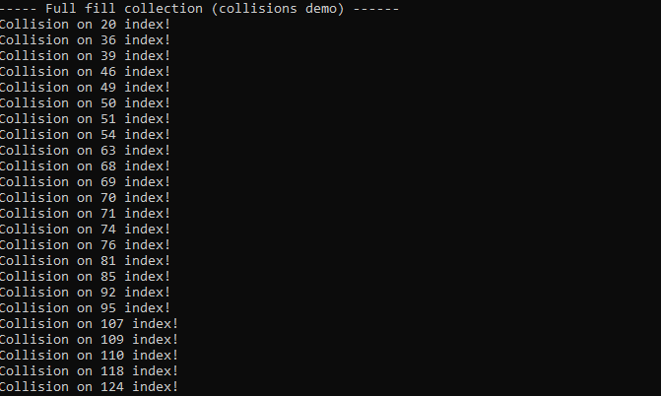

**Задание 4**

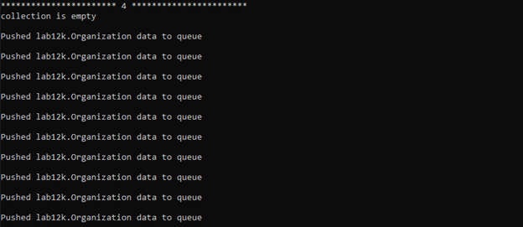

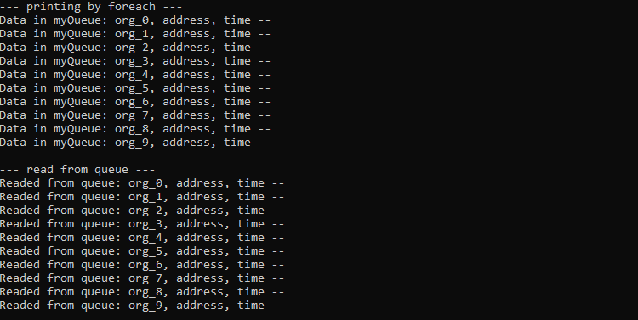

**Исходный код**

**Lab121.cs**

namespace lab12k.labs

{

public class Lab121

{

private static void DraftPrint(MyDCLinkedList<Library>? linkedList)

{

if (linkedList == null)

{

Console.WriteLine("linkedList is null");

return;

}

MyDCLinkedListNode<Library>? node = linkedList.Tail;

while (node != null)

{

Console.WriteLine(node.Data.GetFullInfo());

node = node.Next;

}

}

public void Start()

{

MyDCLinkedList<Library> linkedList = new MyDCLinkedList<Library>();

for (int i = 0; i < 5; i++)

linkedList.InsertLast(new Library($"library_{i}", $"street {i + 25}", "10:00-20:00", i + 100));

/* object for deleting from LL */

Library libForDeleteFromLL = new Library("Unique library", "Chistyakova 15b", "8:00-20:00", 1000);

linkedList.InsertLast(libForDeleteFromLL);

Console.WriteLine("Source elements list:");

//DraftPrint(linkedList);

foreach (var value in linkedList)

Console.WriteLine("value {0}", value.Data.GetFullInfo());

Console.Write("\n");

/* remove element by information */

Console.WriteLine("/* remove element by information */");

if (!linkedList.RemoveElem(libForDeleteFromLL))

Console.WriteLine("failed to delete object from linked list");

Console.WriteLine("Modified elements list:");

foreach (var value in linkedList)

Console.WriteLine("value {0}", value.Data.GetFullInfo());

}

}

}

**Lab122.cs**

namespace lab12k.labs

{

/* node creator impl for create and set data in tree node */

public class TreeNodeCreatorImpl : ITreeBuilderNodeCreator<Library>

{

private int nodeNum;

public TreeNodeCreatorImpl() {

nodeNum = 0;

}

public MyBinaryTreeNode<Library>? CreateNode(MyBinaryTreeNode<Library> ?rootNode, int level) {

Library lib = new Library($"{nodeNum}Library", $"street {nodeNum + 100}", $"8:00-20:00", nodeNum + 222);

MyBinaryTreeNode<Library>? node = new MyBinaryTreeNode<Library>(lib, rootNode);

nodeNum++;

return node;

}

}

/* tree node printer implementation for print data in node graph */

public class TreeNodePrinterImpl : ITreeNodePrinter<Library>

{

public string? Print(MyBinaryTreeNode<Library>? node, int level) {

if (node == null)

return "node was null";

if (node.data == null)

return "node data is null";

return $"{node.data.GetOrgName()} ({level})";

}

}

public class Lab122

{

public void Start()

{

const int numTreeLevels = 3;

TreeNodeCreatorImpl creatorImpl = new TreeNodeCreatorImpl(); // create NodeCreator implementation

IdealBinaryTreeBuilder<Library> treeBuilder = new IdealBinaryTreeBuilder<Library>(creatorImpl, numTreeLevels); // create IdealBinaryTreeBuilder

MyBinaryTreeNode<Library>? idealTreeRootNode = treeBuilder.GetRootNode(); // get ref to root ideal tree node

TreeNodePrinterImpl printerImpl = new TreeNodePrinterImpl(); // create NodePrinter implementation

new MyBinaryTreePrinter<Library>(printerImpl, idealTreeRootNode, numTreeLevels); // print tree

MyBinaryTreeNodesCounter treeElementsCounter = new MyBinaryTreeNodesCounter(idealTreeRootNode, '1'); //create tree elements counter

Console.WriteLine("{0} tree elements starts with '8' first symbol", treeElementsCounter.GetNumNodes()); //print count elements starts with 'L' sym

MyBSTBuilder binaryTreeSearchTreeBuilder = new MyBSTBuilder(idealTreeRootNode, '1');

Console.WriteLine("Num Pathes {0}", binaryTreeSearchTreeBuilder.walkPathes.Count);

foreach(MyBinaryTreeNode<Library> ?rootNode in binaryTreeSearchTreeBuilder.searchTreeRootNodes) {

Console.WriteLine("-------------------------------------------");

new MyBinaryTreePrinter<Library>(printerImpl, rootNode, numTreeLevels); // print BST

}

}

}

}

**Lab123.cs**

namespace lab12k

{

public class Lab123

{

MyHashTable<Organization, string> ?ht;

public void Start()

{

ht = new MyHashTable<Organization, string>(256);

Organization forDeleting = new Organization("For deleting", "", "10:00-20:00");

ht.Add(forDeleting, "ObjectForDeleting");

Console.WriteLine("----- Add 8 elements to collection ------");

for (int i = 0; i < 8; i++) {

string str = $"org_{i}";

Organization org = new Organization(str, $"address {i}", "10:00-20:00");

if(-1 == ht.Add(org, str)) {

Console.WriteLine("Collision!\n");

}

}

ht.Print();

Console.WriteLine("----- find object and delete from collection ------");

if (ht.Find(forDeleting) != null) {

Console.WriteLine("object found");

if(ht.Remove(forDeleting)) {

if(ht.Find(forDeleting) == null) {

Console.WriteLine("object deleted");

ht.Print();

}

}

}

// show collisions

Console.WriteLine("----- Full fill collection (collisions demo) ------");

for (int i = 8; i < ht.Count; i++) {

string str = $"next_{i}";

Organization org = new Organization(str, $"address {i}", "12:00-22:00");

if (-1 == ht.Add(org, str)) {

Console.WriteLine("Collision on {0} index!", i);

}

}

}

}

}

**IdealBinaryTreeBuilder.cs**

namespace lab12k

{

public interface ITreeBuilderNodeCreator<_Ty>

{

/* for create node and set data to default constructor */

public MyBinaryTreeNode<_Ty>? CreateNode(MyBinaryTreeNode<_Ty>? rootNode, int level);

}

public class IdealBinaryTreeBuilder<_Ty>

{

private MyBinaryTreeNode<_Ty> root;

ITreeBuilderNodeCreator<_Ty> creator;

private void BuildTreeBranchRecursive(MyBinaryTreeNode<_Ty>? root, int level, ref MyBinaryTreeNode<_Ty>? node) {

/* end node no have child nodes */

if (level == 0) {

node = null;

return;

}

level--;

node = creator.CreateNode(root, level);

BuildTreeBranchRecursive(root, level, ref node.left);

BuildTreeBranchRecursive(root, level, ref node.right);

}

public IdealBinaryTreeBuilder(ITreeBuilderNodeCreator<_Ty> nodeCreator, int levels) {

creator = nodeCreator;

root = creator.CreateNode(root, levels);

BuildTreeBranchRecursive(root, levels, ref root.right);

BuildTreeBranchRecursive(root, levels, ref root.left);

}

public MyBinaryTreeNode<_Ty> GetRootNode() { return root; }

}

}

**MyBinaryTree.cs**

namespace lab12k

{

public class MyBinaryTreeNode<_Ty>

{

public MyBinaryTreeNode<_Ty>? root;

public MyBinaryTreeNode<_Ty>? left;

public MyBinaryTreeNode<_Ty>? right;

public _Ty data;

public MyBinaryTreeNode(_Ty Data) {

data = Data;

root = null;

left = null;

right = null;

}

public MyBinaryTreeNode(_Ty Data, MyBinaryTreeNode<_Ty> rootNode) {

data = Data;

root = rootNode;

left = null;

right = null;

}

public MyBinaryTreeNode<_Ty>? AddLeftNode(_Ty Data)

{

return left = new MyBinaryTreeNode<_Ty>(Data, this);

}

public MyBinaryTreeNode<_Ty>? AddRightNode(_Ty Data)

{

return right = new MyBinaryTreeNode<_Ty>(Data, this);

}

}

}

**MyBinaryTreeNodesCounter.cs**

namespace lab12k

{

public class MyBinaryTreeNodesCounter

{

int counter;

char firstChar;

int charIdx;

MyBinaryTreeNodesCounter() {

counter = 0;

firstChar ='\0';

charIdx = 0;

}

private void SearchRecursive(MyBinaryTreeNode<Library>? node)

{

if(node == null)

return;

string? str = node.data.GetOrgName();

if (charIdx < str.Length && str[charIdx] == firstChar)

counter++;

SearchRecursive(node.left);

SearchRecursive(node.right);

}

public MyBinaryTreeNodesCounter(MyBinaryTreeNode<Library> ?rootNode, char firstCharForFind, int charIndex = 0) {

counter = 0;

firstChar = firstCharForFind;

charIdx = charIndex;

SearchRecursive(rootNode.left);

SearchRecursive(rootNode.right);

}

public int GetNumNodes() { return counter; }

}

}

**MyBinaryTreePrinter.cs**

namespace lab12k

{

public interface ITreeNodePrinter<_Ty>

{

public string? Print(MyBinaryTreeNode<_Ty>? node, int level);

}

public class MyBinaryTreePrinter<_Ty>

{

private int padWidth;

private int maxLevel;

private ITreeNodePrinter<_Ty> printer;

private void PrintTreeBranch(int level, MyBinaryTreeNode<_Ty>? node)

{

if (null == node /*|| level > maxLevel*/)

return;

int spacesCount = level * padWidth;

Console.WriteLine(String.Format("{0," + spacesCount + "}{1}", "", printer.Print(node, level)));

level++;

PrintTreeBranch(level, node.left);

PrintTreeBranch(level, node.right);

}

public MyBinaryTreePrinter(ITreeNodePrinter<_Ty> nodePrinter, MyBinaryTreeNode<_Ty> ?rootnode, int numlevels, int padwith = 2)

{

if (rootnode == null) {

Console.WriteLine("root node is null");

return;

}

printer = nodePrinter;

padWidth = padwith;

maxLevel = numlevels;

Console.WriteLine(printer.Print(rootnode, 0));

PrintTreeBranch(1, rootnode.left);

PrintTreeBranch(1, rootnode.right);

}

}

}

**MyBSTBuilder.cs**

namespace lab12k

{

/* Binary Search Tree (BST) */

public class MyBSTBuilder

{

public class NodeSearchContext {

public char firstChar;

public int charIdx;

public NodeSearchContext(char chr, int idx) {

firstChar = chr;

charIdx = idx;

}

}

/* this class store all pathes to needed data elem */

public class NodesWalkPath

{

public enum TREE_PATH_DIR

{

DIR_LEFT_NODE = 0,

DIR_RIGHT_NODE = 1

};

private List<TREE_PATH_DIR> nodesWalkDirections;

private MyBinaryTreeNode<Library>? endNodeRef;

private NodeSearchContext seatrchData;

public List<MyBinaryTreeNode<Library>?> ?skipRefs;

public MyBinaryTreeNode<Library>? EndNodeRef {

get { return endNodeRef; }

}

public List<TREE_PATH_DIR> WalkDirections {

get { return nodesWalkDirections; }

}

public NodesWalkPath(NodeSearchContext search) {

nodesWalkDirections = new List<TREE_PATH_DIR>();

seatrchData = search;

}

private bool NodeInSkipList(MyBinaryTreeNode<Library>? node)

{

for (int i = 0; i < skipRefs.Count; i++)

if (node == skipRefs[i])

return true;

return false;

}

// returns true if needed element found in tree branch

private bool SearchRecursive(MyBinaryTreeNode<Library>? node) {

bool b_left_node_found;

bool b_right_node_found;

// node is not exists (end tree node)

if (node == null) {

nodesWalkDirections.Clear(); //clear directions

return false; //break searching

}

string? str = node.data.GetOrgName();

if (seatrchData.charIdx < str.Length && str[seatrchData.charIdx] == seatrchData.firstChar) {

if(!NodeInSkipList(node)) {

endNodeRef = node; // save found node ref0

return true; //break searching

}

}

// recursive search in left branch and in right branch

// if needed value found in one on the branches, return true

b_left_node_found = SearchRecursive(node.left);

if (b_left_node_found)

nodesWalkDirections.Add(TREE_PATH_DIR.DIR_LEFT_NODE); // elem found in left node

b_right_node_found = SearchRecursive(node.right);

if(b_right_node_found)

nodesWalkDirections.Add(TREE_PATH_DIR.DIR_RIGHT_NODE); // elem found in right node

Debug.Assert(!(b_left_node_found && b_right_node_found), "Impossible to find elements in both trees at once!");

return b_left_node_found || b_right_node_found;

}

public bool Search(MyBinaryTreeNode<Library>? rootNode, List<MyBinaryTreeNode<Library>?> ?skipList) {

// recursive search in left branch and in right branch

skipRefs = skipList;

Debug.Assert(rootNode != null, "rootNode must be not null");

return SearchRecursive(rootNode.left) || SearchRecursive(rootNode.right);

}

}

private NodeSearchContext search;

public readonly List<NodesWalkPath?> walkPathes;

public readonly List<MyBinaryTreeNode<Library>?> searchTreeRootNodes;

private bool SearchAllPaths(MyBinaryTreeNode<Library>? rootNode, NodeSearchContext search)

{

List<MyBinaryTreeNode<Library>?> skipNodesList = new List<MyBinaryTreeNode<Library>?>();

// 1-st search

// if this call walked on all tree and not found needed elem, break searching

NodesWalkPath firstWalk = new NodesWalkPath(search);

if (!firstWalk.Search(rootNode, skipNodesList)) {

//There are links in the sheet but the function returned false (not found)

Debug.Assert(firstWalk.EndNodeRef == null, "Ooops! Something went wrong! Search returned false (elements not found) but firstWalk.EndNodeRef != null");

return false; // Eelement with needed info not found in all tree. Return false

}

walkPathes.Add(firstWalk);

// next searches

// Needed element found in tree and this node reference saved in the list. It is one of the pathes :)

// Continue searching from current node next...

for (int i = 0; i < walkPathes.Count; i++) {

NodesWalkPath newWalk = new NodesWalkPath(search);

if(walkPathes[i].EndNodeRef != null) {

if (newWalk.Search(walkPathes[i].EndNodeRef, skipNodesList)) {

walkPathes.Add(newWalk);

Console.WriteLine("");

i = 0; // repeat cycle from start and break current iteration

break;

}

}

}

Console.WriteLine("In binary tree searched {0} pathes", walkPathes.Count);

return true;

}

private bool SearchPathWithIgnoreExistsRefs(MyBinaryTreeNode<Library>? rootNode, List<MyBinaryTreeNode<Library>?> ? skipNodesList)

{

NodesWalkPath firstWalk = new NodesWalkPath(search);

if (firstWalk.Search(rootNode, skipNodesList)) {

//There are links in the sheet but the function returned false (not found)

Debug.Assert(firstWalk.EndNodeRef == null, "Ooops! Something went wrong! Search returned false (elements not found) but firstWalk.EndNodeRef != null");

return false; // Eelement with needed info not found in all tree. Return false

}

walkPathes.Add(firstWalk);

skipNodesList.Add(firstWalk.EndNodeRef);

return true;

}

private bool SearchAllPaths2(MyBinaryTreeNode<Library>? rootNode, NodeSearchContext search)

{

List<MyBinaryTreeNode<Library>?> skipNodesList = new List<MyBinaryTreeNode<Library>?>();

while (SearchPathWithIgnoreExistsRefs(rootNode, skipNodesList));

Console.WriteLine("In binary tree searched {0} pathes", walkPathes.Count);

return true;

}

public void BuildSearchTrees() {

/* search path from end node to root node and generate new search tree */

for (int i = 0; i < walkPathes.Count; i++) {

NodesWalkPath? walkPath = walkPathes[i];

Debug.Assert(walkPath != null, "walkPath was null");

MyBinaryTreeNode<Library>? endSrcNode = walkPath.EndNodeRef;

Debug.Assert(endSrcNode != null, "endSrcNode was null");

Console.WriteLine("walkPath.WalkDirections.Count = {0}", walkPath.WalkDirections.Count);

//TODO: generate seatch tree by direction info and root nodes info

MyBinaryTreeNode<Library>? mySrcRoot = null;

MyBinaryTreeNode<Library>? newNode = null;

MyBinaryTreeNode<Library>? previousRootNode = null;

if(endSrcNode != null) {

newNode = new MyBinaryTreeNode<Library>(endSrcNode.data);

while (endSrcNode != null) {

// this node is chlid?!

mySrcRoot = endSrcNode.root;

if (mySrcRoot != null) {

// this node is child

// create parent for me and set needed link to my ref

MyBinaryTreeNode<Library>? myNewRoot = new MyBinaryTreeNode<Library>(mySrcRoot.data);

/* solve node connection */

if (mySrcRoot.left == endSrcNode)

{

myNewRoot.left = newNode;

}

else if (mySrcRoot.right == endSrcNode)

{

myNewRoot.right = newNode;

}

else

{

Debug.Assert(false, "Unexpected end of tree branch");

}

newNode = myNewRoot;

previousRootNode = newNode;

}

else {

// first root node (no parents)

searchTreeRootNodes.Add(previousRootNode);

Console.WriteLine("Search tree added. Trees count {0}", searchTreeRootNodes.Count);

break;

}

endSrcNode = mySrcRoot;

}

}

}

}

public MyBSTBuilder(MyBinaryTreeNode<Library>? rootNode, char firstSym, int charIdx = 0) {

search = new NodeSearchContext(firstSym, charIdx);

walkPathes = new List<NodesWalkPath?>();

searchTreeRootNodes = new List<MyBinaryTreeNode<Library>?>();

if (SearchAllPaths(rootNode, search))

//if (SearchAllPaths2(rootNode, search))

BuildSearchTrees();

}

}

}

**MyCollectionQueue.cs**

namespace lab12k

{

public class MyCollectionNode<_Ty>

{

MyCollectionNode<_Ty>? next_node;

_Ty node_data;

public MyCollectionNode(MyCollectionNode<_Ty>? next, _Ty data) {

next_node = next;

node_data = data;

}

public _Ty Data {

get { return node_data; }

set { node_data = value; }

}

public MyCollectionNode<_Ty>? Next {

get { return next_node; }

set { next_node = value; }

}

};

public class MyCollectionQueue<_Ty> : IEnumerable<_Ty>

{

public class MyCollectionQueueEnumeraror<_Ty2> : IEnumerator<_Ty2>

{

private MyCollectionNode<_Ty2>? tail;

public MyCollectionQueueEnumeraror(MyCollectionNode<_Ty2>? tailref) {

tail = tailref;

}

public _Ty2 Current {

get { return tail.Data; }

}

object IEnumerator.Current {

get { return Current; }

}

public bool MoveNext()

{

if (tail != null)

tail = tail.Next;

return tail != null;

}

public void Reset()

{

tail = null;

}

public void Dispose() { }

};

public class MyCollectionQueueEnumeraror2<_Ty2> : IEnumerator<_Ty2>

{

_Ty2 data;

MyCollectionQueue<_Ty2> collectionQueue;

public MyCollectionQueueEnumeraror2(MyCollectionQueue<_Ty2>? thisQueue) {

collectionQueue = thisQueue.Copy2();

}

public _Ty2 Current

{

get { return data; }

}

object IEnumerator.Current

{

get { return Current; }

}

public bool MoveNext()

{

if (!collectionQueue.IsEmpty()) {

data = collectionQueue.Front();

return true;

}

return false;

}

public void Reset() { }

public void Dispose() { }

};

public IEnumerator<_Ty> GetEnumerator() {

//return new MyCollectionQueueEnumeraror<_Ty>(tail);

return new MyCollectionQueueEnumeraror2<_Ty>(this);

}

IEnumerator IEnumerable.GetEnumerator() {

return GetEnumerator();

}

int count;

MyCollectionNode<_Ty>? head;

MyCollectionNode<_Ty>? tail;

public int Count {

get { return count; }

}

public MyCollectionQueue() {

head = null;

tail = null;

count = 0;

}

public MyCollectionQueue(int capacity) {

head = null;

tail = null;

count = capacity; // define queue size

// if number of elements greater 0

if(count > 0) {

_Ty data = default(_Ty);

MyCollectionNode<_Ty>? newNode = new MyCollectionNode<_Ty>(null, data);

// create new empty nodes

for (int i = 0; i < count; i++) {

if (head != null) // if head exists element

head.Next = newNode; // set next ref to exists element

head = newNode;

}

}

}

public MyCollectionQueue(MyCollectionQueue<_Ty> ?queueWithInit) {

if(queueWithInit != null) {

MyCollectionQueue<_Ty> copy = queueWithInit.Copy2();

while (!copy.IsEmpty()) {

PushBack(copy.Front());

}

}

}

public void PushBack(_Ty data) {

MyCollectionNode<_Ty>? newNode = null;

newNode = new MyCollectionNode<_Ty>(null, data);

if (head != null) // if previous node exists

head.Next = newNode; // next node for previous - this new node

head = newNode; //set new node to head ref

if (tail == null)

tail = head; // queue is empty or not initialized. Set tail to head ref

count++; // increment count elements in queue

}

public void PushBackMultiple(_Ty[] dataArray, int count) {

if(count > 0) {

for (int i = 0; i < count; i++) {

PushBack(dataArray[i]);

}

}

}

public MyCollectionNode<_Ty>? Find(_Ty dataForFind) {

MyCollectionNode<_Ty>? nodeRef = tail;

if (nodeRef != null) {

while(nodeRef != null) {

if(nodeRef.GetHashCode() == dataForFind.GetHashCode()) {

return nodeRef; // element found

}

nodeRef = nodeRef.Next;

}

}

return null; // not found

}

public bool Remove(MyCollectionNode<_Ty>? nodeRefForDel) {

if (nodeRefForDel == null)

return false;

MyCollectionNode<_Ty>? nodeRef = tail; // tail is start

while (nodeRef != null) { // if start node is not null

MyCollectionNode<_Ty>? nextRef = nodeRef.Next; // save ref to next node

if(nextRef != null) { // if ref to next node is not null

if (nodeRefForDel == nextRef) { // if ref to next node equals ref node for delete

nodeRef.Next = nodeRefForDel.Next; // set 'next' this node ref to 'next' node ref in deleting

return true;

}

}

nodeRef = nextRef;

}

return false;

}

public bool RemoveMultiple(MyCollectionNode<_Ty>?[] nodesRefForDel, int count) {

bool bSuccess = true; // return is OK

for (int i = 0; i < count; i++) // for each element

bSuccess &= Remove(nodesRefForDel[i]); // change bSuccess to false if one of function failed

return bSuccess; // return bSuccess

}

public bool IsEmpty() {

return tail == null; // tail ref is null. queue is empty

}

public _Ty Front() {

_Ty data = default(_Ty); // init new empty object instance data

if (tail != null) { // if tail not null

data = tail.Data; // copy data from queue node

tail = tail.Next; // move to next ref and set tail to this ref

count--; // element readed from queue, decrement count

}

return data; // return copied data

}

public MyCollectionQueue<_Ty> Copy() { // DEPTH copy

return new MyCollectionQueue<_Ty>(this);

}

public MyCollectionQueue<_Ty> Copy2() {

MyCollectionQueue<_Ty> queueCopy = new MyCollectionQueue<_Ty>();

queueCopy.head = head;

queueCopy.tail = tail;

queueCopy.count = count;

return queueCopy;

}

// free memory

public void Free() {

head = null;

tail = null;

}

}

}

**MyDCLinkedList.cs**

/* Double Connected Linked List */

namespace lab12k

{

public class MyDCLinkedListNode<_Ty>

{

public MyDCLinkedListNode<_Ty>? Last;

public MyDCLinkedListNode<_Ty>? Next;

public _Ty Data;

public MyDCLinkedListNode() {

Last = null;

Next = null;

}

public MyDCLinkedListNode(_Ty data) {

Data = data;

Last = null;

Next = null;

}

public MyDCLinkedListNode(MyDCLinkedListNode<_Ty>? alast, MyDCLinkedListNode<_Ty>? anext) {

Last = alast;

Next = anext;

}

public void InsertFirst(MyDCLinkedListNode<_Ty>? node) {

// skip addition null ptr

if (node == null)

return;

MyDCLinkedListNode<_Ty>? lastNode = Last; // save last ptr in temp variable

Last = node; // set last to new node

node.Last = lastNode; // set last node to new node

node.Next = this; // next node for this new node - this

}

public void InsertNext(MyDCLinkedListNode<_Ty>? node) {

// skip addition null ptr

if (node == null)

return;

MyDCLinkedListNode<_Ty>? nextNode = Next;

Next = node; // set Next ptr to this node

node.Next = nextNode; // set Next node ptr to new node

node.Last = this; // set last node ptr to this node

}

/* default insert new node to next position */

public MyDCLinkedListNode<_Ty>? NewNode() {

MyDCLinkedListNode<_Ty>? newNode = new MyDCLinkedListNode<_Ty>();

InsertNext(newNode);

return newNode;

}

/* insert new node to last */

public MyDCLinkedListNode<_Ty>? NewNode(bool bInsertFirst)

{

MyDCLinkedListNode<_Ty>? newNode = new MyDCLinkedListNode<_Ty>();

InsertFirst(newNode);

return newNode;

}

public void Unlink()

{

MyDCLinkedListNode<_Ty>? last = Last;

MyDCLinkedListNode<_Ty>? next = Next;

if(last != null)

last.Next = next;

if (next != null)

next.Last = last;

}

}

public class MyDCLinkedList<_Ty> : IEnumerable<MyDCLinkedListNode<_Ty>>

{

public MyDCLinkedListNode<_Ty> ?Tail; // first added element

public MyDCLinkedListNode<_Ty> ?Head; // last added element

public IEnumerator<MyDCLinkedListNode<_Ty>> GetEnumerator() {

MyDCLinkedListNode<_Ty>? current = Tail;

while (current != null) {

yield return current;

current = current.Next;

}

}

IEnumerator IEnumerable.GetEnumerator()

{

return GetEnumerator();

}

public MyDCLinkedList() {

Tail = null;

Head = null;

}

public MyDCLinkedListNode<_Ty>? InsertFirst(_Ty data) {

MyDCLinkedListNode < _Ty > ?newNode = new MyDCLinkedListNode<_Ty>(data);

/* add node to empty linked list */

//TODO: use IsEmpty()

if (Tail == null) {

Tail = newNode;

Head = newNode;

return newNode;

}

/* add next node */

Tail.InsertNext(newNode);

Tail = newNode;

return newNode;

}

public bool IsEmpty()

{

//Debug.Assert((Head != null && Tail == null) || (Head == null && Tail != null), "What happened?!"); //error state

return Head == null && Tail == null;

}

public MyDCLinkedListNode<_Ty>? InsertLast(_Ty data) {

MyDCLinkedListNode<_Ty>? newNode = new MyDCLinkedListNode<_Ty>(data);

/* add node to empty linked list */

//TODO: use IsEmpty()

if (Head == null) {

Head = newNode;

Tail = newNode;

return newNode;

}

/* add next node */

Head.InsertNext(newNode);

Head = newNode;

return newNode;

}

public MyDCLinkedListNode<_Ty>? Find(_Ty data) {

MyDCLinkedListNode<_Ty>? node = Tail;

while(node != null) {

if(node.Data != null && node.Data.Equals(data)) {

return node;

}

node = node.Next;

}

return null;

}

public bool RemoveElem(_Ty data) {

MyDCLinkedListNode<_Ty>? node = Find(data);

if (node == null)

return false;

node.Unlink();

return true;

}

}

}

**MyHashTable.cs**

namespace lab12k

{

public class MyHashTable<_TyKey, _TyVal>

{

int hashTableSize;

_TyVal[] tbl;

public int Count

{

get

{

return tbl.Length;

}

}

static private int MyHashFunc(_TyKey data) {

return data.GetHashCode();

}

public MyHashTable(int size) {

hashTableSize = size;

if (hashTableSize == 0)

hashTableSize++;

tbl = new _TyVal[hashTableSize];

}

private int GetIndexByKey(_TyKey key) {

return Math.Abs(MyHashFunc(key)) % tbl.Length;

}

public int Add(_TyKey key, _TyVal data) {

int idx = GetIndexByKey(key);

if (tbl[idx] == null) {

tbl[idx] = data;

return idx;

}

return -1;

}

public void Print() {

for (int i = 0; i < hashTableSize; i++) {

if (tbl[i] != null) {

Console.WriteLine("[{0}] Obj: {1}", i, tbl[i]);

}

}

}

public bool Exists(_TyKey key) { return tbl[GetIndexByKey(key)] != null; }

public _TyVal Find(_TyKey key) { return tbl[GetIndexByKey(key)]; }

public bool Remove(_TyKey key) {

int idx = GetIndexByKey(key);

if(tbl[idx] != null) {

tbl[idx] = default(_TyVal);

return true;

}

return false;

}

}

}

**Program.cs**

namespace lab12k

{

internal class Program

{

static void Main(string[] args)

{

Console.WriteLine("\n\n*********************** 1 ***********************");

new Lab121().Start();

Console.WriteLine("\n\n*********************** 2 ***********************");

new Lab122().Start();

Console.WriteLine("\n\n*********************** 3 ***********************");

new Lab123().Start();

Console.WriteLine("\n\n*********************** 4 ***********************");

new Lab124().Start();

}

}

}

**Диаграмма классов**

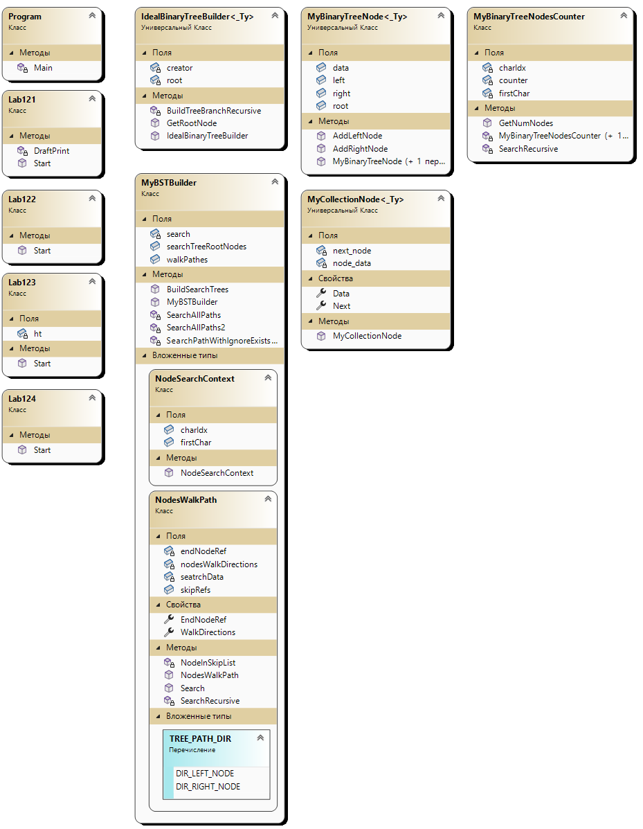

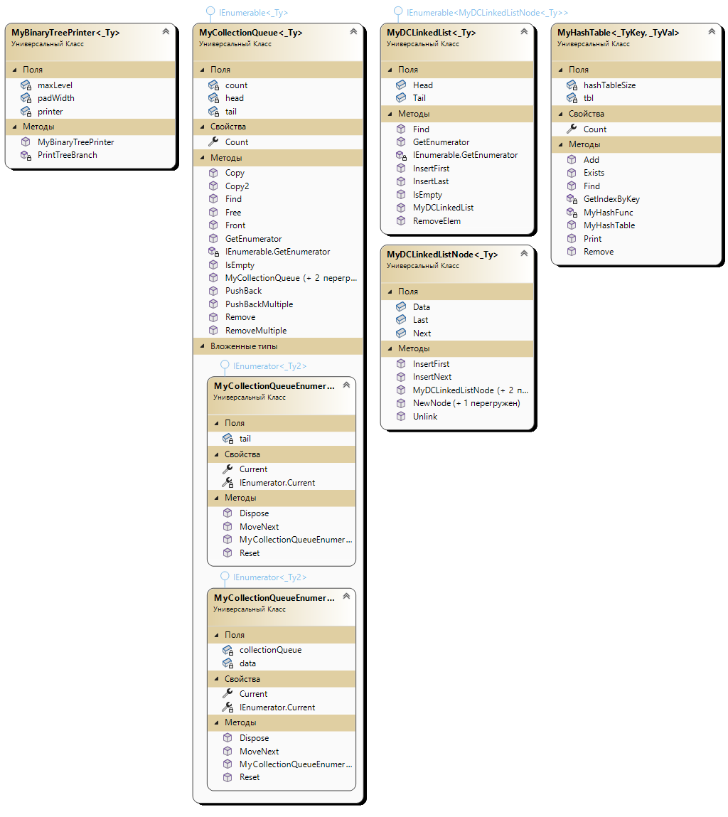

1.