Assignment 1 Q3

gregory f

10/7/2018

gregory = c(.31,.35,.36,.36,.37,.38,.40,.40,.40,.41,.41,.42,.42,.42,.42,.42,.43,.44,.45,.46,.46,.47,.48,.48,.48,.51,.54,.54,.55,.58,.62,.66,.66,.67,.68,.75)  
stem(gregory, scale = 1, width = 80)

##   
## The decimal point is 1 digit(s) to the left of the |  
##   
## 3 | 1  
## 3 | 56678  
## 4 | 000112222234  
## 4 | 5667888  
## 5 | 144  
## 5 | 58  
## 6 | 2  
## 6 | 6678  
## 7 |   
## 7 | 5

mean(gregory)

## [1] 0.4766667

median(gregory)

## [1] 0.445

?stem  
?density  
  
belag = c(590,815,575,608,350,985,408,540,555,679)  
hist(belag, main = "Sales Figures", col = "red",)

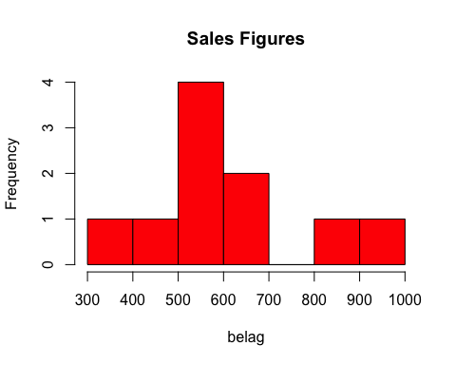

sd(belag)

## [1] 184.1999

mean(belag)

## [1] 610.5

median(belag)

## [1] 582.5

?normal

## No documentation for 'normal' in specified packages and libraries:  
## you could try '??normal'

?lines