test1

gregory f

10/8/2018

library(DevFarn2)

## Loading required package: qcc

## Package 'qcc' version 2.7

## Type 'citation("qcc")' for citing this R package in publications.

data("e1.1")  
hist(e1.1, col = "blue", main = "Olmec La Venta", xlab = "number of x", las=0, breaks = 10)

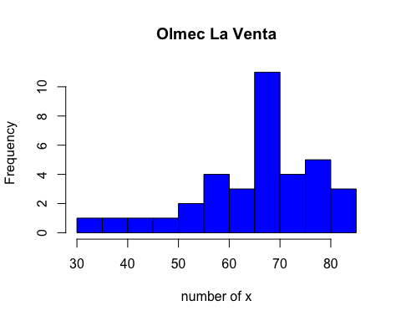

dotchart(e1.1, col = "10", main = "Good Friday", xlab = "test test test", ylab = "ytest ytest ytest")

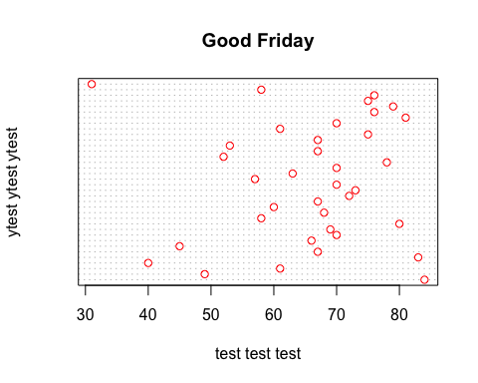

stem(e1.1)

##   
## The decimal point is 1 digit(s) to the right of the |  
##   
## 3 | 1  
## 4 | 059  
## 5 | 23788  
## 6 | 01136777789  
## 7 | 000023556689  
## 8 | 0134

dim("Furnace")

## NULL

########### example for linear model ##########  
x = c(.18,.20,.21,.21,.21,.22,.23,.23,.24,.24,.25,.28,.30,.37)  
y = c(.46,.70,.41,.45,.55,.44,.24,.47,.22,.80,.88,.70,.72,.75)  
  
  
##### better visualization #####  
plot(x,y, main = "Scatter Plot of Example", xlab = "hydrogen content", ylab = "gas propensity", pch=16, col = "blue")

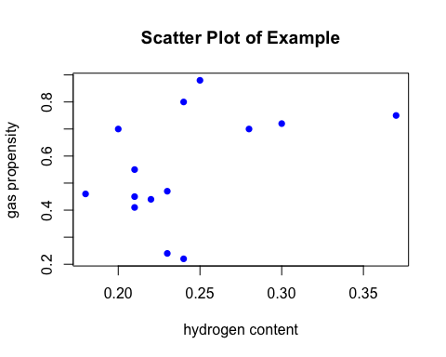

scatter.smooth(x,y, main = "Scatter Smooth Plot of Example", xlab = "hydrogen content", ylab = "gas propensity", col = "blue", pch=14)

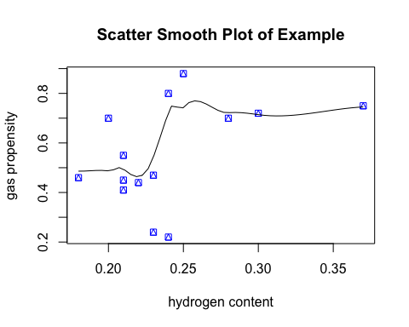

cor(x,y)

## [1] 0.4491168

##### building linear model for the data #####  
dataexample = data.frame(x,y)  
  
  
# build linear regression model on full data #  
lm_model = lm(y ~ x, data = dataexample)  
plot(x,y, main = "Scatter Plot of Example", xlab = "hydrogen content", ylab = "gas propensity", pch=16, col = "blue")  
abline(lm_model, col ="red")

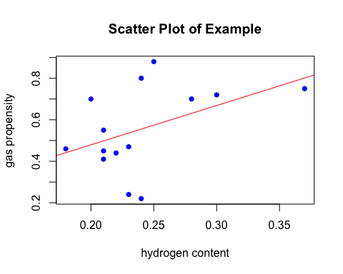

summary(lm_model)

##   
## Call:  
## lm(formula = y ~ x, data = dataexample)  
##   
## Residuals:  
## Min 1Q Median 3Q Max   
## -0.33508 -0.07443 -0.01484 0.06481 0.30598   
##   
## Coefficients:  
## Estimate Std. Error t value Pr(>|t|)  
## (Intercept) 0.1005 0.2667 0.377 0.713  
## x 1.8941 1.0878 1.741 0.107  
##   
## Residual standard error: 0.1906 on 12 degrees of freedom  
## Multiple R-squared: 0.2017, Adjusted R-squared: 0.1352   
## F-statistic: 3.032 on 1 and 12 DF, p-value: 0.1072