Imaging Multiple Sclerosis With MRI
Author: Heidi Veillette, BSc, MRT(R)(MR)
Outline:
- Introduction
  - Overview of multiple sclerosis disease process
  - Prevalence of MS worldwide
  - Common patient symptoms
  - McDonald criteria for diagnosing MS
    - Role of MRI in diagnosis
- MRI Protocols for MS
  - Overview
  - Brain protocol for diagnosis
    - Optional sequences
  - Brain protocol for follow-up imaging
  - Spine protocol
    - Optional sequences
  - Spine protocol for follow-up imaging
- Visible Signs of MS on MR Images
  - Dawson’s fingers
  - Central vein sign
  - Iron rim sign
  - Open ring sign
- Future Considerations and Conclusion

Word count: 2579
Credits: 0.5
Learning Objectives:
- Outline the process of multiple sclerosis (MS) disease development and its associated symptoms.
- Explain the recommended MS brain and spine magnetic resonance imaging (MRI) protocols, including the benefits of each sequence and the recommended use of contrast media.
- Describe the visible signs of MS on MRI.

Highlights
- Magnetic resonance imaging (MRI) is the primary imaging modality for diagnosis of multiple sclerosis by lesion characteristics, such as dissemination in time and space.
- The 3-dimensional fluid-attenuated inversion recovery MRI sequence has the highest sensitivity for demonstrating MS lesions in the brain.
- Advances in technology create high-quality susceptibility-weighted images that show new diagnostic markers such as the central vein sign and iron rim sign.

Introduction
Multiple sclerosis (MS) is a progressive, inflammatory neurodegenerative disease of the central nervous system (CNS). It is considered an immune-mediated disease whereby the body’s immune system attacks the CNS and causes demyelination. Demyelination is when the myelin (the fatty substance surrounding and insulating nerve fibers) is damaged. The nerve fibers, then unprotected, also are damaged and develop scar tissue lesions called sclerosis.² These lesions can occur in many areas of the CNS, giving the disease its name “multiple sclerosis.”² The exact mechanism of why the immune system attacks its own CNS is unknown, but environmental factors, infectious diseases, and genetics are thought to combine to trigger the disease.²

According to the Atlas of MS, an online open-source collection of MS data from around the world, 2.8 million people are living with MS as of 2020. This number has increased from 2.3 million in 2013, and the cause for the increase is unknown.³ Women are 2 to 3 times more likely to have MS than men, with the average age of diagnosis around age 36 years.³ MS is the second most common cause of neurologic impairment in young adults after trauma.

MS leads to chronic, progressive, irreversible disability in most patients. Approximately 85% of patients diagnosed with MS have relapsing-remitting MS (RRMS), which involves periodic attacks (relapses) with partial or complete recovery (remission). Some of these patients with RRMS will progress to the secondary progressive type of MS, when neurologic function progressively worsens over time. Patients diagnosed with primary progressive MS have progressive disability with no relapses or remissions.² Although there is still no cure, several medications are available for treatment to reduce relapse rates and severity and slow the progression of disability.¹

Diagnosing MS is challenging because patients present with varying symptoms and intensities, depending on the quantity, location, and activity of the lesions in the CNS. Table 1 shows the most common symptoms that may be listed on the requisition form when a patient comes to the MRI department for their initial or follow-up MS MRI examination.^{2,}

Accurate and early diagnosis of MS is critical for starting treatment and having an optimal prognosis. The McDonald criteria is the standard set of guidelines used by physicians to diagnose MS. Diagnosis requires clinical testing, elimination of other possible diagnoses, and the evidence of sclerotic lesions in the CNS disseminated in space and time. Dissemination in space (DIS) means that lesions are located in multiple sections of the CNS, including the white matter, grey matter, cerebellum, brainstem, spinal cord, or optic nerve. Dissemination in time (DIT) means that there is evidence that damage occurred at different points in time.²

MRI is the optimal imaging modality for showing both DIS and DIT. It is the primary modality for diagnosing MS and for the follow-up imaging used to determine the disease pattern, progression, and response to treatment.⁵ The 2017 revision of the McDonald criteria highlighted the strong need for strict standardization of MRI acquisition and interpretation to avoid misdiagnosis.

MRI Protocols for MS
While there is no single regulatory body that can provide worldwide standardization of MS MRI protocols, recently published recommendations from the Magnetic Resonance Imaging in Multiple Sclerosis study group, Consortium of Multiple Sclerosis Centers, and North American Imaging in Multiple Sclerosis Cooperative (MAGNIMS-CMSC-NAIMS) include equipment specifications and specific brain and spine sequences for optimal MS imaging.⁹

High-field magnets of 3 Tesla (T) or higher provide a better MS lesion detection rate and possibly shorter acquisition times compared with lower-field magnets, but there is no evidence that 3T MRI provides an earlier diagnosis of MS. The use of 1.5T scanners continues to be sufficient for brain lesion detection at the time of diagnosis, as long as sequences are of good quality with adequate signal-to-noise and spatial resolution. The use of scanners with field strengths lower than 1.5T is not recommended.⁹ For detecting spinal cord lesions, there is no evidence that scanning at higher field strengths leads to a higher detection rate, so 1.5T scanners are adequate for all spinal MS imaging.

MS MRI protocols may vary between sites depending on the radiologist’s preference and equipment specifications, but one aspect of brain MRI that is universally agreed upon is angling axial slices to the anterior commissure–posterior commissure line off a sagittal image. This creates standard axial slices that can be closely compared with previous and future images.

Brain protocol for MS diagnosis
MS lesions in the brain are best visualized on fluid-sensitive sequences such as T2 and fluid-attenuated inversion recovery (FLAIR).⁵ Figure 1A shows MS lesions as seen on an axial FLAIR image. The 3-dimensional (3D) FLAIR sequence is considered the “core” sequence in MS brain MRI protocols due to its high sensitivity in detecting lesions.⁹ 3D acquisitions not only have improved lesion detection over 2-dimesnsional (2D) acquisitions, but they also allow for adjustments to the anatomic orientation when comparing with previous MRI. However, in centers that are unable to acquire 3D FLAIR images with high image quality, 2D sequences with 3-mm slice thickness or less and no gap can provide an acceptable alternative.⁹

In addition to standard 3D FLAIR and axial T2 sequences, injecting gadolinium-based contrast agents during the brain protocol for initial diagnosis is recommended. Gadolinium enhancement occurs when the blood-brain barrier is damaged during active inflammation of new lesions or reactivation of previous lesions.¹¹ This enhancement can demonstrate dissemination in time and exclude other diagnoses. Figure 1B shows enhancing lesions on a post-contrast T1 image.¹² The time delay between contrast administration and the post-contrast axial T1 sequence should be identical during follow-up scans and not shorter than 5 minutes (ideally 10 minutes).

A practical and cost-effective strategy to assure a delay of 5 to 10 minutes is to inject the gadolinium at the beginning of the examination and acquire the T2 and FLAIR sequences before the post-contrast T1 sequence. The T2 and FLAIR sequences are not affected by the presence of gadolinium.⁹

Pre-contrast T1 sequences do not provide added value for routine clinical purposes and are therefore not required.⁹ The recommended brain MRI protocol for the initial diagnosis of MS is shown in Table 2.⁹

Optional sequences for MS diagnosis
Proton density sequences, while commonly performed in the past, are now considered optional because high-quality FLAIR sequences have improved the detection of juxtacortical and periventricular lesions.¹

Diffusion-weighted imaging (DWI) is frequently added to brain imaging protocols for MS diagnosis and monitoring, but its value is limited. DWI should be considered to exclude other diseases during the initial diagnosis scan, but it is not necessary for follow-up scans in patients with known MS.⁹

Susceptibility-weighted imaging (SWI) or T2* sequences can highlight vessels in the brain and may show a central vein sign, which is a hypointense vein running through a hyperintense lesion. SWI can also identify paramagnetic iron rim enhancement around chronic active lesions in 50% of patients with MS. This effect rarely occurs in other neurologic conditions and therefore has the potential to increase the MRI specificity in differentiating MS from non-MS.¹⁵ The central vein sign and paramagnetic iron rim enhancement are explained later in this course.

Brain protocol for follow-up MS imaging
Patients diagnosed with MS will generally have routine follow-up imaging every 6 to 12 months, after starting a new treatment, or during a flare-up or relapse of symptoms.¹¹ These follow-up scans should be done on the same equipment as the initial scan, using the same sequence parameters and slice angles to ensure proper measurements.^{1,9}

Previously, the recommended protocol in these situations included the full brain protocol with an injection of gadolinium.¹¹ The use of gadolinium has been controversial recently, with many agencies recommending a reduction in the number of gadolinium injections due to the unknown toxic effect of multiple injections throughout the course of a lifetime. In addition, some researchers have found that with 3T scanners, the use of a gadolinium-based contrast agent did not change the diagnosis of disease progression. In addition, if the presence or absence of enhancement will not change the clinical management, administration of gadolinium is not needed.¹⁶

The consensus in the literature is that the use of gadolinium is not recommended for standard monitoring purposes, if a comparable recent (within 1 year) MRI scan is available.⁹ New and/or enlarging lesions seen on T2 and FLAIR are reliable markers of active inflammatory disease and may be superior to enhancing lesions in many clinical situations.

The quality of 3D FLAIR images on 3T is so high that some researchers even consider additional T2 sequences to be optional.⁹ An abbreviated protocol with 3D FLAIR reconstructed into axial and sagittal planes and in selected cases, an added contrast-enhanced T1 sequence, is sufficient for follow-up imaging.⁹ Although each site has different protocols for follow-up MS imaging, the recommended abbreviated follow-up MS MRI protocol from the MAGNIMS-CMSC-NAIMS group is shown in Table 2.⁹

Spine protocol for MS diagnosis
A spinal cord MRI is important for demonstrating DIS and DIT for the initial diagnosis of MS and for excluding other diagnoses such as cord compression, vascular disease, or inflammatory disease.¹⁴ The cervical spinal cord is most affected by MS, with the thoracic and lumbar spinal cord sections affected with decreasing frequency. Many sites will image the thoracic spine down to the conus in addition to the brain and cervical spine during the initial diagnostic scan, especially if there are lower body symptoms such as urinary incontinence. In this situation, the thoracic spine protocol will usually be identical to the cervical spine protocol.
The recommended cervical spine protocol must include at least 2 of the following 3 sagittal sequences: T2, proton density, or short-tau inversion recovery (STIR).⁹ The acquisition of 1 sagittal sequence has limited sensitivity in depicting signal abnormalities, so a second sequence is required to confirm the presence of lesions and exclude artifacts. Axial T2 sequences can further improve diagnostic certainty by confirming and characterizing lesions seen on sagittal images and visualizing lesions at the periphery of the spinal cord that may be missed on the sagittal images, but this sequence is not considered necessary in every examination.⁹

Figure 1C shows MS lesions in the cervical and thoracic spinal cord in a sagittal T2 fat-saturated image.¹² Note that the STIR sequence is recommended to replace the T2 fat-saturated sequence in spinal imaging due to better homogenous fat saturation.

Although the occurrence of enhanced lesions is less frequent in the spinal cord than in the brain, a sagittal post-contrast T1 sequence is recommended during the initial diagnostic examination if lesions are detected pre-contrast.⁹ The post-contrast T1 sequence should be performed immediately after the post-contrast brain MRI if both brain and spine scans are performed in the same visit.⁹ The recommended spine protocol for initial MS diagnosis is shown in Table 3.⁹

Spine protocol for follow-up MS imaging
The added value of a spine MRI for follow-up purposes is debatable and should be considered on a case-by-case basis, at the radiologist’s discretion. A follow-up spine MRI may be done if the patient presents with possible new active spinal lesions, symptoms that require an alternate diagnosis, or when monitoring a patient with spinal cord MS with no or a low number of brain lesions.^{9,} The spine protocol for follow-up MS imaging is shown in Table 3.⁹

Visible Signs of MS on MRI
MS lesions are hyperintense to background tissue on the T2 and FLAIR sequences. Lesions in the brain tend to have a round or oval shape measuring at least 3 mm in the long axis and have asymmetric distribution in these 3 areas of the brain⁶:
- Periventricular: adjacent to the walls of the lateral ventricles, extending perpendicularly outward
- Juxtacortical or cortical: adjacent to the cortical band or within the cortical gray matter
- Infratentorial: within the brainstem, pons, or cerebellum
Lesions in the spinal cord are often oval or cigar-shaped, smaller than 2 vertebral body heights, and typically located in the posterior and lateral areas of the spinal cord.⁶

Dawson’s finger lesions
Dawson’s finger lesions are ovoid lesions that extend outward from the lateral ventricles on sagittal FLAIR images. Visualization of Dawson finger lesions can strongly discriminate MS from other inflammatory disorders of the CNS, with very high sensitivity, ranging from 95% to 100%., Figure 2 shows an example of Dawson’s finger lesions on a sagittal FLAIR image.

Central vein sign
MS lesion distribution in the brain occurs in a perivascular pattern, meaning lesions tend to surround a vein. Advanced susceptibility-based techniques such as T2* have made it possible to visualize small veins within the brain. Combining separate T2* images with FLAIR images to create FLAIR* images allows for the simultaneous visualization of MS lesions and their central veins.^{23,} This “central vein sign” is defined as the presence of a vein as a hypointense line or dot in at least 2 perpendicular planes that run centrally through a hyperintense lesion.²³⁻ Example 3T FLAIR* images showing the central vein sign can be seen in Figure 3.

The central vein sign is emerging as a valuable diagnostic marker for MS because a high proportion of lesions with this sign suggests MS rather than its mimics. It is especially useful in certain situations such as when patients present with a clinical suspicion of MS but have atypical clinical, laboratory, or imaging findings.¹ However, because optimal pulse sequences are not widely available on all clinical scanners there is insufficient evidence to recommend the routine use of the central vein sign as a diagnostic marker.⁹
Paramagnetic rim sign
As previously mentioned, an iron rim surrounding a chronic active lesion can be visualized on SWI. This sequence increases the visibility of tissues with iron content due to their paramagnetic properties, and this effect increases with increased field strength.¹ Approximately 50% of patients with MS show at least 1 iron rim lesion, whereas that effect is absent in non-inflammatory neurologic diseases.¹⁵ Figure 4 shows paramagnetic rim enhancement on an SWI in a patient with MS.

SWI sequences are widely available on clinical scanners but often are not performed routinely in MS protocols. More research needs to be done to determine specific SWI sequence parameters and interpretation criteria before the iron rim sign is used as a diagnostic marker for MS.

Open ring sign
In post-contrast T1 brain images, the outer rim of active lesions enhances with an incomplete ring shape, often called an open ring sign. The incomplete portion of the ring usually points to the gray matter. Detection of an incomplete enhancing ring can assist in differentiating demyelination from infections, infarcts, and tumors, which have completely enhanced rings.²⁸ The open ring sign has high sensitivity and specificity regarding the diagnosis of MS.²⁸ An example of the open ring sign can be seen in Figure 5.

Future Considerations and Conclusion
Many aspects of MRI for MS are still under debate or in the initial stages of research. Advances in technology have allowed for improved image quality and a reduction in examination time with the elimination of unnecessary sequences. Further research needs to be done on determining the necessity of gadolinium injections in follow-up MRI scans and on the sensitivity of using the central vein sign and iron rim sign as standard diagnostic criteria.

MRI technologists play a key role in MS diagnosis and follow-up imaging. It is important to recognize that MS symptoms and their accompanying mobility challenges can affect each patient differently. Protocols for MS imaging may vary between sites, but it is essential to understand what each sequence demonstrates. Technologists are the primary health care worker who can adequately answer exam-related patient questions.

TABLES AND FIGURES

Table 1. Common Symptoms in Patients With MS at the Time of Diagnosis and During Relapses or Flare-ups^{2,5}
Cranial Nerve Involvement | Sensory Disturbances | Motor  Disturbances | Other
- Optic neuritis  - Trigeminal neuralgia  - Double vision  - Vertigo | - Paresthesia in extremities (numbness, tingling, often in toes) | - Ataxia (incoordination)  - Gait disturbance  - Weakness in extremities | - Urinary incontinence  - Fatigue  - Depression  - Cognitive decline
MS: multiple sclerosis.

Table 2. Recommended MS Brain MRI Protocols for Initial Diagnosis and Follow-up Imaging⁹
Brain MRI Protocol for MS Diagnosis | Brain MRI Protocol for MS Follow-up
- 3D FLAIR (or 2D axial + sagittal FLAIR)  - Axial T2  - Axial T1 post-contrast  Optional  - Axial PD  - Axial DWI  - Axial SWI or T2* | - 3D FLAIR (or 2D axial + sagittal FLAIR)  Optional  - Axial T2  - Axial T1 post-contrast
2D: 2-dimensional; 3D: 3-dimensional; DWI: diffusion-weighted imaging; FLAIR: fluid-attenuated inversion recovery; MRI: magnetic resonance imaging; MS: multiple sclerosis; PD: proton density; SWI: susceptibility-weighted imaging.

Table 3. Recommended MS Spine MRI Protocols for Initial Diagnosis and Follow-up Imaging⁹
Brain MRI Protocol for MS Diagnosis | Brain MRI Protocol for MS Follow-up
- Sagittal T2, PD, or STIR (2 of these 3 sequences)  - Sagittal T1 post-contrast  Optional  - Axial T2  - Axial GRE  - Sagittal T1 pre-contrast  - Axial T1 post-contrast | - Optional. To be done on a case-by-case basis at the radiologist’s discretion.
FLAIR: fluid attenuated inversion recovery; GRE: gradient echo sequence; MRI: magnetic resonance imaging; MS: multiple sclerosis; PD: proton density; STIR: short tau inversion recovery.

Figure 1. MRI From a 31-Year-Old Male Patient With Known MS Who Presented With Slow Reaction Times and Memory Loss for 3 Days
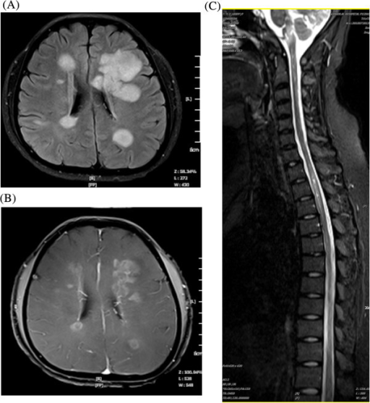
(A) Axial FLAIR sequence shows hyperintense periventricular lesions. (B) Axial T1 post-contrast image demonstrates enhancing uniform nodular, circular lesions. (C) Sagittal T2 fat-saturated image of the cervical and thoracic spines show multiple hyperintense lesions in the spinal cord.
FLAIR: fluid-attenuated inversion recovery; MRI: magnetic resonance imaging; MS: multiple sclerosis.
Reproduced from Li T, et al. Eur J Med Res. 2014;19:20 for educational purposes only.¹²

Figure 2. Sagittal FLAIR Image of Dawson’s Finger Lesions
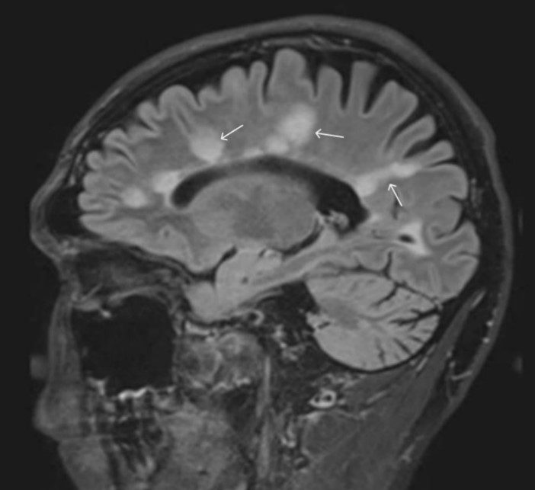
Lesions are perpendicular to the lateral ventricle, giving the classic finger-like appearance called Dawson’s finger lesions (white arrows).
FLAIR: fluid-attenuated inversion recovery.
Reproduced from Lopaisankrit T, Thammaroj J. J Imaging. 2023;9:27 for educational purposes only.²²
Figure 3. 3T FLAIR* Images (FLAIR Images Combined With T2* Images)
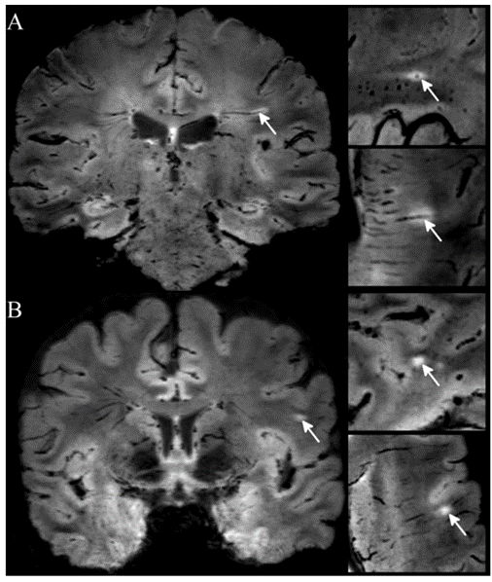
(A) Image demonstrating the central vessel sign in a patient with multiple sclerosis. The hypointense vessel is visible on all 3 planes in the center of the hyperintense lesion. (B) The central vein sign is absent in a patient presenting with a migraine.
FLAIR: fluid-attenuated inversion recovery.
Reproduced from Solomon AJ, et al. Ann Clin Transl Neurol. 2016;3:82-87 for educational purposes only.²⁶

Figure 4. Comparison of Lesion Appearance in Patients With Sjögren Disease (A and C) and MS (B and D)
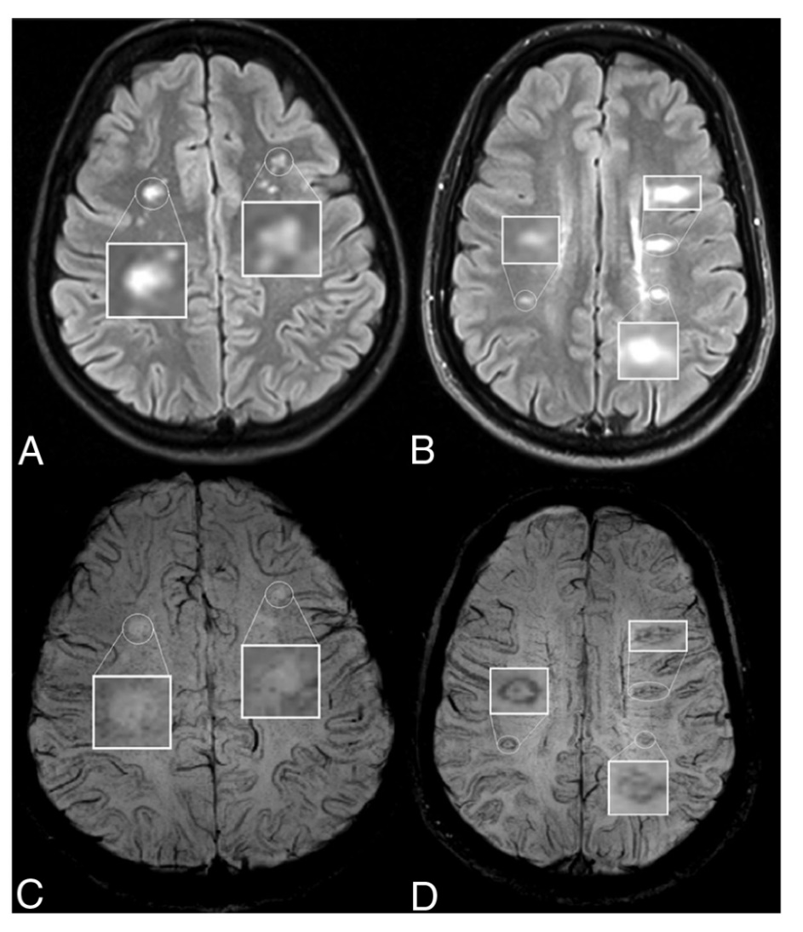
The top row (A and B) are FLAIR images, and the bottom row (C and D) are SWI images. The patient with MS has visible paramagnetic rims around the lesions (white boxes), whereas the patient with Sjögren disease has no visible paramagnetic rim enhancement. The MS lesions also show the central vein sign on SWI (D).
FLAIR: fluid-attenuated inversion recovery; MS: multiple sclerosis; SWI: susceptibility-weighted imaging.
Reproduced from Clarke MA, et al. AJNR Am J Neuroradiol. 2020;41:1001-1008 for educational purposes only.²⁸

Figure 5. Axial T1 Post-Contrast MRI With a Partially Enhancing Rim Around a Lesion Demonstrating the Open Ring Sign
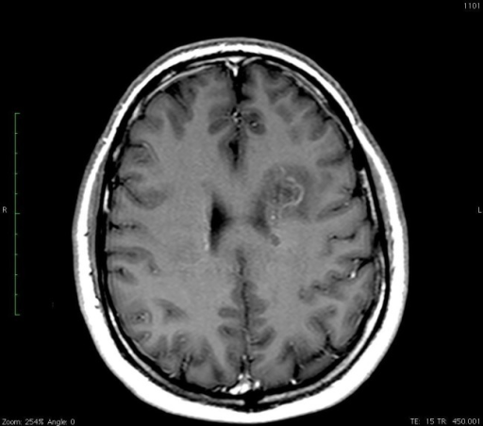
MRI: magnetic resonance imaging.
Reproduced from Nicholas Z, et al. Cureus. 2016;8:e600 for educational purposes only.³⁰

References

Rovira À, Auger C. Beyond McDonald: updated perspectives on MRI diagnosis of multiple sclerosis. Expert Rev Neurother. 2021;21:895-911. doi:10.1080/14737175.2021.1957832
National Multiple Sclerosis Society. Definition of multiple sclerosis. Accessed June 7, 2023. https://www.nationalmssociety.org/What-is-MS/Definition-of-MS
Atlas of MS. Number of people with MS. Accessed March 24, 2023. https://www.atlasofms.org/map/global/epidemiology/number-of-people-with-ms
Sarbu N, Shih RY, Jones RV, et al. White matter diseases with radiologic-pathologic correlation. Radiographics. 2016;36:1426-1447. doi:10.1148/rg.2016160031
Gaillard F, Ranchod A, Yap J, et al. Multiple sclerosis. Radiopaedia.org. Accessed June 7, 2023. doi:10.53347/rID-1700
Weidauer S, Raab P, Hattingen E. Diagnostic approach in multiple sclerosis with MRI: an update. Clin Imaging. 2021;78:276-285. doi:10.1016/j.clinimag.2021.05.025
National Multiple Sclerosis Society. 2017 McDonald criteria for the diagnosis of multiple sclerosis. Accessed March 28, 2023. https://nms2cdn.azureedge.net/cmssite/nationalmssociety/media/msnational/professionals/diagnosing%20criteria/2018_dxcard_2018-01.png
Reich DS, Lucchinetti CF, Calabresi PA. Multiple sclerosis. N Engl J Med. 2018;378:169-180. doi:10.1056/NEJMra1401483
Wattjes MP, Ciccarelli O, Reich DS, et al. 2021 MAGNIMS-CMSC-NAIMS consensus recommendations on the use of MRI in patients with multiple sclerosis. Lancet Neurol. 2021;20:653-670. doi:10.1016/S1474-4422(21)00095-8
Hagens MH, Burggraaff J, Kilsdonk ID, et al. Impact of 3 Tesla MRI on interobserver agreement in clinically isolated syndrome: a MAGNIMS multicentre study. Mult Scler. 2019;25:352-360. doi:10.1177/1352458517751647
Traboulsee A, Simon JH, Stone L, et al. Revised recommendations of the Consortium of MS Centers Task Force for a standardized MRI protocol and clinical guidelines for the diagnosis and follow-up of multiple sclerosis. AJNR Am J Neuroradiol. 2016;37:394-401. doi:10.3174/ajnr.A4539
Li T, Xiao H, Li S, et al. Multiple sclerosis: clinical features and MRI findings in Northern China. Eur J Med Res. 2014;19:20. doi:10.1186/2047-783X-19-20
Hu XY, Rajendran L, Lapointe E, et al. Three-dimensional MRI sequences in MS diagnosis and research. Mult Scler. 2019;25:1700-1709. doi:10.1177/1352458519848100
Thompson AJ, Banwell BL, Barkhof F, et al. Diagnosis of multiple sclerosis: 2017 revisions of the McDonald criteria. Lancet Neurol. 2018;17:162-173. doi:10.1016/S1474-4422(17)30470-2
Maggi P, Sati P, Nair G, et al. Paramagnetic rim lesions are specific to multiple sclerosis: an international multicenter 3T MRI study. Ann Neurol. 2020;88:1034-1042. doi:10.1002/ana.25877
Zarei F, Ghaedian M, Ghaedian T. The role of contrast-enhanced and non-contrast-enhanced MRI in the follow-up of multiple sclerosis. Acta Radiol. 2021;62:916-921. doi:10.1177/0284185120946714
Wang KY, Uribe TA, Lincoln CM. Comparing lesion detection of infratentorial multiple sclerosis lesions between T2-weighted spin-echo, 2D-FLAIR, and 3D-FLAIR sequences. Clin Imaging. 2018;51:229-234. doi:10.1016/j.clinimag.2018.05.017
Philpott C, Brotchie P. Comparison of MRI sequences for evaluation of multiple sclerosis of the cervical spinal cord at 3 T. Eur J Radiol. 2011;80:780-785. doi:10.1016/j.ejrad.2010.09.031
Zecca C, Disanto G, Sormani MP, et al. Relevance of asymptomatic spinal MRI lesions in patients with multiple sclerosis. Mult Scler. 2016;22:782-791. doi:10.1177/1352458515599246
Raz E, Loh JP, Saba L, et al. Periventricular lesions help differentiate neuromyelitis optica spectrum disorders from multiple sclerosis. Mult Scler Int. 2014;2014:986923. doi:10.1155/2014/986923
Tan IL, van Schijndel RA, Pouwels PJ, et al. MR venography of multiple sclerosis. AJNR Am J Neuroradiol. 2000;21:1039-1042. Accessed June 7, 2023. https://www.ajnr.org/content/21/6/1039.long
Lopaisankrit T, Thammaroj J. Brain and spinal cord MRI findings in Thai multiple sclerosis patients. J Imaging. 2023;9:27. doi:10.3390/jimaging9020027
Sati P, Oh J, Constable RT, et al. The central vein sign and its clinical evaluation for the diagnosis of multiple sclerosis: a consensus statement from the North American Imaging in Multiple Sclerosis Cooperative. Nat Rev Neurol. 2016;12:714-722. doi:10.1038/nrneurol.2016.166
Kolb H, Al-Louzi O, Beck ES, et al. From pathology to MRI and back: clinically relevant biomarkers of multiple sclerosis lesions. NeuroImage Clin. 2022;36:103194. doi:10.1016/j.nicl.2022.103194
Mistry N, Dixon J, Tallantyre E, et al. Central veins in brain lesions visualized with high-field magnetic resonance imaging: a pathologically specific diagnostic biomarker for inflammatory demyelination in the brain. JAMA Neurol. 2013;70:623-628. doi:10.1001/jamaneurol.2013.1405
Solomon AJ, Schindler MK, Howard DB, et al. “Central vessel sign” on 3T FLAIR* MRI for the differentiation of multiple sclerosis from migraine. Ann Clin Transl Neurol. 2016;3:82-87. doi:10.1002/acn3.273
Cortese R, Magnollay L, Tur C, et al. Value of the central vein sign at 3T to differentiate MS from seropositive NMOSD. Neurology. 2018;90:e1183-e1190. doi:10.1212/WNL.0000000000005256
Clarke MA, Pareto D, Pessini-Ferreira L, et al. Value of 3T susceptibility-weighted imaging in the diagnosis of multiple sclerosis. AJNR Am J Neuroradiol. 2020;41:1001-1008. doi:10.3174/ajnr.A6547
Masdeu JC, Quinto C, Olivera C, et al. Open-ring imaging sign: highly specific for atypical brain demyelination. Neurology. 2000;54:1427-1433. doi:10.1212/wnl.54.7.1427
Nicholas Z, Sughrue M, Battiste J, et al. When evaluating a new thyroid mass and a ring-enhancing brain lesion (when two presentations collide). Cureus. 2016;8:e600. Accessed June 7, 2023. https://www.ncbi.nlm.nih.gov/pmc/articles/PMC4895081/

