Breast Anatomy and Physiology
Author: Heidi Veillette, BSc, MRT(R)(MR)
Outline:
Introduction
- External Anatomy
  - Breast margins
  - Skin Anatomy
  - Nipple-Areolar Complex
  - Physical Breast Changes of Concern
  - Localization Terminology – quadrants, clock position
    - Triangulation
    - Mammography/Ultrasound Relationship
- Internal anatomy
  - Outer Elements
    - Fascial layers – Cooper’s ligaments and retromammary space
    - Pectoral major muscle
  - Inner Elements
    - Glandular tissue
    - Cytology – epithelial cells, myoepithelial cells, basement membrane
    - Vasculature
    - Lymphatic Drainage - clinical Importance, sentinel lymph node biopsy
- Breast Density
  - Changes over a lifetime – pregnancy and lactation, menopause
  - Mammographic density: BI-RADS density classifications
- Breast cancer screening recommendations, new legislative changes
- Conclusion

Learning Objectives
- Identify the components of the external anatomy of the breast including breast margins, skin characteristics, and the nipple-areolar complex, and explain how to localize an area of concern using the correct terminology.
- Describe the internal anatomy of the breast, including the supporting outer layers, glandular tissue, and vascular and lymphatic components.
- Explain the breast tissue density changes throughout a patient’s lifetime and its significance in breast imaging.

Highlights
- Knowledge of breast anatomy is important for triangulating the location of lesions using the nipple as a guide for the quadrant and clock methods.
- The terminal lobe ductal unit is a clinically significant anatomical structure that produces milk during lactation but is also the source of most breast cancers.
- Mammographic density refers to the amount of fibroglandular and stromal tissue to adipose tissue in the breast. Patients with dense breasts have an increased risk of breast cancer.

Introduction
The incidence of breast cancer and related deaths continues to increase yearly, despite the best efforts of global initiatives and research. This highlights the ongoing significance of breast cancer as a major health concern worldwide. In the United States alone, there were over 300,000 new cases of breast cancer reported in 2023, with almost 44,000 deaths caused by this disease. Early breast cancer diagnosis through mammography is one of the most effective ways to reduce mortality. Accurate early diagnosis relies heavily on high-quality diagnostic images and a comprehensive radiology report.

A thorough understanding of breast anatomy can give mammography technologists the skills to produce high-quality mammograms and identify abnormal breast structures on the images. This knowledge also helps in accurately describing visual abnormalities to radiologists and understanding the rationale behind additional specialized views. This course will review the external and internal anatomy of the breast, with particular consideration on how breast anatomy appears on mammograms. The physiology of lactation and metastatic tumor spread will be covered, as well as how breast density changes throughout a lifetime can impact the effectiveness of mammograms.

External Anatomy
Visible and physical changes in the breast are often the first signs of pathology. The technologist needs to identify abnormalities in the breast and effectively communicate these changes, along with the patient’s symptoms of pain or lumps, to the radiologist. This provides optimal patient care and improves diagnostic accuracy. To communicate effectively about breast changes, it's essential to have knowledge of the breast margins and external features and use accurate terminology for the localization of abnormalities.

Breast Margins
The breast margins in both males and females are standard, although the amount of breast tissue varies greatly. The breasts lie on the anterior thoracic wall, between the second and sixth rib, from the sternum medially to the midaxillary line laterally., The breast may extend towards the axilla at its superolateral aspect, with this small section of tissue known as the axillary tail of Spence., About two-thirds of the breast lies on the pectoralis major muscle, with the remainder overlaying the serratus anterior muscle and upper portion of the abdominal oblique muscle.^{4,5}

The inframammary fold is at the inferior border of the breast. This is where the superficial fascia covering the breast tissue adheres to the chest wall, forming a groove and creating the characteristic curved shape of the base of the breast., This area anchors the breast tissue and has an internal structure called the “zone of adherence”, a passage for arteries and nerves to travel to the breast parenchyma.⁸

Skin
The skin covering the breast is the same as the rest of the body, providing protection, sensory input, and thermoregulation. Major components of the skin include sweat glands, sebaceous glands, and hair follicles. Sweat glands produce sweat to cool the body, while sebaceous glands excrete a mixture of lipids called sebum to lubricate and waterproof the skin.⁹ Sebaceous glands are located in the middle layer of the skin and almost always develop alongside a hair follicle, with an outlet emptying into the follicular canal. The root of the hair is anchored in the follicle.⁹ Chest hair is more prominent in males than females due to increased testosterone during puberty, but females can develop hair on their breasts.⁹

Nipple-Areolar Complex
The nipple is located slightly medial and inferior to the center of the breast at the level of the fourth intercostal space, but its position can change depending on the size of the breast.^{4,} The surface of the nipple has an irregular texture with crevices that lead to duct openings. There are an estimated 15-20 lactiferous duct openings on the nipple.⁵ The nipple is surrounded by the circular pigmented areola, with both areas combined to be referred to as the nipple-areolar complex. The coloration of the areola can vary from light pink to dark brown, with the color deepening during pregnancy.^{9,12} Underneath the nipple-areolar complex is a layer of smooth muscle fibers that contract to erect the nipple in response to appropriate stimuli.¹¹

The areola contains sweat glands, sebaceous glands, and hair follicles.¹² Small bumps or elevations are visible around the periphery of the areola. These elevations are called Morgagni's tubercles, formed by the openings of Montgomery's glands.¹² Montgomery's glands are modified glands that are an intermediary between sebaceous and mammary glands.^{4,9} Montgomery’s glands enlarge during pregnancy and breastfeeding. In addition to producing milk during lactation, they also produce an antibacterial oil, which adds lubrication to protect the nipple from chafing during breastfeeding.¹² Figure 1 shows the external and internal anatomy of the breast and nipple-areolar complex.⁹

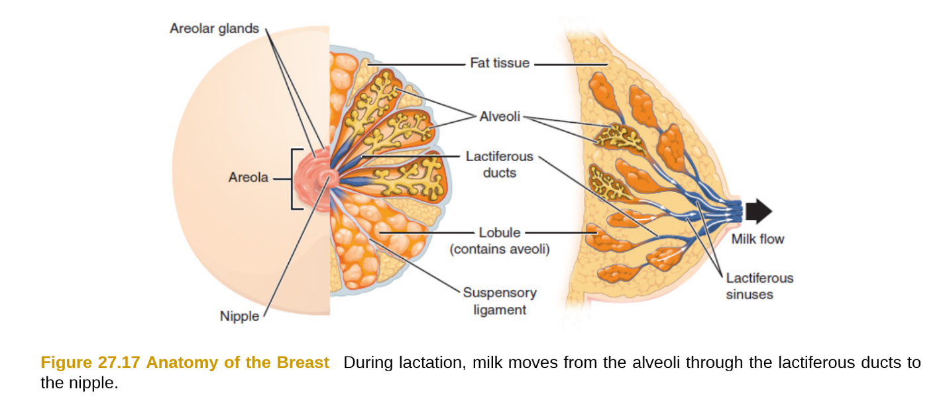
Figure 1: External and internal anatomy of the breast. Areolar glands are also called Montgomery’s glands. The alveoli in the lobules produce milk, which drains through ducts to the nipple. The lobules are supported by suspensory ligaments and surrounded by fat tissue.⁹

Humans have at least two nipples, but extra nipples (polythelia) can develop anywhere along the milk line, from the axilla to the groin.¹² Most accessory nipples are inactive, but if fibroglandular breast tissue is present beneath the nipple, lactation and mastitis can occur.¹² Polythelia is more commonly diagnosed in males at a rate of 1 in 18, compared to only 1 in 50 females.¹²

Nipple inversion, when the entire nipple is pulled inward, can be a genetic condition or the result of pathology. Approximately 10 to 20 percent of the population are born with nipple inversion, with the most common causes being short ducts or a wide areolar muscle sphincter.¹² If a pathology causes the inversion, it can occur gradually over a few years or rapidly in a few months. A rapid inversion of the nipple is more likely to be caused by a malignant pathology.^{11,12} If the reason for the inversion is unknown or the inversion occurred rapidly, then additional imaging, such as ultrasound or mammography with spot compression, may be needed.¹¹

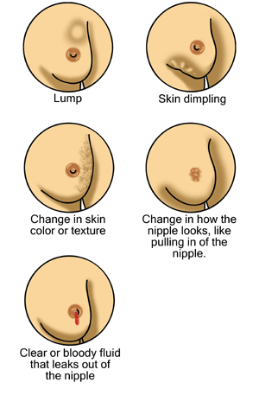

Figure 2: Illustrations of visible and palpable breast changes that may suggest possible pathologies.¹⁴

Physical Breast Changes of Concern
In addition to nipple inversion, many other physical breast changes can indicate a potential pathology. Patients often visit their family doctor when they observe a change and are then referred to have a diagnostic mammogram. Common changes to the breast that may indicate an early sign of breast cancer are shown in Figure 2 and listed below.,
- Swelling or change in size, shape, or color of the breast
- General pain in any area
- Palpable lump in the breast or axilla
- Thickening, redness, or irritation of the skin
- An area of increased temperature
- Dimpling or pitting of the skin like an orange
- Nipple discharge other than milk
- Change in nipple appearance

Localization Terminology
A significant challenge in achieving an accurate, timely diagnosis of breast cancer often lies in correlating the areas of abnormalities observed through physical or visual examination to what is seen in diagnostic images.

There are multiple methods to relay anatomical information for locating an area of the breast. The broadest localization method divides the breast into four quadrants – upper inner, upper outer, lower inner, and lower outer quadrants. The axillary tail of Spence and the majority of the breast volume is present in the upper outer quadrant. This is also the quadrant where breast lesions are most commonly found.^{4,5} In addition to using the four quadrants as a guideline for locating an area of concern, the clock face method is commonly used, especially in ultrasound imaging. The clock method divides the breast into twelve wedges, similar to overlaying a clock face onto the breast.¹⁶ Diagrams showing the quadrant and clock localization methods are shown in Figure 3.¹⁶

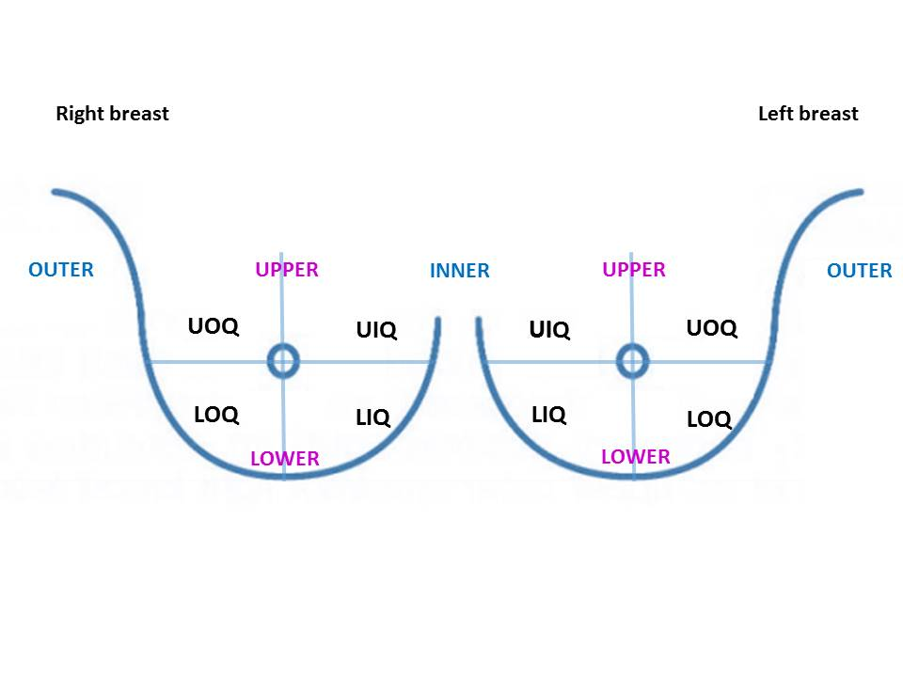
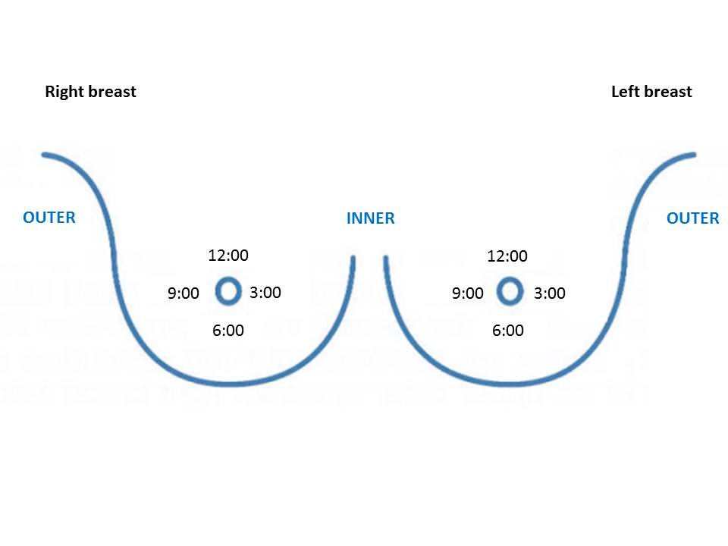
Figure 3: Breast localization methods. Left: Quadrants of the breasts. UOQ: upper outer quadrant; UIQ: upper inner quadrant; LOQ: lower outer quadrant; LIQ: lower inner quadrant. Right: Clock positions of the breasts. Each breast is divided into a clock face when looking at the breast, so the 9:00 position on the right side is on the outer breast, while the 9:00 position on the left side is on the inner breast.¹⁶

Triangulation
To locate a lesion using mammography, it must be visible on at least two projections. There are instances where a lesion deep in the breast or high in the axilla will be visible on the mediolateral oblique (MLO) view but not on the craniocaudal (CC) view. An additional mammographic view, such as the 90° mediolateral (ML) view, may be necessary in such cases.¹⁵

The initial step in locating a lesion is determining its quadrant. An imaginary line is drawn from the nipple to the pectoralis muscle to divide the CC and MLO images roughly in half. The CC view distinguishes between the outer and inner quadrants, while the MLO distinguishes between the upper and lower quadrants.¹⁶ If a lesion is seen at the nipple level on an MLO image, a CC image must be evaluated to determine if the lesion is at the 3 or 9 o’clock location.¹⁵ Additionally, a lesion seen posteriorly high near the pectoralis muscle on an MLO image may be located in the upper outer quadrant near the axilla or in the opposite breast area at the upper inner quadrant.¹⁵

To triangulate a lesion’s location, the nipple is used as a guide. Specifically, the lesion location is explained relative to the nipple, whether it is lateral/medial or superior/inferior. It is crucial to have the nipple in profile on the CC and MLO images for this reason. Examples of the quadrant separations on CC and MLO images are shown in Figure 4.¹⁶
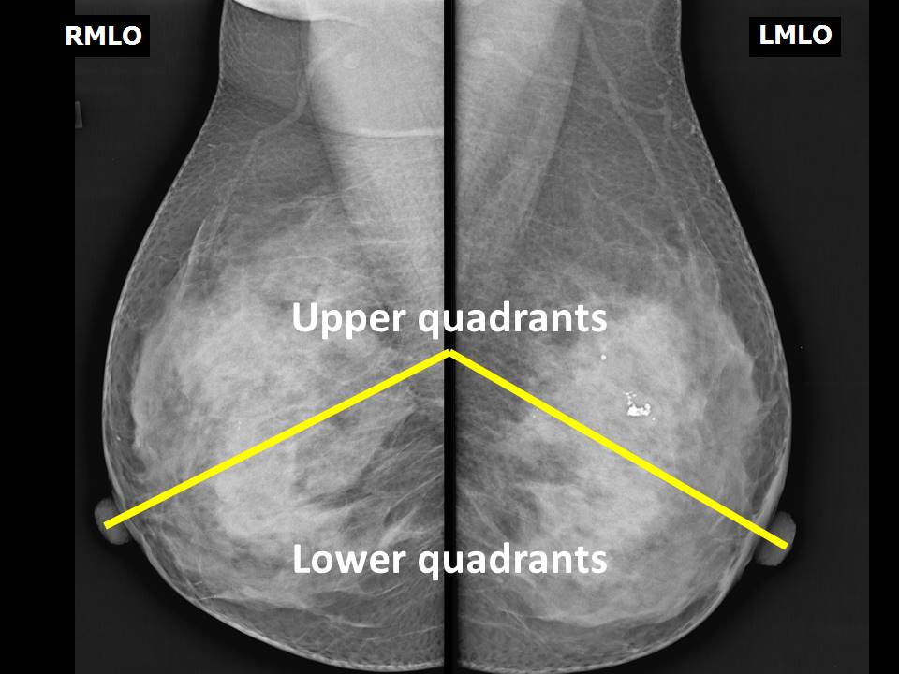
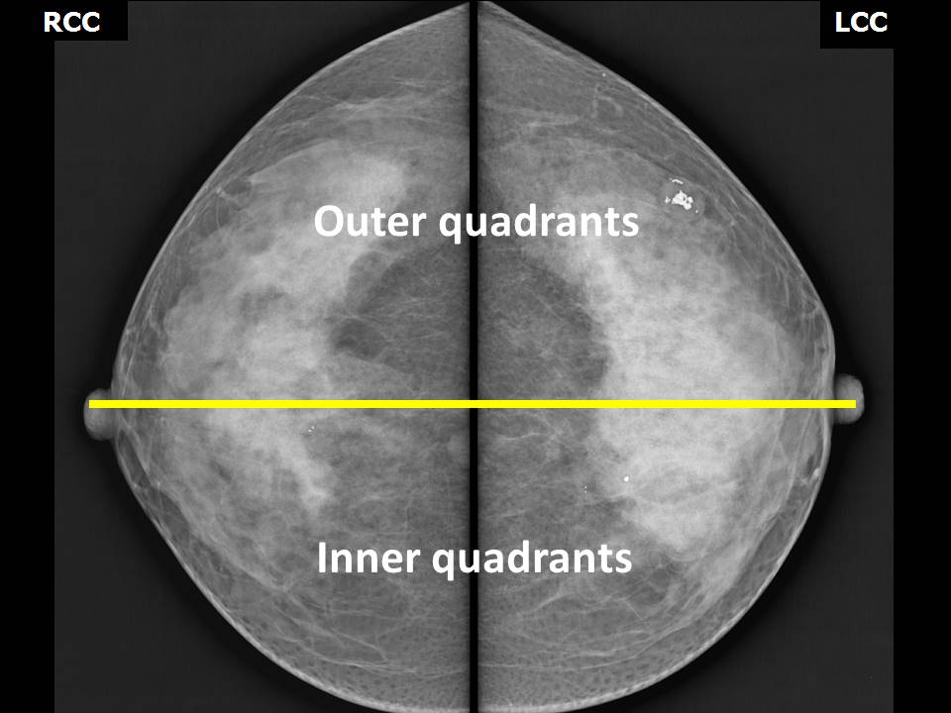
Figure 4: Mammogram images showing separation of quadrants. Left: CC images showing the nipple-pectoral line separating the outer and inner quadrants. Right: MLO images showing the nipple-pectoral line separating the upper and lower quadrants.¹⁶

Mammography – Ultrasound Relationship
Mammography and ultrasound are complementary imaging modalities often done together to locate and characterize a lesion.¹⁶ Correct correlation between the location of the lesion on the two modalities is essential for accurate diagnosis and planning of biopsies or treatment. Incorrect correlation may result in an inaccurate diagnosis or the biopsy of an incorrect area.¹⁶

To ensure proper lesion localization, three essential measurements are required.^{15,16}
- The quadrant and clock position: The affected quadrant can usually be determined from the standard CC and MLO images. Ultrasound is superior for narrowing down the location using the clock positions.
- The depth: The depth of a breast lesion is classified based on whether it's situated in the anterior, middle, or posterior third of the breast.¹⁶ Clinically, the actual measurement of the lesion may not always align with what's observed in the CC or MLO images due to patient positioning and body habitus.^{15,16} Correlation of the lesion depth using ultrasound is recommended.
- The distance from the nipple: The nipple is used as a fixed reference point to pinpoint the lesion location.¹⁶ There are similar issues determining the distance from the nipple on mammography images as determining the depth. Ultrasound can overcome these issues and provide improved localization measurements.¹⁵

It is important to note that there is a significant difference in breast position between mammography and ultrasound. In mammography, the breast tissue is compressed and viewed from above or the side. Ideally, all four quadrants should be under the same amount of compression, but that depends on the patient’s positioning and comfort level and is often not achievable. In contrast, ultrasound shows the breast from anterior to posterior while the tissue is uncompressed and flat.¹⁵ On ultrasound, the gray-scale anatomy in the breast is similar to its mammographic appearance. Fat is hypoechoic and dark gray, whereas fibroglandular tissue is hyperechoic and white. Muscle is usually the reference tissue in ultrasound, as it appears mid-gray (isoechoic).¹⁷

Internal Anatomy
Understanding the internal anatomy of the breast is also essential knowledge for technologists. This information can help with patient positioning and identifying potential pathologies. The internal components of the breast are roughly categorized into two main sections: the outer elements that cover and connect the breast to the body and the internal components including the fibroglandular and fatty tissues, and the vascular and lymphatic systems.

Outer Elements

Fascial layers
The breast is supported and attached to the body by two layers of fascia. The first layer, the superficial fascia, lies beneath the subcutaneous fat layer and covers the entire breast.⁴ The breast is connected to the skin by specialized fibrous bands of connective tissue called Cooper’s ligaments. These ligaments are formed from the connective tissue-rich stroma surrounding the ducts and connect with adipose tissue to create fibrous tissue pockets and provide three-dimensional breast tissue support.^{5,6,8} An illustration of Cooper’s ligaments (also called suspensory ligaments) surrounding lobules can be seen in Figure 1.⁹ Cooper’s ligaments also attach to the clavicle and provide suspensory breast support at the upper border of the breast. Deterioration of these ligaments with age can cause breast sagging.⁴ If a malignant mass infiltrates the breast, it can contract Cooper’s ligaments, causing the characteristic skin dimpling clinically associated with breast pathologies.^{4,5}

The second layer of fascia is the deep fascia, which covers the posterior aspect of the breast and is also attached to the skin by Cooper’s ligaments. The deep fascia is separated from the fascia of the pectoralis major muscle by the retromammary space.⁴ The retromammary space is filled with loose connective tissue and fat, allowing the breast to move freely against the thoracic wall.^{4,6} Deep infiltration of a malignancy through the retromammary space into the underlying pectoralis fascia causes the physical sign of deep tethering of a malignant mass.⁵

Pectoralis Major Muscle
The pectoralis major muscle is a thick, fan-shaped muscle that forms the anterior wall of the chest and lies underneath the breast tissue. The pectoral muscle has two heads, the clavicular and the sternocostal, which reference their origin area. The function of the pectoral muscle depends on which heads of the muscles are involved and includes flexion, extension, adduction, and medial rotation of the arm.¹⁸ For mammographic purposes, the pectoral muscle is a major landmark to ensure accurate positioning. Capturing the pectoral muscle on mammograms implies that no breast tissue along the chest wall has been excluded. Figure 5 shows ideal CC and MLO images with the pectoral muscle well visualized.¹⁹

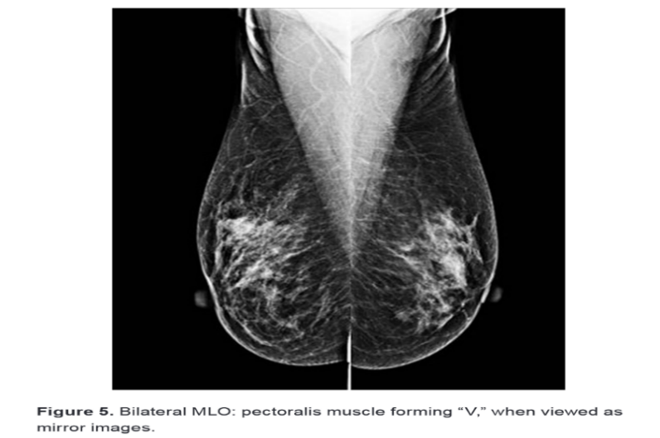
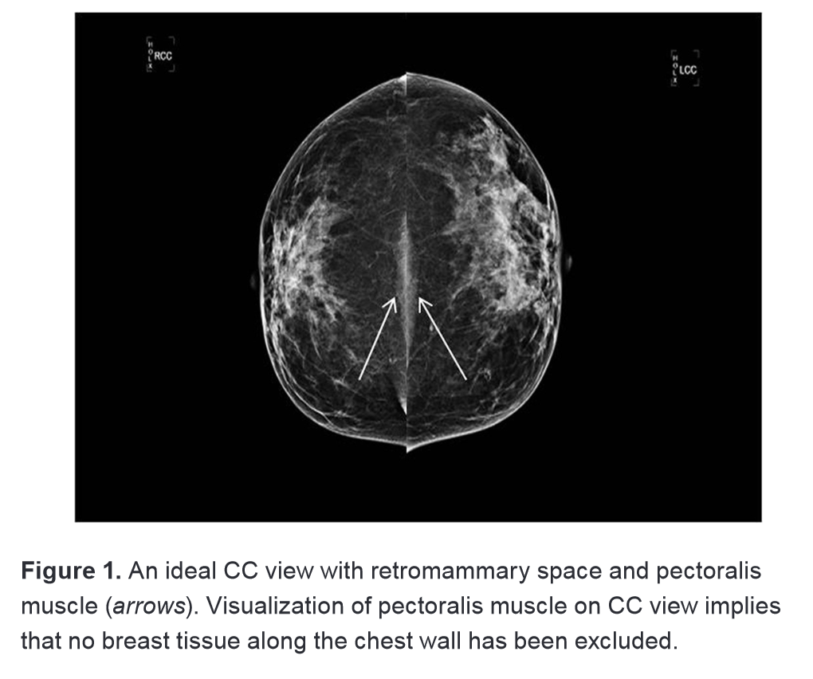
Figure 5: Bilateral craniocaudal (CC), left, and mediolateral oblique (MLO), right, images. Proper positioning of the breast shows the nipple in profile, symmetry between breasts, and the pectoralis muscle well visualized (arrows on left image, white “V” shape on right image). On the MLO view, the inferior edge of the pectoralis should be located below the nipple-pectoral line.¹⁹

Optimal positioning can be challenging, as patients have varying angles of the pectoral muscle depending on their habitus. Short, stocky women tend to have more horizontally oriented pectoral muscles, while tall, thin women tend to have them more vertically oriented. Attempting to get the pectoral muscle in profile in the MLO view on a patient with the muscle at a steep angle off of the standard 45° can produce a distorted projection of the muscle with abnormal breast quadrant distribution.²⁰

Inner elements
The breast parenchyma is the functional tissue responsible for milk production in a female breast. It is made up of glandular tissue that is surrounded by stroma and supported by fibrous Cooper's ligaments, which are collectively called fibroglandular tissue. The size of a breast depends on the amount of fatty adipose tissue surrounding the fibroglandular tissue.⁴ In men, the breast tissue usually only contains adipose tissue, with no fibroglandular tissue present. Nevertheless, breast cancer can still occur in males, often with severe consequences, as it is often not detected until the metastatic spread has occurred.⁶

Glandular tissue
The glandular breast parenchyma is composed of 15 to 20 lobes.⁴ Each lobe is made up of 20-40 lobules, with each lobule containing 10-100 hollow cavities known as alveoli.³ The alveoli are a few millimeters in
size and lined with milk-producing cells.⁹ A section of these lobules and their associated intralobular and extralobular ducts is called a terminal duct lobular unit (TDLU).^{11,} The TDLU is a clinically relevant structure, as it is responsible for milk production during lactation and is the primary source of over 75% of benign and malignant breast diseases^{.21,}

The lactiferous ducts that drain the TDLU broaden to form a lactiferous sinus before reaching the nipple.³ As mentioned previously, there are 15-20 ductal openings on the surface of the nipple. The ductal network of each breast is complex and not always arranged symmetrically nor in a perfect radial pattern as anatomically illustrated.¹⁷ Figure 6 shows a diagram of a terminal duct lobular unit and the related ducts and sinuses in the breast.
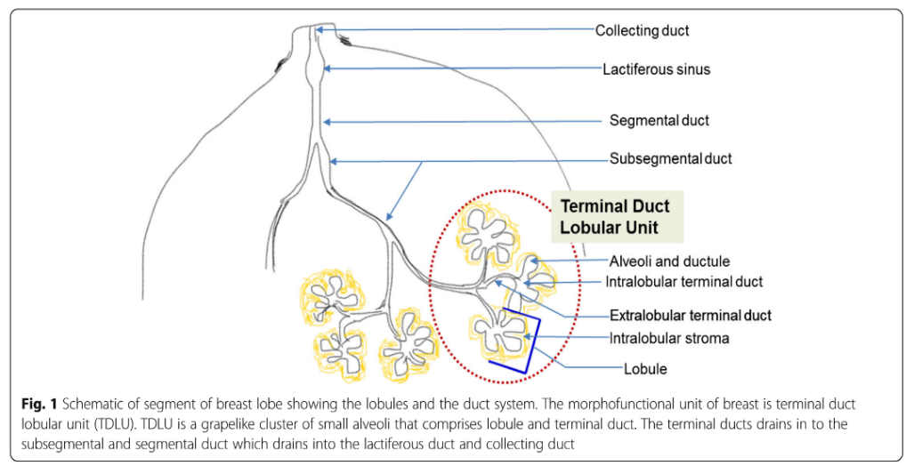

Figure 6: Diagram of a segment of a breast lobe showing the ducts and lobules. The terminal duct lobular unit (TDLU) is outlined in a red circle.²³

Cytology
The inner lumen of the lobular duct system is lined by two cellular layers – epithelial cells and myoepithelial cells – which are separated from the surrounding breast tissue by a thin structural layer called the basement membrane. The luminal epithelial cells are the functionally active milk-producing cells and a common site of carcinogenesis. Myoepithelial cells contract to move the milk through the ducts during lactation and also play an active role in tumor suppression by creating a physical barrier between cancer originating in the luminal epithelial cells and the surrounding breast tissue.²⁵
If a tumor progresses, the myoepithelial cells and the basement membranes can be broken down and gradually disappear.^{24,25} This can cause infiltrative spread of the cancer cells to the surrounding tissue, lymph vessels, and blood vessels, resulting in metastatic spread throughout the body.^{24,25} Figure 7 shows the lumen of a normal duct and what happens to the luminal cells in the event of a carcinoma. These cancers are labeled as “ductal” or “lobular” based on the cellular information from a biopsy, despite their common origin in the TDLU.²² Cancer in the TDLU appears as spiculated or ovoid structures on mammograms.²² There are multiple types of breast cancer, but this course only mentions those originating from the TDLU as an example since they account for 70% of invasive breast carcinomas.
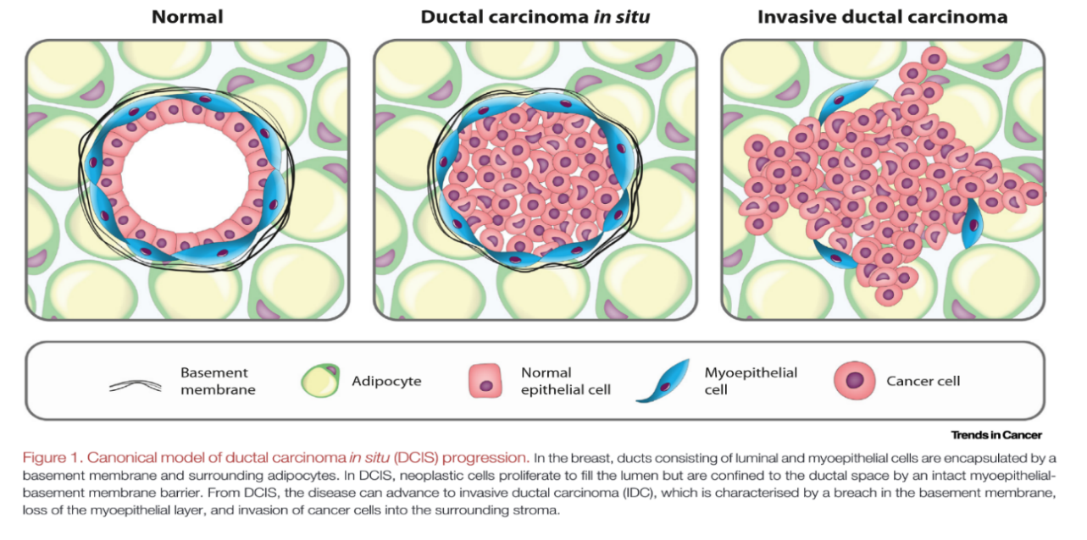

Figure 7: Normal and abnormal breast duct cytology. Normal ducts are lined with epithelial and myoepithelial cells, encapsulated by a basement membrane. In ductal carcinoma in situ (DCIS), cancer cells originate from the epithelial cells and proliferate to fill the lumen. DCIS can advance into invasive ductal carcinoma (IDC) when the myoepithelial cell layer and basement membrane are compromised. The cancer cells then invade the surrounding stroma and metastasize.²⁶

Vasculature
Most of the blood supply to the breast comes from the internal mammary and lateral thoracic arteries. The internal mammary artery supplies around 60% of the blood, while the lateral thoracic artery supplies around 30%. The intercostal arteries supply a smaller amount of blood (5%).²⁸ The venous anatomy of the breast generally parallels the arterial anatomy, with most venous drainage going to the axillary and internal thoracic veins.^{6,17}

Although uncommon, vascular lesions can develop in the breast, including benign hemangiomas and malignant angiosarcomas. Carcinoma of the breast may spread to other parts of the body via the bloodstream. For example, breast cancer metastases often spread to the vertebral column via deep veins surrounding the spine. These veins do not have valves, so venous blood from the breast can flow directly to this area, quickly spreading cancer to the vertebrae and spinal cord.²⁷

Lymphatic drainage
The lymphatic system is part of the body’s immune system, filtering and draining interstitial fluid back into the bloodstream. The lymphatic vessels run through the body parallel to the venous system and drain into nodes for filtering before entering the bloodstream.¹⁷ The axillary group of lymph nodes is the primary group of nodes that drain the lymph from the breasts. There are usually 20 to 30 nodes in the axillary region, draining almost 75% to 80% of the lymph from the breasts.⁴ The axillary lymph nodes are kidney-shaped and often visible on the MLO images.¹⁷ The internal mammary group of lymph nodes along the sternum drains the remaining 20 to 25% of lymph.²⁷

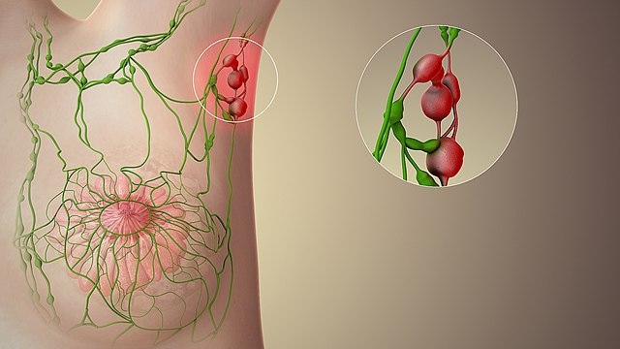
Metastatic spread of breast cancer typically occurs through the lymphatic system. If the breast skin's lymphatic area is affected, interstitial fluid drainage is compromised, and excess fluid builds up. This lymphedema can cause deviation of the nipple and a thickened, leather-like appearance of the skin.⁶ Cancerous cells often settle in the axillary lymph nodes and multiply, enlarging the node to the point of being noticeable on palpitation.⁶ Palpable axillary nodes may indicate breast cancer, but the absence of enlarged nodes does not guarantee that metastases has not occurred.⁶ Figure 8 illustrates breast lymphatics and enlarged axillary lymph nodes.

Figure 8: The breast lymphatic system. The lymphatic drainage from the breast mainly goes to the axillary lymph nodes. Enlarged axillary lymph nodes (red, in circle) can indicate metastatic spread of breast cancer.³⁰

When tumor cells detach from the primary tumor and travel to the lymph nodes, the first set of nodes they encounter are called the sentinel lymph nodes. A biopsy of the sentinel lymph nodes is often done to determine the presence or absence of metastatic cells, which can aid in staging the cancer. A radioactive substance or dye is injected into the tumor area, and the path of lymph drainage is followed by a probe to determine the location of the sentinel lymph nodes.³¹

The right breast lymph is drained by the right lymphatic duct, while the left breast is drained by the thoracic duct.⁹ Since the breasts drain into separate blood vessels, the early spread of a tumor from one side to another via lymphatics does not occur.⁵

Breast Density

Changes over lifetime
The female breast begins development during puberty due to the increase in estrogen and completes development during the onset of pregnancy.¹⁷ During pregnancy, the breast volume and density increase as the amount of active glandular tissue doubles relative to fat tissue.⁴ Other breast changes during pregnancy include dilation of superficial veins and darkening in color of the nipple-areola complex.^{3,4} When a baby nurses, or draws milk from the breast, the entire areolar region is taken into the mouth.⁹ This stimulates the release of hormones that begins milk production in the epithelial cells.^{9,17} Breast size does not affect the amount of milk produced.⁹
The increase in glandular tissue during pregnancy causes a noticeable increase in mammographic density. This can make it challenging to identify any pathologies in the lactating breast. Figure 9 shows an MLO image of a lactating breast with high mammographic density.

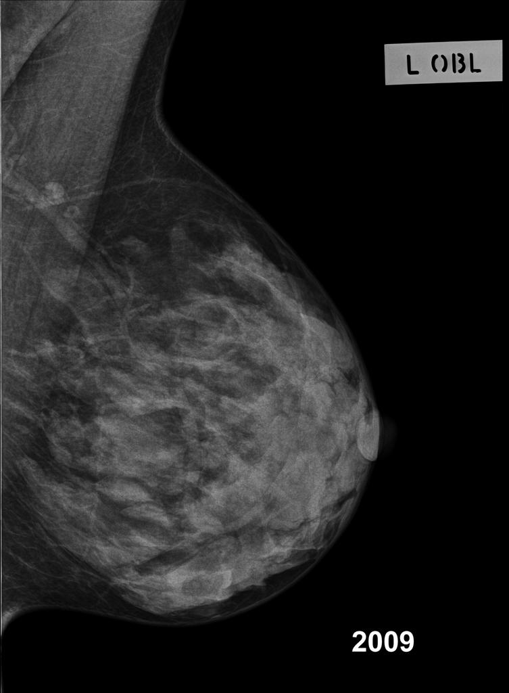

Figure 9: MLO image showing increased density during lactation. This patient felt left breast pain and a lump six weeks post partum. There is no obvious mass or collection noted on this mammogram.³²

When the baby is weaned and breastfeeding stops, the lobular epithelial cells return to their nonfunctioning state, and extra stromal and glandular tissues atrophy, decreasing the breast size.^{5,17} As women reach the age of 40 and begin menopause, the amount of fibroglandular breast tissue continues to decrease or involute. These tissues are replaced by connective tissue and fat.¹⁷ Over time, the amount of fatty tissue may also decrease, and the suspensory ligaments of Cooper relax, resulting in breast shrinkage, sagging, and loss of contour.⁴ There is a clear correlation between the development of breast cancer and age, with 80% of cancers occurring in women over 50.

Mammographic density
Mammographic density refers to the proportion of fibroglandular tissue (stroma and ductal tissues) to adipose tissue in the breast. Since adipose tissue is radiologically translucent, it appears dark on the mammogram. Fibroglandular and stromal tissue are denser and appear white. There are large differences in the amount of stroma between women, contributing to the range of mammographic densities. Figure 10 shows the difference in stromal, ductal, and adipose tissues in breasts with low- and high-mammographic densities.³⁵

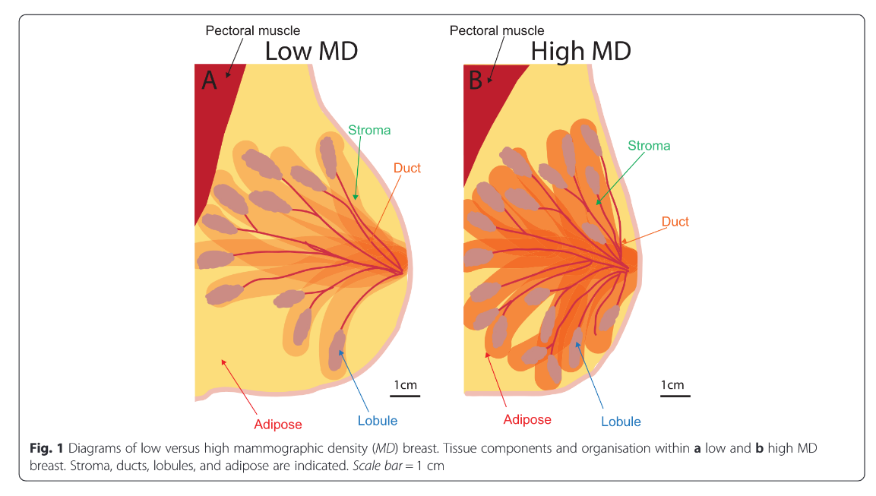

Figure 10: Diagrams of breasts with low and high mammographic density (MD). A breast with low MD (A) has less stromal and glandular tissue and more adipose tissue than a breast with high MD (B).³⁵

A significant risk factor for developing breast cancer is the presence of mammographically dense breast tissue, as women with high-density breast tissue are more likely to develop cancer than women with low-density breast tissue. Additionally, mammographic screening is less effective in detecting suspicious lesions in dense breast tissue, with 27% of breast cancers missed in women with dense breasts due to the lesion being hidden.³³ This can delay diagnosis and lead to poor health outcomes.³⁴ More than half of women under the age of 50 years have high mammographic density.³⁴

BI-RADS density classifications
Mammographic density is assessed using the American College of Radiology’s (ACR) Breast Imaging Reporting and Data System (BI-RADS) guidelines. The BI-RADS atlas is a standardized reporting system for describing breast anatomy and pathology as viewed on mammograms, ultrasounds, and magnetic resonance imaging (MRI). The purpose of this system is to ensure clear communication between radiologists and other physicians by providing standardized terminology and management recommendations.³⁶

The 5th edition of the BI-RADS atlas was released in 2013, and it includes four categories for characterizing breast density on mammograms. The categories are listed below, with associated mammographic images shown in Figure 11.
- A: the breasts are almost entirely fatty
- B: there are scattered areas of fibroglandular density
- C: the breasts are heterogeneously dense, which may obscure small masses
- D: the breasts are extremely dense, which lowers the sensitivity of mammography
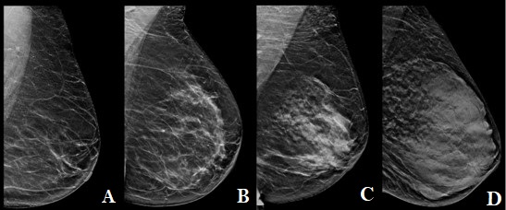
Figure 11: Digital breast tomosynthesis MLO images showing different breast density categories. From left to right, category A, almost entirely fat; Category B: scattered fibroglandular densities; Category C: heterogeneously dense; Category D: extremely dense.³⁷ Image cropped and annotated by author.

Breast Cancer Screening Recommendations
In the United States, the ACR and the National Comprehensive Cancer Network (NCCN) recommend that women with an average risk of breast cancer undergo yearly screening mammography starting at age 40, with self breast exams beginning at the age of 25., Women with an increased lifetime risk of breast cancer of 20% or more due to factors such as dense breast tissue, family history, or presence of the BRCA-1 gene are advised to start screening earlier than those with an average risk.³⁸ Women with very dense breasts are recommended to have additional screening using ultrasound, MRI, or digital breast tomosynthesis methods, and women previously diagnosed with breast cancer should be screened with MRI.^{33,}

Screening recommendations vary between countries and their regulatory bodies. For example, the European Union recommends screening mammography once every two or three years beginning at age 45. The advice from the American Cancer Society (ACS) differs slightly from the ACR and NCCN recommendations. The ACS recommends that low-risk women can choose to begin their first screening mammogram between the ages of 40 and 44 and continue to have yearly mammograms until the age of 55 when they can opt to have a mammogram every other year.

The variability between regulatory bodies is due to the risk/benefit analysis of exposing patients to ionizing radiation versus early detection of cancer. Numerous studies have demonstrated that the likelihood of radiation-induced breast cancers due to mammographic screening is minimal compared to the advantages of early detection., Patients who approach the technologist about these conflicting rules should be directed to consult their healthcare provider.

The Mammography Quality Standards Act (MQSA) are regulations set by the US Food and Drug Administration (FDA) to establish standards to ensure that all women have access to high-quality mammography services. These regulations require mammography facilities to undergo strict accreditation, certification, and equipment inspections to ensure that they provide safe, reliable, and accurate services.⁴⁵ As of March 2023, the MQSA requires facilities to provide a written report to patients after their mammography exam. This report will mention the density of their breasts in a patient-friendly language, explain how breast density can impact mammographic accuracy, and recommend that patients discuss their individual situation with their healthcare provider.⁴⁶

Conclusion
Breast cancer is the most commonly diagnosed malignancy worldwide, second only to lung cancer. It is also the most frequently diagnosed and fatal cancer among women. Early detection of a breast lesion and its correct diagnosis as benign or malignant is critical to start the patient on a treatment plan, ultimately reducing the probability of breast cancer mortality. Screening mammography is the best method for early detection of abnormal lesions in the breast, with confirmation and localization of lesions often done with ultrasound.

In addition to finding breast lesions through screening mammography, lesions may be discovered by noticing palpable and visible changes in the breast. When imaging these areas of concern, the mammography technologist plays a vital role in describing their locations using a proper quadrant and clockface terminology. Providing high-quality images to the radiologist relies on knowing the correct patient positioning techniques to display the nipple in profile and an adequate amount of pectoralis muscle in the images.

The glandular breast components of the terminal lobe ductal unit are a primary source of breast cancer, while the vascular and lymphatic systems play a significant role in cancer spread. Although the amount of fibroglandular breast tissue decreases with age, the risk of breast cancer increases. For this reason, screening mammograms are generally recommended to begin at the age of 40. Women with high-density breasts are advised to have additional screening exams such as ultrasound or MRI. This is because high-density breast tissue can obscure lesions on mammograms.

Key Terms
Fibroglandular tissue – the fibrous connective tissue and glandular tissue
Involution – atrophy of fibroglandular tissue after menopause
Mammographic density – the amount of dense fibroglandular and stromal tissue compared to the less dense adipose tissue
Parenchyma – the functional tissue of an organ; glandular tissue in breasts
Polythelia – more than two nipples present
Sentinel lymph nodes – the first set of lymph nodes that metastatic breast cancer spreads to; usually biopsied to determine the stage of cancer
Stroma – the framework supporting an organ. Breast stroma surrounds glandular tissue and consists of connective tissue elements, giving rise to Cooper’s ligaments
Abbreviations (in order of appearance in text)
CC – craniocaudal mammography view
MLO – mediolateral oblique mammography view
ML – mediolateral mammography view
UIQ – upper inner quadrant
UOQ – upper outer quadrant
LIQ – lower inner quadrant
LOQ – lower outer quadrant
TDLU – terminal duct lobular unit
DCIS – ductal carcinoma in situ
IDC – invasive ductal carcinoma
MD – mammographic density
ACR – American College of Radiology
BI-RADS – Breast Imaging and Reporting Data System
NCCN – National Comprehensive Cancer Network
ACS – American Cancer Society
MQSA – Mammography Quality Standards Act
FDA – Food and Drug Administration
References

Pfeiffer RM, Webb-Vargas Y, Wheeler W, Gail MH. Proportion of U.S. Trends in Breast Cancer Incidence Attributable to Long-term Changes in Risk Factor Distributions. Cancer Epidemiol Biomark Prev Publ Am Assoc Cancer Res Cosponsored Am Soc Prev Oncol. 2018;27(10):1214-1222.
Siegel RL, Miller KD, Wagle NS, Jemal A. Cancer statistics, 2023. CA Cancer J Clin. 2023;73(1):17-48.
Alex A, Bhandary E, McGuire KP. Anatomy and Physiology of the Breast during Pregnancy and Lactation. Adv Exp Med Biol. 2020;1252:3-7.
Pandya S, Moore RG. Breast development and anatomy. Clin Obstet Gynecol. 2011;54(1):91-95.
Ellis H. Anatomy of the breast. Surg - Oxf Int Ed. 2010;28(3):114-116.
Agur AMR, Dalley, Arthur F. Thoracic Wall. In: Moore’s Essential Clinical Anatomy. 7th ed. Wolters Kluwer; :192-196.
Gui GPH, Behranwala KA, Abdullah N, et al. The inframammary fold: contents, clinical significance and implications for immediate breast reconstruction. Br J Plast Surg. 2004;57(2):146-149.
McGhee DE, Steele JR. Breast Biomechanics: What Do We Really Know? Physiol Bethesda Md. 2020;35(2):144-156.
Betts JG, Desaix P, Johnson E, et al. Anatomy & Physiology. OpenStax Publishing, 2017.
Hoover E, Aslam S, Krishnamurthy K. Physiology, Sebaceous Glands. In: StatPearls. StatPearls Publishing; 2023. Accessed June 25, 2023.
Da Costa D, Taddese A, Cure ML, Gerson D, Poppiti R, Esserman LE. Common and unusual diseases of the nipple-areolar complex. Radiogr Rev Publ Radiol Soc N Am Inc. 2007;27 Suppl 1:S65-77.
Stone K, Wheeler A. A Review of Anatomy, Physiology, and Benign Pathology of the Nipple. Ann Surg Oncol. 2015;22(10):3236-3240.
What Are the Symptoms of Breast Cancer? Centers for Disease Control and Prevention. Published March 9, 2022. Accessed June 20, 2023. https://www.cdc.gov/cancer/breast/basic_info/symptoms.htm
Breast disease. In: Wikipedia. ; 2023. Accessed June 20, 2023. https://en.wikipedia.org/w/index.php?title=Breast_disease&oldid=1139175444
Park JM, Franken EA. Triangulation of breast lesions: review and clinical applications. Curr Probl Diagn Radiol. 2008;37(1):1-14.
Atlas of breast cancer early detection. Accessed June 20, 2023. https://screening.iarc.fr/atlasbreastdetail.php?Index=050&e=
Jesinger RA. Breast anatomy for the interventionalist. Tech Vasc Interv Radiol. 2014;17(1):3-9.
Solari F, Burns B. Anatomy, Thorax, Pectoralis Major Major. In: StatPearls. StatPearls Publishing; 2023. Accessed June 11, 2023. http://www.ncbi.nlm.nih.gov/books/NBK525991/
Popli MB, Teotia R, Narang M, Krishna H. Breast Positioning during Mammography: Mistakes to be Avoided. Breast Cancer Basic Clin Res. 2014;8:119-124.
Pacifici S. Pectoralis major muscle | Radiology Reference Article | Radiopaedia.org. Radiopaedia. rID-15425
Figueroa JD, Pfeiffer RM, Patel DA, et al. Terminal Duct Lobular Unit Involution of the Normal Breast: Implications for Breast Cancer Etiology. JNCI J Natl Cancer Inst. 2014;106(10).
Tabár L, Dean PB, Tucker FL, et al. Breast cancers originating from the terminal ductal lobular units: In situ and invasive acinar adenocarcinoma of the breast, AAB. Eur J Radiol. 2022;152:110323.
Banik U, Parasuraman S, Adhikary AK, Othman NH. Curcumin: the spicy modulator of breast carcinogenesis. J Exp Clin Cancer Res CR. 2017;36(1):98.
Ghannam SF, Rutland CS, Allegrucci C, Mongan NP, Rakha E. Defining invasion in breast cancer: the role of basement membrane. J Clin Pathol. 2023;76(1):11-18.
Gudjonsson T, Adriance MC, Sternlicht MD, Petersen OW, Bissell MJ. Myoepithelial cells: their origin and function in breast morphogenesis and neoplasia. J Mammary Gland Biol Neoplasia. 2005;10(3):261-272.
Gibson SV, Roozitalab RM, Allen MD, Jones JL, Carter EP, Grose RP. Everybody needs good neighbours: the progressive DCIS microenvironment. Trends Cancer. 2023;9(4):326-338.
Khan YS, Sajjad H. Anatomy, Thorax, Mammary Gland. In: StatPearls. StatPearls Publishing; 2023. Accessed June 11, 2023. http://www.ncbi.nlm.nih.gov/books/NBK547666/
Geddes DT, Aljazaf KM, Kent JC, et al. Blood flow characteristics of the human lactating breast. J Hum Lact Off J Int Lact Consult Assoc. 2012;28(2):145-152.
Baker GM, Schnitt SJ. Vascular lesions of the breast. Semin Diagn Pathol. 2017;34(5):410-419.
Wiki Images. Scientific Animations. Accessed June 28, 2023. https://www.scientificanimations.com/wiki-images/
Manca G, Tardelli E, Rubello D, et al. Sentinel lymph node biopsy in breast cancer: a technical and clinical appraisal. Nucl Med Commun. 2016;37(6):570-576.
Holland M. Lactating breast | Radiology Case | Radiopaedia.org. Radiopaedia. rID-19434
Walker RA, Martin CV. The aged breast. J Pathol. 2007;211(2):232-240.
Nazari SS, Mukherjee P. An overview of mammographic density and its association with breast cancer. Breast Cancer Tokyo Jpn. 2018;25(3):259-267.
Sherratt MJ, McConnell JC, Streuli CH. Raised mammographic density: causative mechanisms and biological consequences. Breast Cancer Res BCR. 2016;18(1):45.
Spak DA, Plaxco JS, Santiago L, Dryden MJ, Dogan BE. BI-RADS® fifth edition: A summary of changes. Diagn Interv Imaging. 2017;98(3):179-190.
Tari DU, Santonastaso R, De Lucia DR, Santarsiere M, Pinto F. Breast Density Evaluation According to BI-RADS 5th Edition on Digital Breast Tomosynthesis: AI Automated Assessment Versus Human Visual Assessment. J Pers Med. 2023;13(4):609.
Monticciolo DL, Newell MS, Hendrick RE, et al. Breast Cancer Screening for Average-Risk Women: Recommendations From the ACR Commission on Breast Imaging. J Am Coll Radiol. 2017;14(9):1137-1143.
Guidelines Detail. NCCN. Accessed June 12, 2023. https://www.nccn.org/guidelines/guidelines-detail
New Breast Cancer Screening Guidelines Address Heightened Risk for LGBTQ Persons and Black Women. Accessed June 27, 2023. https://www.acr.org/Media-Center/ACR-News-Releases/2021/New-Breast-Cancer-Screening-Guidelines-Address-Heightened-Risk-for-LGBTQ-Persons-and-Black-Women
European Commission Initiative on Breast and Colorectal cancer. Accessed June 28, 2023. https://healthcare-quality.jrc.ec.europa.eu
ACS Breast Cancer Screening Guidelines. Accessed June 28, 2023. https://www.cancer.org/cancer/types/breast-cancer/screening-tests-and-early-detection/american-cancer-society-recommendations-for-the-early-detection-of-breast-cancer.html
Hauge IHR, Pedersen K, Olerud HM, Hole EO, Hofvind S. The risk of radiation-induced breast cancers due to biennial mammographic screening in women aged 50-69 years is minimal. Acta Radiol Stockh Swed 1987. 2014;55(10):1174-1179.
Yaffe MJ, Mainprize JG. Risk of radiation-induced breast cancer from mammographic screening. Radiology. 2011;258(1):98-105.
Mammography Quality Standards Act. Accessed June 27, 2023. https://www.acr.org/Advocacy-and-Economics/Legislative-Issues/MQSA
FDA Updates Mammography Regulations to Require Reporting of Breast Density Information and Enhance Facility Oversight. FDA. Published March 10, 2023. Accessed June 15, 2023. https://www.fda.gov/news-events/press-announcements/fda-updates-mammography-regulations-require-reporting-breast-density-information-and-enhance
Cancer today. Accessed June 28, 2023. http://gco.iarc.fr/today/home

