Login
As a non-authenticated user, I want the system to display the login page so I can enter my authentication credentials to login into the system.

The login form is presented as a popup on the welcome page. If the login fails, an error message have to be displayed as an error message in that popup. If the login is successful, the browser have to redirect to the search page.

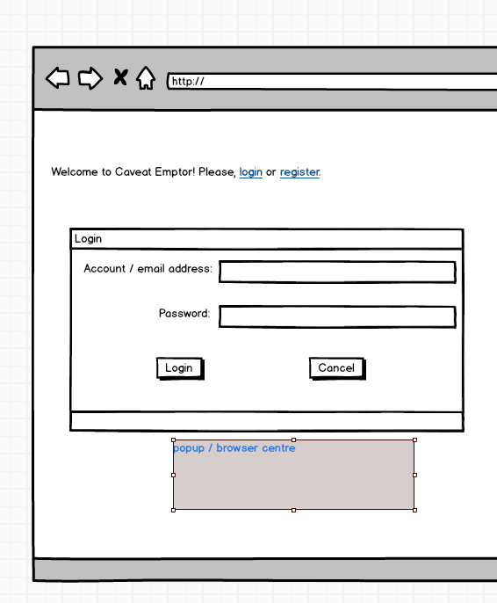

User Registration
As a visitor, I want the system to display the “subscribe as new user” page/popup so I can register myself and receive a registration confirmation email with an email containing an activation link.

The registration form is presented on a popup on the welcome page. If the registration fails, an error message have to be displayed as a separate popup.

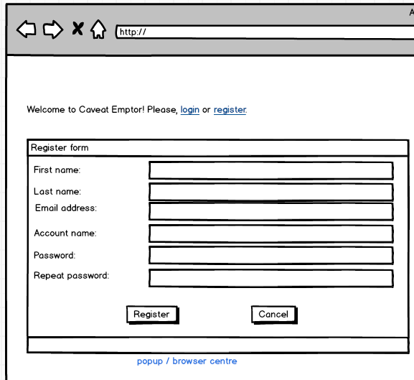

If the registration is successful, a confirmation email is sent to the specified email address; that email contains an activation link that si available for the following 24 hours only (the system should drop all activation codes that are too old):
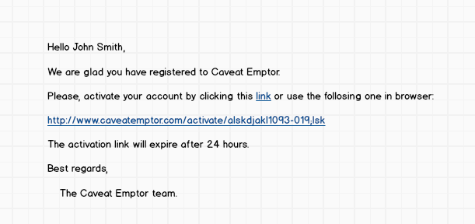
After successful activation, a confirmation page needs to be displayed (with a link to the welcome page)

Search page

As a regular authenticated user, I want to see the system's main page – the search page - so I can perform search ops on categories and items, seeing some minimal items details (name, truncated description, best bid value, bid closing date, number of bids).

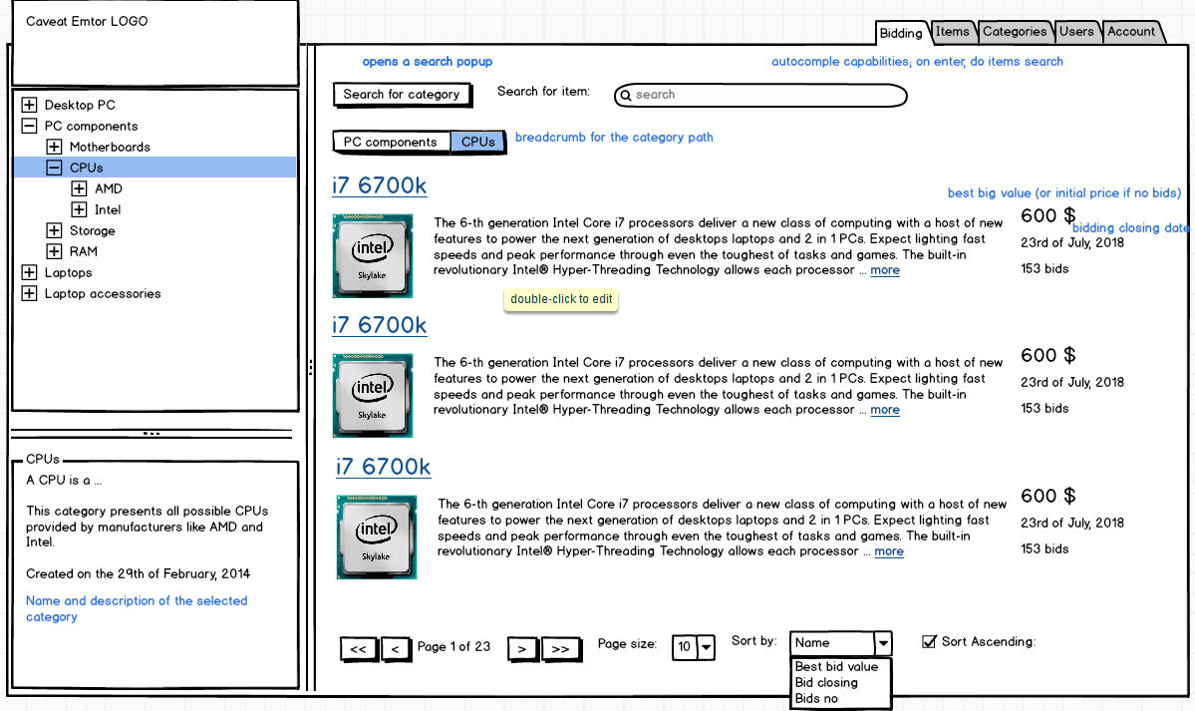

When another category is selected, the system should perform a search automatically on the category (keeping the previously specified search / sort filters)

Items that are not yet open for bidding (or the bidding window expired) will not be displayed.

The “Search for category button” opens a search popup allowing selection of a single category:
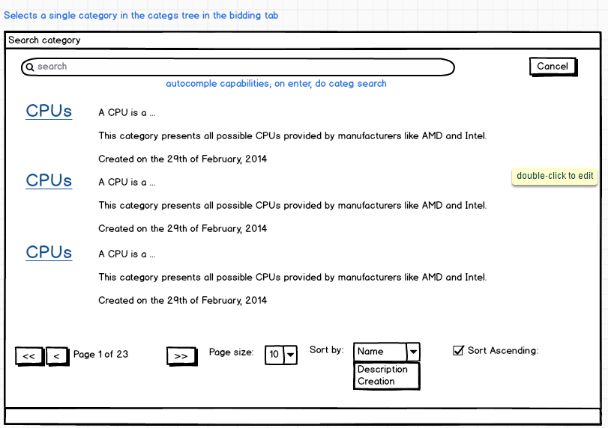
Items details page – bid creation

As a regular authenticated user that selected an item, I want to see the item details page so I can bid on it.
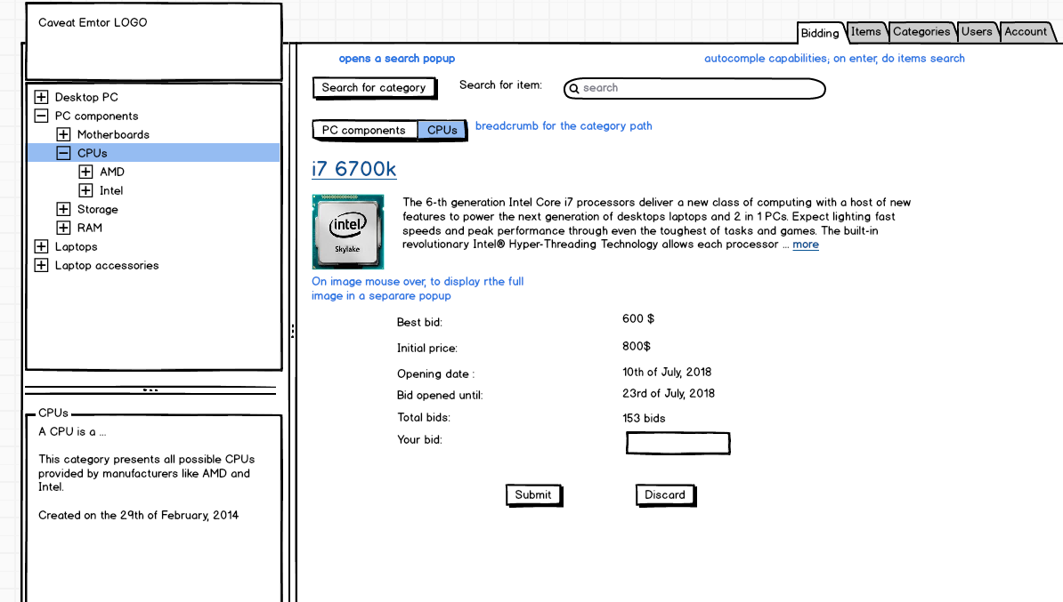

If the bid is created with success, a confirmation message have to be displayed on the same page as a popup. When the popup is closed, the page needs to be updated with the new bid info (see bellow).

When a bid is created, the item owner have to be notified by email.

Items details page – bid update

As a regular authenticated user that selected an item, I want to see my own bid info on the item details page so I can update it / delete it

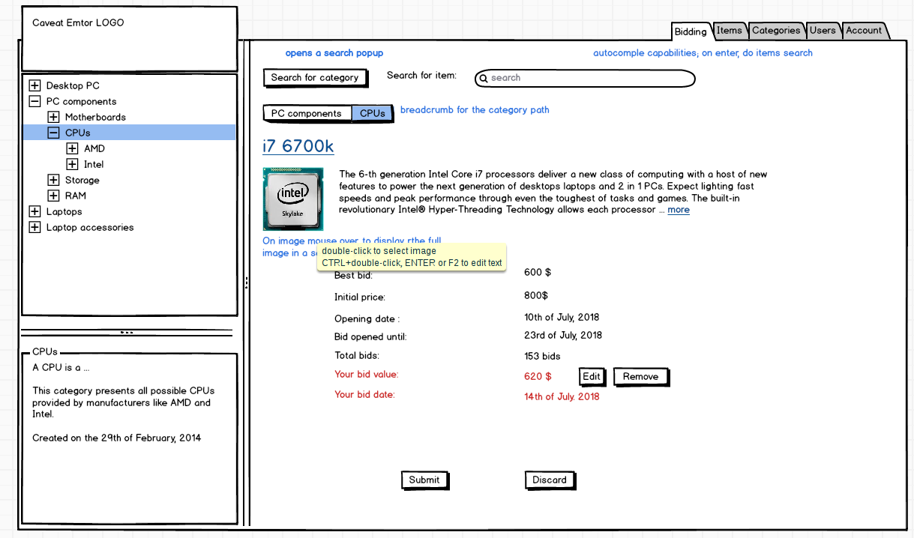
The “Submit” button should become visible only if the “edit” button have been clicked. In that case, a text box need to be rendered instead of the user's bid value, allowing a new bid value.

If the bid is updated with success, a confirmation message have to be displayed on the same page as a popup. When the popup is closed, the page needs to be updated with the new bid info (see bellow).

If the removal is OK, the system should go back to the search items page.
When a bid is changed (or removed), the item owner have to be notified by email.

Category management page

As an authorized user, I want to see the category management page so I can start managing the category tree.

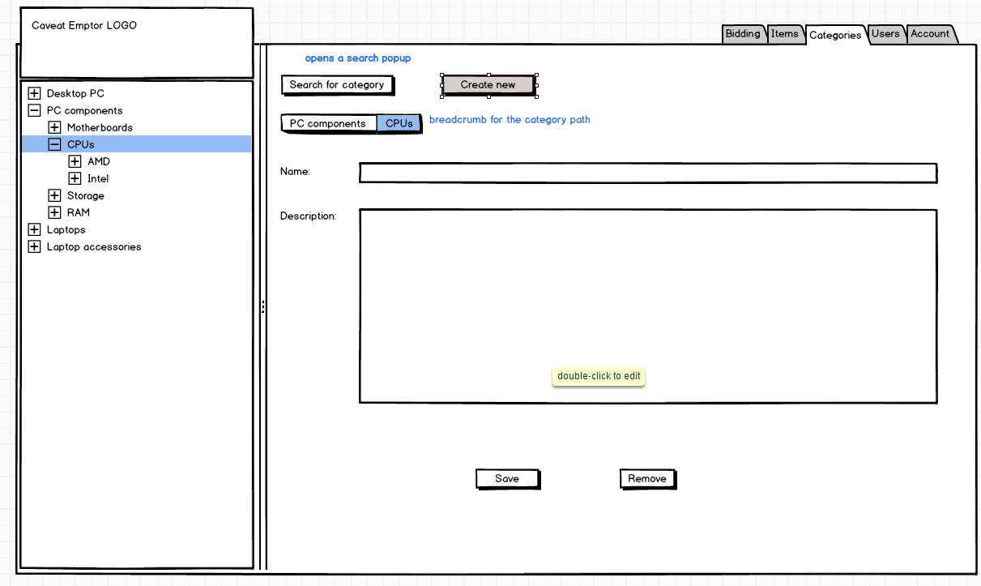
If there are is selected category (or none at all), only the create button should be visible.

When the create button is clicked, the “name” and “description” need to be emptied – and that form should have a title like “New category” (and no Remove button all).

If an existing category is selected, the form should present selected category details – after a parameterizable amount of time (not immediately).

The remove operation needs a removal confirmation via a popup.

If the “save” operation is ok, the category needs to appear in the category tree with the updated (new) name.

Users Management page

As an authorized user, I want to see the users management page so I can start searching, sorting and managing the list of users by disabling / enabling them.

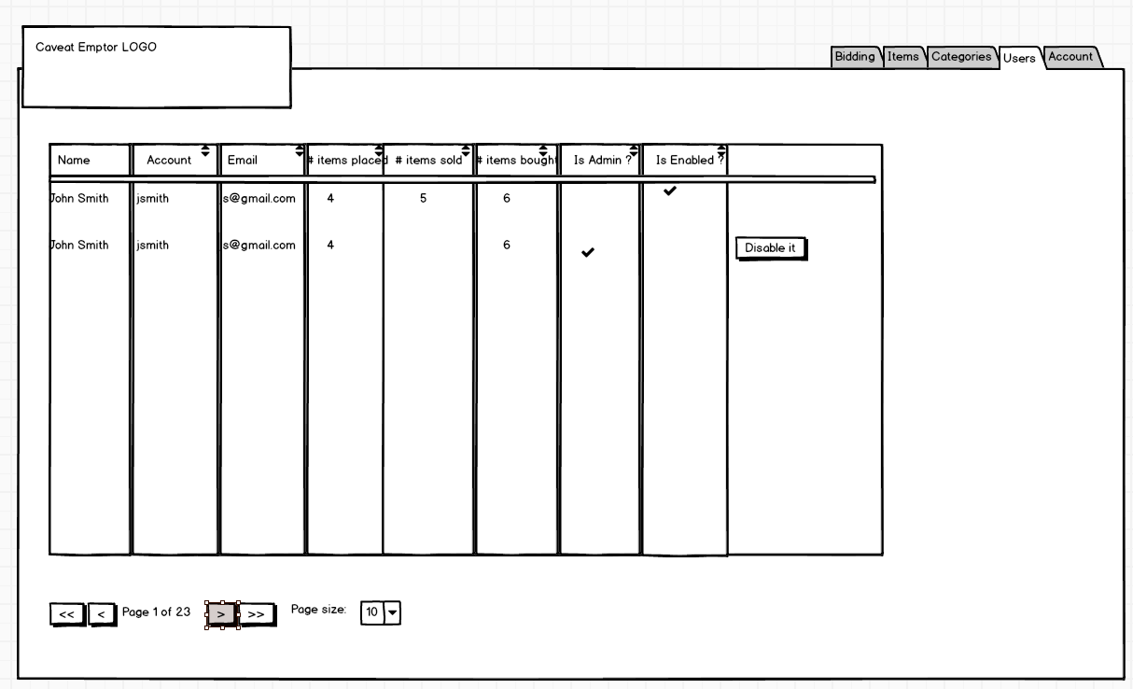
The search / sort filters need to be defined in place, in table column names.

Account page

As an authenticated user, I want manage my own account details so I can define my billing / shipping / home address, to change my first / last name / email address & phone numbers; to change my password.

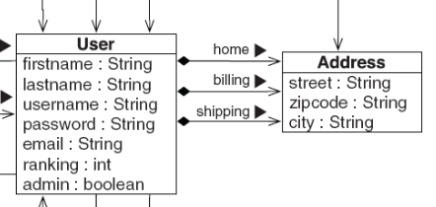

Items to sell

As an authenticated user, I want see all items that I've defined for selling so I can modify them, see their bidding status (best bid value, bidding life time interval, item name) and to define new items to sell.

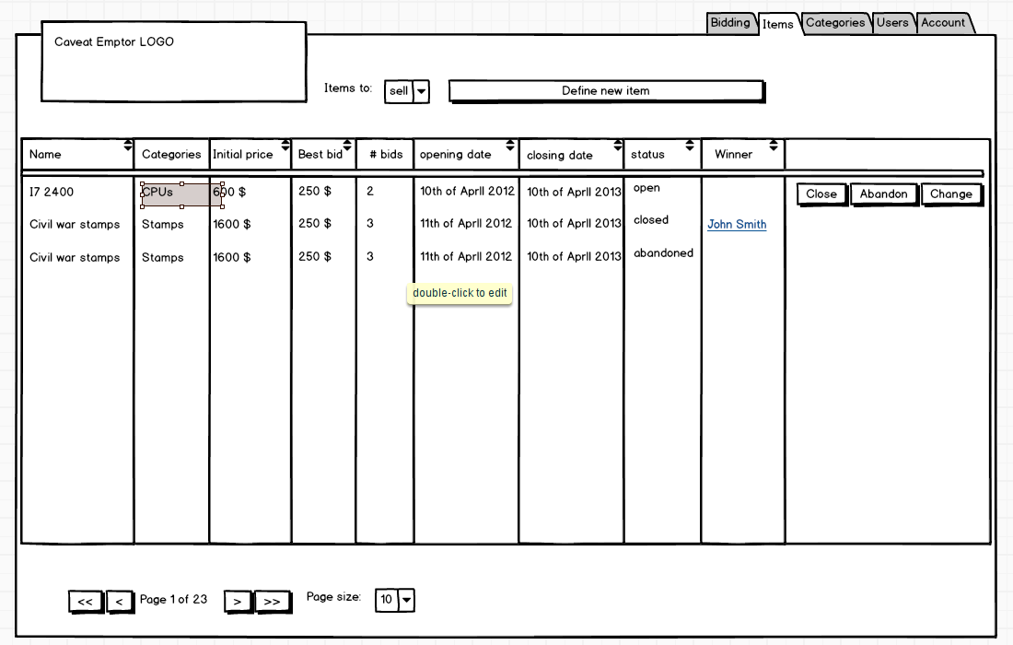
The search / sort filters need to be defined in place, in table column names.

An item might have following statuses:
- abandoned – when the author canceled the bidding process (no explanation required)
- closed – the bidding life time expired (current date > end date); only the item author might see that item
- open – open for bidding (start date <= current date <= end date)
- not yet open - current date < start date

A not yet opened item that is abandoned have to be removed for good.
An opened item that is abandoned have to be marked as abandoned.
Only not yet opened items might be changed.

When the “Define new item” is clicked, an item creation wizard needs to be displayed into a new popup. The first step selects the categories of the item (multiple categories of the item). The second step allows definition of:
- item name
- item description
- initial price (big decimal)
- bidding start date (calendar UI control)
- bidding end date (calendar UI control)

Move to the previous step & Move to the next step buttons are required. Save and Cancel buttons.

If the save operation is OK, the new item needs to appear on the “Items to sell” page.
An error message have to be shown by the wizard is the save op fails.

Items to buy

As an authenticated user, I want see all items for witch I've placed bids (best bid value, my bid value, bidding life time interval, item name) and change my bids if that is possible.

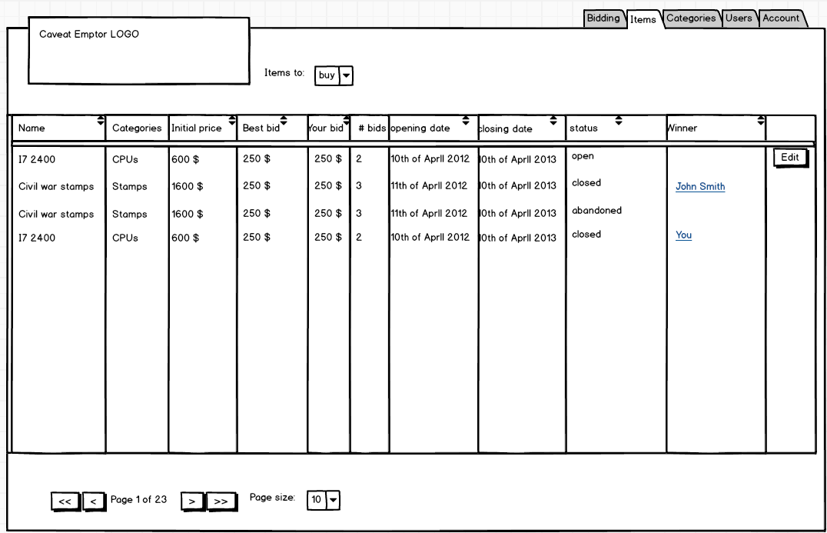

The search / sort filters need to be defined in place, in table column names.

The “edit” button is displayed only if the item is still open for bidding – and goes to the Items details page – bid update

