**Can autocorrelated recruitment be estimated using integrated assessment models, and how does it affect population forecasts?**

Kelli Johnson1, Elizabeth Councill1,2*, James T. Thorson1, Elizabeth Brooks3, Richard D. Methot4, André E. Punt2

1School of Aquatic and Fishery Sciences, University of Washington, Box 355020, Seattle, WA 98195-5020, USA

2Fisheries Resource Assessment and Monitoring Division, Northwest Fisheries Science Center, National Marine Fisheries Service, National Oceanic and Atmospheric Administration, 2725 Montlake Blvd. East, Seattle, WA 98112, USA

3Northeast Fisheries Science Center, 166 Water Street, Woods Hole, MA 02543, USA

4NOAA Senior Scientist for Stock Assessments, National Marine Fisheries Service, National Oceanic and Atmospheric Administration, 2725 Montlake Blvd. East, Seattle, WA 98112, USA

*Corresponding author:

telephone: +1 206 543 4270;

fax: +1 206 616 8689;

email: kfjohns@uw.edu

**Abstract**

Recruitment is often autocorrelated for marine fishes, and autocorrelation can arise due to numerous factors including regime shifts and periodicity in environmental drivers affecting survival rates during larval and juvenile stages. Patterns of first-order temporal autocorrelation in recruitment deviations are identified by periods of time where recruitment deviations are positive or negative for several years in a row. The ability of stock assessments to accurately estimate the magnitude of recruitment autocorrelation, and its effect on the quality of forecasts of spawning stock biomass , has not generally been analyzed. Monte Carlo simulations were used to evaluate how well Stock Synthesis, an integrated age-structured stock assessment method used extensively in the management of fish stocks, estimates autocorrelation in the presence of a range of autocorrelated recruitment deviations. The precision and accuracy of estimated autocorrelation, and the ability of the stock assessment framework to forecast the true dynamics of the system, were compared for scenarios where autocorrelation was fixed at zero, fixed at its true value, internally estimated, and input as a fixed value determined using an external estimation procedure. Penalized-likelihood estimates of autocorrelation produced by Stock Synthesis were biased toward zero when autocorrelation was larger than zero, but were unbiased when the true level of autocorrelation was less than or equal to zero. However, a less biased estimate of autocorrelation was obtained by estimating it from the recruitment deviations estimated within Stock Synthesis. Additionally, the forecast interval for estimates of spawning stock biomass during the forecast period was more uncertain when the true level of autocorrelation was high. Our results suggest that autocorrelation should first be estimated internally within a stock assessment, then externally calculated from the estimated recruitment deviations, especially in cases when the internally-estimated value is positive and nonzero. Results using this approach lead to estimates of autocorrelation that have small bias, and results in accurate forecast interval coverage (i.e., a 50% forecast interval that includes the true value of spawning stock biomass for 50% of simulation replicates).

**1. Introduction**

Under the U.S. Magnuson-Stevens Fishery Conservation and Management Act (MSA; U.S. Public Law 104-297), overfished stocks in the U.S. must have a rebuilding plan. This plan involves specifying management measures to rebuild the stock to a biomass associated with maximum sustainable yield ($β_{MSY}$) within 10 years (or, if rebuilding within 10 years is impossible, then one generation time plus the median time for rebuilding in the absence of fishing). Legally, this rebuilding plan must be more likely than not to succeed, i.e., it is based upon a probabilistic forecast of future population dynamics given different potential levels of fishing. Additionally, the National Marine Fisheries Service (NMFS) must identify target and limit reference points for all stocks included in fishery management plans. As NMFS works to reduce the number of overfished stocks, projection success is being examined more critically, and the accuracy of probabilistic forecasts in rebuilding plans is receiving increased research attention (Neubauer et al. 2013, NRC 2013).

Reference points and rebuilding forecasts are often estimated using a population dynamics model that treats fluctuations in recruitment as a random process around a prediction derived from a presumed relationship between spawning output and recruits (Clark, 1993; Methot and Wetzel, 2013). Stock assessments are increasingly conducted using an “integrated” population dynamics model that typically incorporates many data types, including samples of compositional data from fishery and surveys, indices of abundance, and information regarding total fishery harvest (Maunder and Punt, 2013). These data are combined to estimate values for population productivity (parameters in the stock-recruit relationship) and status (spawning biomass in each year). Probabilistic forecasts are then calculated by calculating probable values for future recruitment and then projecting population dynamics forward into future years given probable levels for recruitment.

Recent studies illustrate that recruitment for many fishes includes periods that are anomalously high or low (Szuwalski et al., 2014). Ideally, researchers can identify measureable environmental factors that are correlated with recruitment deviations or regime shifts, and which can be forecast into the future (Haltuch and Punt, 2011). If an environmental factor that helps predicts future recruitment can be identified, it can then be used to inform rebuilding forecasts (Holt and Punt 2009, Punt 2011) and reference point calculations (Schirripa et al. 2009). If an environmental factor cannot be identified, population forecasts are sometimes calculated for different “states-of-nature”, where each state-of-nature depends upon a hypothetical scenario for future recruitment (e.g., high, average, and low productivity scenarios).

When correlated measurable environmental factors remain unidentified, regime shifts can instead be treated as autocorrelation in recruitment deviations (i.e., where recruitment deviations are greater or less than zero for many years in a sequence). Including ‘autocorrelated recruitment’ in the population dynamics model may result in wider forecasting intervals compared with assuming recruitment follows a white-noise process. This wider forecast interval may, in some cases, have better statistical coverage (e.g., a 75% forecast interval that contains the true value 75% of the time). Well-calibrated statistical coverage is a pre-requisite of probabilistic methods used for forecasting and reference point determination (Shertzer et al. 2008).

In this study, we explore and evaluate the performance of population forecasts obtained from an integrated, age-structured assessment model when recruitment is autocorrelated. We conduct a simulation experiment using a factorial design involving five plausible levels of autocorrelation in recruitment deviations, and several alternative configurations for the assessment model (e.g., ignoring autocorrelation, estimating an autocorrelation parameter internally or externally to the assessment, or fixing the autocorrelation parameter at its true value). We explore model performance by answering two questions:

1. How well can the magnitude of autocorrelation be estimated? and
2. Does accounting for autocorrelation improve the accuracy and predictive coverage of forecasts compared with ignoring autocorrelation in recruitment deviations?

We conclude by outlining a practical strategy to test and account for autocorrelated recruitment when generating forecasts in real-world assessment models.

**2. Methods**

We conduct a simulation experiment using the Stock Synthesis (SS) assessment software (Methot and Wetzel 2013), which is widely used in the U.S. and provides a generic implementation of an integrated assessment model. SS estimates recruitment at the same time as other parameters that govern stock productivity and status, and uses the delta-method to propogate uncertainty about past and future recruitment when calculating standard errors for population forecasts. Simulations and analyses were accomplished using the *ss3sim* software package (Anderson et al. 2014a, 2014b), and a public repository houses our simulation code online (github.com/kellijohnson/AR-perf-testing) to ensure our results are reproducible.

The simulation framework consists of three components: (1) an operating model that generates the true population dynamics; (2) a sampling model that generates data from the operating model; and (3) an estimation method that is applied to the simulated data, where the parameter estimates and derived quantities (i.e., population abundance during a forecast period) from the estimation method can be compared with their true values from the operating model. We use a factorial design involving five scenarios, each with a different level of recruitment autocorrelation, and four alternative configurations for the estimation method (i.e, fixing the autocorrelation parameter at its true value, ignoring autocorrelation, or estimating an autocorrelation parameter internally or externally to Stock Synthesis). One hundred simulation replicates were generated for each scenario, where each replicate has a different realization of process (recruitment deviations) and observation errors. Each replicate involves simulating population dynamics over 100 years, which we divide into three periods:

1. “Burn-in period” – Years 1-25 are simulated without any fishing;
2. “Fishing period” – Years 26-80 include a simulated fishery and survey, which generate data for an assessment model conducted in year 80; and
3. “Forecast period” – Years 81-100 are simulated without any fishing, which can be compared to forecasts based on parameter estimates derived from the estimation method.

**2.1 Operating model**

The operating model represents a cod-like (i.e., slow-growing and long-lived) life history based on North Sea cod (*Gadus morhua*; R. Methot, NMFS, NOAA, pers. comm.). The operating model used biological parameters estimated from its respective stock assessment with some simplifications facilitating interpretation of the results (e.g., one fishery and one survey, combined sexes, and fishery selectivity that mirrors the maturity ogive; Table 1).

We used the steepness-parameterization of the Beverton-Holt stock-recruit function:

$r_{t}=\frac{4hr_{0}b_{t}}{b_{0}\left(1-h\right)+b_{t}(5h-1)}e^{ε_{t}-γ_{t}σ_{r}^{2}/2}$ (1)

where *rt* and *bt* are the estimate of recruitment output and spawning biomass, respectively, in year *t*, *h* and *r0* are estimated parameters representing steepness (the strength of recruitment compensation) and average recruitment at unfished spawning biomass *b0*, and recruitment deviation *εt* is calculated as:

$ε_{t}=ρε_{t-1}+δ_{t}\sqrt{1-ρ^{2}}$ (2)

where *δt* is a normally distributed coefficient representing recruitment variability:

$δ_{t}\sim N(0,σ_{r}^{2})$ (3)

where $σ_{r}^{2}$ is the marginal variance of recruitment deviations and *ρ* is the magnitude of autocorrelation in recruitment. Equation (1) includes the term $e^{ε_{t}-γ_{t}σ_{r}^{2}/2}$, where bias-correction term $e^{-γ_{t}σ_{r}^{2}/2}$ is included to ensure that *r0* is equal to the mean (not the median) recruitment given unfished spawning biomass and $γ_{t}$ is the annual bias-correction factor (Methot and Taylor, 2011).

Each replicate of the operating model involved simulating true dynamics over 100 years, where recruitment variation is simulated for all 100 years. Years 1 through 25 had no fishing and are included to ensure that the population age-structure in year 25 had plausible deviations away from its expectation in an unfished state. In subsequent years, fully-selected fishing mortality, *F*, was fixed at the value that produced maximum sustainable yield. Fishery selectivity was logistic, based on fish length, and was identical to the maturity ogive. Survey selectivity was similar, except that the length at which 50% of individuals were selected was specified as 80% of the length at which 50% of individuals were mature to ensure that the survey sampled younger fish than were caught in the fishery.

We simulated data for six scenarios that differed in the value of autocorrelation used to generate recruitment. Autocorrelation *ρ* for each scenario was -0.25, 0, 0.5, 0.75 and 0.9, where these values are centered approximately around estimates from recent meta-analyses (Mueter et al. 2007, Thorson et al. 2014). Random draws for process errors were the same across scenarios given an iteration (i.e., the values of $δ_{t}$ for the first replicate of the *ρ* = 0 scenario were the same as for the first replicate of the *ρ* = 0.9 scenario).

**2.2 Sampling model**

Annual catch was reported without error from the start of the fishery (year 26) to the year of the assessment (year 80; see Fig. 2). Fishery length- and age-composition data were simulated every other year for years 26-80, and were drawn from a Dirichlet distribution with twice the standard deviation of a multinomial distribution given an annual sample size of 100. Survey length- and age-composition data were simulated every other year for years 41-79, and were drawn from a multinomial distribution with an annual sample size of 100. The survey was simulated every other year providing an index of relative abundance for years 41-79, was drawn from a lognormal distribution with log-standard deviation of 0.1.

**2.3 Estimation model**

An age-structured stock assessment model was generated to each simulated data set, using data generated during the “fishing period (years 25-80, see Table 1 for a list of estimated parameters), and we refer to this as the “estimation model”. The estimation model also estimated recruitment deviations for years 1-25 (to simulate initial age-structure given plausible deviations away from the unfished age-distribution), and for years 81-100 (to simulate recruitment variability when forecasting population dynamics forward for 20 years after the simulated assessment in year 80). The correct input sample size for both the multinomial and Dirichlet composition samples (*Ninput* = 100 and 100/22, respectively) were specified in each estimation method (i.e., the estimation model had correct weighting for age- and length-composition sampling data). The bias correction factor $γ_{t}$ was also estimated using five simulation replicates for each level of autocorrelation used to generate the data (Methot and Taylor, 2011).

The following four estimation methods were investigated for each simulated level of autocorrelation:

1. “True” – For each simulation replicate, we include an estimation model where autocorrelation was fixed autocorrelation at the level used to generate the recruitment deviations input into the operating model. This estimation model is not plausible for any real-world assessment (given that the true level of autocorrelation will be unknown), but is included as a reference case, to demonstrate model performance if autocorrelation were known exactly.
2. “Zero” – We also include an estimation model where autocorrelation is fixed at zero. This estimation model represents the most common assumption in stock assessment models to date.
3. “Internal” – We next include an estimation model where the magnitude of autocorrelation (ρ) is estimated as a fixed effect. This scenario will likely result in biased estimates of autocorrelation, given that Stock Synthesis implements “penalized likelihood” estimation rather than true “mixed-effect” estimation (Thorson and Minto, 2015). Previous research demonstrates that penalized likelihood estimation results in negative bias when estimating the magnitude of recruitment deviation (*σr*, Thorson *et al*., 2014). However, its performance when estimating the magnitude of recruitment autocorrelation has not been previously explored.
4. “External” – Finally, we include an estimation model where recruitment autocorrelation is estimated externally to Stock Synthesis. Specifically, this involves extracting estimates of recruitment deviations from the “Internal” estimation model, and then estimating the sampling autocorrelation of these estimates using the *acf* function in R (R Core Development Team 2015). This level of autocorrelation is then input as a fixed value in Stock Synthesis, and Stock Sythesis is run a second time to estimate other parameters for a given data set. This estimation model will likely have different estimation performance than the “internal” scenario, given that sample and population-level estimates are often different in mixed-effects models.

Each estimation method generates forecasts of population abundance during years 81 to 100 following the simulated stock assessment in year 80. All estimation models have no additional data during this forecast period, so recruitment deviations for years 81-100 are estimates at their expected value (i.e., zero when autocorrelation is absent, or decaying towards zero from the value of the estimated recruitment deviation in year 80 when autocorrelation is nonzero). Stock Synthesis uses the delta-method when calculating uncertainty in population abundance during the forecast period. Therefore, forecast period abundance has a standard error that includes uncertainty about recruitment deviations, and this uncertainty is affected by the level of recruitment autocorrelation.

For each estimation model, we specified that fishing mortality was zero during the forecast period, and this matches the operating model which has no fishing during the forecast period. Given that fishing rate is correctly specified during the forecaast period, any bias or imprecision in population abudance during the forecast period arises either from (1) bias and imprecision for estimating parameters during the fishing period, or (2) the impact of mis-specifying autocorrelation on forecasts of recruitment during the forecast period.

Convergence of the estimation model was determined using the maximum gradient of the objective function, where models with a maximum gradient of less than 0.01 and a positive defifinite Hessian matrix were assumed to have converged. Models that failed to converge were removed from the analysis, and exploratory analysis confirms that results are qualitatively similar when changing the gradient threshold used to identify model convergence. Estimation performance was evaluated using relative error, $RE=\left(\hat{θ}-θ\right)/θ$, where $\hat{θ}$ and $θ$ are estimated and true parameter values, respectively, and the forecast interval coverage, defined as the proportion of replicates where the forecast interval contains the true value from the operating model. A well-calibrated model will have approximately nominal forecast interval coverage, i.e., where a 50% forecast interval will contain the true value in 50% of simulation replicates.

**3. Results**

**3.1 How well can the magnitude of autocorrelated recruitment be estimated?**

To determine how well the magnitude of recruitment autocorrelation can be estimated, we evaluate estimates produced either when treating autocorrelation as a fixed effect (“internal”) or when calculating the sample autocorrelation of estimated recruitment deviations (“external”, see Fig. 3). Estimation as a fixed effect is biased towards zero in all scenarios, where this bias is particularly apparent for scenarios where true autocorrelation is greater than 0.5. In particular, internal estimation results in a median estimate of 0.5 when true autocorrelation is 0.9. This bias is largely diminshed when calculating the sample autocorrelation of recruitment deviations, i.e., where the median estimate is 0.8 when true autocorrelation is 0.9. We therefore conclude that “external” estimation will likely result in better estimation performance when calculating the magnitude of autocorrelated recruitment in when using penalized likelihood estimation.

**3.2 What impact does autocorrelated recruitment have on forecasts of population abundance?**

We first illustrate the effect of autocorrelated recruitment on estimated spawning output for all years for the first replicate of the simulation experiment (1-100; see Fig. 4). As expected, fixing autocorrelation at its true value results in a forecast interval that expands rapidly during the forecast period (years 81-100). In particular, the lower confidence bound for forecasts of spawning output declines over time when recruitment autocorrelation is 0.9, despite the forecast model correctly assuming that fishing is absent during this period (top-right panel of Fig. 4). This increase in forecast interval width is largely absent when autocorrelation is assumed to be zero (second row of Fig. 4). The interval is substantially smaller for the “internal” estimation model than the “true” estimation model, and is somewhat larger for the “external” than “internal” estimation model.

These patterns also hold when summarizing relative error in estimates of spawning output across all simulation replicates (Fig. 5). Relative error is generally less than 0.25 for all estimation models and all levels of true autocorrelation during the “fishing” period (years 26-80). We therefore conclude that increased recruitment autocorrelation, or mis-specifying recruitment autocorrelation, has relatively little impact on the precision and accuracy of spawning output estimates during the period with information to estimate recruitment deviations. However, increased autocorrelation causes a large increase in relative error during the forecast period (years 81-100), such that relative error is sometimes greater than 0.75 when autocorrelation is 0.9. There is little difference among estimation models in relative error during the forecast interval, although the “true” and “external” estimation models do have a somewhat smaller interquartile range for relative error than the “zero” estimation model when autocorrelation is high. We also note that all models have a small positive bias in spawning biomass during the forecast period when autocorrelation is 0.9. Exploratory analysis indicates that this bias arises due to the nonlinear stock-recruit function, i.e., because calculating forecasts based on the mean of the stock-recruit function is not identical the expectation of the forecast due to this nonlinearity.

Finally, we illustrate 50% forecast interval coverage for each estimation model, defined as the proportion of simulation replicates where true spawning spawning output falls within a 50% forecast interval (Fig. 6). When autocorrelation is absent, all estimation models have approximately nominal coverage, although all models exhibit a greater-than-50% coverage (indicating too wide of forecast intervals) in 83-85. When autocorrelation is fixed at its true value, coverage remains close to 50% for all levels of true autocorrelation. However, increasing autocorrelation causes a large decline in coverage for the estimation model that neglects autocorrelation. For this model, coverage is close to 25% in year 90 (only 10 years after the assessment) when autocorrelation is 0.75, and is approximately 10% in this year when autocorrelation is 0.9. By contrast, coverage is closer to 50% for the external estimation model when autocorrelation is 0.75, and is declines to approximately 40% by year 100 when autocorrelation is 0.9. We therefore conclude that external estimation has substantially improved forecast interval performance relative to the model that neglects autocorrelated recruitment.

**4. Discussion**

Fisheries management in the United States and worldwide increasingly uses integrated stock assessment models to evaluate the likely impact of alternative management measures of fish population abundance. In particular, the U.S. and Europe both seek to end overfishing and rebuild overfished stocks. Rebuilding plans in the U.S. are based upon forecasts of population rebuilding, and each U.S. fisheries management council is required to provide a rebuilding plan that will result in rebuilding within a pre-determined time frame. Rebuilding plans are also required to be more likely than not to succeed in their stated timeframe, i.e., rebuilding plans are premised on a probabilistic interpretation of the forecasts generated from integrated stock assessment models. A probabilistic interpretation of catch advice arising from stock assessment models is also used in many U.S. regions to account to incorporate scientitic uncertainty when defining catch limits (Shertzer et al., 2008).

In this study, we have demonstrated that autocorrelated recruitment has a substantial impact upon the both the precision of forecasts (i.e., how close are they to the true value) as well as the width of forecast intervals (i.e., how large is the estimated standard error during forecasts). In particular, high levels of autocorrelation (i.e., ρ>0.5) results in significant increases in the relative error of population forecasts, regardless of whether the stock assessment model includes autocorrelation or not. Also, a model where autocorrelation is fixed at its true value showed that forecast interval width is hugely increased when autocorrelation is high. These results confirm that the certainty of population forecasts is highly dependent upon the presence or absence of recruitment aucorrelation. Presumably, high recruitment autocorrelation could contribute to the lack of rebuilding for some fishes under rebuilding plans worldwide (Neubauer *et al.*, 2013, Hutchings XXXX). Previous analysis of model output from stock assessment models suggests that recruitment may have intermediate, positive autocorrelation for marine fishes (Thorson et al., 2014). However, these previous results are based on model-output, which is fraught with statistical issues (Brooks and Deroba, 2015; Thorson et al., 2015a). We therefore recommend that future research be conducted to estimate the average magnitude of recruitment autocorrelation using integrated assessment models.

We have also shown improvements in forecast interval performance when fixing autocorrelation at the sample autocorrelation of estimated recruitment deviations. It is not necessary to accurately estimate forecast interval width of management only interprets the median of the forecast. However, if fisheries managers use other quantities from the forecast (i.e., seek a management procedure that achieves a target biomass with 75% probability), thin it is necessary to have accurate estimates of forecast interval width. Our simulation results show that the “external” estimate of autocorrelation results in less biased estimates of autocorrelation than treating autocorrelation as a fixed effect. The poor forecast interval performance when estimating autocorrelation as a fixed effect likely arises from our use of penalized-likelihood estimation methods. Penalized likelihood has previously been shown to result in a negative bias when estimating the variance of recruitment deviations (Thorson et al., 2015b), and a sample-based statistic has therefore been developed for estimating this variance (Methot and Taylor, 2011). However, we note that fixing autocorrelation externally does not propogate uncertainty about the magnitude of autocorrelation when estimating standard errors for other parameters (e.g., average unfished spawning biomass).

**5. Conclusions**

**6. Acknowledgements**

We gratefully acknowledge help from Ian Taylor, Chantel Wetzel, and Allan Hicks on implementation issues regarding ss3sim and forecasting within Stock Synthesis. This publication is partially funded by the Joint Institute for the Study of the Atmosphere and Ocean (JISAO) under NOAA Cooperative Agreement No. ?, Contribution No. ?. Partial funding for KFJ was provided by Washington Sea Grant.

**References**

Aanes, S. and Pennington, M. 2003. On estimating the age composition of the commercial catch of Northeast Arctic cod from a sample of clusters. ICES Journal of Marine Science, 60: 297-303.

Anderson, S. C., Monnahan, C. C., Johnson, K. F., Ono, K., and Valero, J. L. 2014a. ss3sim: An R package for stock assessment simulation with Stock Synthesis. Plos One 9: e92725

Anderson, S. C., Monnahan, C. C., Johnson, K. F., Ono, K., Valero, J. L., Cunningham, C. J., Hurtado-Ferro, F., Licandeo, R., McGilliard, C. R., Szuwalski, C. S., Vert-pre, K. A., and Whitten, A. R. 2014b. ss3sim: Fisheries stock assessment simulation testing with Stock Synthesis. R package version 0.8.9.9.

Clark, W. G. 1991. Groundfish exploitation rates based on life history parameters. Canadian Journal of Fisheries and Aquatic Sciences, 48: 734-750.

Holt, C. A., and Punt, A. E. 2009. Incorporating climate information into rebuilding plans for overfished groundfish species of the U.S. west coast. Fisheries Research, 100: 57-67.

Hulson, P-J. F., Hanselman, D. H., and Quinn, T. J., II. 2011. Effects of process and observation errors on effective sample size of fishery and survey age and length composition using variance ration and likelihood methods. ICES Journal of Marine Science, 68: 1548-1557.

Methot, R.D., and Taylor, I.G. 2011. Adjusting for bias due to variability of estimated recruitments in fishery assessment models. Can. J. Fish. Aquat. Sci. 68: 1744-1760.

Methot, R.D., and Wetzel, C.R. 2013. Stock synthesis: A biological and statistical framework for fish stock assessment and fishery management. Fish. Res. **142**: 86–99.

Maunder, M. N. 2011. Review and evaluation of likelihood functions for composition data in stock-assessment models: estimating the effective sample size. Fisheries Research, 109: 92-99.

Mueter, F. J., Boldt, J. L., Megrey, B. A., Peterman, R. M. 2007. Recruitment and survival of Northeast Pacific Ocean fish stocks: temporal trends, covariation, and regime shifts. Canadian Journal of Fisheries and Aquatic Sciences, 64: 911-927.

Neubauer, P., Jensen, O. P., Hutchings, J. A., and Baum, J. K. 2013. Resilience and recovery of overexploited marine populations. Science, 340: 347-349.

NRC. 2013. Evaluating the Effectiveness of Fish Stock Rebuilding Plans in the United States. The National Academies Press, Washington, D.C. Available from http://www.nap.edu/catalog.php?record_id=18488

Punt, A. E. 2011. The impact of climate change on the performance of rebuilding strategies for overfished groundfish species of the U.S. west coast. Fisheries Research, 109: 320-329.

R Core Team. 2014. R: A language and environment for statistical computing. R Foundation for Statistical Computing, Vienna, Austria. URL http://www.R-project.org/.

Schirripa, M. J., Goodyear, C. P., and Methot, R. M. 2009. Testing different methods of incorporating climate data into the assessment of US West Coast sablefish. ICES Journal of Marine Science, 66: 1605-1613.

Shertzer, K. W., Prager, M. H., and Williams, E. H. 2008. A probability-based approach to setting annual catch levels. Fishery Bulletin, 106: 225-232.

Thorson, J.T., Jensen, O.P., and Zipkin, E.F. 2014. How variable is recruitment for exploited marine fishes? A hierarchical model for testing life history theory. Can. J. Fish. Aquat. Sci. **71**(7): 973–983. doi: 10.1139/cjfas-2013-0645.

Venables, W. N. and Ripley, B. D. (2002) Modern Applied Statistics with S. Fourth Edition. Springer-Verlag.

Vert-pre, K. A, Amoroso, R. O., Jensen, O. P., and Hilborn, R. 2013. Frequency and intensity of productivity regime shifts in marine fish stocks. Proceedings of the National Academy of Sciences, 110: 1779-1784.

Table . Parameter specifications used in the operating models (OMs) and estimation methods (EMs). Parameter specifications that vary among scenarios (combinations of OMs and EMs) are denoted in the table.

|  |  |  |  |
| --- | --- | --- | --- |
| Parameter |  | OM | EM |
| Name | Symbol | True value | Fixed (F) or estimated |
| Natural mortality rate | *M* | 0.2 yr-1 | F |
| Length at age 1 | *La=1* | 20 cm | Est |
| Asymptotic maximum length | *L∞* | 132 cm | Est |
| Von Bertalanffy growth coefficient | *k* | 0.2 yr-1 | Est |
| Coefficient of variation for length at age 1 | *CVa=1* | 0.1 | Est |
| Coefficient of variation for asmptotic maximum length | *CV∞* | 0.1 | Est |
| Length of 50% maturity | $$θ{}_{1}^{mat}$$ | 38.2 cm | F |
| Length at 95% maturity | $$θ{}_{2}^{mat}$$ | 48.9 cm | F |
| Average recruits for the unfished population (natural log) | *ln(r0)* | 18.7 | Est |
| Steepness of the Beverton-Holt stock recruit function | *h* | 0.65 | F |
| Marginal log-standard deviation of recruitment | *σR* | 0.4 | F |
| Magnitude of autocorrelated recruitment | *ρ* | varies | varies |
| Random coefficients for recruitment variability (years 1-100) | *δt* | varies | Est |
| Catchability coefficient for survey index of abundance (natural log) | *ln(q)* | 0 | Est |
| Length of 50% selection in the fishery | $$θ{}_{1}^{fishery}$$ | 38.2 cm | Est |
| Length of 95% selection in the fishery | $$θ{}_{2}^{fishery}$$ | 48.9 cm | Est |
| Length of 50% selection in the survey | $$θ{}_{1}^{survey}$$ | 30.6 cm | Est |
| Length of 95% selection in the survey | $$θ{}_{2}^{survey}$$ | 39.1 cm | Est |

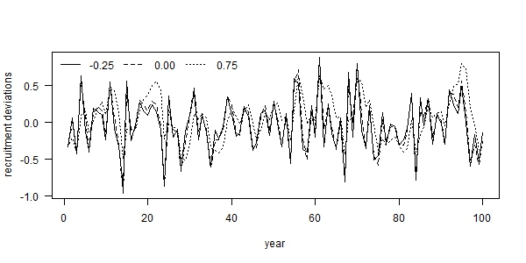

Fig. 1. Examples of autocorrelated recruitment deviations for three levels of autocorrelation: (i) -0.25 (solid line), (ii) 0.00 (dashed line), and 0.75 (dotted line), where each example used the same set of process error deviations ($δ_{t}$).

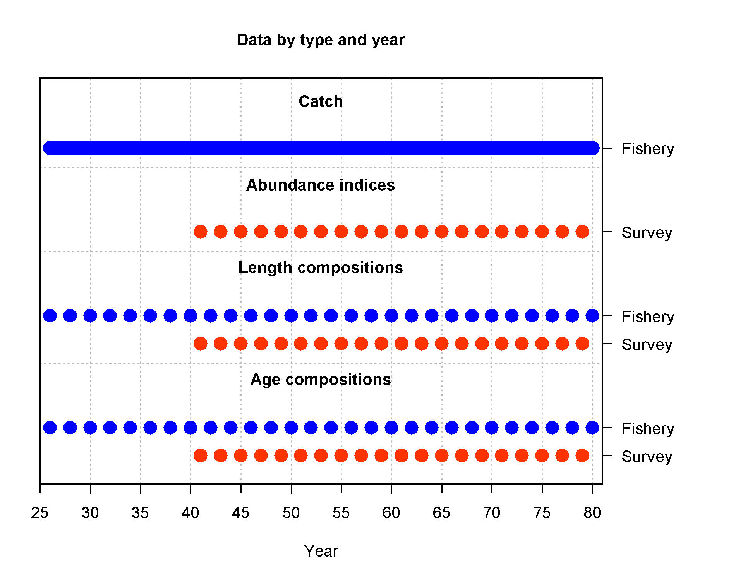

Fig. 2. Summary of simulated data available to the estimation model during the fishing period (years 25-80).

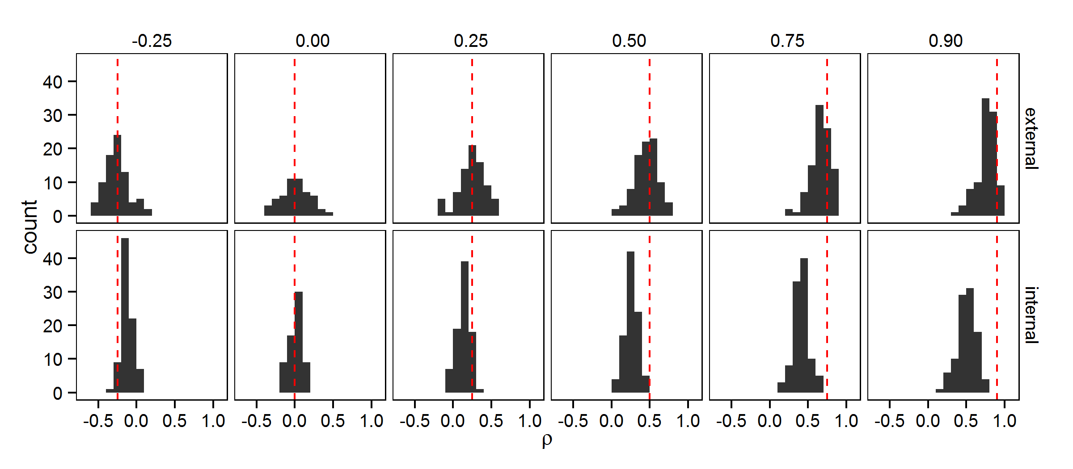

Fig. 3. Estimates of recruitment autocorrelation (*ρ*) from two estimation models: (i) calculated as the sample autocorrelation of recruitment deviations estimated in Stock Synthesis (“external”; top row) and (ii) estimated as a fixed effect within Stock Synthesis simultaneously with other parameter estimation (“internal”; bottom row), for six levels of recruitment autocorrelation (columns). The dashed red line illustrates the true level of autocorrelation, while the black shaded area is a histogram representing the simulation distribution for each scenario and estimation model.

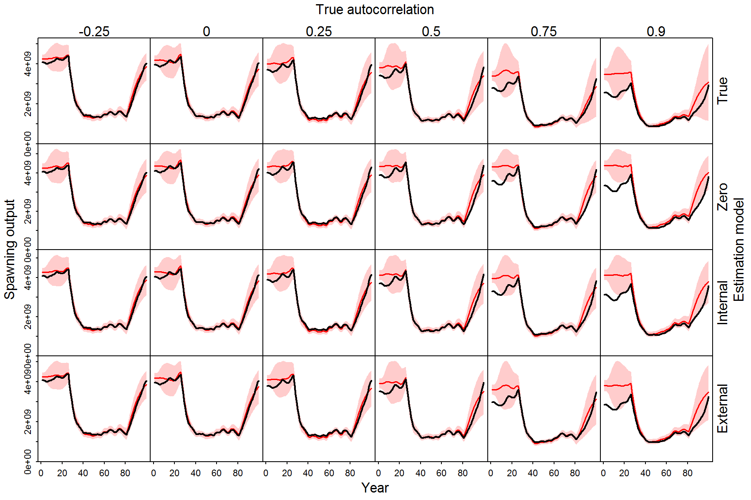

Fig. 4. Illustration of estimated spawning stock biomass (SSB) during 100 simulated years for different scenarios (columns, where recruitment autocorrelation is ρ={-0.25, 0.0, 0.25, 0.5, 0.75, 0.9}), and four different estimation models (rows: external estimation, international estimation, fixing at the true value, or fixing at zero), where each panel shows the true spawning biomass (black line) and the red shaded area shows the 95% confidence and forecasting interval for the estimating spawning biomass.

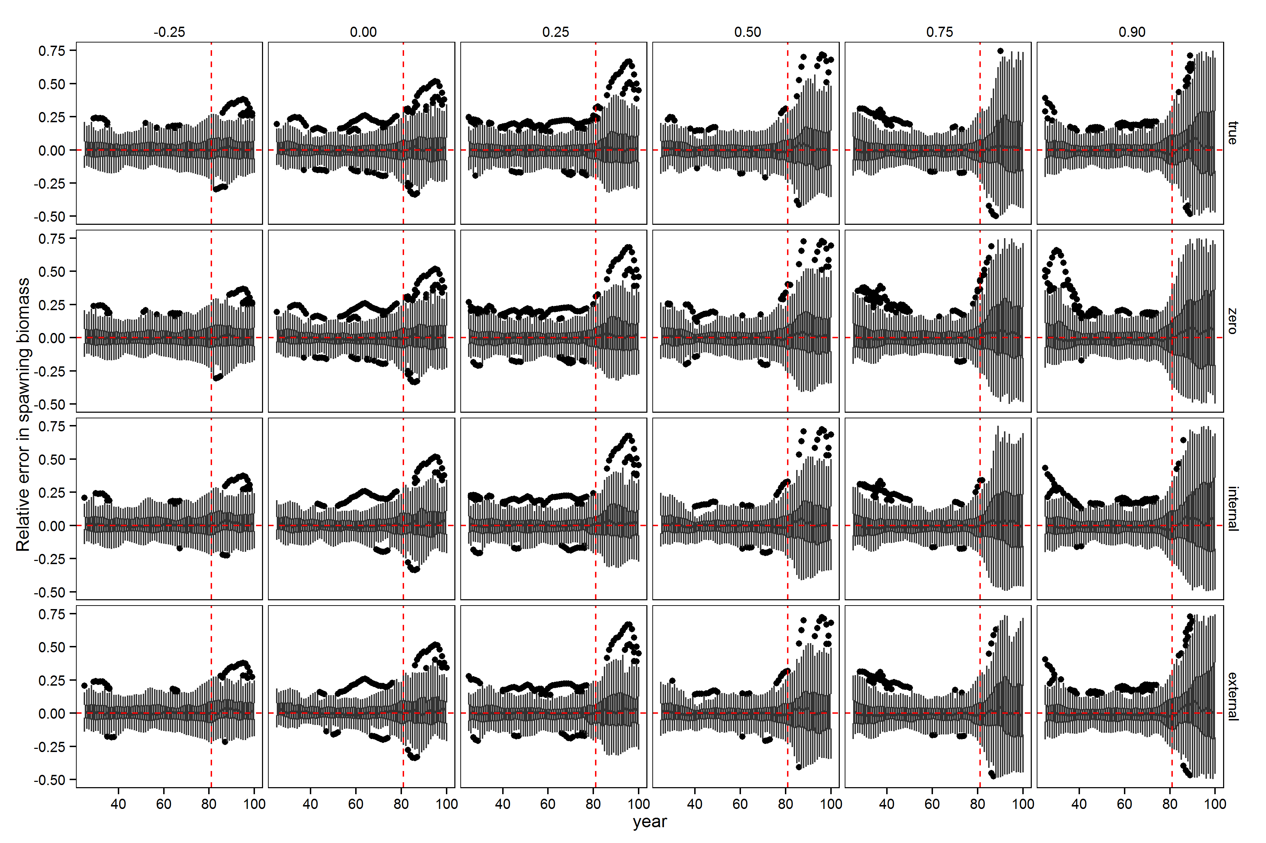

Fig. 5. Relative error in spawning stock biomass during years for which the assessment method was provided data (years 26 through 80) and the forecast period (years 81 through 100) for six levels of autocorrelation in the simulated data (columns) and four estimation methods (rows). Horizontal dashed red lines indicate a relative error of zero. Upper and lower edges of the boxes correspond to the first and third quartiles (the 25th and 75th percentiles) and the whiskers correspond to 1.5 times the distance between the first and third quartiles.

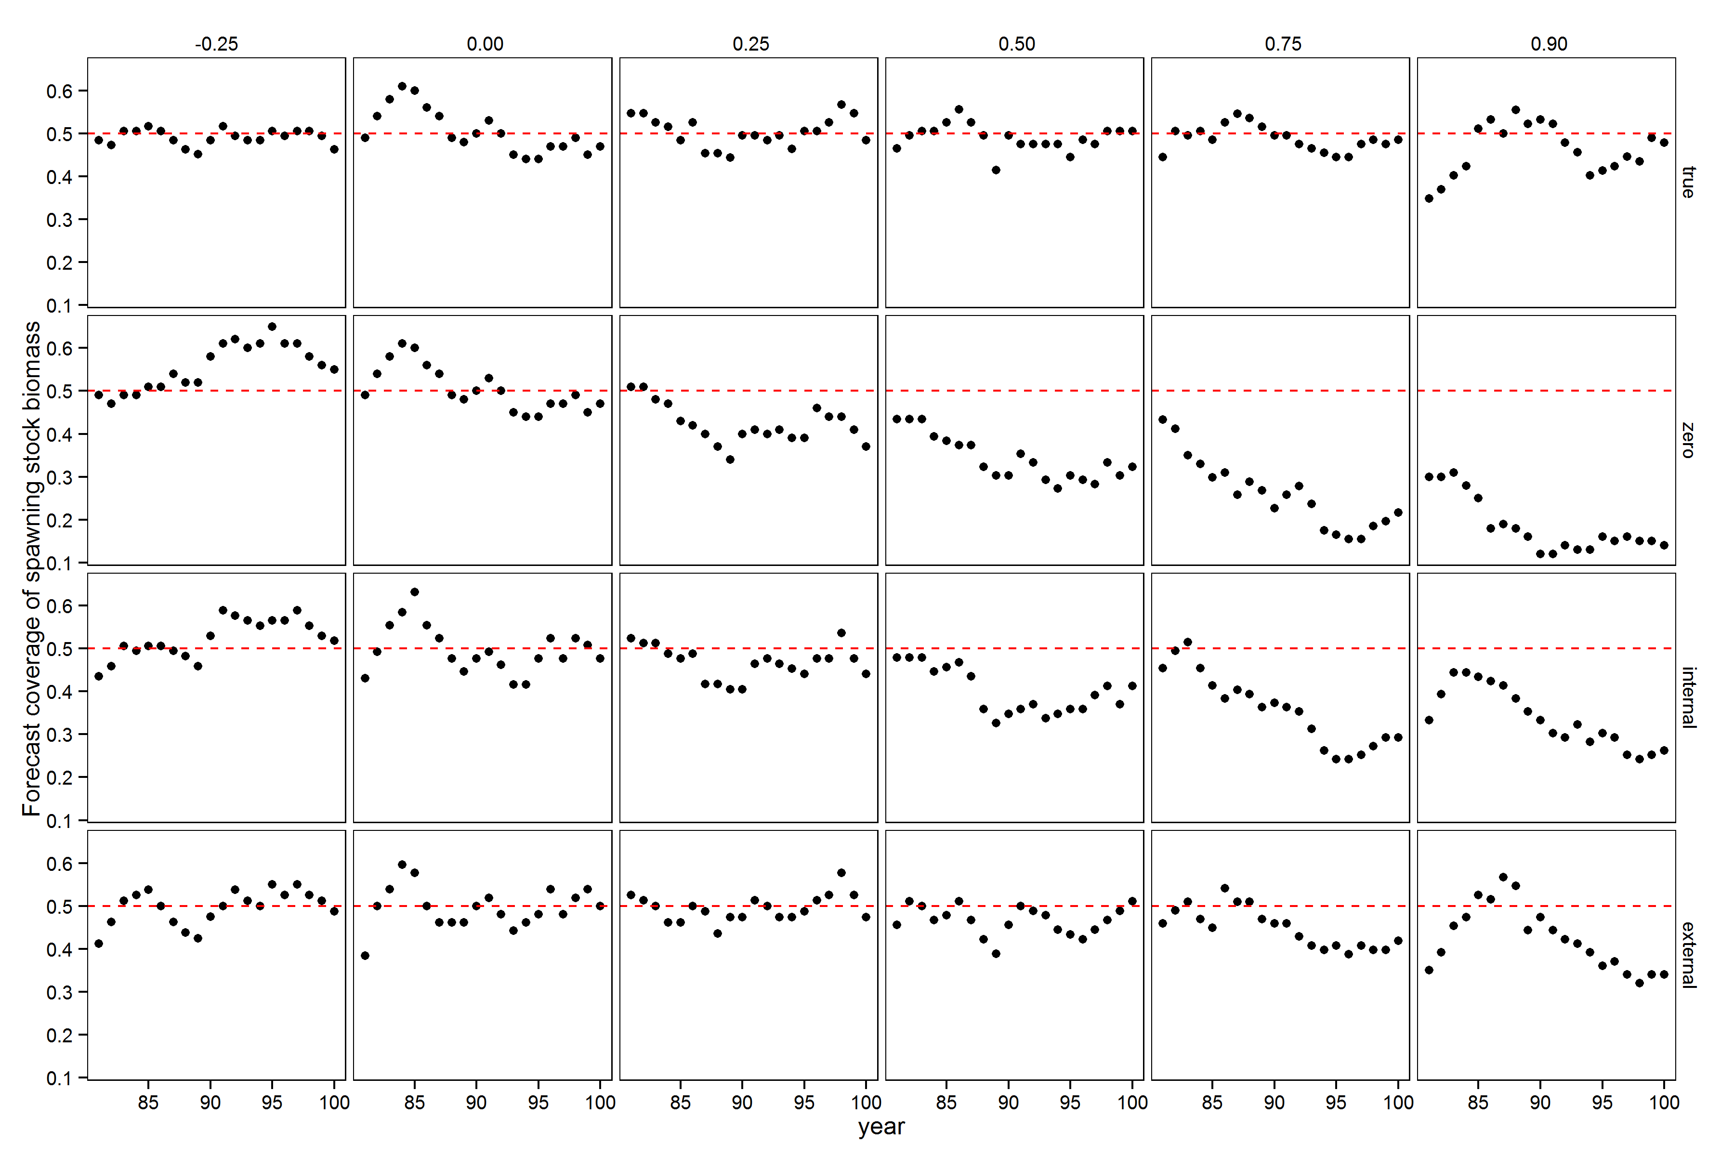

Fig. 6. Performance of forecast interval estimates for different estimation models (rows) and levels of autocorrelation (columns), where ach panel shows the proportion of 50% forecast intervals for spawning stock biomass that contain the true value. A well calibrated 50% forecast interval will contain the true value 50% of the time, and this value is indicated by a red dashed line in each panel.