**Can autocorrelated recruitment be estimated using integrated assessment models, and how does it affect population forecasts?**

Kelli Johnson1,*, Elizabeth Councill1,2, James T. Thorson1, Elizabeth Brooks3, Richard D. Methot4, André E. Punt2

1School of Aquatic and Fishery Sciences, University of Washington, Box 355020, Seattle, WA 98195-5020, USA

2Fishery Resource Analysis and Monitoring Division, Northwest Fisheries Science Center, National Marine Fisheries Service, National Oceanic and Atmospheric Administration, 2725 Montlake Blvd. East, Seattle, WA 98112, USA

3Northeast Fisheries Science Center, 166 Water Street, Woods Hole, MA 02543, USA

4NOAA Senior Scientist for Stock Assessments, National Marine Fisheries Service, National Oceanic and Atmospheric Administration, 2725 Montlake Blvd. East, Seattle, WA 98112, USA

*Corresponding author:

telephone: +1 206 543 4270; fax: +1 206 616 8689; email: kfjohns@uw.edu

**To do list:**

1. Scenarios
   1. Decisions needed to go forward
      1. V2 or V4 of tpl
      2. Estimate early recdevs before start of fishery (i.e., years 1-25) or change EM to start the same year as the start of the fishery. Rick seemed to think the answers would be the same, but because of the bias adjustment the answers are slightly different.
      3. Perform a power analysis to determine the amount of data needed to internally estimate AR: AEP and Liz suggested removing the early fishery data and reducing the sample sizes to 25. A more systematic approach is needed as the current value of 100 with data every other year is arbitrary.
         1. Minimum number of years needed to estimate ρ
            1. Try: 25, 50, 75
         2. Number of age samples
            1. Try: 25, 100, 200, 500, 1000
         3. Number of length samples
            1. Try: 0, 25, 100, 200, 500, 1000
      4. Keep steepness fixed or try to estimate it?
   2. Change
      1. Insert code into SS to use externally calculate ρ and use the external calculation for the forecasts?
      2. Run each EM twice so that the bias adjustment is specific to each data set and EM, where right now it is only specific for each level of AR
      3. AEP thinks the sd of the survey is too high at 0.1
   3. Additional
      1. Externally estimate AR when AR was fixed at zero in the EM prior to externally estimating it.
      2. Try different values of $σ_{R}$ in the OM, as pseudo life-history differences without adding a new species.
      3. Young of the year survey with age compositions.
      4. Missspecify yearly sample sizes.
      5. Ageing error
2. Text
   1. Update results
   2. Update discussion:
      1. Add future work paragraph.
      2. Add text about how ageing error would change things.
   3. Check that all listed references are cited
   4. Check that all references are listed
   5. Keywords: a maximum of five keywords using American spelling
   6. Highlights: eventually move to a separate file
      1. a short collection of bullet points that convey the core findings
      2. submitted in a separate editable file
         1. use 'Highlights' in the file name
      3. 3 to 5 bullet points
      4. maximum 85 characters, including spaces, per bullet point
      5. http://www.elsevier.com/highlights
   7. Provide a reference for sections in the text where “citation” is located.
3. Figures
   1. Check if figures should have multiple panels and if so make sure both panels exist and are labeled or appropriately documented in the caption.
   2. Fig. 3: Add the additional external estimation routine when the recruitment deviations passed to the estimator are based on a fixed value of 0.0 for AR in the EM, place median of each histogram in upper left hand corner.
   3. Fig. 6: Add 75%, 90% and 95% intervals to the forecast period coverage -AEP

**Highlights**

* bullet 1
* bullet 2
* bullet 3
* bullet 4
* bullet 5

**Abstract**

The time series of annual recruitment is often autocorrelated for marine fishes due to numerous factors including regime shifts and periodicity in environmental drivers affecting survival rates during larval and juvenile stages. Patterns of first-order temporal autocorrelation in recruitment deviations are identified by periods of time where recruitment deviations are positive or negative for several years in a row. The ability of stock assessments to accurately estimate the magnitude of recruitment autocorrelation, and its effect on the quality of forecasts of spawning stock biomass, has not generally been analyzed. Monte Carlo simulations were used to evaluate how well Stock Synthesis, an ‘integrated’ age-structured stock assessment method used extensively in the assessment of fish stocks, estimates autocorrelation in the presence of a range of levels of autocorrelation in recruitment deviations. The precision and accuracy of estimated autocorrelation, and the ability of the stock assessment framework to forecast the true dynamics of the system, were compared for scenarios where autocorrelation parameter within the assessment was fixed at zero, fixed at its true value, internally estimated, or input as a fixed value determined using an external estimation procedure. Penalized-likelihood estimates of autocorrelation produced by Stock Synthesis were biased toward zero when autocorrelation was larger than zero, but were unbiased when the true level of autocorrelation was less than or equal to zero. Less biased estimates of autocorrelation were obtained by externally estimating it from the recruitment deviations estimated within Stock Synthesis when autocorrelation was greater than zero. Irrespective of the method used to estimate autocorrelation, prediction interval uncertainty for estimates of spawning stock biomass during the forecast period were large when the true level of autocorrelation was high (0.9 in our study). Our results suggest that autocorrelation should first be estimated internally within a stock assessment, then externally calculated from the estimated recruitment deviations, especially in cases when the internally-estimated value is positive and nonzero. Results using this approach lead to estimates of autocorrelation that have small bias and accurate prediction interval coverage (i.e., a 50% prediction interval that includes the true value of spawning stock biomass for 50% of simulation replicates).

**Keywords:** five keywords go here

**1. Introduction**

Under the United States Magnuson-Stevens Fishery Conservation and Management Act (MSA; United States Public Law 104-297), all stocks included in United States Fishery Management Plans must have target and limit reference points and all overfished stocks must have a rebuilding plan. Rebuilding plans involve specifying management measures to rebuild the stock to a biomass associated with maximum sustainable yield ($β_{MSY}$) within 10 years (or, if rebuilding within 10 years is impossible, then one generation time plus the median time for rebuilding in the absence of fishing). Legally, rebuilding plans must be more likely than not to succeed, i.e., be based upon a probabilistic forecast of future population dynamics given the agreed level of fishing that implies recovery with ≥ 50% probability.

Stock assessment models represent the link between collected data and scientific advice in fisheries management. Assessments are expected to use fits to historical data and prescribed harvest policies to forecast future stock abundance and catch levels. These predicted “Acceptable Biological Catches” must account for scientific uncertainty and provide ≤ 50% probability that overfishing will occur (Methot et al., 2013). Variability in recent recruitment to the stock is a major contribution to this scientific uncertainty. As National Marine Fisheries Service (NMFS) works to reduce the number of overfished stocks, projection success is being examined more critically, and the accuracy of probabilistic forecasts in rebuilding plans is receiving increased research attention (Neubauer et al., 2013; NRC, 2013).

Reference points and rebuilding forecasts are often estimated using a stock assessment model that treats fluctuations in recruitment as a random process around a prediction derived from a presumed relationship between spawning output and recruits (Clark, 1993; Methot and Wetzel, 2013). Stock assessments are increasingly conducted using “integrated” population dynamics models that typically incorporate many data types, including samples of compositional data from fisheries and surveys, indices of abundance, and information regarding total fishery harvest (Maunder and Punt, 2013). These data are combined to estimate values for population productivity (parameters in the stock-recruit relationship) and status (spawning biomass in each year relative to reference points). Probabilistic forecasts of future population dynamics can then be made given assumed fishing mortality rates.

Recent studies illustrate that recruitment for many fishes is non-random over time and includes high and low periods (Hollowed et al., 2001; Szuwalski et al., 2014). This could be driven by environmental factors acting on recruit survival (citation) or adult reproduction (citation), or both (citation), or changes in the abundance of predators (citation). Ideally, researchers can identify measureable environmental factors that are correlated with recruitment deviations or regime shifts, and which can be forecast into the future (Haltuch and Punt, 2011). If an environmental factor that helps predict future recruitment can be identified, it can then be used to inform rebuilding forecasts (Holt and Punt 2009, Punt 2011) and reference point calculations (Schirripa et al., 2009). If an environmental factor cannot be identified, population forecasts are sometimes calculated for different “states-of-nature”, where each state-of-nature depends upon a hypothetical scenario for expected future recruitment (e.g., high, average, and low productivity scenarios; citation).

When correlated measurable environmental factors remain unidentified, the influence of regime shifts can still be accounted for by invoking autocorrelation in future recruitment deviations (i.e., where future recruitment deviations are greater or less than zero for many years in a sequence). Including “autocorrelated recruitment” in the population dynamics model may result in wider forecasting intervals compared with assuming recruitment follows a white-noise process. This wider forecast interval may, in some cases, have better statistical coverage (e.g., a 75% forecast interval that contains the true value 75% of the time). Well-calibrated statistical coverage is a pre-requisite of probabilistic methods used for forecasting and reference point determination (Shertzer et al. 2008).

In this study, we explore and evaluate the performance of population forecasts obtained from an integrated, age-structured assessment model when recruitment is autocorrelated. We conduct a simulation experiment using a factorial design involving six plausible levels of autocorrelation, ρ, in recruitment deviations and four alternative configurations for estimating ρ in the assessment model. We explore model performance by answering two questions:

1. How well can the magnitude of autocorrelation be estimated? and
2. Does accounting for autocorrelation improve the accuracy and predictive coverage of forecasts compared with ignoring autocorrelation in recruitment deviations?

We conclude by outlining a practical strategy to test and account for autocorrelated recruitment when generating forecasts in real-world assessment models.

**2. Methods**

We conduct a simulation experiment using the Stock Synthesis (SS) assessment software (Methot and Wetzel 2013), which is widely used in the Unites States and provides a generic implementation of an integrated assessment model. SS estimates recruitment at the same time as other parameters that govern stock productivity and status, and uses the delta-method to propagate uncertainty about past and future recruitment when calculating standard errors for population forecasts. Simulations and analyses were accomplished using the *ss3sim* software package (Anderson et al. 2014a, 2014b), and a public online repository houses the simulation code (github.com/kellijohnson/AR-perf-testing) to ensure the results are reproducible.

The simulation framework consists of three components: (1) an operating model that generates the true population dynamics; (2) a sampling model that generates data from the operating model; and (3) an estimation method that is applied to the simulated data, where the parameter estimates and derived quantities (i.e., forecasted future population abundances) from the estimation method can be compared with their true values from the operating model. We use a factorial design involving six levels of recruitment ρ and four alternative configurations for the estimation method. One hundred simulation replicates were generated for each scenario, where each replicate has a different realization of process (recruitment deviations) and observation errors. Each replicate involves simulating population dynamics over 100 years, which we divide into three periods:

1. “Burn-in period” – Years 1-25 are simulated without any fishing;
2. “Fishing period” – Years 26-80 include a simulated fishery, which fishes at *MSY,* and the potential for data from the fishery and/or survey, which is used to fit an assessment model conducted in year 80; and
3. “Forecast period” – Years 81-100 are simulated without any fishing, which can be compared to forecasts based on parameter estimates derived from the estimation method.

**2.1 Operating model**

The operating model represents a cod-like (i.e., slow-growing and long-lived) life history based on biological parameters estimated from the stock assessment for North Sea cod (*Gadus morhua*; Deroba et al., 2015) with some simplifications facilitating interpretation of the results (Table 1). Simplifications include: one fishery and one survey, combined sexes, and selectivity parameters based on the maturity ogive.

We used the steepness-parameterization of the Beverton-Holt stock-recruit function:

$r_{t}=\frac{4hr_{0}b_{t}}{b_{0}\left(1-h\right)+b_{t}(5h-1)}e^{ε_{t}-γ_{t}σ_{r}^{2}/2}$ (1)

where *rt* and *bt* are the estimate of recruitment output and spawning biomass, respectively, in year *t*, *h* and *r0* are estimated parameters representing steepness (the strength of recruitment compensation) and average recruitment at unfished spawning biomass *b0*, and recruitment deviation *εt* is calculated as:

$ε_{t}=ρε_{t-1}+δ_{t}\sqrt{1-ρ^{2}}$ (2)

where *δt* is a normally distributed coefficient representing recruitment variability:

$δ_{t}\sim N(0,σ_{r}^{2})$ (3)

where $σ_{r}^{2}$ is the marginal variance of recruitment deviations and *ρ* is the magnitude of autocorrelation in recruitment. Equation (1) includes the term $e^{ε_{t}-γ_{t}σ_{r}^{2}/2}$, where the bias-correction term $e^{-γ_{t}σ_{r}^{2}/2}$ is included to ensure that *r0* is equal to the mean (not the median) recruitment given unfished spawning biomass and $γ_{t}$ is the annual bias-correction factor (Methot and Taylor, 2011).

Each replicate of the operating model involved simulating true dynamics over 100 years, where recruitment is variable each year but the same across scenarios given an iteration (i.e., the values of $δ_{t}$ for the first replicate of the *ρ* = 0.0 scenario were the same as for the first replicate of the *ρ* = 0.9 scenario). Years 1 through 25 had no fishing and are included to ensure that the population age-structure in year 25 had plausible deviations away from its expectation in an unfished state. In years 26-80, fully-selected fishing mortality, *F*, was fixed at the value that produced maximum sustainable yield. Fishery selectivity was logistic, based on fish length, and was identical to the maturity ogive. Survey selectivity was similar, except that the length at which 50% of individuals were selected was specified as 80% of the length at which 50% of individuals were mature to ensure that the survey sampled younger fish than were caught in the fishery.

We simulated data for six scenarios that differed in the value of autocorrelation used to generate recruitment: -0.25, 0, 0.25, 0.5, 0.75 and 0.9. Included levels of ρ are centered approximately around estimates from recent meta-analyses (Mueter et al. 2007, Thorson et al. 2014).

**2.2 Sampling model**

Annual catch was reported without error from the start of the fishery (year 26) to the year of the assessment (year 80; see Fig. 2). Fishery length- and age-composition data were simulated every other year for years 26-80, and were drawn from a Dirichlet distribution with twice the standard deviation of a multinomial distribution given an annual sample size of 100. The Dirichlet distribution was used to more accurately reflect the reduced information contained in data collected from fisheries compared to surveys (Aanes and Pennington, 2003; Hulson et al., 2011). Survey length- and age-composition data were simulated every other year for years 41-79, and were drawn from a multinomial distribution with an annual sample size of 100. The survey was simulated every other year providing an index of relative abundance for years 41-79, and was drawn from a lognormal distribution with log-standard deviation of 0.1.

**2.3 Estimation model**

An age-structured stock assessment model was fit to each simulated data set, using data generated during the “fishing period” (years 26-80), and we refer to this as the “estimation model” (see Table 1 for a list of estimated parameters). The estimation model also estimated recruitment deviations for years 1-25 (to estimate the initial age-structure given plausible deviations away from the unfished age-distribution), and for years 81-100 (to simulate recruitment variability when forecasting population dynamics forward for 20 years after the last year, year 80, of the simulated assessment period). The correct input sample size for both the multinomial and Dirichlet composition samples (*Ninput* = 100 and 100/22, respectively) were specified in each estimation method (i.e., the estimation model had correct weighting for age- and length-composition sampling data). The bias correction factor $γ_{t}$ was estimated using five simulation replicates for each level of autocorrelation used to generate the data (Methot and Taylor, 2011). The average of the bias correction parameters from the five replicates were then used for all estimation methods. The marginal log-standard deviation of recruitment $σ_{R}$ was fixed at the true value (Table 1).

The following four estimation methods were investigated for each level of ρ:

1. “True” – an estimation model where the autocorrelation parameter was fixed at the level used to generate the recruitment deviations in the operating model. This estimation model is not plausible for any real-world assessment (given that the true ρ will never be unknown), but is included as a reference case, to demonstrate model performance if the extent of autocorrelation were known exactly.
2. “Zero” –an estimation model where the autocorrelation parameter is fixed at zero. This estimation model represents the most common assumption in stock assessment models to date.
3. “Internal” – an estimation model where the autocorrelation parameter is estimated as a fixed effect. This scenario will likely result in biased estimates of autocorrelation, given that SS implements “penalized likelihood” estimation rather than true “mixed-effect” estimation (Thorson and Minto, 2015). Previous research demonstrates that penalized likelihood estimation results in negative bias when estimating the variation in the recruitment deviations (*σr*, Thorson *et al*., 2014). However, its performance when estimating the magnitude of ρ has not been previously explored.
4. “External” – an estimation model where the autocorrelation parameter is estimated externally to SS. This involves extracting estimates of recruitment deviations from the “Internal” estimation model, and then estimating the sampling autocorrelation of these estimates using the *acf* function in R (R Core Development Team 2015). This level of autocorrelation is then set as a fixed value in SS, and SS is run a second time to estimate other parameters for a given data set. This estimation model will likely have different estimation performance than the “internal” estimation model, given that sample- and population-level estimates are often different in mixed-effects models (citation).

Each estimation method generates forecasts of population abundance during years 81 to 100. All estimation models have no additional data during this forecast period, so recruitment deviations for years 81-100 are estimated at their expected value (i.e., zero when autocorrelation is absent, or decaying towards zero from the value of the estimated recruitment deviation in year 80 when autocorrelation is nonzero). SS uses the delta-method when calculating uncertainty in population abundance during the forecast period. Therefore, forecast period abundance has a standard error that includes uncertainty about future recruitment deviations, and this uncertainty is a function of the level of recruitment autocorrelation.

For each estimation model, we specified that fishing mortality was zero during the forecast period, and this matches the operating model which has no fishing during the forecast period. Given that fishing rate is correctly specified during the forecast period, any bias or imprecision in population abundance during the forecast period arises either from (1) bias and imprecision of estimated parameters during the fishing period, or (2) the impact of mis-specifying ρ during the forecast period.

Convergence of the estimation model was determined using the maximum gradient of the objective function, where models with a maximum gradient of less than 0.01 and a positive definite Hessian matrix were assumed to have converged. Models that failed to converge were removed from the analysis, and exploratory analysis confirms that results are qualitatively similar when changing the gradient threshold used to identify model convergence. Estimation performance was evaluated using relative error, $RE=\left(\hat{θ}-θ\right)/θ$, where $\hat{θ}$ and $θ$ are estimated and true parameter values, respectively, and the forecast interval coverage, defined as the proportion of replicates where the forecast interval contains the true value from the operating model. A well-calibrated model will have approximately nominal forecast interval coverage, i.e., where a 50% forecast interval will contain the true value in 50% of simulation replicates.

**3. Results**

**3.1 How well can the magnitude of autocorrelated recruitment be estimated?**

To determine how well the magnitude of recruitment autocorrelation can be estimated, we evaluate estimates produced either when treating autocorrelation as a fixed effect (“internal”) or when calculating the sample autocorrelation of estimated recruitment deviations (“external”, see Fig. 3). Estimation as a fixed effect is biased towards zero in all scenarios, where this bias is particularly apparent for scenarios where true autocorrelation is greater than 0.5. In particular, internal estimation results in a median estimate of 0.5 when true autocorrelation is 0.9. This bias is largely diminished when externally calculating the sample autocorrelation of recruitment deviations, i.e., where the median estimate is 0.8 when true autocorrelation is 0.9.

External estimates are the same/different when the external routine is based on recruitment deviations estimated using a fixed ρ of 0.0 compared to when ρ was freely estimated (Fig. 3). The ability to detect ρ is … When ρ was 0.0 in the operating model and the estimation method was properly specified, external estimates of ρ were …

Estimates of ρ differed when bias adjustment parameters were … The change in the logarithm of the likelihood from the estimation method was …

A benefit of internally estimating ρ within an assessment model if one also obtains estimates of the associated error surrounding the estimate. The standard deviation of ρ was …

**3.2 What impact does autocorrelated recruitment have on forecasts of population abundance?**

We first illustrate the effect of autocorrelated recruitment on estimated spawning output for all years (years 1-100) for the first replicate of the simulation experiment (Fig. 4). As expected, fixing autocorrelation at its true value results in a forecast interval that expands rapidly during the forecast period (years 81-100), with larger positive autocorrelation producing wider intervals. Most noteable, the lower confidence bound for forecasts of spawning output declines over time when recruitment autocorrelation is 0.9, despite the forecast model correctly assuming that fishing is absent during this period (top-right panel of Fig. 4). This increase in forecast interval width is largely absent when autocorrelation is assumed to be zero (second row of Fig. 4). The interval is substantially smaller for the “internal” estimation model than the “true” estimation model, and is somewhat larger for the “external” than “internal” estimation model.

These patterns also hold when summarizing relative error in estimates of spawning output across all simulation replicates (Fig. 5). During the “fishing” period (years 26-80), relative error of spawning output is generally less than 0.25 for all estimation models and all levels of true autocorrelation. We therefore conclude that increased recruitment autocorrelation, or mis-specifying recruitment autocorrelation, has relatively little impact on the precision and accuracy of estimates of spawning output during the period with information to estimate recruitment deviations. However, increased autocorrelation leads to a large increase in relative error during the forecast period (years 81-100), such that relative error is sometimes greater than 0.75 when autocorrelation is 0.9. There is little difference among estimation models in relative error during the forecast interval, although the “true” and “external” estimation models do have a somewhat smaller interquartile range for relative error than the “zero” estimation model when autocorrelation is high. All models have a small positive bias in spawning biomass during the forecast period when autocorrelation is 0.75 and even more so when autocorrelation is 0.9. Exploratory analysis indicates that this bias arises due to the nonlinear stock-recruit function, i.e., because calculating forecasts based on the mean of the stock-recruit function is not identical to the expectation of the forecast due to this nonlinearity.

Finally, we illustrate 50% forecast interval coverage for each estimation model, defined as the proportion of simulation replicates where true spawning output falls within a 50% forecast interval (Fig. 6). When autocorrelation is absent (column “0.00” in Fig. 6), all estimation models have approximately nominal coverage, although all models exhibit a greater-than-50% coverage (indicating too wide of forecast intervals) in years 83-85. When autocorrelation is fixed at its true value (Fig. 6, upper rows), coverage remains close to 50% for all levels of true autocorrelation. However, increasing autocorrelation leads a large decline in coverage for the estimation model that neglects autocorrelation (Fig. 6, row two). For this model, coverage is close to 25% in year 90 (only 10 years into the forecast period) when autocorrelation is 0.75, and is approximately 10% in this year when autocorrelation is 0.9. By contrast, coverage is closer to 50% for the external estimation model when autocorrelation is 0.75, and it declines to approximately 40% by year 100 when autocorrelation is 0.9. We therefore conclude that external estimation has substantially improved forecast interval performance relative to the model that neglects autocorrelated recruitment.

When the early fishery data was eliminated the forecasts …

**4. Discussion**

Fisheries management in the United States and worldwide increasingly uses integrated stock assessment models to evaluate the likely impact of alternative management measures on fish population abundance. The United States and Europe both seek to end overfishing and rebuild overfished stocks (citation). Rebuilding plans in the United States are based upon forecasts of population abundance, and each United States Regional Fisheries Management Council is required to developed an approved Rebuilding Plan that will result in rebuilding within a pre-determined time frame. Rebuilding Plans are also required to be more likely than not to succeed in their stated timeframe, i.e., rebuilding plans are premised on a probabilistic interpretation of the forecasts generated from integrated stock assessment models. A probabilistic interpretation of catch advice arising from stock assessment models is also used in many United States regions to incorporate scientific uncertainty when defining catch limits (Shertzer et al., 2008).

In this study, we have demonstrated that autocorrelated recruitment has a substantial impact upon both the accuracy of forecasts (i.e., how close they are to the true value) as well as the width of forecast intervals (i.e., how large is the estimated standard error during forecasts). In particular, high levels of autocorrelation (i.e., ρ>0.5) result in significant increases in the relative error of population forecasts, regardless of whether the stock assessment model includes autocorrelation or not. Also, a model where autocorrelation is fixed at its true value showed that forecast interval width is substantially increased when autocorrelation is high. These results confirm that the certainty of population forecasts is highly dependent upon the presence or absence of recruitment autocorrelation. Presumably, high recruitment autocorrelation could contribute to the lack of rebuilding for some fishes under rebuilding plans worldwide, particularly if forecasted biomass is overestimated as in our results (Hutchings, XXXX; Neubauer *et al.*, 2013). Previous analysis of model output from stock assessment models suggests that recruitment may have intermediate, positive autocorrelation for marine fishes (Thorson et al., 2014). However, these previous results are based on model-output, which is fraught with statistical issues (Brooks and Deroba, 2015; Thorson et al., 2015a). We therefore recommend that future research be conducted to estimate the average magnitude of recruitment autocorrelation using integrated assessment models.

We have also shown improvements in forecast interval performance when fixing autocorrelation at the sample autocorrelation of estimated recruitment deviations. It is not necessary to accurately estimate forecast interval width as if management only currently utilize the median of the forecast, but the accuracy of the median will be very important. However, if fisheries managers use other quantities from the forecast (i.e., seek a management procedure that achieves a target biomass with 75% probability), or have Harvest Control Rules where the percentile for catch advice depends on the degree of depletion, then it is necessary to have accurate estimates of forecast interval width. Our simulation results show that the “external” estimate of autocorrelation results in less biased estimates of autocorrelation than treating autocorrelation as a fixed effect. The poor forecast interval performance when estimating autocorrelation as a fixed effect likely arises from our use of penalized-likelihood estimation methods. Penalized likelihood has previously been shown to result in a negative bias when estimating the variance of recruitment deviations (Thorson et al., 2015b), and a sample-based statistic has therefore been developed for estimating this variance (Methot and Taylor, 2011). However, we note that fixing autocorrelation externally does not propagate uncertainty about the magnitude of autocorrelation when estimating standard errors for other parameters or derived quantities for management (e.g., the CV of average unfished spawning biomass may be different when ρ is estimated compared to when ρ is fixed). In general, estimated uncertainty for spawning output was ? when autocorrelation was externally estimated compared to when it was internally estimated.

Future work should investigate ρ using MCMC and the Laplace approximation.

**5. Conclusions**

We conclude that “external” estimation will likely result in better performance when estimating the magnitude of autocorrelated recruitment when estimation is based on penalized likelihood.

* Following my comment on section 3.1 (line 236), this might be a good place to summarize the detectability vs false-positive question. I’ve used SCAAs with and without ρ terms, and I suspect readers fall into that same category. Given that results in fishing years didn’t seem to vary across ρ cases or estimation configurations, and the fact that often times a separate forecast tool is used, it would be good to provide advice as to whether you can leave ρ=0 during the assessment model, then get a decent estimate of ρ externally and just use it in forecasts.
* The reliability of forecasts degrades for high autocorrelation, especially beyond the first 5-10 years. Rebuilding success is supposed to occur within 10 years, if feasible given life history. This suggests that progress towards rebuilding should be evaluated, and perhaps the assessment and forecast updated, within 5 years to avoid a “balloon payment” if overestimates in biomass are allowed to accumulate for too many years.

**6. Acknowledgements**

We gratefully acknowledge help from Ian Taylor, Chantel Wetzel, and Allan Hicks on implementation issues regarding ss3sim and forecasting within Stock Synthesis. This publication is partially funded by the Joint Institute for the Study of the Atmosphere and Ocean (JISAO) under NOAA Cooperative Agreement No. ?, Contribution No. ?. Partial funding for KFJ was provided by a grant from Washington Sea Grant, University of Washington, pursuant to National Oceanic and Atmospheric Administration Award No. NA140AR4170078. The views expressed herein are those of the authors and do not necessarily reflect the views of NOAA or any of its sub-agencies.

**References**

Aanes, S., Pennington, M., 2003. On estimating the age composition of the commercial catch of Northeast Arctic cod from a sample of clusters. ICES J. Mar. Sci. 60, 297-303.

Anderson, S. C., Monnahan, C.C., Johnson, K.F., Ono, K., Valero, J.L., 2014a. ss3sim: An R package for stock assessment simulation with Stock Synthesis. Plos One 9, e92725.

Anderson, S.C., Monnahan, C.C., Johnson, K.F., Ono, K., Valero, J.L., Cunningham, C.J., Hurtado-Ferro, F., Licandeo, R., McGilliard, C.R., Szuwalski, C.S., Vert-pre, K.A., Whitten, A.R., 2014b. ss3sim: Fisheries stock assessment simulation testing with Stock Synthesis. R package version 0.8.9.9.

Clark, W.G., 1991. Groundfish exploitation rates based on life history parameters. Can. J. Fish. Aquat. Sci. 48, 734-750.

Deroba, J.J., Butterworth, D.S., Methot, R.D., Jr., De Oliveira, J.A.A., Fernandez, C., Nielsen, A., Cadrin, S.X., Dickey-Collas, M., Legault, C.M., Ianelli, J., Valero, J.L., Needle, C.L., O’Malley, J.M., Chang, Y-J., Thompson, G.G., Canales, C., Swain, D.P., Miller, D.C.M., Hintzen, N.T., Bertignac, M., Ibaibarriaga, L., Silva, A., Murta, A., Kell, L.T., de Moor, C.L., Parma, A.M., Dichmont, C.M., Restrepo, V.R., Ye, Y., Jardim, E., Spencer, P.D., Hanselman, D.H., Blaylock, J., Mood, M., Hulson, P.-J.F., 2015. Simulation testing the robustness of stock assessment models to error: some results from the ICES strategic initiative on stock assessment methods. ICES J. Mar. Sci. 72, 19-30.

Hollowed, A.B., Hare, S.R., Wooster, W.S., 2001. Pacific Basin climate variability and patterns of Northeast Pacific marine fish production. Prog. Oceanogr. 1-4, 257-282.

Holt, C.A., Punt, A.E., 2009. Incorporating climate information into rebuilding plans for overfished groundfish species of the U.S. west coast. Fish. Res. 100, 57-67.

Hulson, P-J.F., Hanselman, D.H., Quinn, T.J., II., 2011. Effects of process and observation errors on effective sample size of fishery and survey age and length composition using variance ration and likelihood methods. ICES J. Mar. Sci. 68, 1548-1557.

Methot, R.D., Taylor, I.G., 2011. Adjusting for bias due to variability of estimated recruitments in fishery assessment models. Can. J. Fish. Aquat. Sci. 68, 1744-1760.

Methot, R.D., Wetzel, C.R., 2013. Stock synthesis: a biological and statistical framework for fish stock assessment and fishery management. Fish. Res. 142, 86–99.

Methot, R.D., Jr., Tromble, G.R., Lambert, D.M., Greene, K.E., 2013. Implementing a science-based system for preventing overfishing and guiding sustainable fisheries in the U.S. ICES J. Mar. Sci. 71, 183-194. 10.1093/icesjms/fst119

Maunder, M.N., 2011. Review and evaluation of likelihood functions for composition data in stock-assessment models: estimating the effective sample size. Fish. Res. 109, 92-99.

Mueter, F.J., Boldt, J.L., Megrey, B.A., Peterman, R.M., 2007. Recruitment and survival of Northeast Pacific Ocean fish stocks: temporal trends, covariation, and regime shifts. Can. J. Fish. Aquat. Sci. 64, 911-927.

Neubauer, P., Jensen, O.P., Hutchings, J.A., Baum, J. K., 2013. Resilience and recovery of overexploited marine populations. Sci. 340, 347-349.

NRC, 2013. Evaluating the Effectiveness of Fish Stock Rebuilding Plans in the United States. The National Academies Press, Washington, D.C. http://www.nap.edu/catalog.php?record_id=18488

Punt, A.E., 2011. The impact of climate change on the performance of rebuilding strategies for overfished groundfish species of the U.S. west coast. Fish. Res. 109, 320-329.

R Core Team, 2014. R: A language and environment for statistical computing. R Foundation for Statistical Computing, Vienna, Austria. http://www.R-project.org/.

Schirripa, M.J., Goodyear, C.P., Methot, R.M., 2009. Testing different methods of incorporating climate data into the assessment of US West Coast sablefish. ICES J. Mar. Sci. 66, 1605-1613.

Shertzer, K.W., Prager, M.H., Williams, E.H. 2008. A probability-based approach to setting annual catch levels. Fish. Bull. 106, 225-232.

Thorson, J.T., Jensen, O.P., Zipkin, E.F., 2014. How variable is recruitment for exploited marine fishes? A hierarchical model for testing life history theory. Can. J. Fish. Aquat. Sci. 71, 973–983. doi: 10.1139/cjfas-2013-0645

Venables, W.N., Ripley, B.D., 2002. Modern Applied Statistics with S. Fourth Edition. Springer-Verlag.

Vert-pre, K.A, Amoroso, R.O., Jensen, O.P., Hilborn, R., 2013. Frequency and intensity of productivity regime shifts in marine fish stocks. Proc. Nat. Acad. Sci. 110, 1779-1784.

Table . Parameter specifications used in the operating models (OMs) and estimation methods (EMs). Parameter specifications that vary among scenarios (combinations of OMs and EMs) are denoted in the table.

|  |  |  |  |
| --- | --- | --- | --- |
| Parameter |  | OM | EM |
| Name | Symbol | True value | Fixed (F) orEstimated (Est) |
| Natural mortality rate | *M* | 0.2 yr-1 | F |
| Length at age 1 | *La=1* | 20 cm | Est |
| Asymptotic maximum length | *L∞* | 132 cm | Est |
| Von Bertalanffy growth coefficient | *k* | 0.2 yr-1 | Est |
| Coefficient of variation for length at age 1 | *CVa=1* | 0.1 | Est |
| Coefficient of variation for asymptotic maximum length | *CV∞* | 0.1 | Est |
| Length at 50% maturity | $$θ{}_{1}^{mat}$$ | 38.2 cm | F |
| Length at 95% maturity | $$θ{}_{2}^{mat}$$ | 48.9 cm | F |
| Average recruits for the unfished population (natural log) | *ln(r0)* | 18.7 | Est |
| Steepness of the Beverton-Holt stock recruit function | *h* | 0.65 | F |
| Marginal log-standard deviation of recruitment | *σR* | 0.4 | F |
| Magnitude of autocorrelated recruitment | *ρ* | varies | varies |
| Random coefficients for recruitment variability (years 1-100) | *δt* | varies | Est |
| Catchability coefficient for survey index of abundance (natural log) | *ln(q)* | 0 | Est |
| Length at 50% selection in the fishery | $$θ{}_{1}^{fishery}$$ | 38.2 cm | Est |
| Length at 95% selection in the fishery | $$θ{}_{2}^{fishery}$$ | 48.9 cm | Est |
| Length at 50% selection in the survey | $$θ{}_{1}^{survey}$$ | 30.6 cm | Est |
| Length at 95% selection in the survey | $$θ{}_{2}^{survey}$$ | 39.1 cm | Est |

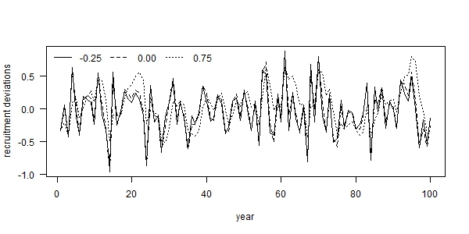

Fig. 1. Examples of autocorrelated recruitment deviations for three levels of autocorrelation: (i) -0.25 (solid line), (ii) 0.00 (dashed line), and 0.75 (dotted line), where each example used the same set of process error deviations ().

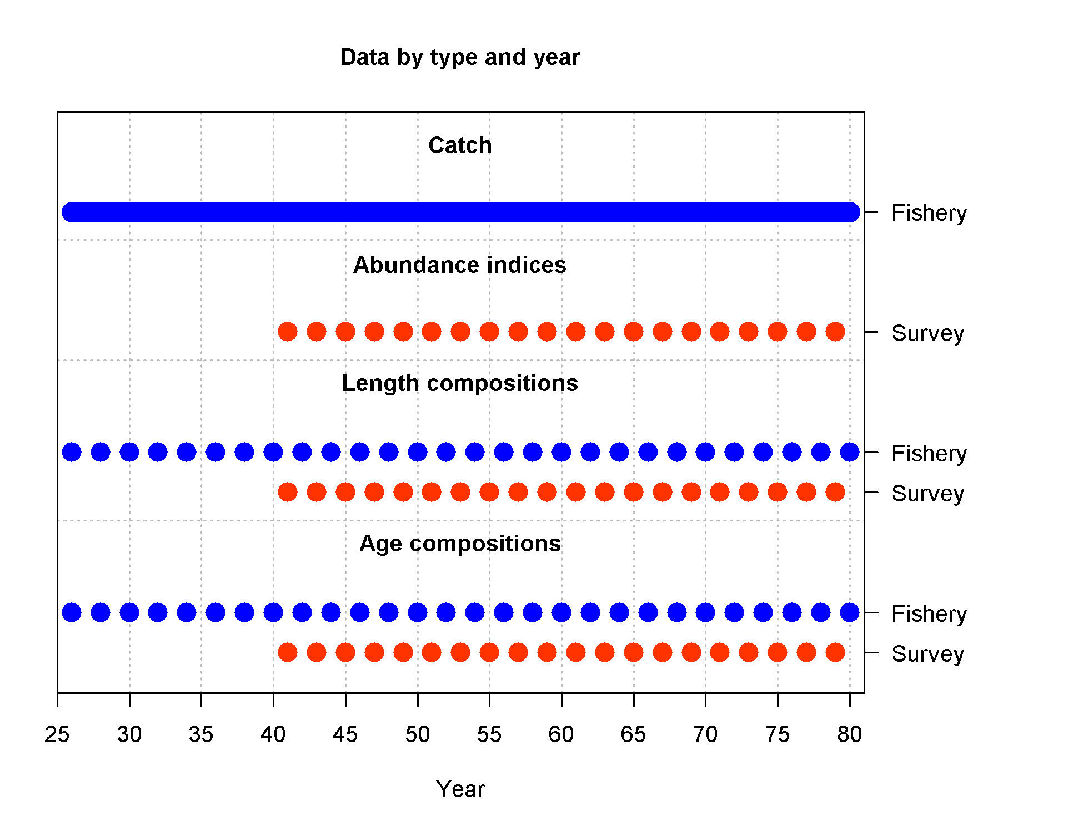

Fig. . Summary of simulated data available to the estimation model during the fishing period (years 26-80).

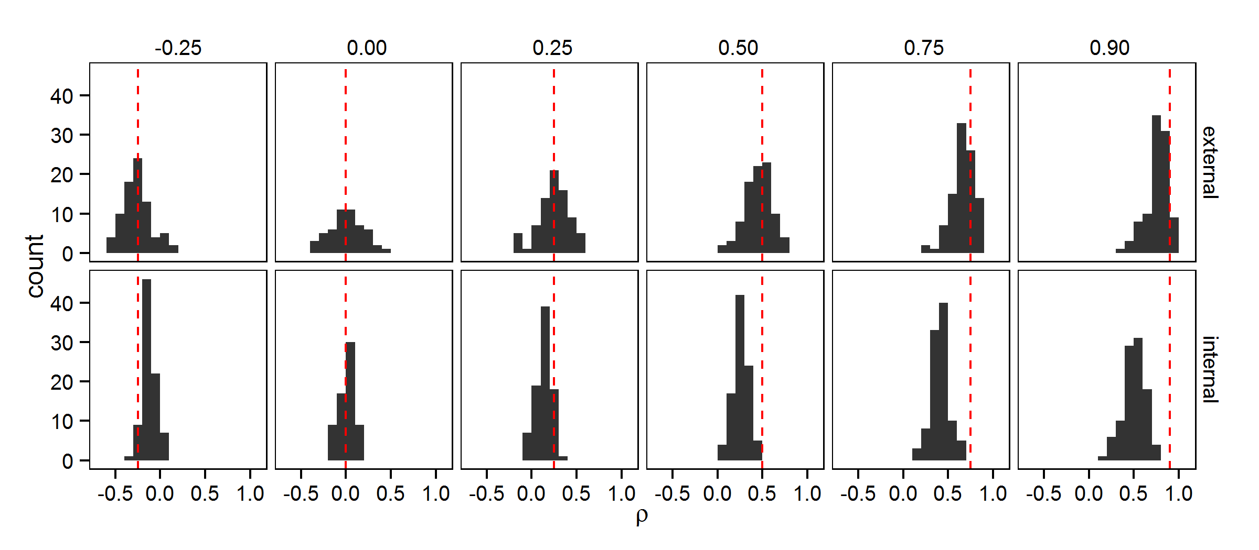

Fig. . Estimates of recruitment autocorrelation (*ρ*) from two estimation models: (i) calculated as the sample autocorrelation of recruitment deviations estimated in Stock Synthesis (“external”; top row) and (ii) estimated as a fixed effect within Stock Synthesis simultaneously with other parameter estimation (“internal”; bottom row), for six levels of recruitment autocorrelation (columns). The dashed red line illustrates the true level of autocorrelation, while the black shaded area is a histogram representing the simulation distribution for each scenario and estimation model.

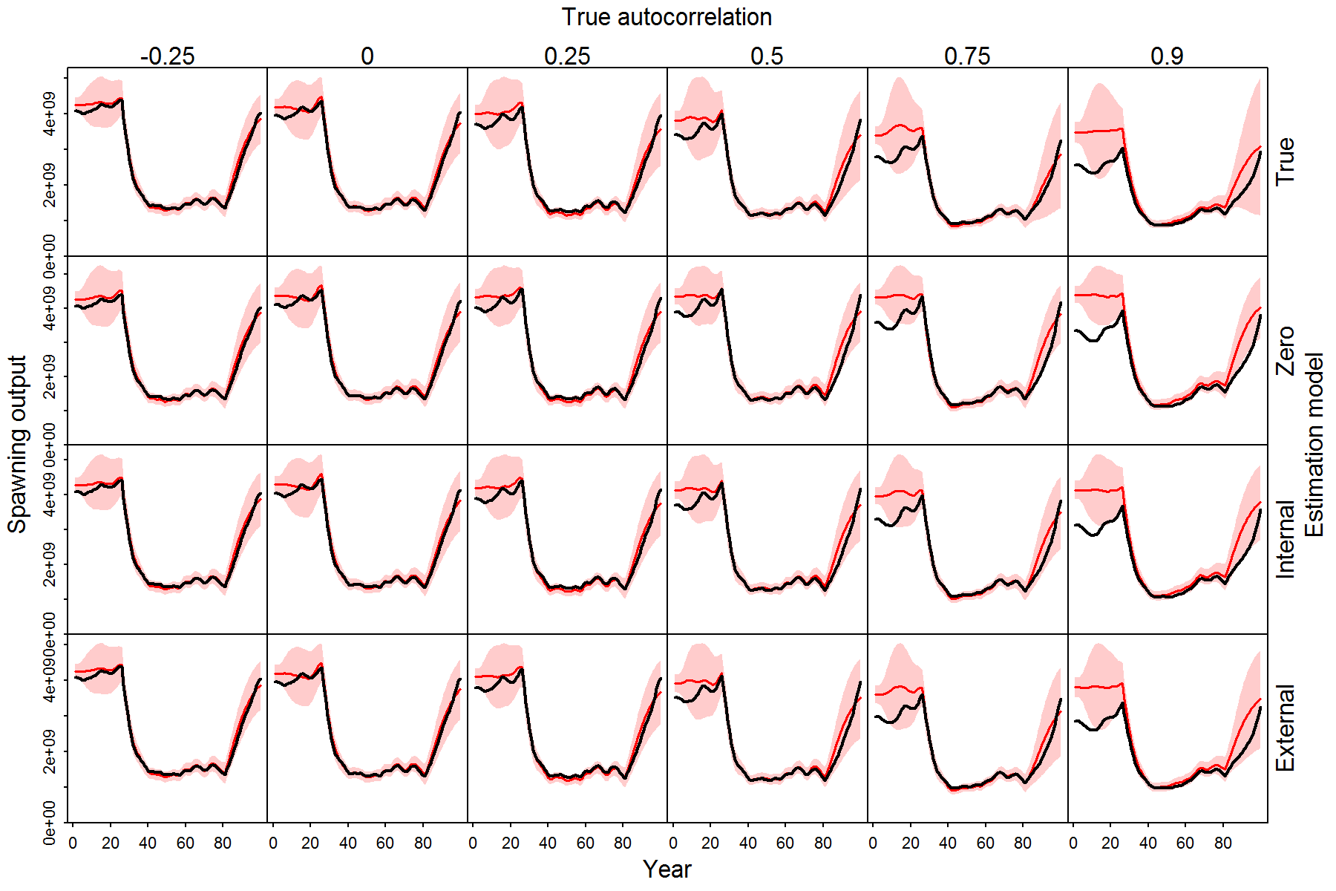

Fig. 4. Illustration of estimated spawning stock biomass (SSB) during 100 simulated years for different scenarios (columns, where recruitment autocorrelation is ρ={-0.25, 0.0, 0.25, 0.5, 0.75, 0.9}), and four estimation models (rows: external estimation, internal estimation, fixed at the true value, or fixed at zero), where each panel shows the true spawning biomass (black line) and the red shaded area shows the 95% confidence and forecasting interval for the estimating spawning biomass.

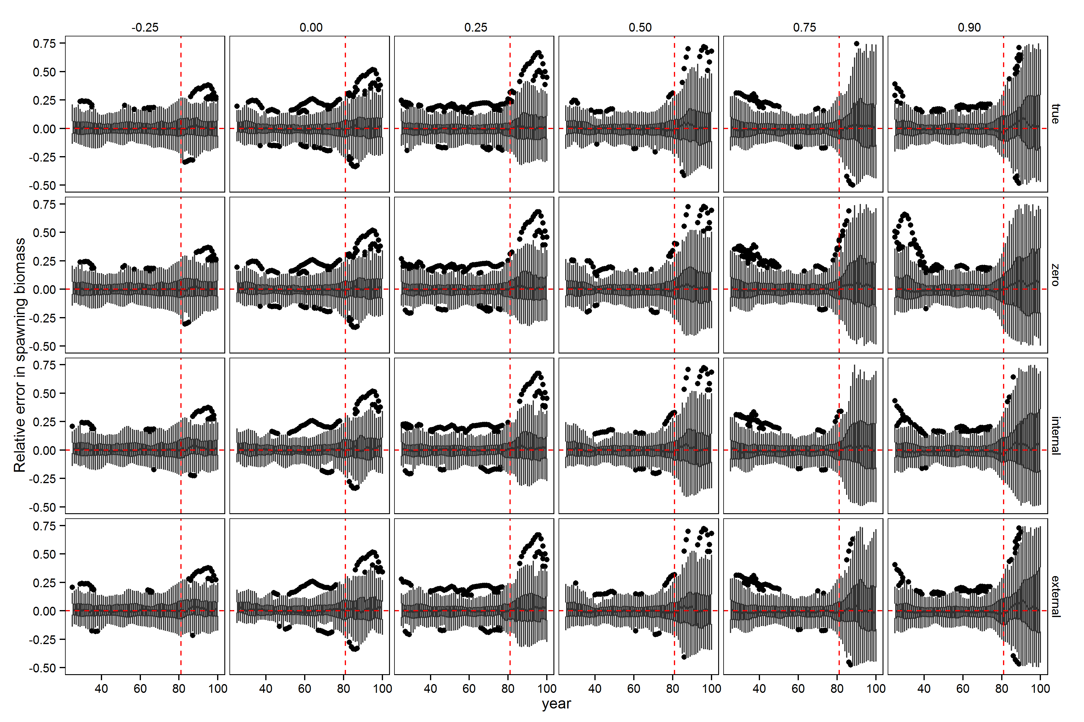

Fig. 5. Relative error in spawning stock biomass during years for which the assessment method was provided data (years 26 through 80) and the forecast period (years 81 through 100, to the right of vertical red dashed lines) for six levels of autocorrelation in the simulated data (columns) and four estimation methods (rows). Horizontal dashed red lines indicate a relative error of zero. Upper and lower edges of the boxes correspond to the first and third quartiles (the 25th and 75th percentiles) and the whiskers correspond to 1.5 times the distance between the first and third quartiles. 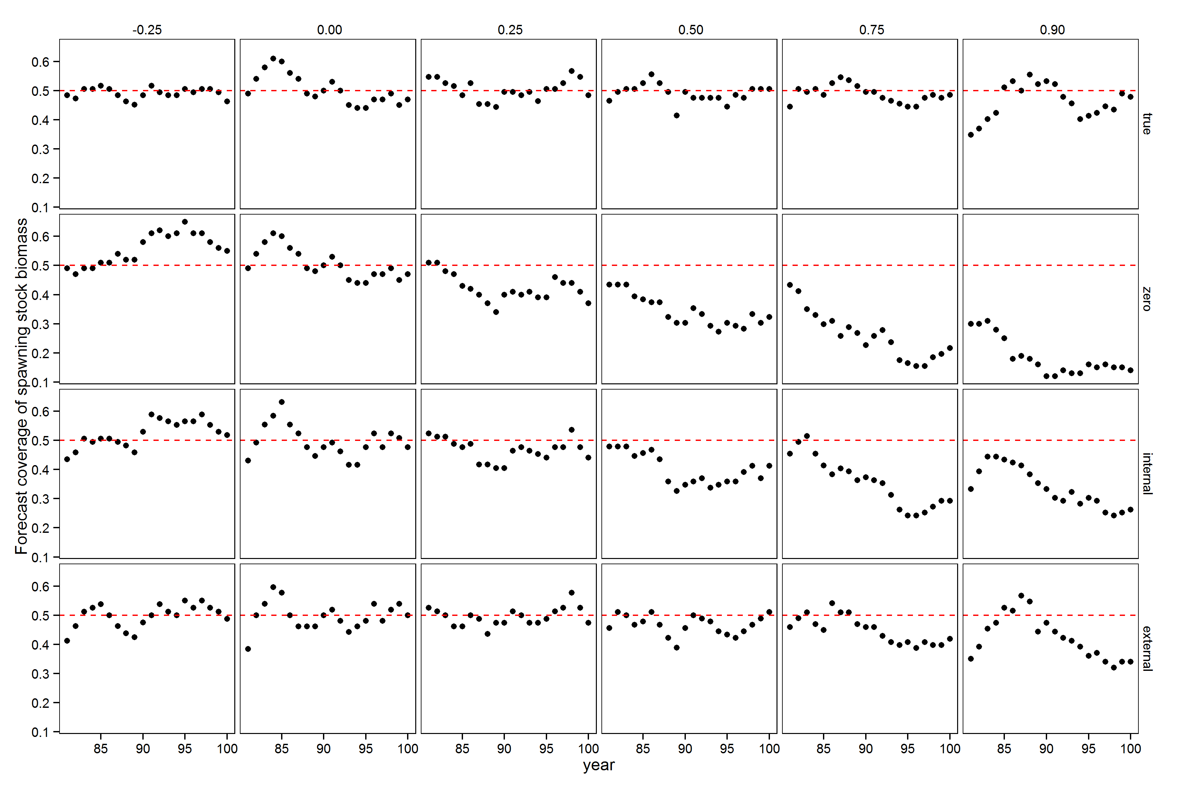

Fig. 6. Performance of forecast interval estimates for different estimation models (rows) and levels of autocorrelation (columns), where each panel shows the proportion of 50% forecast intervals for spawning stock biomass that contain the true value. A well calibrated 50% forecast interval will contain the true value 50% of the time, and this value is indicated by a red dashed line in each panel. Points above or below the line indicate forecast intervals were too wide or not wide enough, respectively.