Problem Set 2: Polygons
Getting started
Areas
Drawing

Getting started
- implement the specified functions in the code template below:
  - You should not do any input or printing in your functions

'''  Name: YOUR NAME HERE  Problem set 2  '''  import turtle  def rectArea( b, h ):  pass  def circleArea( r ):  pass  def triangleArea( b, h ):  pass  def houseArea( b, h ):  pass  def drawRect( t, b, h ):  pass  def drawCircle( t, r ):  pass  def drawTriangle( t, s1, a, s2 ):  pass  def drawHouse( t, b, h ):  pass | def turtleStuff():  t = turtle.Turtle()  t.speed(0)  t.pu(); t.goto(100,100); t.pd()  drawRect( t, 150, 100 )  t.pu(); t.goto(100,-100); t.pd()  drawCircle( t, 50 )  t.pu(); t.goto(-100,-100); t.pd()  drawTriangle( t, 100, 90, 100 )  t.pu(); t.goto(-100,100); t.pd()  drawHouse( t, 150, 100)  def main():  ra = rectArea( 4, 3 )  print( ra ) # 12  ca = circleArea( 3 )  print( ca ) # 28.3  ta = triangleArea( 4, 3 ) # 6  print( ta )  ha = houseArea( 4, 3 ) # 16  print( ha )  s = turtle.Screen()  try:  turtleStuff()  finally:  s.mainloop()  main()

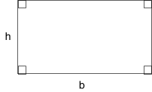
Areas

rectArea( b, h )
- parameters
  - b: base width of rectangle
  - h: height of rectangle
- return
  - area of rectangle
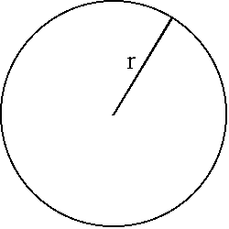
circleArea( r )
- formula:
- parameters:
  - r: radius of circle
- return
  - area of circle
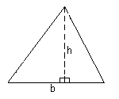
triangleArea( b, h )
- formula:
  - 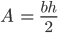
- parameters
  - b: base width of triangle
  - h: height of triangle (perpendicular to base)
- return:
  - area of triangle

houseArea( b, h )
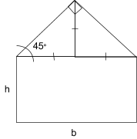
- parameters
  - b: base length of house
  - h: height of house to roofline (bottom of roof)
- return
  - area of house
- note:
  - you should use your other functions inside of this function.
  - you can assume that the roof is formed by two adjacent isosceles triangles. in other words, each triangle's base and height are each one-half the base length of the house.

Drawing

drawRect( t, b, h )
- parameters:
  - t: use this turtle to draw
  - b, h: width and height

drawCircle( t, r )
- parameters:
  - t: use this turtle to draw
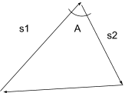
  - r: radius of circle

drawTriangle( t, s1, a, s2 )
- draw a triangle
- parameters:
  - t: use this turtle to draw
  - s1: draw this side first
  - a: turn this many degrees
  - s2: draw this side second

drawHouse( t, b, h )
- parameters
  - t: use this turtle to draw
  - b, h: same as above

