Step 1:

Target:

1. Get the basic skeleton right. We will try and avoid changing this skeleton as much as possible.
2. Results:

|  |  |
| --- | --- |
| Number of Parameters | 194k |
| Best Training Accuracy | 99.33 |
| Best Test Accuracy | 98.75 |
| Number of Epoch | 15 |
| Model Name | Net |

Analysis:

* 1. The model is large, but working.
  2. We see some over-fitting

Step 2:

Target:

1. Make the model lighter
2. Results:

|  |  |
| --- | --- |
| Number of Parameters | 15408 |
| Best Training Accuracy | 99.54 |
| Best Test Accuracy | 98.62 |
| Number of Epoch | 15 |
| Model Name | Net2 |
| File Name | SP- S7_skl_v1.ipynb |

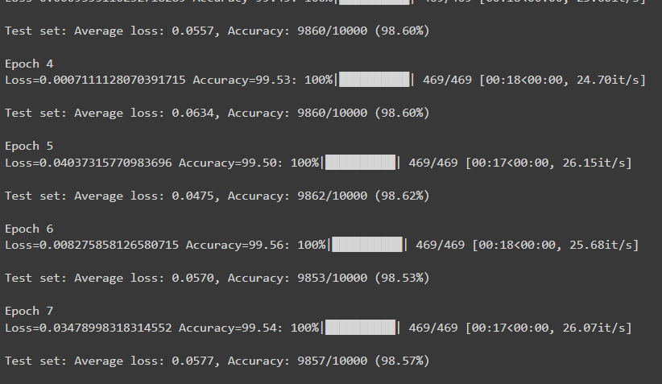

Analysis:

* 1. Reduced the model size
  2. over-fitting, model

Step 3:

Target:

1. Make the model lighter
2. Improve accuracy with lesser parameters

|  |  |
| --- | --- |
| Number of Parameters | 6302 |
| Best Training Accuracy | 99.21 |
| Best Test Accuracy | 99.02 |
| Number of Epoch | 15 |
| Model Name | Net3 |
| File Name | SP- S7_skl_v2.ipynb |

1. Analysis:
   1. Reduced the model size
   2. Added batch-normalization
   3. Model is better and less over fitting

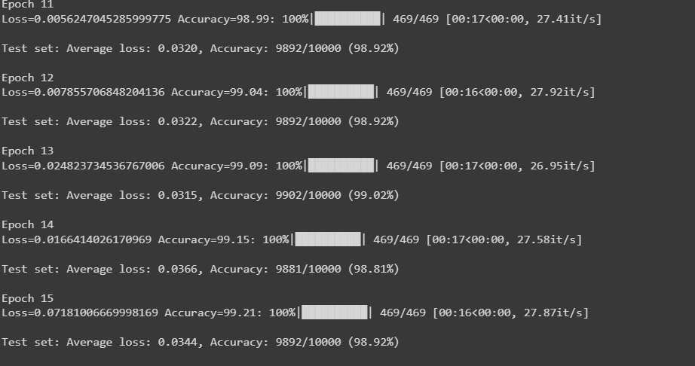

Step 4:

Target:

1. Improve Accuracy
2. Reduce Overfitting

|  |  |
| --- | --- |
| Number of Parameters | 6302 |
| Best Training Accuracy | 99.28 |
| Best Test Accuracy | 99.24 |
| Number of Epoch | 15 |
| Model Name | Net4 |
| File Name | SP- S7_skl_v2.ipynb |

Analysis:

1. Maintained the model size
2. Improved the accuracy
3. Reduced over-fitting ( till 11th Epoch Model was generalizing very well)

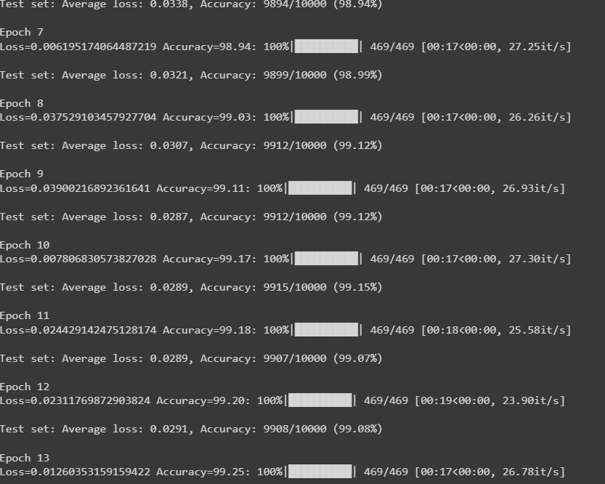

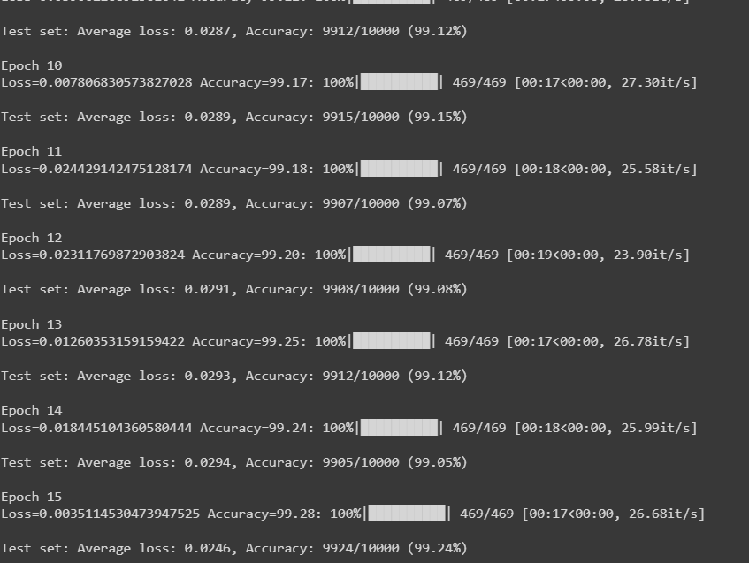

Step 5:

Target:

1. Improve Accuracy
   1. We will try to do some augmentation
   2. Reduce Overfitting in the later stage

|  |  |
| --- | --- |
| Number of Parameters | 6302 |
| Best Training Accuracy | 99.09 |
| Best Test Accuracy | 99.28 |
| Number of Epoch | 15 |
| Model Name | Net4 |
| File Name | SP- S7_skl_v2.ipynb |
|  |  |

Analysis:

1. Maintained the model size
2. There is no more over-fitting. Test Accuracy is always greater than training accuracy

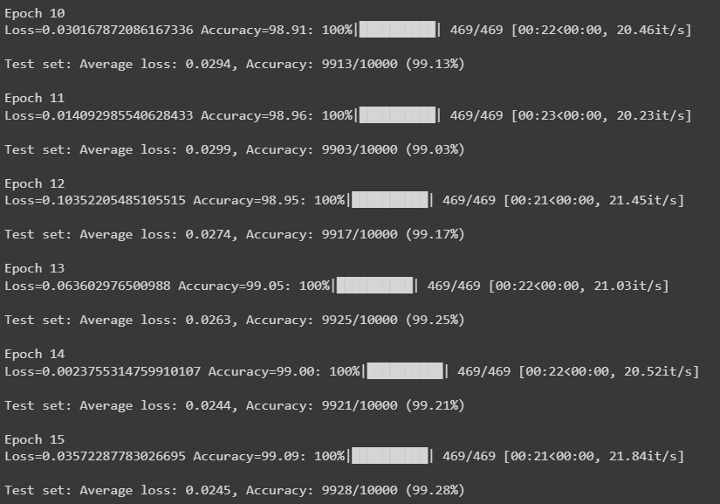

Step 6:

Target:

1. Improve Accuracy
   1. Let’s change the batch size to 64
   2. Add GAP

|  |  |
| --- | --- |
| Number of Parameters | 6422 |
| Best Training Accuracy | 99.08 |
| Best Test Accuracy | 99.41 |
| Number of Epoch | 15 |
| Model Name | Net5 |
| File Name | SP- S7_skl_v2.ipynb |
|  |  |

Analysis:

1. Slight increase in model parameters
2. There is no more over-fitting. Test Accuracy is always greater than training accuracy
3. We can see Model is hitting 99.41

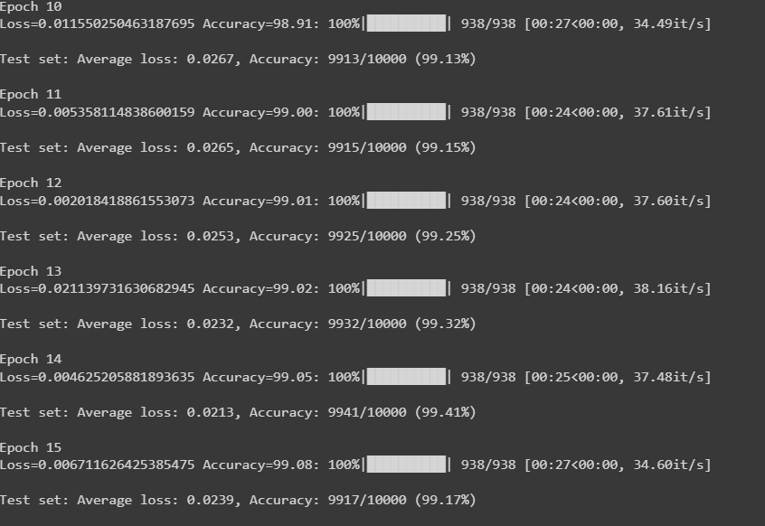

Step 7:

Target:

1. Improve Accuracy
   1. Let’s change the LR using scheduler
   2. After 6th epoch we are reducing by factor of gamma

|  |  |
| --- | --- |
| Number of Parameters | 6422 |
| Best Training Accuracy | 99.50 |
| Best Test Accuracy | 99.40 |
| Number of Epoch | 15 |
| Model Name | Net6 |
| File Name | SP- S7_skl_v2.ipynb |
|  |  |

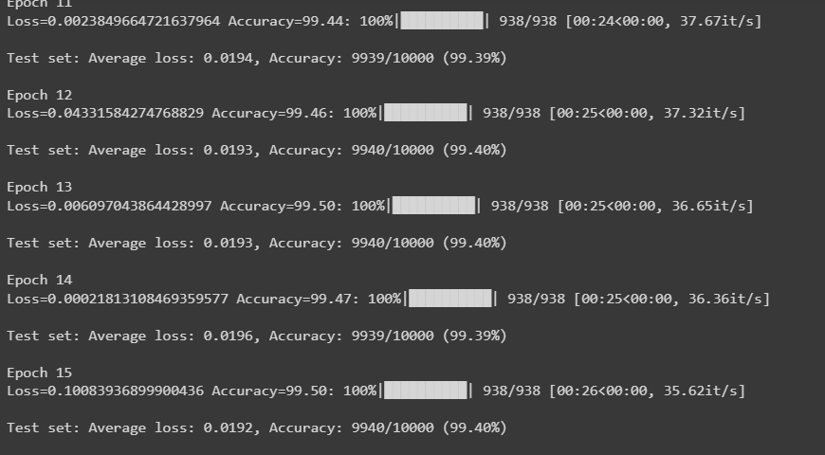

Analysis :

The network is constantly hitting 99.40 with some amount of over-fitting.. I will submit it as we are achieving the objectives