INIT D Script



Starting

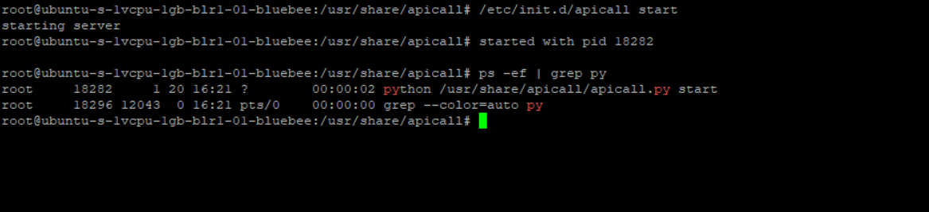

Stop

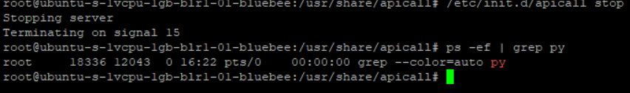

LOGS

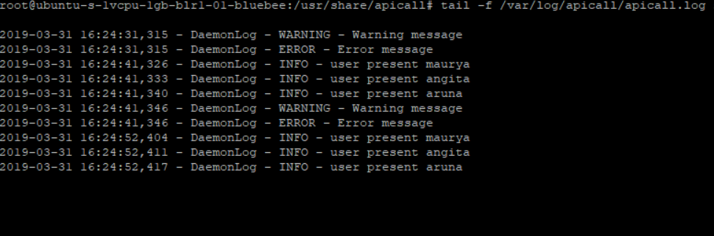

OUTPUT

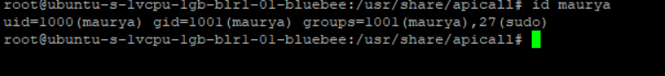

As a service

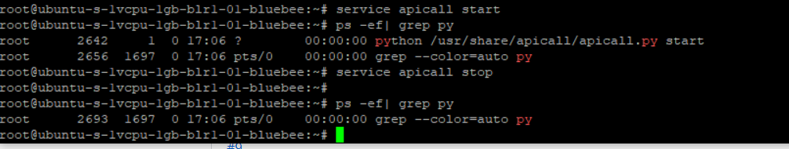

BEFORE REBOOT

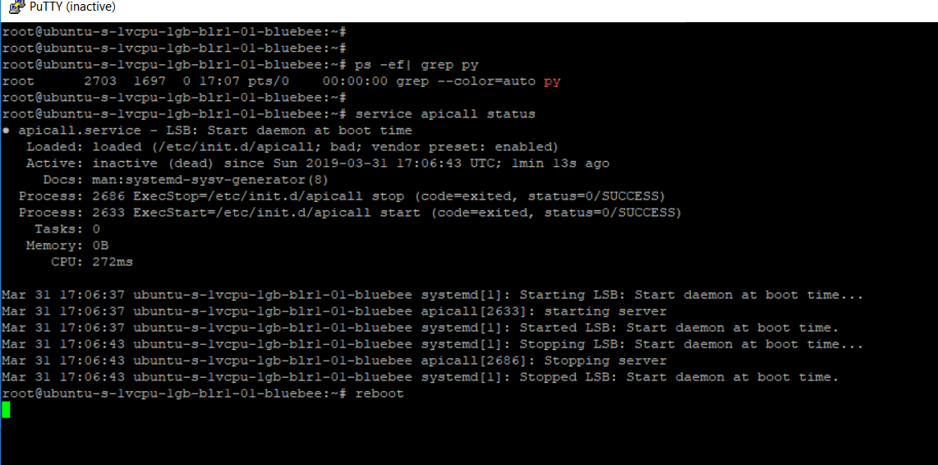

AFTER REBOOT

